Applying Climate Information to Achieve the Sustainable Development Goals

UNDP Programme on Climate Information for Resilient Development in Africa

Improving climate information and early warning systems across Africa has the potential to significantly improve lives, build resiliency and support us in our global efforts to achieve the Sustainable Development Goals.
18 November, 2015 | Prepared by Bonizella Biagini

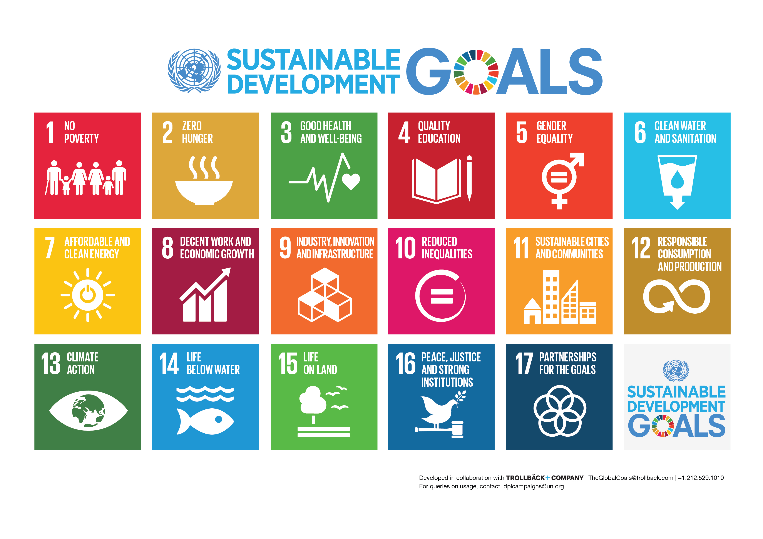

Overview
Information is a cross-cutter. It can be applied to almost everything. And improving climate information and early warning systems across Africa has the potential to significantly improve lives, build resiliency and support us in our global efforts to achieve the Sustainable Development Goals.
For over 30 years, the international development community has made substantial investments in climate information systems for Africa, nevertheless, according to the World Bank, “most hydromet services are unable to meet the needs for weather and climate information.” This lack of quality information is costing African nations dearly. With effectively structured public-private partnerships, new low-cost technology advances such as Automatic Weather Stations, cloud computing and automated emergency warning systems, strengthened institutions, increased regional cooperation and continued capacity building, sustainable climate and weather information solutions are a realistic and attainable goal. Reaching this target could have a significant impact on our ability to protect human life, build resiliency in the face of a changing climate, and foster long-term prosperity.
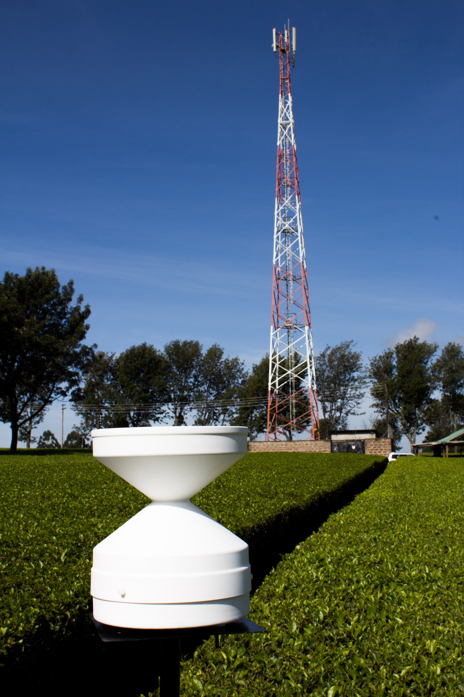
Providing vulnerable farmers and communities with improved weather and climate information has the potential to increase farm production, build market stealth and lower risk. With better information on extreme weather events, improved crop forecasts and more actionable information on what to do when bad weather hits, farmers can protect property and human lives, access risk-management mechanisms like index-based insurance, and create long-term plans for a future that will be highly dependent on rainfall patterns, droughts, floods and other natural disasters. Decision makers can use this valuable information to inform National Adaptation Plans, strengthen national production, lower migration caused by climate change, and build climate-smart infrastructure designed to withstand the potential dangers a changing climate.
So how can African leaders apply climate information and early warning systems to the SDGs? It’s about embracing innovation, learning from the past and supporting enabling actions that build to a more sustainable future for investments in the climate services sector.

Applying Climate Services to the Sustainable Development Goals

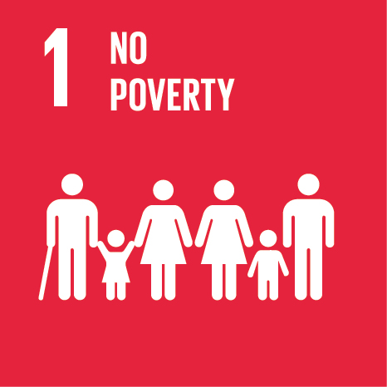 | Through the Millennium Development Goals, Africa’s Least Developed Countries have achieved significant gains in addressing poverty traps and building the institutions and infrastructure necessary for long-term sustainability. But we have a long way to go, and information is going to be essential in breaking the poverty cycle. Globally, weather impact caused 1.94 million deaths and resulted in an estimated US$2.4 trillion in economic losses between 1970 and 2012. Over the past three decades, floods and droughts have already cost Zambia $13.8 billion, equivalent to a 0.4 percent loss in annual economic growth. This astonishing figure could be significantly reduced if proper weather and climate information systems are established, along with the long-term visions, capacity building and support needed to ensure initial investments in infrastructure and technology are sustainable. The technological basis for this new vision is founded on relatively recent innovations in hydro-meteorological observation and forecasting technologies, as well as advances in telecommunication services and computing, which are rapidly spreading across the continent. The emergence and combination of these technologies enable the deployment of dense arrays of low-cost weather and climate monitoring sensors onto cellular communications towers into areas that were previously too difficult or costly to reach. With the necessary power, telecommunications, and security services in place to ensure the safe and continuous operation of this equipment, National Meteorological and Hydrological Services (NMHS) in sub-Saharan Africa can place a greater emphasis on the interpretation and transmission of life-saving information to the public, rather than making manual observations or attempting to fix far more costly and difficult to maintain traditional radar systems. By engaging with a number of new actors in this space, they also have the opportunity to create new partnerships with the private sector to improve the quality of weather information, share weather alerts and build revenue streams through the sale of data to industries with vested interest in the weather, such as aviation, banking and mineral extraction.
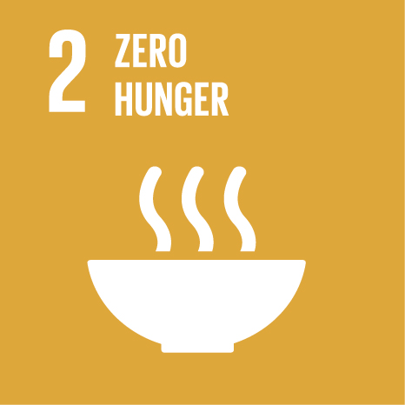 | There will be about 2 billion extra mouths to feed by 2050 if population trends continue. This means we are going to need to find innovative solutions to boost crop productivity while ensuring we are aligning with best practices to protect the environment. Not an easy task, but better weather information could aid in these efforts.  Consider this, about 25 to 40 percent of the food produced in Africa is lost because of inadequate harvest, storage and transport practices. If farmers are given relevant weather information they need to plant, harvest and hit the market at the right time, not only could they improve their incomes, they could also increase production levels to meet our growing food needs. Additionally, by providing early warning systems, African nations have the opportunity to mitigate the affects of natural disasters, which sap national resources and hinder food security initiatives. If global warming continues at the current rate, sub-Saharan Africa could see a 5 to 22 percent drop in crop production levels by 2050. Knowing the weather will be essential to the continent’s most vulnerable farmers in building systems and methodologies that are resilient to increased chances of drought and erratic rains.
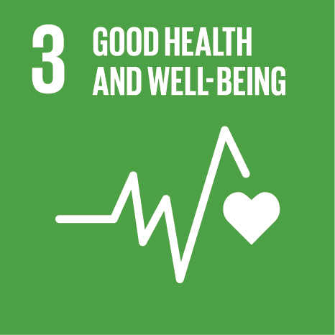 | Early-warning systems, especially lightning detection, can save lives. Lightning is one of the number-one weather-related dangers for villagers living in rural Africa. The region receives more lightning strikes than anywhere else in the world, and poorly designed buildings and a general lack of awareness of what to do when lightning strikes only adds to the risk.  Death numbers from lightning strikes in Africa are similar to what they were in the developed world over a hundred years ago - before the Industrial Revolution and rapid urbanization dropped death tolls in places like the United States from around 400 a year to just 30 today. Initiatives like the UNDP Programme on Climate Information for Resilient Development in Africa (CIRDA) and the Severe Weather Nowcasting Based on Total Lightning Detection in Africa’s Lake Victoria Region are working with African countries to deploy low-cost lightning detection systems that can aid in the issuance of life-saving alerts.  And what about mosquito-born disease? Since 2000, nearly 700 million cases of malaria have been prevented in Africa and death rates have fallen 60 percent globally. But changing weather patterns increase the risk of malaria outbreaks, and actionable information would help policy makers protect programs that have aided in slowing its spread. On the village level, if poor rural people had better weather information, they would know when it’s time to spray for bugs and sleep under nets.
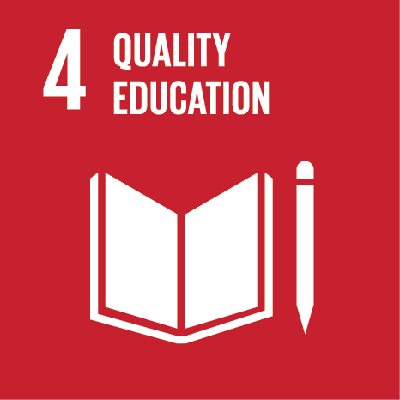 | Of course improved productivity and reduced risk means school-age children will have better access to long-term education opportunities. It’s easier to stay in school if you are not fleeing drought zones and floods, or returning to the farm to rebuild after a flash flood. There are also innovative ways in which climate information is being coupled with education to support education in science, technology, engineering and math. In March 2015, the Trans-African Hydro-Meteorological Observatory (TAHMO) installed a weather station at a high school near the coast of Lake Victoria as part of their School-2-School Programme. The students there will be comparing data with a sister school in Idaho, USA. This not only supports accurate, real-time weather data-gathering, but also helps build a next generation of scientists, and raises awareness of climate change and environmental stewardship.
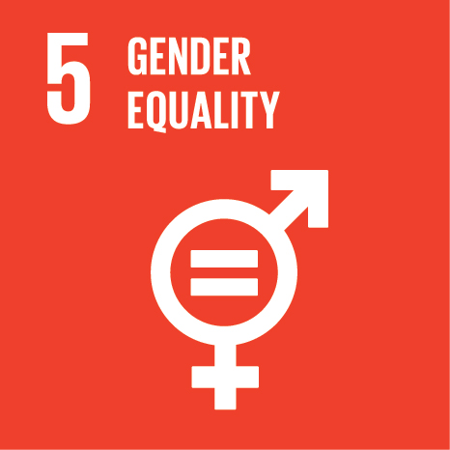 | How do the genders use climate information differently? While men may look to the information to avoid dying while out fishing on Lake Victoria – where an estimated 5,000 people die each year due to erratic weather – women use and process the information differently. For instance, women may be in charge of marketing food, and can choose to hit markets at optimal price points. They are generally in charge of family health, and knowing what weather will come can help them feed, protect and nourish their children to keep them out of harms way and build healthier lives. There’s also a peace of mind that comes with knowing the weather. And knowing what the weather will bring can foster a safer home environment.
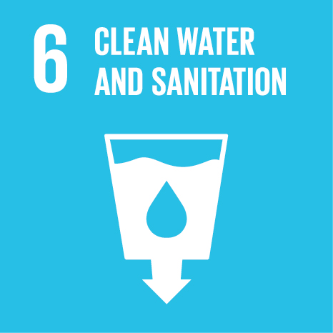 | Floods, droughts and other weather shocks can wipe out entire sanitation systems, effectively putting us back to square one. With better information, policy makers can plan around changing climate patterns, build resilient systems that withstand these shocks and protect clean water sources through the effective monitoring of rainfall and other hydrological activity.
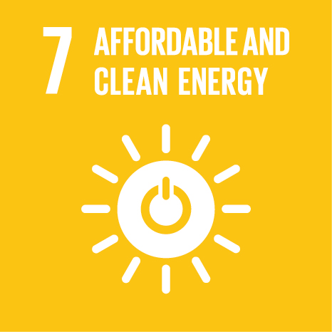 | Weather information has a huge impact on the energy industry. For instance, water flows affect dam production, wind direction, speed and consistency affect wind production and the sun, well… it affects solar production. Effectively looking both at short-term forecasts and long-term trends will empower decision makers in building sustainable energy systems, increasing output and building smarter energy grids that adapt to energy needs.
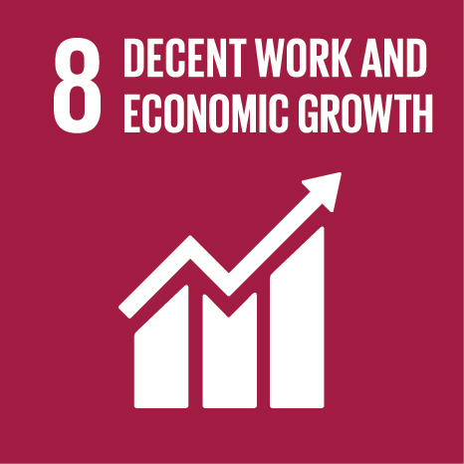 | Not only can smallholder farmers, pastoralists and rural entrepreneurs use weather information to build crop efficiency and optimize market potential, it is also a game changer for large industries such as banking, insurance, telecommunications, tourism, natural resource exploitation, and any number of related industries.
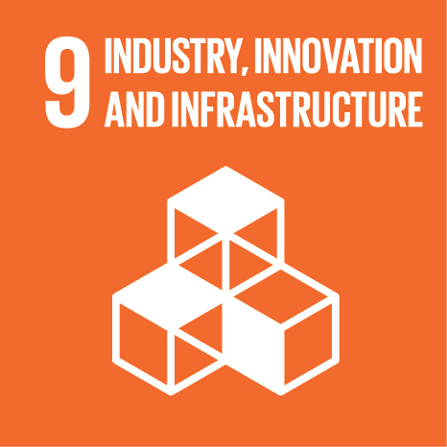 | If you know the weather, you can create index-based insurance that protects agricultural production – both large and small – along with larger infrastructure projects. More importantly, better information works to increase production and market knowledge and stealth, while at the same time decreasing risk profiles.
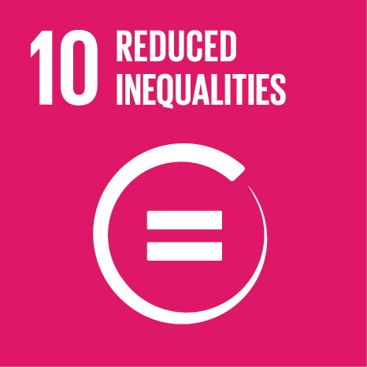 | We live in an age of information haves-and-have-nots. Climate shocks in the developed world hurt, but when they happen in least developed countries with limited resources and disaster relief systems, they can be a knock out blow. By providing useable weather information to poor farmers – along with large industry – we can even the playing field.  Knowing the weather should be a public good. Unfortunately, in many African nations, the poorest farmers have zero access to accurate forecasts. Instead they look to the skies to see their future. Hopefully, as part of this massive effort to achieve the Sustainable Development Goals they will be able to look to their cellphones instead, where they will receive an SMS alert saying that it’s time to plant sorghum, time to move to higher ground, time to bring their crops to market.
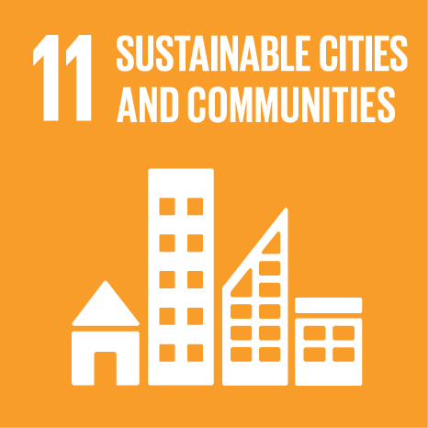 | Reliable weather information means vulnerable communities can optimize planting cycles. It means they can plan for long-term prosperity because they can protect roads and other productive infrastructure. It means they can address public health issues like malaria outbreaks that result from unusually heavy rains, allowing them to focus on more important things like better schools. It also means more opportunity and security in the countryside, which has the potential to slow the tide of urbanization and climate-change-induced migration across the continent.
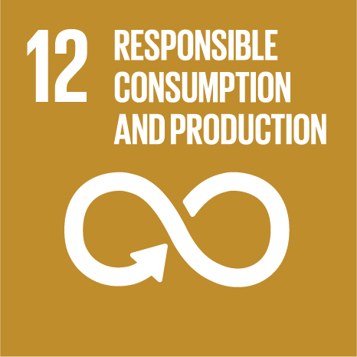 | With better information, comes better decision-making and long-term planning. Armed with accurate climate and weather information, African governments can create virtuous consumption and production cycles that adapt to changes in weather patterns. It also aids in strengthening value chains and fortifying virtuous cycles between consumer and vendor.
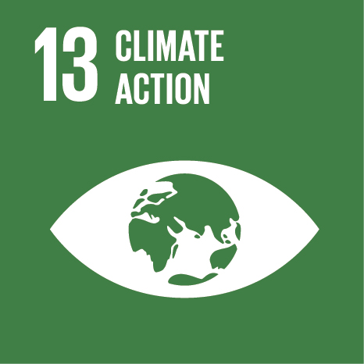 | Action requires information. Only by informing the world’s decision makers with accurate models of long-term climatic risks can we make the right decisions to navigate these treacherous waters. We also need to be realistic in our approach to climate action. Mitigation alone will not be enough. African nations need to adapt their economies, their cultures, their societies, their way of doing things to a new global reality. With the right information, and the right support, they can achieve this, building resilient nations that can withstand the winds of change.
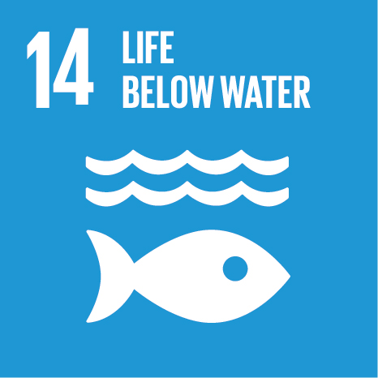 | Climate change is severely impacting coral reefs, fisheries, and the broader ocean ecosystem. With better information on storms, fisherman can properly plan and manage their fisheries, stay safe from storms and build prosperous futures that work in harmony with the ocean’s natural rhythms.
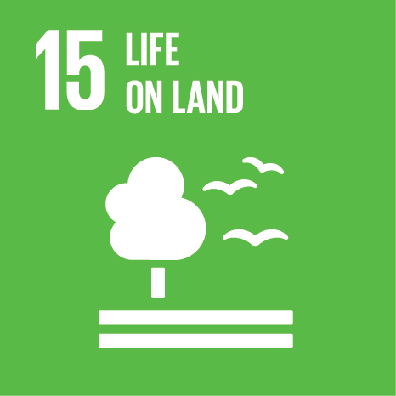 | On land, this information can inform watershed management, biosphere protection zones and other mitigation efforts. It can also provide the framework to build conservation policies that protect our planet.
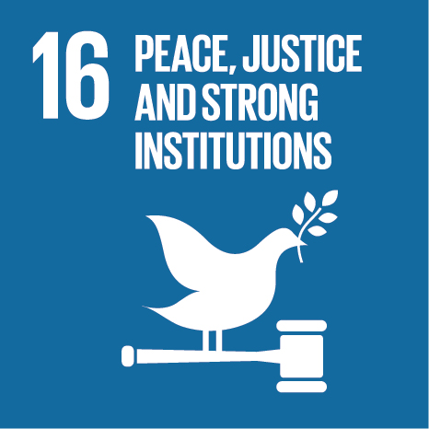 | With our changing climate – and lack of adequately shared information - we are seeing a global increase in climate refugees and the specters of insecurity that manifest themselves in battles for scarce resources. By knowing what lies ahead, we can effectively plan for a new future. There is also the very real opportunity to fortify the structures of the African institutions that share weather information and the disaster management systems that keep her people safe.
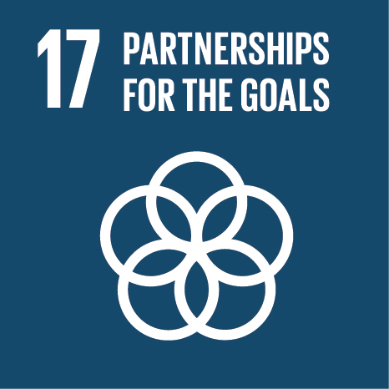 | The weather knows no borders. It does not respect international treaties. By fostering the interchange of weather information across countries, we can limit the spread of disease, reduce knock-on affects from natural disasters and foster a culture of cooperation that shares valuable information for the global good.  In order to achieve financial sustainability of investments in the climate services sector, African leaders will need to engage a new group of private-sector actors working in this space – private weather vendors, industries such as mining, banking and insurance, and telecommunications firms that can help in the collection and distribution of early warnings. This type of engagement has the potential to amplify the impact of investments in new climate information and early warning systems across sub-Saharan Africa, while addressing pressing challenges facing National Meteorological and Hydrological Services – lack of capacity, limited staffing levels, budgets that prioritize other pressing humanitarian issues such as health and education, and outdated, hard-to-maintain and ineffective technology.

