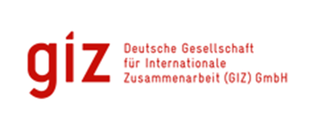

**THEMATIC REPORT: ICCAS PROJECT**

**Climate Change Adaptation: Finance Readiness**

 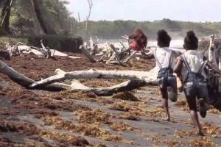

**Submitted**

By

**David A. Simmons**

92A Benjamin St., Diego Martin

Trinidad and Tobago

**Email:** [**davidAsimmons@outlook.com**](mailto:davidAsimmons@outlook.com)

|  |  |  |  |
| --- | --- | --- | --- |
| **Integrated Climate Change Adaptation Strategies (ICCAS): Thematic Report** | | | |
| **Thematic Area: Climate Finance Readiness** | | **Period:** January 2016 – August 2017 | |
| **IMPLEMENTING AGENCIES** | | | |
| United National Development Programme (UNDP) | The Environment Unit of the Ministry of Agriculture, Lands, Forestry, Fisheries and the Environment | | German Development Cooperation (GIZ), BMUB |

|  |  |
| --- | --- |
| **Context** | Grenada contributes comparatively little to global warming in absolute terms but the small developing island state is greatly affected by changes in climate patterns and their consequences. The negative impacts of climate change form an additional financial burden for the tri-island state which affects its economic and social development. The Government of Grenada has committed to climate protection and to adaptation to climate change, while being cautious of not diverting scarce local resources from ongoing development priorities like education, health and social development.  A central element of the ICCAS Programme was Component 4 “Capacity to access climate finance and knowledge management” which sought to strengthen Grenada’s capacity to access climate finance, by supporting a more integrated approach to climate change that will help to attract financing for climate resilient practices, and by direct assistance to access and absorb sufficient finance for activities to build climate resilience and increase the usage of renewable energy. |
| **Background** | At the commencement of the ICCAS project the Government of Grenada had little experience in attracting climate finance or preparing proposals for large projects that will enable Grenada to access international climate change finance. This, therefore, hampered the Government´s ability to effectively acquire resources for urgent adaptation needs. In that regard, the country sought and obtained assistance from the German Government and through GIZ, a recognized delivery partner for the Green Climate Fund (GCF), prepared and provided a Climate Readiness and Preparatory Support programme which provided training in the requisite legal, policy and institutional framework as well as the building of human resource expertise that would enable the country to achieve climate finance readiness. The preparation of the National Adaptation Plan (NAP), which has been the vehicle through which the “mainstreaming” of climate change adaptation was pursued, also became Grenada’s main mechanisms for accessing external climate financing as it outlines the key areas of action needed to be taken to tackle the negative impacts of climate change. This framework provides the basis for approaching other development agencies with a commitment to climate change, to access both grant and loan funding for projects with climate adaptation and resilience building components. |

**Overall Success:**

Several activities have been undertaken to help Grenada achieve its objectives regarding access to climate finance access and achieve climate finance readiness. 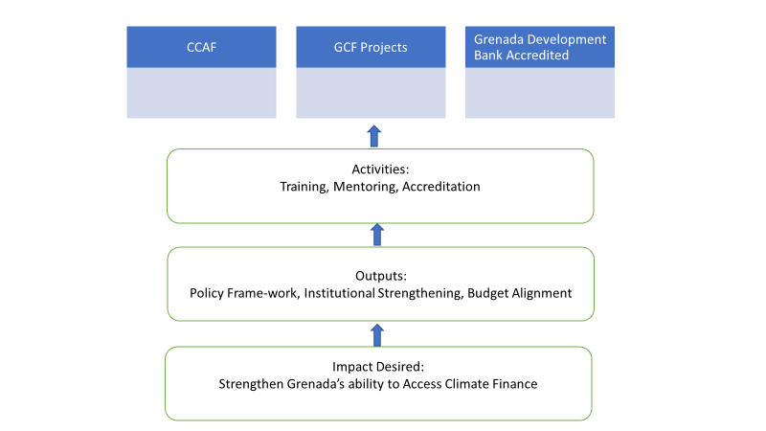

These included:

* Preparation of the National Adaptation Plan (NAP) the vehicle through which the mainstreaming of climate adaptation and resilience is outlined and outlines the key areas of action needed to be taken to tackle the negative impacts of climate change.
* Preparing the country’s legal, policy and institutional framework as well as the building of human resource expertise that would enable the country to achieve climate finance readiness.
* Providing capacity enhancement: Training for private sector on accessing climate finance – Feb 2018.
* Public Sector training in 2016 – 20 public officers and NGO personnel trained on accessing funds from the Green Climate Fund (GCF).
* Mentoring – public sector officials and relevant agencies (Grenada Development Bank etc) shadow consultants.
* Accrediting the Grenada Development Bank (GDB) to be the National entity responsible for accessing and disbursing international funds through review and improvement of internal processes. This is close to being accomplished.
* Institutionalising the Community Climate Change Adaptation Fund to provide opportunities for local communities to increase their resilience to climate change.

**Overall Success:**

With support from the GIZ Project team a Climate Finance Readiness Action Plan was developed and several steps were taken to access funds from international institutions. These involved the establishment of the

* A Climate Finance Readiness Action Plan was developed;
* The NDA for the Green Climate Fund (GCF) was established, and
* continuous support on capacity building was provided through training of several persons in the public sector.
* Grenada has also received support from the Caribbean Climate Finance Readiness Programme for the assessment of its state of climate finance readiness, capacity building measures as well as in-depth gap analysis for potential National Implementing Entities to be accredited with the Green Climate Fund.

These initiatives have borne fruit with the approval of:

1. a Readiness Support project by the GCF - In July 2017, a technical assistance project financed by the Climate Technology Centre and Network for the water sector was approved;
2. In 2018 approval by the GCF of the “Climate Resilient Water Sector in Grenada G-CREWS)” which is aimed at mainstream and implement climate resilience throughout Grenada’s entire national water sector.
3. Technical cooperation with the Japanese Caribbean Climate Change Partnership

**Lessons Learnt:**

* The successful access to international funding requires capacity building in the public sector in general and the need for persons trained in preparation of proposal preparation and specific aspects of climate finance within the local community
* Focal agencies need to achieve accreditation quickly (e.g. Grenada Development Bank) to access the relevant bilateral and multilateral financing institutions (e.g., GCF). The Government must ensure that local capacity, both in terms of obtaining accreditation and executing functions (financial management) is built and sustained.
* Partnering with institutions with the relevant experience is beneficial and necessary in helping to achieve the following:
  + Building capacity
  + Providing bridging finance to jumpstart initiatives or
  + Undertaking necessary feasibilities to adequately determine the technical and financial resources needed to facilitate climate adaptation and build resilience.

The documenting of the CCCAF’s functioning and using these results to inform the institutional strengthening process needed to make Grenada ready to access larger scale climate change financing is the key take away from the CCCAF.

The CCCAF success in community projects which involved stakeholders in design and implementation of projects demonstrated a high level of country ownership and provided evidence of the country’s commitment to utilising the resources provided to building resilience and addressing climate risks. Feedback received from the communities of their willingness to take on bigger projects is demonstrative of a best practice that can be scaled up in the development of larger project funding exercises**.**

**Recommendations based on the Lessons Learnt and Best Practices Analysis:**

1. Institutionalize capacity building so that newcomers are trained, and training upgraded as required
2. Include funding accreditation requirements in ongoing planning activities at the policy and program level
3. Align policy programs and plans with climate change adaptation goals plans and activities and ensure the budgetary cost and expenditure categories reflect those goals plans and activities.
4. Institutionalize the bottom up input into planning and implementation exercises so that the funds are effectively used to improve the quality of life in the communities.

Author: David Simmons & Christina Barradas-Brewster/ Consultants/ Caribbean/

Contact: [davidasimmons@outlook.com](mailto:davidasimmons@outlook.com)

Location of Project: Caribbean/OU/Grenada/St Andrew

MHT: What is the Major Habitat Type for this partnership? Farming community, school

Types of Partners: Government, Place-based NGO, International NGO, Community Based Organization.

Priority: Freshwater

Date: May 2018

Links: <http://www.iccas.gd/?q=about-iccas>

<https://www.greenclimate.fund/-/climate-resilient-water-sector-in-grenada-g-crews->

<http://www.adaptation-undp.org/projects/japan-caribbean-climate-change-partnership> <http://www.gov.gd/egov/news/2017/oct17/10_10_17/item_1/green-climate-fund-approves-readness-preparatory-support-programme-grenada.html>