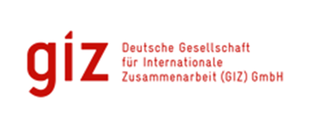

CASE STUDY: ICCAS PROJECT
Climate Kids Adventure
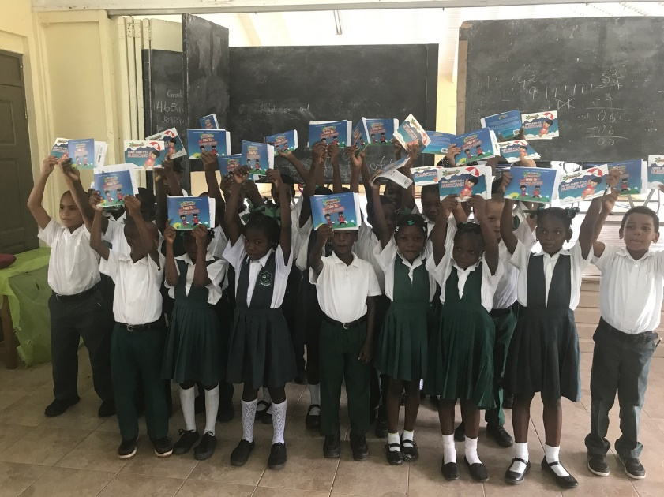

Submitted
By
David A. Simmons
92A Benjamin St., Diego Martin
Trinidad and Tobago
Email: davidAsimmons@outlook.com
Integrated Climate Change Adaptation Strategies (ICCAS): Case Study
Title: Climate Kids Adventure |  | Period: January 2016 – August 2017
IMPLEMENTING AGENCIES
United National Development Programme (UNDP) | Ministry of Education Human Resources Development & Environment, NAWASA |  | German Development Cooperation (GIZ), BMUB

Background:
The Integrated Climate Change Adaptation Strategies (ICCAS) project was designed to provide a holistic approach to climate change adaptation and mainstreaming in Grenada. The overall aim of the ICCAS project was to increase resilience of vulnerable communities and ecosystems to climate change risks on the three islands: Grenada, Carriacou and Petite Martinique. The project, which has four Components, uses a comprehensive, integrated approach for analysing and implementing adaptation strategies. It also used a unique approach of establishing the institutional and operational framework for building adaptation and resiliency with direct support for the implementation of small-scale adaptation initiatives through a community based climate change adaptation fund which contributed immensely in informing ordinary citizens about the impacts of climate change and demonstrating through actual interventions, how they can initiate various activities, in their homes, schools and communities to build resiliency.

The complete ICCAS Programme was comprised of four (4) components out of which a number of projects were conceived and executed. These projects can be grouped along the following themes:
- Agriculture and water
- Marine and coastal areas
- Education and awareness
- Flood mitigation
- Recycling
- Land degradation
The Climate Kids Adventure Project is one of the 27 projects funded under the umbrella ICCAS programme and falls within the thematic area of Education and Awareness.

Climate Kids Adventure: Project Summary
This project, which received a grant of USD50,000, was aimed at raising awareness of climate change among children young children. It sought to inform them about climate change and how it can be addressed by communicating in a fun and understandable way the causes, impacts and measures we can all take to adapt to its effects. It also sought to use them as influencers in ensuring that the adults in the households were made more aware of climate change. In that regard, the education/ outreach components of project targeted school children, given their low level of climate change awareness, but more importantly, because of the general belief that students can be an effective medium of reaching parents and teachers. The books, “Hurry Hurry it’s a Hurricane and “Hike to Camp Cool”, both addressed climate change issues and helped to raised awareness of climate change origins, disaster risk reduction practices and climate change adaptation strategies to minimise impacts of climate change. A mobile app was developed and made available along with the books.
The books targeted children between the ages of 5-7 and were distributed in all the schools in Grenada (including private schools) and based on the school population approximately 7000 children were exposed to the climate change topic. The books and mobile application were used as tools to engage the target group. It was expected that the children’s improved knowledge would serve as a conduit to raising awareness among their parents and greater community and give rise to widespread discussion and consideration for positive change.

The Project was expected to be evaluated and monitored by the number of downloads from the mobile applications and Adaptation and risk reduction initiatives put forward by the Primary Schools.

The project commenced in 2016 with a baseline survey and was completed by 2017 with the administration of an end of project survey. The surveys were used to measure the increase in awareness of climate change issues among the children targeted by the group

The project envisaged that the topic of climate change would be integrated within the school education system and penetrate the homes using the books as tools. Both school staff and PTA’s were therefore key stakeholders in the success of the project.

Project Objectives/Goals
The project’s main objective was to engage young children on climate change, adaptation, and risk reduction by communicating in a fun and understandable way the causes, impacts and measures we can all take to adapt to its effects.

Climate Change Adaptation impact
The Baseline study showed 72% of the nation’s children between the ages of 5-7 had not heard the words climate change nor were they aware of the concept of climate change, before the project. However, after the project was implemented the knowledge relating to climate change increased by 26.25%. This demonstrates that the project had a considerable impact on the target age group. It is expected that this number will increase as the books and apps continue to be used in the schools.

Moreover, in the parish of St. Marks where originally only 1% of all the students were aware of climate change the post project survey showed a change to 13% of students saying they knew about or heard of climate change which is a highly significant improvement in awareness.

Positive Lessons that can be Extracted from this Project
The climate change adventures project did several things very well:
- It did a detailed baseline survey of children in the targeted age-group before the project commenced and followed that up with an end of project survey after the books and application were distributed which allowed for quantitative analysis of the achievement of key indicators.
- It used the school system to ensure wide distribution of the materials produced to the target age-group.
- The books were attractive and well written and had broad appeal to children in the target age groups. This is evidenced by the fact that the books were selected and featured by the Grenada community library Annual Christmas gala.
- The project also used the appropriate technology in the modern context making wide use of social media and of course using mobile apps for distribution of the book. Between January 2017 - March 2018 a total of 59,348 persons have been reached through Facebook, Instagram and Website with the website have the most hits. Additionally, the application and book downloads totalled 2,638.
- One of the teachers in the schools where the books were distributed used the books as a teaching tool in various subjects on the syllabus, and it was clear that her pupils had absorbed much more of the climate change concepts in the books.
The use of social media platforms and of mobile apps in this project can be considered a monitoring best practice because it allows for counting of usage in an automatic way.

Areas for improvement when replicating this Project Approach
- The project was delayed initially due to the following:
  - Receipt of permission from the Ministry of Education re. the distribution of the books in the schools
  - There was a delay in the receipt of approval of the book concept

- There were delays in distribution due to difficulties in scheduling the school visits since the schools seemed to have very packed schedules.
The above suggests that the project timeline should have included more time for receipt of approvals. It also suggests that I f more defined project concepts (for example the characters, story line etc.,) had been in place initially the approval process would have been shorter, and the project would have been able to proceed more quickly.
Additionally, the difficulties with school scheduling might have been avoided if the schools as stakeholders were informed and therefore knowledgeable about the project at an earlier stage. That could have promoted more project buy-in and commitment and made coordination with them easier.
- There were technical difficulties in launching the application particularly on the apple platform which resulted from lack of k now of how that platform works. More research before the design and launch could have avoided this.
- The app. reads to the children and has some animation of the characters. This does not encourage long term use. A more sophisticated application with some learning games might have promoted more use and therefore more learning.
- Some feedback from teachers suggests that targeting Grade 3 children would have been better since that is the level where science is introduced and the it would have made integration of the books into the curriculum easier.
- The biggest lesson that can be learned from the above and from the delays in distribution is that involvement of primary stakeholders (teachers and schools in this case) in the development of the project concept and the project implementation schedule is key to project success. In this case, early involvement could have influenced the age group of the project and could have allowed for some integration into the school curriculum which would have produced an even higher improvement in awareness of the concepts of climate change both in the project year, and possibly in succeeding years since that approach would facilitate ongoing use of the books in the schools (sustainability).
- The Baseline survey was not shared with the schools, so the educators were not made aware of the gaps in the children’s knowledge. This is noteworthy because the baseline survey itself found that schools and teachers are the main source of children’s knowledge on climate change issues. Teacher and school buy in, therefore, is an essential element in this kind of project being successful and sustainable.

Key Comments on Project Success from Stakeholders
One of the principals of the schools said that she thought the initiative targeting younger students was a wonderful one “because they are smaller their actions will have a long-lasting impact”. This confirms the idea behind the project which aims at changing attitudes in the very young to bring long lasting change to the society as a whole.

Resources:
Author: David Simmons & Christina Barradas-Brewster/ Consultants/
Contact: davidasimmons@outlook.com
Location of Project: Caribbean/OU/Grenada/
MHT: What is the Major Habitat Type for this partnership? Primary schools
Types of Partners: Government, Community Activist, International NGO, Community Based Organization
Priority: Community Awareness
Date: May 2018
Links:
http://climatekids.gd/#home
https://youtu.be/qlRrCqw2z-E
https://youtu.be/xnoqfyRbBVI

