Climate Information & Early Warning Systems Communications Toolkit

UNDP Programme on Climate Information for Resilient Development in Africa

Learn to issue and package early warnings and create integrated communications strategies that support the value proposition for climate information, weather forecasts and National HydroMeteorological Services in Africa.

March 2016 | Prepared by The UNDP CIRDA Programme. Contact Gregory Benchwick gregory.benchwick@undp.org.

UNDP Programme on Climate Information for Resilient Development in Africa

Learn to issue and package early warnings and create integrated communications strategies that support the value proposition for climate information, weather forecasts and National Hydrological and Meteorological Services in Africa.

1 December, 2015 | Prepared by Greg Benchwick

Overview
This toolkit provides National HydroMeteorological Services (NHMS), policy makers, and media and communications for development practitioners with the tools, resources and templates necessary to design and implement an integrated communications strategy.

These communications strategies include the effective issuance and packaging of early warnings as well as the creation of supportive communications products and outreach efforts that will support the long-term sustainability of investments in the climate information and services sector. While this communications toolkit is tailored to the specialized needs and political contexts of sub-Saharan Africa, it can easily be applied to other developing nations.

Communications is a cross-cutter and should be injected and leveraged at every stage of project implementation. Thoughtful and purposeful communication and advocacy can build in-house collaboration, foster knowledge sharing between nations, support technology transfer and build political support.

More importantly, through the issuance of early warnings and improved climate and weather information – and the development of appropriate public service announcements on what to do when bad weather hits – integrating communications into the everyday activities of NHMS can save lives, support sustainability and build livelihoods.

In this toolkit, we will define goals for the issuance of early warnings, and creation of improved climate information products and supportive communications strategies. These supportive strategies serve to engage actors, build political support, engage the private sector and present a true value proposition to end users. The toolkit explores best practices, defines roles and expands on the tools that are necessary to create an integrated communications strategy. The toolkit continues with a step-by-step outline to create response protocols and issue early warnings, address challenges and opportunities, define messages and stakeholders, package early warning systems, and engage with individual media and other relevant actors. There is a communications strategy template and TORs template that can be used by projects and practitioners to generate integrated communications strategies.

Table of Contents
Overview 2
Table of Contents 3
Defining Goals 6
Best Practices, Defining Roles, Required Tools 7
Best practice examples of early warning systems 9
Europe – Cross-Border Collaboration 9
Resources 10
Alert Levels 11
USA – Defined Roles, Standard Operating Procedure 12
Resources 12
U.S. Emergency Alert System 13
The Philippines – Leveraging Public-Private Partnerships 14
Resources 14
Benin – Establishment of a Standard Operating Procedure 15
Resources 15
Defining roles 16
Who Does What? 16
Guiding Principles 17
Cross Border Sharing 18
Regional Cooperation Entities 18
Required tools 19
Cycle of Preparedness 19
Cycle of response 19
Early Warning Dissemination Strategy 20
Early Warning Systems, Forecasts, Nowcasts and more 20
Developing the message content 21
Historical Data 22
Nowcasting 23
Short Range Forecasting 24
Combining different time scales 25
Identifying Stakeholders 26
End Users 26
Actors 27
Understanding your stakeholders 27
Questions to Ask 27
Resources 28
Addressing Challenges and Opportunities (SWOT) 28
SWOTs to Include 28
Sample SWOTs 29
SWOT ANALYSIS OF CLIMATE INFORMATION IN SUB-SAHARAN AFRICA 29
Resources 29
ZAMBIA METEOROLOGICAL DEPARTMENT (ZMD) 30
Defining the Message 31
Creating an Emotional Brand 31
Messages for Specific Stakeholders 31
Resources 32
Engaging Schools and Health Sectors 33
Building your narrative 34
Questions to Ask 34
Methodology 35
WMO Common Alerting Protocol 35
Resources 35
Sharing Early Warnings 35
Principles on the sharing of early warnings 35
Creating a response matrix for EWS 36
Sharing Climate Information 36
Packaging Early Warnings 36
COMET Resources on Early Warnings and Communications 37
Media best practices 38
Media Partnerships 38
Emergency Alert Systems 38
Resources 40
Public Service Announcements 40
Video 41
Sample Script for Animated TV PSA 41
Radio 42
Print 42
Social Media 42
Internet and Mobile Apps 43
SMS and Messaging 43
Types of Messaging 44
Resources 44
Advocacy to support communication goals 45
Communication Strategy Template, TORs 47
Communications Strategy Template 47
Section 1: Overview 47
Section 2: Goals 47
Section 3: SWOT Analysis 48
Section 4: Stakeholders 48
Section 5: Knowing Your Core Product and Core Messages 49
Section 6: Early Warnings 50
Section 7: Distribution 51
Section 8: Products 52
Section 9: Budget 52
Section 10: Monitoring and Evaluation 52
Resources 52
Communications Consultant TORs Template 53
Title 53
Application Deadline: 53
Location: 53
Type of Contract: 53
Individual Contract 53
Languages Required: 53
Starting date: 53
Duration of Initial contract: 53
Supervisor: 53
Background 53
Scope of work and deliverables 54
Qualifications 55
More Resources 57
WMO Communications Guidelines 57
Other Resources 58

Defining Goals
The goal of individual communications strategies will in many ways define the approach. In the case of the climate information and early warning systems space the main goal is to leverage best practices, innovative methodologies and existing assets to share actionable early warnings and build sustainability for climate information and early warning systems initiatives. From this central goalpost, the approach is based on four high-level pillars that should be considered when creating a communications strategy.

Early Warnings. According the the WMO, “The primary objective of a warning system is to empower individuals and communities to respond timely and appropriately to the hazards in order to reduce the risk of death, injury, property loss and damage. Warnings need to get the message across and stimulate those at risk to take action.” In order to do this, one needs to collect and analyze data, package and distribute early warnings, build appropriate processes and response matrixes to allow fast delivery, and share relevant information with stakeholders and actors to ensure people know what do to when bad weather hits.

Forecasts. Short-term forecasts and long-term outlooks can all benefit end users. The packaging, distribution and messaging is going to depend on the end-user, the information provided and the final goal of sharing that information.

Supportive Communications and Advocacy. This is a softer piece of the equation. The goal is to build political support, foster understanding of the importance of NHMS, early warnings and climate information, share best practices, actively engage community actors and brand ambassadors, and build the value proposition being offered by NHMS.

Coordination. Coordination between agencies is key. NHMS are often the generators of early warnings and weather and climate-related communications. However, NHMS need to work with partner agencies, ministries, the media and more to ensure effective distribution and action based on climate information and early warnings.

Best Practices, Defining Roles, Required Tools
This section provides you with best practice examples from both industrialized and developing countries on how to issue early weather warnings. There is continued exploration on defining roles and required tools. To truly understand what’s required, it’s also worthwhile to quickly explore the context of early warning systems in Africa.
There are a few high-level principles and challenges that should guide this conversation. For many African readers, this will come as no surprise. However, only by understanding high-level challenges can we create communications products and strategies to overcome those hurdles. Principle challenges for the effective issuance of early warnings in Africa include:

- Lack of reliable data. With limited staffs, restricted budgets and unreliable monitoring systems, the information coming out of most NHMS in sub-Saharan Africa is very limited – but it’s getting better! Without good information, you can’t meet the needs of end-users or build a true value proposition.
- Lack of credibility. With new investments in climate monitoring and information services, the information generated by NHMS is getting better. However, many NHMS continue to suffer from a serious image problem. Because there hasn’t been much reliable information, people, politicians and media do not always trust the information coming out of NHMS. This means that the main actors you would use to share climate information and early warnings are disconnected from your core product offering. Re-engaging these actors to demonstrate your value proposition will be key to success.
- Lack of protocols. Let’s say you’ve figured out how to collect and analyze weather and climate data, and by creating some smart and innovative communications strategies, you’ve nipped the credibility challenge in the bud. Now how do you create the response matrix necessary to issue early warnings, and how do you work with other government agencies, actors, media and more to make sure everybody knows what they’re doing? While most African nations have some sort of emergency response protocol, the packaging and diffusion (and preventative response actions) are limited. Benin’s response protocol shows an example of how it can work.
- Limited sophistication in packaging. People read with their eyes and hearts – minds come in later when you are analyzing what you’ve just read. In large part, there is still limited capacity to effectively package weather information – in the form of early alerts, actionable climate information (like crop reports, Public Service Announcements (PSAs) on what to do when bad weather hits, and tailored information for private sectors). By creating pretty packages, NHMS not only have the opportunity to bust the credibility problem, they also work to build more effective connection with their end users.
- Limited relationships with traditional media and other actors. The role of the NHMS is often limited to the generation of the early warning messages. These are then passed onto other actors in the system that are responsible for dissemination and action. Other actors – including the media, extension agencies, government partners, private companies and more – need to play a part. While limited cross-sectorial, cross-agency collaboration is currently hindering the ability to effectively engage with these potential brand ambassadors and messengers, there is a strong opportunity here to engage them.
- Lack of distribution systems. The information is good, it’s packaged well, people trust what you are saying and know what to do in the event of bad weather, now how do you get the information to a farmer living in a remote valley? There are numerous opportunities in this space – along with just as many challenges. In some cases, African nations are making good strides in creating effective distribution systems, but still lack an-effective end-to-end package that will truly reach end-users and save lives.
- Limited business-development capacity and necessary frameworks. Developing business plans and communications strategies – or building the conducive legal and policy frameworks necessary to foster these plans – is a very different skill set from the traditional skills of collecting, analyzing and sharing data. By developing business acumen, NHMS have the opportunity to address credibility challenges, build revenue streams and engage with a whole new group of potential partners. The connections are not yet there, but in several countries they are starting to blossom.
- Cultural challenges. Cultural challenges span language, belief, education, gender, age and literacy. This is one of the largest challenges in the use and/or understanding of early warnings. How do you reach a diverse group who speak numerous languages, have unique cultural optics on weather information (where the word of the village elder may trump that of the weather forecaster), and are often illiterate or have lack of formal educations? This piece is not easily answered, but we make some attempts in the following sections.
- Political challenges. The continued lack of credibility has fostered a lack of political will to support NHMS with either bigger budgets or stronger institutional status. This is where the software piece comes in. By creating supportive advocacy communication strategies and actively engaging relevant actors on the policy and public good level, you have the opportunity to break the non-virtuous cycle and reconnect with your champions in the political space.
- Economic challenges. It’s not cheap and outside circumstances may divert funds from weather and climate services. The value proposition will aid to lessen these economic challenges, but they are, nevertheless, a recognized limiting factor, making certain outreach techniques often employed in developed world contexts less appropriate for the unique social, cultural, political and economic landscape of modern-day Africa.
- Climatic challenges. Changing weather patterns, more severe weather conditions, overall climatic changes, floods, droughts, lightning, heavy rains and other extreme weather conditions all present new challenges for NHMS and the development community as a whole. Addressing these challenges and providing integrated adaptation approaches will build lasting resilience from the ground up. But in order to adapt, the relevant stakeholders will require timely, accurate and easily digestible information on weather and climate.

Best practice examples of early warNing systems
So how do you do it? Here we provide links to samples on how to build an early warning system, and how to build an integrated communications and advocacy strategy from both developing and industrialized nations.

Europe – Cross-Border Collaboration
“Most European countries are relatively small in comparison with the scale of typical synoptic meteorological phenomena. Many important weather events, including windstorms, heavy rains, coastal surges or cold spells can affect large geographical areas containing several countries simultaneously; and these can occur within a very short timescale.” This means that the need for effective exchange of warnings has existed in various European countries, and such exchanges have been developed for some time.

The European Multi-Purpose Meteorological Awareness (EMMA) Programme is based on the concept of meteorological awareness and its general objective is to develop a graphical information system accessible by the general public for the provision of expected meteorological hazard information within 24 hours. The system is intended to complement the existing national warning systems by providing a simple and efficient way of making users aware of possible meteorological risks. It also allows an efficient method of exchanging meteorological information related to high-impact weather events between European forecasters.

The main characteristics of the system include:
- Color-coded regions related to the meteorological awareness level for the severe weather phenomena covered by the system.
- A core of severe weather phenomena to be addressed across Europe and to be displayed through a homogeneous set of pictograms, to be augmented, as necessary, by some “national” phenomena.
- Interactive access to additional levels of information, such as risk qualification for the identified phenomena to develop awareness.
- Flexible updating procedures designed to account for individual NHMS modus operandi, geographical areas and time zones.
- Availability of textual information in several languages, at least for the higher levels of access.
- Implementation of the Meteoalarm website (www.meteoalarm.eu)”

Resources
- Private-Sector Severe Weather Warnings in Europe
- Presentations & Videos of Good Practices in Multi-Hazard Early Warning Systems (MHEWS)
- The French Vigilance System
- Institutional Partnerships in Multi-Hazard Early Warning Systems: A Compilation of Seven National Good Practices and Guiding Principles
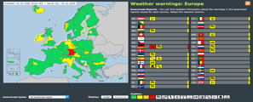

Alert Levels
Most countries choose to customize their alert levels. A simple yellow, orange, red system is used by the Irish Meteorological Service (Irish Early Warning System). Simple, easy to understand, actionable.
Yellow - Weather Alert - Be Aware
The concept behind YELLOW level weather alerts is to notify those who are at risk because of their location and/or activity, and to allow them to take preventative action. It is implicit that YELLOW level weather alerts are for weather conditions that do not pose an immediate threat to the general population, but only to those exposed to risk by nature of their location and/or activity.
Orange - Weather Warning - Be Prepared
This category of ORANGE level weather warnings is for weather conditions which have the capacity to impact significantly on people in the affected areas. The issue of an Orange level weather warning implies that all recipients in the affected areas should prepare themselves in an appropriate way for the anticipated conditions.
Red - Severe Weather Warning - Take Action
The issue of RED level severe weather warnings should be a comparatively rare event and implies that recipients take action to protect themselves and/or their properties; this could be by moving their families out of the danger zone temporarily; by staying indoors; or by other specific actions aimed at mitigating the effects of the weather conditions. This level of warning assumes a high confidence of the event occurring. Any false warnings could lead to unnecessary panic and loss of credibility.
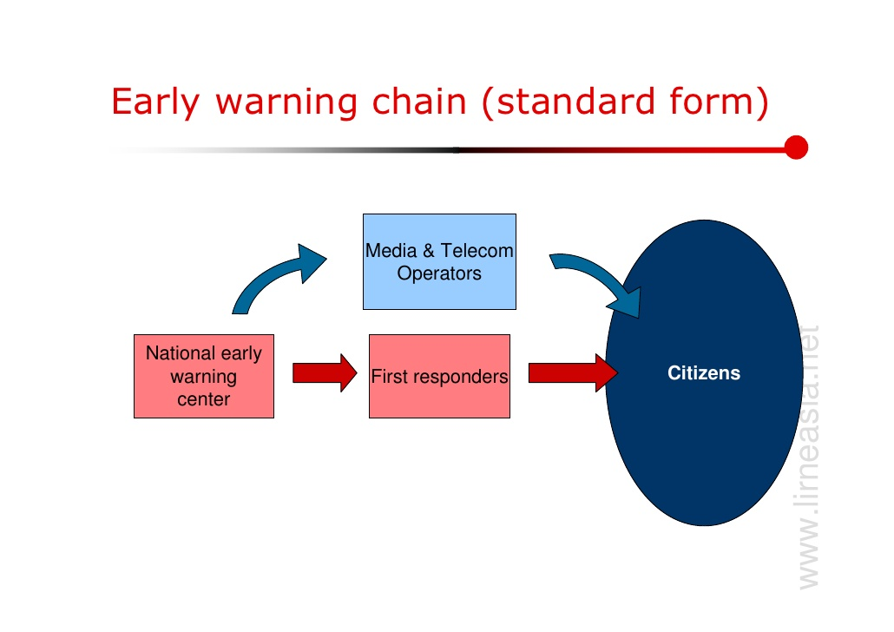

USA – Defined Roles, Standard Operating Procedure
The United States has a quick acting early alert system that works across agencies to bring weather alerts at the blink of an eye. On average, the US does 76 billion observations a year, making 1.5 million forecasts and 50,000 warnings.

Here’s how it works. The U.S. National Response Framework (NRF) provides the guiding principles that enable all response partners to deliver a unified national response to disasters and emergencies. They share this information with a number of agencies on the local, state and federal level. It is maintained by the U.S. Department of
Homeland Security’s Federal Emergency Management Agency (FEMA).

The National Incident Management System (NIMS) provides information to partner agencies and the private sector. NIMS provides the framework for incident management, preparedness, communications and information management, resource management, and other functions.

The US Emergency Management System is comprised of various agencies responsible for coordinating the preparedness for, response to, recovery from and mitigation of disaster events. Local agencies are primarily responsible for severe weather preparedness and warning.

Who does what? Before the event, a number of support agencies work together to coordinate response. Local agencies provide public awareness materials. During the event, local Emergency Management Agencies coordinate with the National Weather Service to activate warnings. Post event, disaster declarations are issued, and state, local and federal agencies work through joint field offices to provide assistance.

Why does it work? Central components of the effective communications system are ongoing communication between agencies through online meetings, chats, SMS and phone. There needs to be a culture of mutual trust and respect. Real time coordination during the events is also key, as is clear messages from the National Weather Service (NWS). Weather information is also part of everyday activities in the US. Not only do you talk about it, there’s a cable channel, websites, apps and educational programs to reinforce the value of weather information.

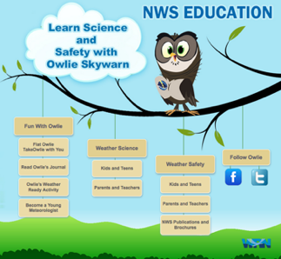
How does it work? Integrated warning teams, including the NWS, local media and local emergency managers create a common communication protocol to the public. Trust is obviously key here. The NWS then issues warning polygons by geographic area. Once these are issued, the collaborative team creates notifications via text, radio, television through the emergency alert system. Continued public education means most US citizens know to “Turn Around Don’t Drown” in the event of floods, seek shelter from lightning, and go to basements for tornadoes. It also means the cycle of trust can continue.

How does the alert system work? It’s fairly simple. An “outlook” provides readiness, a “watch” triggers issuance of notification to the public and people know to keep an eye out for bad weather, a “warning” tells you there is dangerous weather nearby, then an event “alert” tells people to take immediate action. The cause (i.e. Tornado) and expected action (take shelter in a basement) are both included in the alert message.

Resources
- www.weather.gov/alerts
- Multi-Hazard Early Warning System of the United States National Weather Service

U.S. Emergency Alert System

“The Emergency Alert System (EAS) is a national public warning system that requires broadcasters, cable television systems, wireless cable systems, satellite digital audio radio service (SDARS) providers, and direct broadcast satellite (DBS) providers to provide the communications capability to the President to address the American public during a national emergency. The system also may be used by state and local authorities to deliver important emergency information, such as AMBER (child abduction) alerts and weather information targeted to specific areas.
The Federal Communications Commission (FCC), in conjunction with Federal Emergency Management Agency (FEMA) and the National Oceanic and Atmospheric Administration's National Weather Service (NWS), implements the EAS at the federal level. The President has sole responsibility for determining when the EAS will be activated at the national level, and has delegated this authority to the director of FEMA. FEMA is responsible for implementation of the national-level activation of the EAS, tests, and exercises. The NWS develops emergency weather information to alert the public about imminent dangerous weather conditions.
The FCC's role includes prescribing rules that establish technical standards for the EAS, procedures for EAS participants to follow in the event the EAS is activated, and EAS testing protocols. Additionally, the FCC ensures that the EAS state and local plans developed by industry conform to FCC EAS rules and regulations.”
- EAS FCC Website
- Hungarian National Association of Radio Distress-Signaling and Infocommunications (RSOE)
- US Launches Cell Phone Emergency Alert System
- Integrated Public Alert & Warning System Open Platform
- Wireless Emergency Reports

The Philippines – Leveraging Public-Private Partnerships
In the Philippines a new network of nearly 1,000 Automatic Weather Stations (AWS) – installed and maintained through innovative public-private partnerships – is looking to provide the 100 million people of this island nation with free, accurate and localized weather information that can be used to save lives, contain losses, build resilience and improve livelihoods.

The Weather Philippines Foundation (WPF) has also developed a strong public outreach program to assist the population of the Philippines in becoming “weather-wiser,” that is, knowing what weather information will be made available from the WPF, understanding how such information can be used in a variety of situations, and then applying that information properly, especially in times of severe weather. There’s an app, a webpage, dedicated TV channel, and of course Facebook and Twitter pages. The real value is found in the localized, and quite accurate, five-day forecasts and automated current weather feeds that update every ten minutes from the system of AWS monitoring stations.
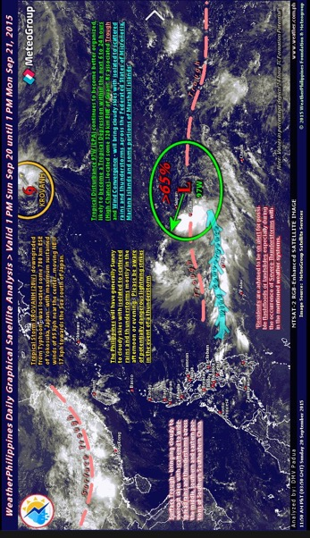

Resources
- Learn More about the Philippines Programme
- Applying Lessons from the Philippines to the Africa Context
- The Bangladesh Cyclone Preparedness Program
- The Tropical Cyclone Early Warning System of Cuba

Visible satellite image and overlain analysis and discussion for 20 September 2015 from the WPF web portal (also posted to the Foundation’s Facebook page). This visible image is accompanied by the corresponding infra-red (IR) image (not shown). The visible image, its analysis and discussion, and the associated IR image are prepared by MeteoGroup.

Benin – Establishment of a Standard Operating Procedure
In Benin, 800,000 people now have access to early weather warnings, thanks to the establishment of a Standard Operating Procedure supported through the UNDP Climate Information and Early Warning Systems Project.

The country issued early warnings for flooding through a multi-agency committee in 2014 and 2015, using manual monitoring of river levels, data processing and information analysis. The country has also adopted a standard operating procedure for the diffusion of alerts through the National Disaster Management Agency. Additionally, Benin has the technical and institutional frameworks in place for climate modelling. The country has the legal framework required to monetize weather and climate data, but has had little success to date in successfully packaging relevant information for use by the private sector.

The Government of Benin initiated a study to create the SOP. The communications assessment included a review of past efforts, a state of the art, interagency brainstorming to create the SOP, SWOT analysis, analysis of the existing communications channels and flows, and finally the proposal of a new communications flow.

The main goals of the study were to:
- Identify and analyze the content of all regulations and legislation on the dissemination of alerts related to disasters in Benin. This basic desk study gave an overall picture of how information is shared and responsibilities.
- Identify and analyze the strengths and weaknesses of existing protocols for early warning dissemination in African countries.
- Propose a standardized system of communication and warning dissemination. This communication system specifies roles and responsibilities and expected actions from various actors.
- Identify the legal requirements for the creation of the SOP.
- Assess specific communications needs of each stakeholder.

Resources
- Protocole Normalise de Communication et de Diffusion d'alerte en cas de Catastrophe Hydroclimatique au Benin
- Video Benin's Early Warning System

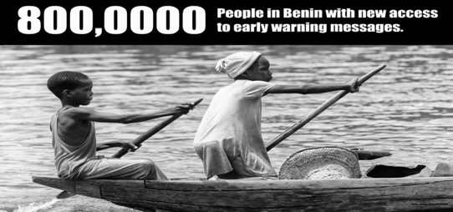

Defining roles
Who does what? How can information be shared across agencies and across borders? What structures are in place to aid in collaboration? Defining roles is an essential component of any communications strategy. Not only is it necessary to ensure effective issuance of early warnings, it also plays an important role in how you will elaborate a supportive communications strategy.

Who Does What?
In order to avoid disputes over roles and responsibilities, foster buy-in and build a standard operating protocol for the issuance of early warning messages, you’ll need to assign roles, foster a culture of collaboration and develop non-territorial approaches. Like almost any initiative, the assignment and distribution of roles and responsibilities should begin from the ground up. This will ensure buy-in from all stakeholders. Because every country has its unique political framework, there are no off-the-shelf solutions. However, focusing on a few key areas will help in the definition of roles and responsibilities.

If you look at the roles from the bottom up, you might generalize them in the following way (as adapted from the FEMA roles and responsibilities matrix):

- Local. Local leaders and emergency managers prepare communities to manage incidents locally.
  - Elected Officials ensure the safety and welfare of the people under their jurisdiction. They also work closely with congressional and regional leaders to ensure effective response and distribution of emergency warnings and actions.
  - Emergency Manager. The local emergency manager has the day-to-day authority and responsibility for overseeing emergency management programs and activities. They are not necessarily responsible for the issuance of early alerts.
  - Department and agency heads. Coordinate local services.
  - Individuals and communities. Reduce hazards, prepare for emergencies, monitor emergency communications.
- States, Territories, Autonomous/Tribal Governments. Support local efforts. They may be charged with regional emergency response, or this responsibility may lay at the local or national level.
  - Governor and elected officials. Communicate with local groups, national groups and affected communities.
  - State Emergency Agency. This may not be applicable in all situations.
- Federal. In most African nations, emergency alerts will be initiated on the federal level.
  - President. Overall oversight.
  - Ministries. Individual ministries may be responsible for sectorial response and alerts (i.e. hydrology, agriculture, energy, national security)
  - NHMS. Monitor weather and issue alerts (or alert relevant disaster management agency)
  - Disaster Management Unit. Not all countries have a dedicated unit. This revolving point can be used to coordinate warnings.
- International. On the international level, either the President or Minister of Foreign Affairs would be responsible for international coordination. However, weather alerts should be shared with NHMS in neighboring countries to trigger their own response.
- Private Sector. The private sector is often responsible for large pieces of infrastructure. In the case of the issuance of early warnings, private telecoms and media companies can also aid in the distribution of warnings.
- NGOs. This group of actors can mobilize supplies, share emergency information and provide response. They can also be mobilized to provide training on what to do in the event of a warning, and as broadcasters for information on required actions in the event of an emergency.

Guiding Principles

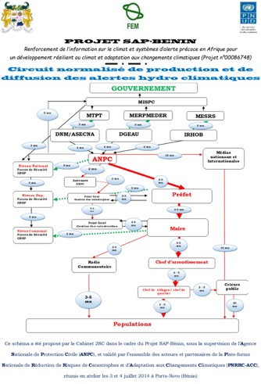
- Create Buy-In. Brainstorming sessions, interagency committees and working groups are all essential for building the necessary collaboration.
- Communicate. By communicating regularly with all stakeholders (not just about roles, but about effective actions), you continue to perpetuate that circle of trust.
- Assign Roles and Responsibilities. Make it clear who is responsible for what.
- Engage Actors. Reaching your goals will require connection with a large number of regional, territorial and local actors.
- Rehearse. Practice what you are doing before it’s time to actually issue a warning.
- Activate. When the time comes to issue an early warning, be sure to maintain constant contact between organizations to ensure collaboration.
- Follow up. After the storm, you should take stock of successes, failures, challenges and next steps. Bring together all major players to discuss next steps.
Information flow from the Benin SOP.

Cross Border Sharing
Weather does not respect borders. Rains in one country may produce flash floods in another. Increased cooperation, data sharing and compatible systems are needed to improve early warning systems and the overall climatological record of the African continent. With improved synoptic and local monitoring, country-specific weather and climate data and information can be shared with both the WIGOs and Global Telecommunication System. Data produced in border regions can be analysed to enhance the accuracy of forecasts across the border and create early warnings for storms that originate in Country X, but don’t have significant strength until they reach Country Y. And in some regions – Lake Victoria for instance – purposeful regional monitoring systems should be considered with the goal of providing forecasts not just for national use, but for the entire region. The role of regional cooperation is discussed in some depth in the UNDP publication “A New Vision for Weather and Climate Services in Africa.” Principles of regional cooperation for communications and the issuance of early warnings include the following.
- Leverage regional cooperation institutions.
- Share data with WIGOS and the Global Telecommunication System.
- Use common data parameters and analysis.
- Create or optimize communications channels to ensure effective communication and collaboration in the event of an emergency.
- WMO Guidelines on international and cross-border collaboration in the warning process.

Regional Cooperation Entities
Existing or dormant regional agreements could foster information exchange. Aside from the main economic collaboration entities, you may wish to consider engaging with the following (if you have not already):
- ACMAD – African Centre of Meteorological Applications for Development
- ACPC – African Climate Policy Center
- AfDB – African Development Bank
- AGRHYMET – Agro-meteorology and Hydrology Regional Centre
- AMESD – African Monitoring of Environment for Sustainable Development
- AUADARE – African Upper Air Data Rescue IEDRO – International Environmental Data Rescue Organization
- CDMSs – Climate Data Management Systems
- RBCN – Regional Base Climatological Network
- RCCs – Regional Climate Centres (RCCs)
- SADC-CSC – Southern African Development Community-Climate Services Center
- ICPAC – IGAD Climate Prediction and Applications Centre
- CILSS – Comité permanent Inter-Etats de Lutte contre la Sécheresse dans le Sahel
- ASECNA – Agence pour la sécurité de la navigation aérienne en Afrique et à Madagascar
- WMO Severe Weather Forecasting Demonstration Project (SWFDP)

Required tools
The required tools include an institutional framework, planning and response cycles, and of course the technology, human resources and capacity to get the job done.

Cycle of Preparedness

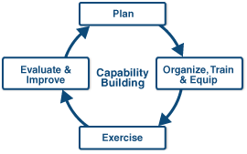
- Plan. Planning and capacity building, information gathering and analysis.
- Organize. Organizing the responsible parties, strengthening leadership and establishing roles, acquiring necessary equipment, training on the use of equipment.
- Exercise. Practice and simulate what you do.
- Evaluate and Improve. Take the lessons learned to improve your response services.
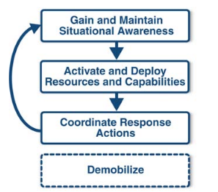

Cycle of response

- Situational Awareness. Establish baseline priorities, provide the right information at the right time, share local incidents with relevant actors, link operations, issuance of alerts, creation of operation centers and units.
- Activate and Deploy. Activate and deploy people, resources, capabilities, establish emergency operations center.
- Coordinate Response. Coordinate between all relevant actors, including coordinating initial actions, requests for additional support, identifying and integrating resources and capabilities, information flow.

Early Warning Dissemination Strategy
This section starts with a basic overview of the elements required to create early warnings, nowcasts, short-range forecasts and combined weather reports. It then moves into a discussion on the specific needs of end-users and effective methodologies to reach them.

Early Warning Systems, Forecasts, Nowcasts and more
“Natural Hazards will always challenge us, but people-centered early warning systems can be a potent weapon in ensuring that natural hazards do not turn into unmanageable disasters.”

Increasingly, it is recognized that disasters are linked. The impacts of many types of natural disasters do not happen in isolation, but recognition of such cause and effect on a global and regional scale is leading to the creation of early warning systems that can accommodate multiple hazards and cross-boundary impacts.

Though many natural hazards may be inevitable, natural disasters are not totally unavoidable. A disaster will depend on the characteristics, probability, and intensity of the hazard, as well as the susceptibility of the exposed community based on physical, social, economic, and environmental conditions. In some instances, natural disasters cannot be prevented from occurring. However, their overall impact can be significantly reduced through disaster prevention, mitigation and risk transfer. This concept is also applicable to less extreme changes in weather that have an impact on operations. For example, lightning from a thunderstorm poses a risk to workers in open environments, electrical substations and the general public.

A paradigm shift is occurring with a move away from purely reactive response and recovery to a much more proactive and holistic concern about preparedness and prevention of the impacts of adverse weather to operations. Proactive mechanisms are sought to reduce the economic costs and impacts of hazards, improve response capacity, decrease vulnerability, and enhance communities’ resilience to disasters.

The primary objective of a warning system is to empower individuals and communities to respond in a timely and appropriate manner to the hazards in order to reduce the risk of death, injury, property loss and damage. Warnings need to get the message across and stimulate those at risk to take action. Risk mitigation decision makers require increasingly precise warnings to ensure effective measures may be formulated. This implies that the messages and communications must be in time, accurate, relevant and easy to take decisions on. It is therefore the responsibility of the NHMS in conjunction with partner agencies and the affected stakeholder to develop a strategy that satisfies their requirements for risk mitigation.

Developing the message content

Once the strategy has been developed, the messages must be prepared in line with and the available resources to meet the client requirements. An easy way to view the message that can be developed is to view the products and services offered by the NHMS as a time series (see Figure below). An observation made today becomes historical data tomorrow. Forecasts made today looking into the future increases in uncertainty the further into the future we look.

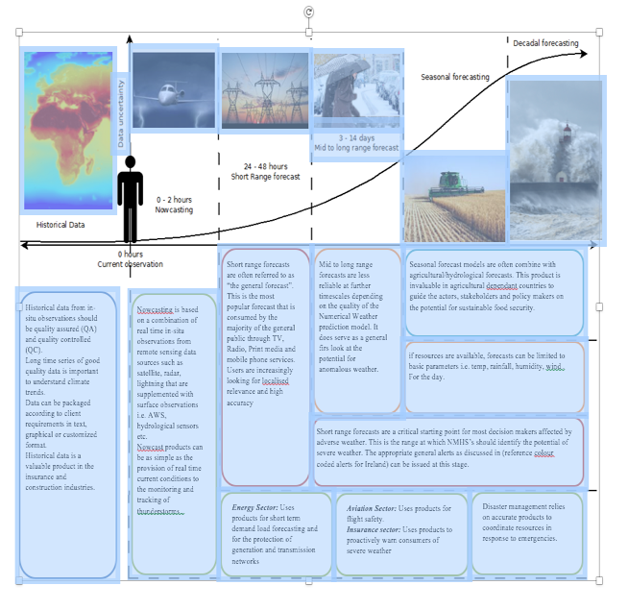

Historical Data

Historical data can be provided in tabular text formats i.e. excel, .txt, databases etc. Or can be provided in graphical formats. See below:

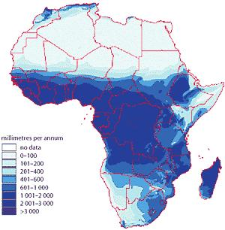
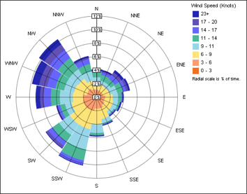
Wind Rose showing average speed and direction of prevailing winds
Where data and resources allow, historical data can be shown as heat maps:

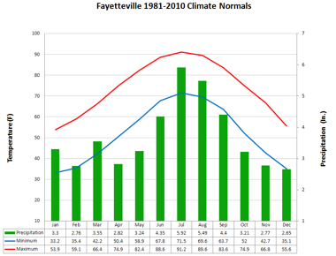

30 year climate data for precipitation with Average, max and min

Nowcasting

Nowcasting messages are generally associated with severe thunderstorm warnings that include heavy rain, large hail, damaging winds and the potential of flash floods. Depending on the communication strategy, the message content can range from a few characters i.e. twitter, sms, to a more substantial narrative sent via email. Bear in mind that severe thunderstorms in convective environments can develop within 15 to 30 minutes. It is therefore necessary to convey as much information as possible in a short concise message. See a sample message from the Bureau of meteorology in Australia.

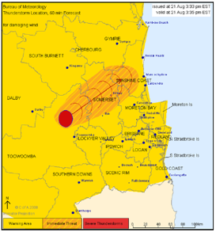
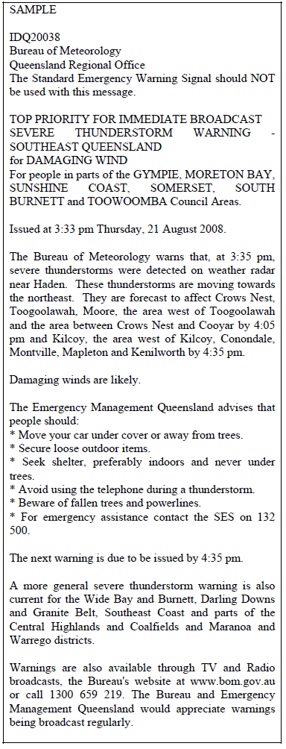
Infographic generated from radar and short range forecasting models showing the path of the identified storm. Note: Australia has a comparatively high level of meteorological literacy amongst its population due to an extensive education campaign over the years
Advisory and action
Radio and TV Broadcast

Short-Range Forecasting

The preparation of short-range forecasts is the most flexible depending on the requirements of the end user.
The most common means of providing the general forecast is through a basic infographic. Most basic web-based platforms have built in tools that can allow for automated infographic generation. The use of symbols can aid understanding amongst illiterate people.

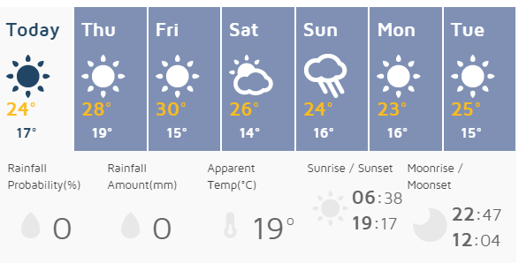

More complex methods of forecast display are through Meteograms:

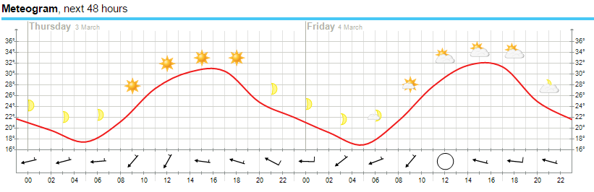
It should be noted that Meteograms are dependent on good NWP processing capability to downscale regional forecasts to an hourly update for up to 30 parameters.

Combining different time scales
Weather Philippines is a successful story of the relationship between the private and the public sectors. The organization has successfully leveraged its large network of automatic weather stations to provide accurate real time weather information and short range forecast information.
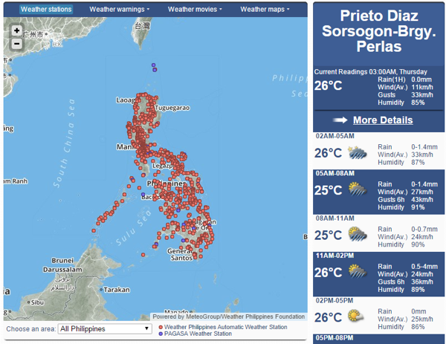
Over 1000 AWS shown as red dots
Real time data
This approach leverages existing application interfaces available freely on the web to integrate real time and forecast data. This ensures that there is a low cost of replication to target as many end users through a single platform.

Identifying Stakeholders
The most important element of communication is remembering your audience. Only by knowing and listening to your target market can you effectively share messages with them. End users for climate information and early warning systems include farmers, communities, policy makers and the private sector. Actors to reach these stakeholders include telecoms/electronic media, NHMS, community leaders, first responders, NGOs, education, health, early warning center, brand ambassadors, country projects, partner agencies, CIRDA, UNDP and the community of practice, rural radio… and the list goes on.

Understanding stakeholders is not an easy process, especially as regional linguistic, cultural, media and political variations create nuances from country to country for both end-users (communities and farmers) and policy makers. Messages to reach specific stakeholders are discussed later in this toolkit.

End Users
Farmers. This target group is comprised of crop farmers, smallholder farmers, industrialized farmers, pastoralists (livestock herders), fishermen and rural enterprisers. This target group has multiple needs for weather and climate information. It can save lives, contain losses, increase productivity and reduce risk. Reaching rural farmers is a challenge, Internet communication is virtually impossible, literacy is low, and there are regional and village-level cultural and linguistic differences. Primary methodologies for reaching this group include: rural radio, SMS, trainings and informational meetings hosted at the community level, billboards, outreach from schools and health organizations, NGOs, pamphlets and other advocacy methods. They can also be reached through value-added service provides, extension services, cooperatives and innovative last mile approaches such as Human Network International’s 3-2-1 Service.

Local Communities. This group is comprised of community leaders, farm cooperative leaders, village leadership, regional politicians, children, teachers, moms, elders and other community members that don’t work in farming, local NGOs, extension services and medium-scale local enterprisers. Reaching this group is a little easier. Villages will often have access to television, radio, and may even have access to the Internet. Primary vehicles to reach them include Public Service Announcements (PSAs), TV, training, radio, policy dialogue (learning routes), print media, social media (growing but still limited), community meetings, school and hospital outreach, SMS and engagement with extension services. Some communities have enabled communications tree within the leadership to ensure messages are disseminated rapidly once generated.

Policy Makers. This group is comprised of national leaders in the NHMS, Senate, House of Representatives, executive branch, ministries, media, large private-sector enterprise (telecommunications, banking, mining, etc.), universities, think tanks, and regional cooperation entities (i.e. African Union). Reaching them should be the easiest of all. They can be reached by email, social media, print, radio, broadcast, and advocacy. However, impacting their opinions and policies is a whole other ballgame. In order to reach them and sway opinion and policy, you first need to reach their constituencies (farmers and communities), empower product champions, and foster learning opportunities.

Private Sector. Not only do private sector enterprises benefit from tailored weather information – to protect human and physical resources and make climate-smart business decisions – they can also play a role in disseminating messages. Telecommunications firms can site AWS and serve as go-betweens to send early alerts, mining companies can be tapped to leverage corporate social responsibility dollars, or pay for tailored weather information, media can be used to share early alerts and PSAs. In order to engage the private sector, you need to create a narrative that underscores your specific value to them and to their consumers. They need to understand you are creating a valuable product that they can trust.

Actors
Reaching these groups means enlisting the support of a wide group of actors. These actors serve as brand ambassadors, as messengers, as emergency responders and as education providers. The specific needs and responsibilities of these actors were addressed in the Who Does What section.

Understanding your stakeholders
There are various methods to understand your stakeholders. These include surveys, community forums, policy dialogue, media monitoring, and outreach to leaders. Constant contact between stakeholders is key. Some other indicators may also give you unique insights on public opinion, these include elections, lobbying and interest groups, market forces and demand, monitoring of traditional and electronic media, direct letters and calls, protests, and straw polls.

Questions to Ask
Not only do you need to understand your stakeholders, you also need to understand what type of information they need and demand, how they get and use information, their media habits and how information is shared. Approaches will vary by country, but important questions to ask yourself and your stakeholders include the following:
- What did our baseline study tell us about our target market?
- What are end-user requirements for/reliance on reliable meteorological information?
- What current assets do we have? Is there a market study, broader analysis on media use, demographic information? How can we use this information to engage our stakeholders?
- How is their current weather/climate information acquired? (it may not be the media, NHMS or an NGO, but village elders, religion, nature’s signs, etc.)
- What is the most popular media? And what are the media habits of our stakeholders? Understanding how people use media and the reasons for their choices will define your channels and messages.
- What is the age and gender demographic preferences per dissemination technology? What about the influence of education and income? Rural vs. urban populations? Young people may be more attuned to information via SMS or smart phone, while the older generation– or wealthier families – may prefer radio.
- What are the past experiences related to warnings and disasters – timeliness, accuracy, content, recommendations, consistency across various sources.
- Are you disseminating information to people inside buildings or outside? Different communication means may be needed to disseminate the message to these two groups. This is especially important in urban areas.
- Who are the trusted sources of your audiences? Will they trust a SMS from the NHMS or would they prefer to get the message from a village leader? And if so, how do you inform the village leader?

Resources
- A Detailed Snapshot of Africa’s emerging Internet and social media space – the users and what they are doing
- Nielsen Guide to African Market Demographics – Country-by-country analysis of media habits, market segments
- Measuring Public Opinion
- Creating Surveys
- Public Forums
- Brand Ambassadors
- Best Practices for Research

Addressing Challenges and Opportunities (SWOT)
As you get started in creating a communications strategy, you may wish to consider including a SWOT analysis. This measures the strengths, weaknesses, opportunities and threats of your products and stakeholders. You may need to conduct more than one SWOT analysis. For instance, if you want to know how the media will react to your product offering, you’ll wish to do a SWOT analysis ahead of time.

SWOTs to Include
- Internal. How well are the project team and the broader group working together to improve climate information and early warning systems? Are there communications bottlenecks, challenges that need to be addresses? Who would do the best job at achieving specific tasks?
- Inter-Agency. Move it up a notch. How do the various agencies work together? How do they interrelate? Do you require a process of change management?
- End Users. Who are your end users, how do they use information, do they trust the information you are providing?
- Actors. Who can you engage to move your message to end users and achieve project goals?
- Media. Yes, media is a fine asset. But within your country, how do people interact with media, do the media trust the forecasts and share them, are they a true brand ambassador or are they a threat?
- Private Sector. Are there industries that could benefit from tailored weather information? What’s their perception?
- Your Product. First you’ll need to define your product. Is it the project itself? Or is it the climate information and early warnings you are producing? Most marketers would argue the latter. If so, what are the strengths and value propositions of that product? Where are the weaknesses? How can you reach new people and new markets? And what forces could derail your efforts? Looking at these will help you define your message, your channel and your strategy.

Sample SWOTs
SWOT ANALYSIS OF EARLY WARNINGS

SWOT ANALYSIS OF CLIMATE INFORMATION IN SUB-SAHARAN AFRICA
STRENGTHS | WEAKNESSES | OPPORTUNITIES | THREATS
There have been significant advances in explaining the dynamics of African climate variability, which has led to a growing confidence in climate forecasts while seasonal outlooks have gained greater importance in managing climatic risks.  Climate forecasts can help those who depend on agriculture with decisions such as: whether or not to plant, when to sow, which seeds or crop varieties to choose, herd migration, livestock sale or slaughter, what pest protection alternative is best and whether or not to apply inorganic fertilizers. Additionally, forecasts can also help anticipate the emergence of certain types of pests, fungi and smuts.  Climate forecasts can increase farmers’ preparedness and lead to better economic and environmental outcomes in the long run.  Climate information can improve resource management and enhance the welfare of agricultural and rural populations, which also represent the bulk of people living in poverty.  Climate information helps to mitigate risk, which is a documented reason for the weak performance of sub-Saharan countries. The inherent uncertainty arising from natural climate variability is challenging since farmers must take many critical and climate-sensitive decisions months before the impacts of climate are realized.  Climate forecasts can help contain disasters and also capitalize on temporarily favourable states of nature. | Sub-Saharan Africa’s climate observation networks and systems are poor. Where networks and infrastructure do exist, many are in decline.  Low quality and limited accessibility of climate data.  Sparse data coverage and temporal gaps. In some locations, time series data have been, and continue to be, disrupted by natural disasters and/or conflict.  The development and refinement of climate models typically take place outside of Africa.  Packaging skills are lacking, making it difficult to reach end-users effectively.  Climate information is not sold to the private sector on a large scale. | Increase the quality and quantity of climate observation networks and infrastructure in sub-Saharan Africa.  Recover unarchived historical data that has not been digitised yet and therefore, it has been inaccessible to researchers.  Address barriers to the uptake of climate information, including institutional mandates, hierarchical structures and the lack of adequate incentives.  Promoting the usefulness of climate information in ways that decision-makers value most. There is a need to help them understand what climate information should and should not be used for, and to encourage more systematic and evidence-based approaches to decision making under uncertainty.  Farmers will increase their demand for accurate climate forecasts as climate change renders their traditional information sources and experiences less reliable.  Break poverty cycles. By having access to seasonal forecasts, for instance, subsistence farmers can adapt their strategies accordingly and avoid losses or complete crop failure. Success, however, hinges on farmers having access to adaptation options.  Partner with the health sector. Most infectious diseases can be better managed if climate information is readily available to predict changes in rainfall, temperature and humidity.  Fostering economic development via better informed sectors, such as agriculture, forestry, fishing, mining, water resources, energy, transportation, aviation and tourism. In addition, national hydromet services can also supplement their resources by packaging and selling information to the private sector. | Lack of capacity and/or willingness among potential users to access, understand the probabilistic nature of climate information, process and act upon the available information.  Political and socioeconomic factors may be inimical to the uptake of climate information in decision making processes with long term consequences.  Limited capacity to identify needs for training on climate change and its potential impacts, as well as on how to integrate medium- to long-term information into existing policies and decision making processes.  The role of communicating climate information is usually given to formal scientific bodies and the information that reaches end users is usually overly technical, ill-matched to their demands and easily leads to misunderstanding of the uncertainties associated with it.  Lack of effective communication and engagement between the users and producers of climate information, which leads to misunderstandings about the merits and limitations of its use.  There is a mismatch between the capacity of climate scientists to produce policy-relevant information, and the decision-makers’ unrealistic expectations about the information they could receive.  Sometimes religious beliefs clash with the concept of being able to predict the weather and the use of climate information is consequently reduced.

Resources
- Promoting the use of climate information to achieve long-term development objectives in sub-Saharan Africa.

ZAMBIA METEOROLOGICAL DEPARTMENT (ZMD)
This SWOT was included in the Zambia CI/EWS draft communications strategy, and provides a solid look at challenges and actions to remedy those challenges. Within the Zambia strategy, SWOT analysis for partner agencies, government officials, end users, relevant actors and the media were all included. Each analysis was preceded by a description of the agency mandate and possible actions to react to the SWOT presented.

SWOT ANALYSIS OF THE ZMD AND RECOMMENDATIONS
STRENGTHS | WEAKNESSES | OPPORTUNITIES | THREATS
The ZMD has legal mandate to provide meteorological services for dissemination to the various stakeholders.  Headed by the Director of Meteorology, ZMD has qualified, talented and knowledgeable personnel and has offices in every Province and some districts.  Through the UNPD CIEWS Project and other projects, the ZMD is upgrading and expanding the number of its weather stations across the country.  Existing support, programmes and networks such as RANET. | Weak institutional coordination between institutions leading to limited packaging, translation and dissemination of weather and climate information and warnings.  Being a department in the Ministry of Communications, the operational and administrative framework of the ZMD is heavily bureaucratic and hence decision making and implementation of activities get affected and delayed.  Whereas the ZMD has qualified personnel, the organizational structure & culture of the department does not allow for effective internal communication between top management and lower-ranking officers and vice-versa.  Inadequate weather and climate monitoring infrastructure, which limits data collection, analysis and provision of timely met services.  Limited knowledge and capacity to effectively project future climate events as result of acute shortage of technology, adequate skilled human resources, as well as access to climate models and hardware.  Lack of motivation or incentives to project team members for extra-hours of work done outside the routine working hours. Much as the members of the CIEWS Project are expected to commit themselves to the Project as part of the contributions of their respective institutions, CIEWS Project activities that are scheduled outside routine workings hours should be compensated. | Through the UNDP CIEWS Project and other projects, the ZMD has the potential to be a leading center for providing meteorological services and effective dissemination to the various stakeholders.  Although most of the ZMD officers are qualified, there is potential for its personnel to undergo further training including in the areas of community/stakeholder engagement, communication and change management.  Improved weather stations, communication infrastructure and other resources for effective operations. | The activities of the PPCR and other institutions involved in weather, climate and early warning services if not properly harmonized pose a big threat to the effective dissemination of the CIEWS messages.  Lack of long-term adequate and sustainable support especially from GRZ may jeopardize all the CIEWS efforts in the near future.  Use of external weather and climate forecasts by ZNBC and other broadcast stations in Zambia pose a direct threat to the efforts of the CIEWS Project and the ZMD  No payment for Project members and other stakeholders for the extra-hours of work done outside the routine hours will demotivate and lead to limited outputs.

Defining the Message
Defining a common narrative can build cohesion, strengthen outreach and fortify the impact of your work. While this narrative will need to be tailored to meet individual country and target-audience needs, it’s a starting point to begin the hard work of creating those tailored messages and a framework on which to base all communications. The current narrative on climate information, climate services and early warnings is too technical for the majority of our stakeholders. We are talking UN, instead of talking human. We need to focus on simpler language that captures the emotional appeal of complex subjects.

Creating an Emotional Brand
Marketers often talk about creating emotional messages. Emotional messages focus on needs, wants and desires. They service the heart and not the mind. These messages answer why and not what. This is often broken down into a brand pyramid, with emotional messages on top, benefits in the middle and attributes on the bottom. You need to talk about attributes in order to get to the benefits, but an overarching narrative that creates an emotional appeal needs to be woven into the conversation.

Emotion. Security. Safety. Comfort. Trust. Value. You can rest easy knowing what weather is coming your way. If you are a farmer, you know there won’t be a flood tonight and that your family is safe. If you are a farm leader, you know what strategy to adopt so that productivity will increase and your community will prosper. If you are a policy maker, you feel secure that your constituent’s needs are being met and you have the information you need to make climate-smart decisions. You will also be producing a public good that saves lives and improves livelihoods.

Benefits. You will be saving lives and improving livelihoods. Lives will be saved. Productivity will increase. You will make more money. Vulnerable rural communities will become more resilient. Better weather and climate information means African nations become better prepared for the new challenges posed by climate change. Improved forecasts can lower risks from mosquito-borne illnesses, and avoid the loss of life and property from flood, hail, lightning and other severe weather. Better weather and climate information benefits a number of industries that support the economy and generate jobs, including aviation, banking, maritime, resource extraction, energy, tourism and construction. It also makes for better decision making over the long haul. Good data makes for good decision-making, and good decision-making can build empowered lives and resilient nations.

Attributes. What is your product offering? New AWS, new monitoring, new analysis, new models for business, new distribution models to share warnings, improved climate information that can be used by all, accurate weather forecasts, accurate long-term forecasts, nowcasts, alerts? No longer will poor farmers need to look to the sky to know their future. It will come in a simple SMS via their cell-phone. On a project level, CI-EWS are procuring new hydrology and meteorological equipment, training staff on how to use this equipment and creating systems to share early warnings with vulnerable communities.

Messages for Specific Stakeholders
The messages to specific stakeholders are going to vary by country, by village, by gender and by segment. A farmer doesn’t care if energy production levels will rise nationally or if he’s getting information from an AWS or a Doppler radar (he cares if he will have electricity and if he can feed his family). A fisherman doesn’t care if long-term policies will reduce overall risk to changing climatic conditions and increased severe weather (he cares if he is going to die today because of a storm). A policy maker cares little about microwave attenuation (he cares if it works and if celltower integration and AWS will protect human life, and make his constituents happy).

End Users. The information we are giving you is reliable and it will make your life better. Your families are safer because you will know when natural disasters are coming. The weather is changing. Rains aren’t falling like they used to, and there will likely be more severe storms, longer periods of drought and more lightning. By understanding what weather is coming your way, you can keep your families safe and make more money. By knowing the weather, you can plant at the right time, you can get out of harms way when floods and hail come, you can grow better crops for this growing season, and you can thrive. *Note that while the preservation of human life is a solid argument, evidence from other C4D practices indicates that underscoring monetary value is a stronger message. Messages should also concentrate on immediate value for this segment.
For early warnings, end users need simple messages that indicate the danger, the timeframe, the area at risk, and the required action. More examples are included below.

Vulnerable Communities. The information we are giving you will make your community safer and will improve productivity. Reliable climate information means you can optimize planting cycles to hit markets from your farmer cooperatives. It means you can plan for long-term prosperity because you can protect roads and other productive infrastructure with early warnings of natural disasters. It means that you can address public health issues like malaria outbreaks that result from unusually heavy rains. Because your community is safer, you can concentrate your efforts on educating your children, strengthening your health system, building roads and expanding businesses.
For early warnings, community leaders need more in-depth information. Where should people take shelter, what assistance will be provided, what are the communications channels, what actions need to take place.

Policy Makers. The status quo just isn’t working. We need innovative solutions. Through the effective use of climate information, you can take decisions and make investments that are proactive, durable and robust. Effective use of climate information also minimizes the risk that decisions will adversely affect other systems, sectors or social groups. For over 30 years, the international development community has made substantial investments in climate information systems for Africa, nevertheless, most hydromet services are unable to meet the needs for weather and climate information. This lack of quality information is costing you dearly. The collection, analysis and distribution of reliable climate and weather information has the potential to greatly benefit your most vulnerable rural communities, build your economy and strengthen your nation. Most importantly, reliable weather information can save lives. We need a new vision, and you are essential to making that vision happen. With effectively structured public-private partnerships, new technology, strengthened institutions, increased regional cooperation and continued capacity building, sustainable climate and weather information solutions are a realistic and attainable goal. Reaching this target could have a significant impact on your ability to protect human life and foster long-term prosperity.

Resources
- The Principles of Climate Change Communication in Brief
- Change Management Communications
- Rebranding Strategies: A Step-By-Step Approach
- Building a Brand Pyramid
- Climate Change Guide - Society of Environmental Journalists
- Climate change in Africa: a guidebook for journalists
- Weather Forecasting, Meteorology, Weather Prediction
- USA Emergency Alerts

Engaging Schools and Health Sectors
Schools and health sectors are especially low-hanging fruit for the dissemination of targeted on-the-ground messages. School-aged children have more neuroplasticity than adults. This means it’s easier to change a child’s mind than an adult’s. They also spend about half their time in school, meaning they are a captive audience. By sharing specific PSAs, messages and rolling out on-the-ground communications initiatives through schools, we have the opportunity to change public sentiment and steer the conversation. Then when Mom asks what did you learn in school today, they might just say, “I learned that we are going to receive messages on coming storms. If a storm is coming, we should seek shelter in a grounded building.” Similarly health sectors can greatly benefit from better weather information (as it can be a predictor of mosquito-borne illnesses). They also have good outreach on the village level and can be a key partner in the dissemination of on-the-ground messages.

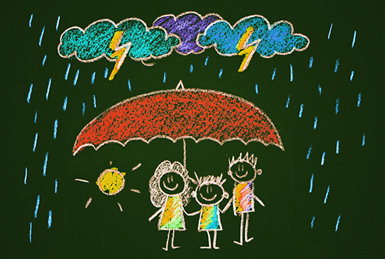

Building your narrative
Individual products will need individual narratives. The value of climate information may be that it will make for better decisions in the face of a changing climate. The value of early warnings is about the protection of life and property. It’s about safety and trust.

Questions to Ask
- What is my product? In the end, your core product and your core brand isn’t the CI/EWS project or new AWS, it’s the product you create (early warnings and improved climate information, and the capacity to act on that information).
- What is the message? Has it been tested? Create a list of top talking points and messages. Take them to the field, listen to your stakeholders, do they ring true?
- Who is repeating my message and in what way? Constant monitoring of media and your stakeholders helps assess the stickiness and penetration of messages.
- What is my value proposition? Where do my end users see value in this? For early warnings, value may be preservation of life, for climate information it may be making more money. The value proposition will also change by target market.
- Do people trust your product? Build confidence in weather information and warnings. Doing this may even require a substantial rebranding of your product. Do people trust the forecasts and reports issued by the NHMS (your stakeholder survey and monitoring should tell you)? If not, how do you pivot the conversation, engage stakeholders and build the brand that says: “Our forecasts are trustworthy, easy to access and built on the latest in technology.”
- Do people understand your product? Weather reports aren’t always right, in fact, they can be wrong, even in the most developed contexts. Long-term forecasts have an even higher margin of error. But you’ve put the mechanisms in place to improve fidelity. Make sure your end user understands this aspect of your product – understanding both its advantages and shortcomings will bolster confidence in the end. For early warnings and short time-scale forecasts, your accuracy is better, and because you’ve created a system to monitor local weather, you are getting the information you need to issue those reports.

Methodology
In this section we examine the methodology in creating both early warnings and supportive communications strategies. There is more information on packaging early warnings, channel specific models, WMO Common Alerting Protocol Guidelines, types of alerts, response matrix, and monitoring and evaluation. At the core, good internal communication means good external communications. Only with working communication inside your organization, project or ministry can you expect to easily communicate with broader groups of external stakeholders.

WMO Common Alerting Protocol
“The Common Alerting Protocol (CAP) is an international standard format for emergency alerting and public warning. It is designed for "all-hazards", related to weather events, earthquakes, tsunami, volcanoes, public health, power outages, and many other emergencies. CAP is also designed for "all-media", including communications media ranging from sirens to cell phones, faxes, radio, television, and various digital communication networks based on the Internet.”

Resources
- Video Introduction to Common Alerting Protocol
- CAP Flyer
- Guidelines for Implementation of Common Alerting Protocol (CAP)-Enabled Emergency Alerting
- Guidelines on early warning systems and application of nowcasting and warning operations
- Administrative Procedure for Registering WMO Alerting Identifiers

Sharing Early Warnings
Early warnings should be multi-lingual and work across various platforms. They should include information on what to do when bad weather hits. Most importantly, they should be simple!

Principles on the sharing of early warnings
- Keep it simple.
- Create brand and message ambassadors. Make sure village leaders, regional leaders have early warnings and can activate local response and further distribution of messages.
- Maintain constant contact.
- Create threat levels and types of alerts. For instance, yellow, orange and red (as is the case in Ireland).
- Integrate with other alerting systems (i.e. earthquake and health alerts).
- Create a community response plan (i.e. training, simulation, awareness building).
- Does the alert dissemination plan work with and without electric power?
- Is the dissemination/communication technology sustainable? Are you building a dissemination strategy that will work long-term, say for a decade or more?
- Are you disseminating information to people inside buildings or outside? Different communication means may be needed to disseminate the message to these two groups. Especially important in urban areas.
- What are the restrictions on each dissemination mechanism?

Creating a response matrix for EWS
Creating a response matrix for early warning issuance will depend on the roles and responsibilities of individual organizations. Here are some samples.
- UK Response Matrix
- Protocole Normalise de Communication et de Diffusion d'alerte en cas de Catastrophe Hydroclimatique au Benin
- UN/ISDR Platform for the Promotion of Early Warnings

Sharing Climate Information
Climate information is packaged differently and achieves different goals than that of early warnings and weather forecasts. Climate information can be used to inform policy decisions, investments on infrastructure, long-term planning and even crop production.

- Participatory Integrated Climate Services for Agriculture (PICSA): Field Manual
- Promoting the use of climate information to achieve long-term development objectives in sub-Saharan Africa

Packaging Early Warnings
You’ve gone through your response matrix. It’s go time. You need to issue an early warning. Packaging that information is just as important as the information itself.
- Universal symbols. In places with high levels of illiteracy, you should consider the use of universal symbols. The message could be as simple as this: (flash flood, food will be distributed at the community house) or (warning cyclone, seek shelter).
- Text should be simple and indicative of the danger, the area, the action and where to get more information or receive support.
- You will need to package per media. Radio requires audio reports, broadcast requires either text or video reports, SMS requires text.
- Make sure the response action is clear. You’ve already practiced this in the simulations. Now it’s time to act. This is not a drill. There is a flash flood in your area. Move to higher ground immediately.

COMET Resources on Early Warnings and Communications

- Comet Flash Flood Early Warning System Reference Guide
- Tsunami Warning Systems
- ASMET: Flooding in West Africa
- Nowcasting for Aviation in Africa
- Urban Flooding: It Can Happen in a Flash!
- Fire Weather Forecasting: Clear Communications
- Forecasting Heavy Rains and Landslides in Eastern Africa
- Anticipating Hazardous Weather and Community Risk, 2nd Edition
- Weather and Health
- Community Tsunami Preparedness, 2nd Edition
- Marine Weather Services Incident Response and Decision Support
- Fire Model Matrix
- Flash Flood Case Studies

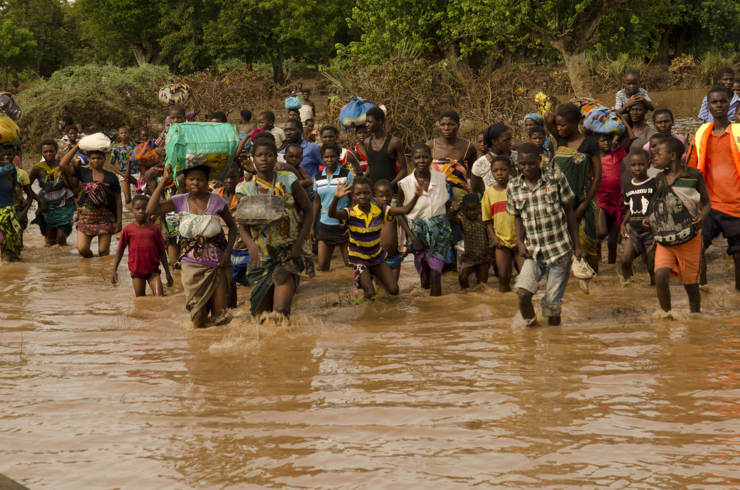

Media best practices
Now let’s get into the nitty-gritty. This section goes in depth to provide you with the information and resources you need to make it work. Generally speaking, to package early warnings and share climate information, you will need either a dedicated communications unit or personnel assigned to communications tasks. The job is to take information from the NHMS and package it for mass consumption. It’s a different skill set from most meteorologists and thus requires dedicated personnel.

Media Partnerships
There are several ways to partner with media companies to ensure effective delivery of early weather alerts and other applicable climate data. These include:
- Journalist Training Events. Inviting journalists and media directors to tailored training events on weather alerts, climate information and other NHMS activities is a proven method to inform the informers. It can also create the lasting synergies needed to create an early alert system for TV, radio, SMS and internet.
- Public-Private Partnerships. Partnerships with private-sector interests such as telecom operators, television and media offers the opportunity for expanded distribution of early alerts. When creating PPPs with the media, you will want to institute a response matrix that assigns roles and responsibilities, and makes it clear when, how and who does what to interrupt broadcasts for the issuance of early warnings.
- Paid Media. While the distribution of early alerts is a public good (and agreements to allow for their issuance through major media should be reached – as is the case in the US and other developed nations), paying for media is also an option. Under this model, the NHMS would pay for airtime, newspaper inserts, PSAs, etc. This paid advertising should be closely monitored for impact. In the end, it’s just another arrow in your quiver to reach end users.
- Earned Media. This is where you share a story with the media (say a news release on a flood or a press release on the deployment of new AWS). If the media covers that story, you are generating earned media. Careful attention to the clarity and accuracy of the message should be considered.
- Press Conferences and Media advisories. Weekly press conferences and media advisories will engage the press.

Emergency Alert Systems
There are numerous examples of emergency alert systems (sometimes referred to as emergency broadcast systems) provided in the Best Practices section of this publication. Effectively, an emergency alert system allows the government to interrupt radio and TV broadcasts, or access cellphones, to issue early warnings. The following outline covers the US FEMA Emergency Alert system.
- Coordinated. EAS are generally coordinated between the NHMS, disaster management agency and national communications agency.
- EAS messages are transmitted via AM, FM, broadcast television, cable television and Land Mobile Radio Service, as well as VHF, UHF, and FiOS (wireline video providers). Digital television, satellite television, and digital cable providers, along with cell phone services may be included in an EAS system.
- Messages in the EAS are composed of four parts: a digitally encoded SAME header, an attention signal, an audio announcement, and a digitally encoded end-of-message marker.
- The SAME header is the most critical part of the EAS design. It contains information about who originated the alert, a short, general description of the event (tornado, flood, severe thunderstorm), the areas affected (county or state), the expected duration of the event (in minutes), the date and time it was issued (in UTC), and an identification of the originating station.
- Primary Entry Point (PEP) stations. PEP stations are private or commercial radio broadcast stations that cooperatively participate to provide emergency alert and warning information to the public before, during, and after incidents and disasters. PEP stations are equipped with additional and backup communications equipment and power generators designed to enable them to continue broadcasting information to the public during and after an event. High level tasks for activating a new PEP station include: initial site assessments, environmental assessments, design specifications, construction of special facilities, and coordinating memorandums of agreement with the stations and activity coordination with the state, territorial, tribal, or local jurisdictions. PEP stations with next generation alert and warning equipment to include Common Alert Protocol (CAP) compliance equipment, and Internet Protocol enabled equipment are encouraged.
- EAS Header. Because the header lacks error detection codes, it is repeated three times for redundancy. However, the repetition of the data can itself be considered an error detection and correction code – like any error detection or correction code, it adds redundant information to the signal in order to make errors identifiable. EAS decoders compare the received headers against one another, looking for an exact match between any two, eliminating most errors which can cause an activation to fail. The decoder then decides whether to ignore the message or to relay it on the air if the message applies to the local area served by the station (following parameters set by the broadcaster).
- The SAME header bursts are followed by an attention signal which lasts between eight and 25 seconds, depending on the originating station. The tone is 1050 Hz (help·info) on a NOAA Weather Radio (NOAA/NWS) station, while on commercial broadcast stations, it consists of a "two tone" combination of 853 Hz and 960 Hz sine waves, the same one used by the older Emergency Broadcast System.
- The message ends with three bursts of the AFSK "EOM", or End of Message, which is the text NNNN, preceded each time by the binary 10101011 calibration.
- Station Requirements. The FCC requires all broadcast stations and multichannel video programming distributors (MVPD) to install and maintain FCC-certified EAS decoders and encoders at their control points or headends. These decoders continuously monitor the signals from other nearby broadcast stations for EAS messages. For reliability, at least two source stations must be monitored, one of which must be a designated local primary. Stations are required by federal law to keep logs of all received messages.
- Television broadcast stations transmit a visual message containing the Originator, Event, Location and the valid time period of an EAS message. This may be a text "crawl" or a static visual message.
- Stations are required by federal law to relay Emergency Action Notification (EAN) messages immediately. In the US, stations traditionally have been allowed to opt out of relaying other alerts such as severe weather, and child abduction emergencies (AMBER Alerts) if they so choose.
- All EAS equipment must be tested on a weekly basis.
- Targeting. The ability to narrow messages down so that only the actual area in danger is alerted is extremely helpful in preventing false warnings, which was previously a major tune-out factor. Instead of sounding for all warnings within a station's area, SAME-decoder radios now sound only for the counties for which they are programmed.

Resources
- CAP-EAS Converters start at US$1350. http://www.gorman-redlich.com/

Public Service Announcements
Even if our end users get better weather information, they may not know what to do with it. In the U.S. for instance, young people have been doing tornado drills since the first grade and know to “turn around, don’t drown” in a flood (not the case in Africa). NHMS may consider creating a series of public service announcements on what to do when bad weather hits. These simple messages can be shared via TV, radio, print, billboard and social media. Not only do they serve as an advocacy tool to validate the importance of good weather and climate information, they also have the potential to benefit end users and save lives. Initial product investment includes the following:

- Radio announcement. Thirty-second radio segments on what to do when bad weather hits. Can also be shared as a podcast for internet distribution.
- TV announcement. Animated three-minute videos on what to do when bad weather hits. These videos would be humorous and familiar in tone and targeted to a young audience (especially school children). They would be distributed via social media on YouTube, facebook and twitter, and provided to national communications office, met office and the department of health and education for dissemination. Paid distribution via broadcast should be considered. The Didier Drogba vs. Malaria video is a good example.

Video
There are several options for video. These include long-form documentaries, video news releases and short information videos.
- Incorporate TV broadcasters into an Early Alert System.
- If the NHMS is issuing Video News Releases (VNR), they would require a spokesperson to read the announcement, video camera, sound equipment, lighting and backdrop for filming, and an editor to edit the video. Free video editing software (included on most computers today) may suffice for VNR or professional packages such as Adobe Premiere could be used.
- There is the option to pay for air time, reach agreements for the fair use of airtime in the event of emergency or agreements to share daily, weekly, seasonal and relevant tailored forecasts.
- In the end, if you have good information, you can approach broadcasters with a solid value proposition. This content will benefit your viewers.
- It’s also worthwhile bringing a sponsor for your broadcasts. Thus weekly weather forecasts could be sponsored by a local seed company (with cost sharing between the NHMS and broadcaster).

Sample Script for Animated TV PSA
Big mountain range. A farmer is standing on one side in a horrible thunderstorm. On the other side of the mountain range a boy is playing soccer in the sun, a farmer works in a field, a Mom hangs laundry to dry.
The man in the rain tries to yell that bad weather is coming but no one hears him. The boy continues to play. The guy in the rain writes a note, makes it into a paper airplane and throws it. But it runs into the mountain. He builds a catapult, attaches a note showing lighting and shoots it in the air, but the rock falls on top of him.
Then the storm comes over. The boy sees the storm and runs under a tree but lighting strikes. It fries the boy. The boy runs to a gas station but lightning strikes it and makes a big explosion. Then the boy builds a Rube Goldberg-style contraption to protect against the lightning but it still gets him.
The dad’s crops are destroyed and lightning comically zaps his cow. The mom and sister get zapped comically.
The Mom goes to the village and organizes the women, and everybody comes together in protest. They go to a rural office and the crowd gets bigger. They go to the capital and the crowd gets bigger. A politician listens to them. Back at the mountain, a group of men come and erect an AWS on a cell tower on the hill. They pull down the boy’s Rube Goldberg contraption and put a lightning rod on his school.
A storm forms over the mountain. The AWS detects it and sends a message out to all the farmers on cell phones. The farmer hauls in his crops and puts them in a granary. The mom hears it on the radio, and gathers the children and goes to the school with the lightning rod. A fisherman receives an SMS and goes into port. The storm passes. Nobody dies. The sun comes out again.

Radio
Rural radio remains a solid distribution channel for climate information, PSAs and early warnings. Top line considerations include:
- Include radio stations in EAS.
- Use rural radios to share PSAs on what to do when bad weather hits and communicate climate outlooks and the implications of future climatic conditions as far as the agriculture or the health sectors are regarded.
- Create original content. These can include emergency alerts, longer news programs on crops reports or health information, PSAs and more.
- It’s easier than you think to create audio content.
- You will need a recording system, microphone, and audio editing software.

Print
You can engage with print media. Print is less prevalent in poorer communities, making this a better channel for long-term planning messages and messages to engage decision makers.
- Print products can include press releases, brochures, newsletters, banners, billboards, advertisements, and more.
- Newspapers can be used to communicate seasonal climate outlooks – rain, temperature. These outlooks can be accompanied by recommendations on how to improve productivity based on expected conditions.
- For print products, you may require graphic design to insert symbols and create visual alerts. This can generally be achieved by a graphic designer, and would require the Adobe Creative Suite or other graphic design software.
- Press releases. In order to share printed early warnings, you will need somebody to write the press release, a distribution system for the release, and somebody dedicated to answering questions.

Social Media
Social media is growing in popularity, but is still largely the domain of urbanites and people with access to internet. This dynamic is changing rapidly, and having a social media strategy in place will aid in both the issuance of early alerts and the sharing of PSAs and relevant information.
- Different channels require different dynamics.
- Facebook, twitter and other social networking sites can be used to crowd source information (imagine a network of tweeting weather spotters) and to share information (imagine sending geo-targeted messages via facebook). Both are possible!
- Hootsuite and tweetdeck are common platforms for channeling social media.
- As with any media, a response protocol is recommended.
- Social media is about engagement. In a typical communications directorate, there would be dedicated personnel. If you do not have the dedicated personnel, you may wish to consider delaying your engagement.

Internet and Mobile Apps
With new technology, building mobile apps is simpler than ever. Opensource platforms are available to customize apps and websites. However, without dedicated personnel, forays into both internet and mobile apps should be taken on a country-by-country basis. In the end, a website needs to be maintained, you need quick response to questions and you need to have accurate information. Every NHMS should have a website that includes the following information, at the very least.
- Alerts and polygons that demonstrate alert areas.
- Nowcast, hourly, daily, weekly and seasonal forecasts.
- Information on what to do when bad weather hits and educational information.
- RSS feed
- Press Center
- Localized weather reports
- Tailored reports for crops, health, etc.
- Easy navigation
- Long term climate information and its implications
- Safety section for all relevant regional disasters (i.e. flood, lightning, etc.).
- Incorporated social media and rss feed
- Information on your early alert systems
- An easy-to-understand taxonomy and information archive that ensures searchability, ease of use and functional conveyance of both weather and climate information.
- Archive of climate information and data description – how it was measured, when, etc.
- HydroMet infrastructure

SMS and Messaging
There are numerous platforms and systems to share short text messages. These include What’s APP, Viber, SMS and more. Deciding on your distribution platform – or platforms – will be just as important as the message itself.

- Messages should be short, and include the requirements outlined by CAP.
- Messages can be used for issuance of early warnings, and sharing of valuable climate information that can aid in productivity (i.e. 3-2-1).
- The Cellular Messaging Alert System allows for geotargeted SMS alerts. CMAS can be effectively used to warn the public in cases of dangerous fires, earthquakes, volcanic eruptions, hurricanes, floods, landslides and tsunamis… any inclement weather or natural disaster event that people need to be alerted of. A number of targeted services work to provide SMS capability (see resources below). Once example is the CMAS system, which has Common Alerting Protocol capability and is designed to work as a standalone alerting platform or in conjunction with an existing system. www.cmasalert.com.
- In order to send SMS, you need a dedicated distribution service and the requisite agreements with SMS service providers.

Types of Messaging
While there are numerous platforms and formats for messages, top choices include:
- Short Message Service (SMS) is a text messaging service component of phone, Web, or mobile communication systems. It uses standardized communications protocols to allow fixed line or mobile phone devices to exchange short text messages.
- Interactive voice response (IVR) is a technology that allows a computer to interact with humans through the use of voice and Dual Tone Multiple Frequency (DTMF) tones input via keypad.
- Unstructured Supplementary Service Data (USSD) is a protocol used by GSM cellular telephones to communicate with the service provider's computers. USSD can be used for Wireless Application Protocol (WAP) browsing, prepaid callback service, mobile-money services, location-based content services, menu-based information services, and as part of configuring the phone on the network. USSD messages are up to 182 alphanumeric characters in length. Unlike Short Message Service (SMS) messages, USSD messages create a real-time connection during a USSD session. The connection remains open, allowing a two-way exchange of a sequence of data. This makes USSD more responsive than services that use SMS.
- A WAP browser is a web browser for mobile devices such as mobile phones that uses the protocol. Before the introduction of WAP, mobile service providers had limited opportunities to offer interactive data services, but needed interactivity to support Internet and Web applications such as Email by mobile phone.

Resources
- World Text
- Open Street Maps
- UMS Alerts
- Free Humanitarian and Country Icons
- How to Record Streaming Audio, System Sound, or What You Hear Using Audacity - Free Software
- Sony Journalist Backpack
- 10 Tricks to Make Amateur Video Look Professional
- www.cmasalert.com
- Google Public Alerts - Google.org
- Facebook - Emergency Management
- 50 Open Source Mobile Tools
- PhoneGap – to create apps easily
- The Social Media Best Practices Handbook
- Frontline SMS
- Africa’s Talking
- Nexmo

Advocacy to support communication goals
This issuance of early alerts and sharing of public service announcements and climate outlooks is just a piece of the overall communications puzzle. In order to build political support, improve budgets and effectively engage with all stakeholders – the vary ingredients required to ensure sustainability of project initiatives – supportive communications strategies should also be considered. This is often called advocacy or supportive communications. In order to build trust, old fashioned community engagement is still recommended. This means Townhall meetings, engagement with village leaders, sectorial leaders and other actors. Connect in person, follow up virtually.

The considerable socio-economic benefits of a well-functioning NHMS should be presented in awareness raising campaigns targeting government as well as the general public. Included in this material should be the likely returns derived from investments in the NHMS human resources and infrastructure. The objective of the awareness raising campaigns would be greater political support for the NHMSs and ultimately greater funding streams from government and the private sector. The national treasury would be a particularly important target audience.

- Strengthen political dialogue. Engage with actors from every agency to ensure sharing of information.
- Communicate success. The successes of the NHMS should be shared with the public via press releases, press conferences, social media and other relevant channels. Remember to stay on message, communicate your core brand and engage on the subjects of benefits and emotions (not just attributes of what you are doing).
- Monitoring and Evaluation. This is a key step often left out of media plans. What are your metrics for success? Response and engagement with messages, testing of messages, number of viewers, messages sent, surveys and face-to-face engagement are all good indicators. Tracking should be continual throughout the process. If you are doing your job right, you should see increases across the board – another shareable success come budget time.
- Sharing with UNDP, donors and other countries. The sharing should not stop at the door of the NHMS or even the relevant ministry. Successes should be shared across the community of practice, with donors and with neighboring countries to ensure the sharing of best practices.
- Change management. Sometimes you have to start over (or pivot from your starting point). By looking at integrated change management strategies you can effectively engage stakeholders, solidify your brand and create that true value proposition you need to succeed.

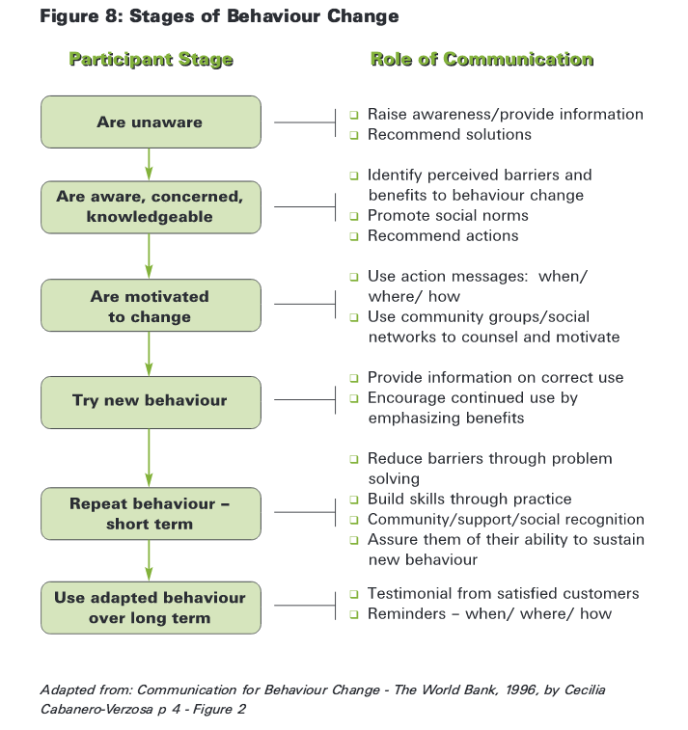

Communication Strategy Template, TORs

Communications Strategy Template
This basic template can be used to create a communications strategy.

Section 1: Overview
What can we take from this strategy?

Section 2: Goals
What programme goals do you hope to achieve with your communications strategy?

1.

2.

3.

How can communication work to achieving each of these goals?

1.

2.

3.

Section 3: SWOT Analysis
What are your current strengths, weaknesses, opportunities and threats in communicating early warnings, sharing climate information and advocacy?

SWOT ANALYSIS OF EARLY WARNINGS
STRENGTHS |  | WEAKNESSES | OPPORTUNITIES |  | THREATS

SWOT ANALYSIS OF CLIMATE INFORMATION
STRENGTHS | WEAKNESSES | OPPORTUNITIES | THREATS

Section 4: Stakeholders
Who are your main end users (including current users and potential users)?

1.

2.

3.

How do these end users interact with information (ie. They are illiterate, they speak multiple languages, they prefer village councils to newspapers)?

What are the climate and weather needs of these end users?

1.

2.

3.

Which of the above needs have not been met? What about those that have been met only partially?

Who are the main actors that will help deliver information to your end users?

SWOT ANALYSIS OF END USERS
STRENGTHS | WEAKNESSES | OPPORTUNITIES | THREATS

Section 5: Knowing Your Core Product and Core Messages
What are your core products?

What are the attributes of your product?

What are the benefits to end users of your product?

What is the key message or emotion you want your end users to feel?

What are the main messages you need to reach your end users?
1.

2.

3.

Section 6: Early Warnings
What is your current early warning system?

How does information flow in the current system?

Create a new information flow based on the diagram below.

Section 7: Distribution
What channels can you use to distribute climate information and early warnings?

Who are the main actors for these channels?

Who will be responsible for the packaging, distribution and monitoring of climate information?

SWOT ANALYSIS OF Distribution Channels
STRENGTHS | WEAKNESSES | OPPORTUNITIES | THREATS
Channel 1

Channel 2

Channel 3

Channel 4

Section 8: Products
What supporting/advocacy products do you need to achieve your goals?

Who will create these products?

Section 9: Budget
Create a sample budget, outlining costs, timelines, deliverables.

Product | Deliverables | Timeline | Cost

Section 10: Monitoring and Evaluation
What are the metrics for success of new early warning and climate information products (ie. Early warnings will reach 80% of the population)?

What are the metrics of success for communications products (ie. Number of views, actions taken, early warnings issued, people reached, direct engagement and feedback)?

How will you communicate and monitor that success?

Resources
- Writing a communication strategy for development - Unicef
- Developing a communications strategy — Knowhow Nonprofit
- Template for Strategic Communications Plan - W.K. Kellogg
- Communications Strategy Template - UNEP
- Creating a Basic Internal Communications Strategy

Communications Consultant TORs Template

UNITED NATIONS DEVELOPMENT PROGRAMME
TERMS OF REFERENCE

Title | Communications Specialist

Application Deadline:

Location:
Type of Contract: | Individual Contract

Languages Required:

Starting date:

Duration of Initial contract:

Supervisor:

Background

The UNDP-supported Climate Information and Early Warning Systems in [country] works to [insert project goal]

Climate stresses and low adaptive capacity are increasing [country] vulnerability to climate change. Climate related shocks to the economy, vulnerable populations, ecosystems and infrastructure threaten development goals and poverty alleviation strategies. The ability of decision-makers to understand and communicate the likely impacts of climate change is of critical importance in adapting development plans to new climate realities. However, the lack of access to reliable climate information and the lack of capacity of disseminating it prove to be significant obstacles in allowing governments and populations to develop the correct tools to address the changes that will be brought on as a result of climate change.

The programme is being implemented by [implementing agency] with funding from the Global Environment Facility (GEF) Least Developed Country Fund (LDCF) and is an example of the concrete actions that the UN is taking to reduce the impacts of climate change in all development sectors.

As part of its work, the Climate Information and Early Warning Systems Project seeks to hire a communications specialist to aid in the creation and implementation of a communications strategy, understand the needs of key stakeholders, create messages to reach those stakeholders, engage with a number of actors (including the media, community leaders, extension agencies, ministries and the community of practice) to aid in the distribution of messages, and monitor and evaluate the impact of communications initiatives. Through the work, the communications specialist will create a number of unique communications products to educate the public of the value of climate information and early warning systems and create advocacy materials and actions to support the achievement of the overall communications objectives of the project.

Scope of work and deliverables

Under the guidance and supervision of the [manager], the consultant will provide the following:

Stakeholder Analysis
- Review of existing stakeholders (including end-users and actors) involved in the climate information and early warning system space.
- Review of existing stakeholder surveys
- Interviews with key stakeholders

Review of Existing Assets
- Review existing communications assets, including [insert current communications channels]

Creation of a Communication Strategy
- Working with relevant stakeholders, the consultant will develop a communications strategy. The strategy will focus on [issuance of early warnings or advocacy communications]
- The strategy will include the following elements: Overview, goals, SWOT analysis of existing products, stakeholder analysis (including SWOT analysis of end users), message creation and identification of core products and central benefits, SWOT analysis of early warning systems [if applicable], identification of distribution channels and SWOT analysis, list of recommended communications products to achieve project goals, budget to create products, monitoring and evaluation matrix.

Implementation of Communication Strategy [Ideally, an initial contract would build the strategy, with a follow up contract to implement agreed upon products]
- The consultant will work with the manager to identify prime communications products and implementation strategy.
- Products will include an editorial and product calendar and agreed upon communications products.

Qualifications

Education: | - Degree in Communications, Journalism, Public Policy or other closely related field (max 10 points).
Experience and requirements | - At least 7 years relevant working experience developing and implementing communications strategies (max 20 points).  - Demonstrable communication products from past assignments that showcase experience in producing advocacy materials (please attach or provide links to at least 3 samples of previous work in your application) (max 30 points);  - Advanced skills in current communications practices and communication for development. Graphic design, web design, social media experience is a bonus. (max 20 points);  - Experience working with UNDP and familiarity with UNDP corporate design and branding guidelines and templates, is an asset (10 points).
Language Requirements: | - Fluency in [language] (max 10 points).

More Resources

WMO Communications Guidelines
Guidelines for Creating a Memorandum of Understanding and a Standard Operating Procedure between a National Meteorological or Hydrometeorological Service and a Partner Agency (PWS-26) | English version
Guidelines on the strategies for use of social media by National Meteorological and Hydrological Services (PWS-24) | English version  PWS-24 Spanish
1. Guidelines on International and Cross-Border Collaboration in the Warning Process (PWS-22)  2. Lignes directrices pour la collaboration internationale et transfrontalière  en matière d’alerte (PWS-22)  3. DIRECTRICES SOBRE LA COLABORACIÓN INTERNACIONAL Y TRANSFRONTERIZA EN EL PROCESO DE AVISO (PWS-22) | 1. English Version  2. Version Française  3. Versión en Español
Guidelines on Early Warning Systems and Application of Nowcasting and Warning Operations (PWS 21)  Directives sur les systèmes d'alerte précoce et l'application des prévisions immédiates et des alertes (PWS 21)  DIRECTRICES SOBRE SISTEMAS DE  ALERTA TEMPRANA Y APLICACIÓN  DE PREDICCIÓN INMEDIATA Y  OPERACIONES DE AVISO (SMP 21) | PDF Format  2. Version Française  3. Versión en Español
Administrative Procedure for Registering WMO Alerting Identifiers (PWS-20) | PDF English version
Procédure Administrative Pour l’Enregistrement des Identificateurs d’Alerte de L’OMM (PWS-20) | Version Française
PWS Summary Guide to Survey Design and Delivery | PDF Format
Working with the Media | PDF Format
Using Surveys to Evaluate Services | PDF Format
Communicating with the Public | PDF Format
Communication, Public Education and Outreach | PDF Format
Communicating Forecast Uncertainty | PDF Format
1. Guidelines on Communicating Forecast Uncertainty (PWS-18)  2. Principes Directeurs Pour la Communication Relative à l'incertitude des prévisions (PWS-18)  3. DIRECTRICES SOBRE LA COMUNICACIÓN  DE LA INCERTUDUMBRE DE LAS  PREDICCIONES (PWS-18) | 1. English Version  2. Version Française  3. Versión en Español
1. Examples of Best Practice in Communicating Weather Information (PWS 17)  2. Exemples de Bonnes Pratiques en Matières de Communications d'Informations Météorologiques (PWS 17)  3. EJEMPLOS DE BUENAS PRÁCTICAS PARA COMUNICAR INFORMACIÓN METEOROLÓGICA (PWS 17) | 1. English version  2. Version Française  3. Versión en Español
Strategy for Developing Public Education and Outreach (PWS-14) | PDF format
Guidelines on Integrating Severe Weather Warnings into Disaster Risk Management (PWS-13) | PDF format
Guidelines on Weather Broadcasting and the Use of Radio for the Delivery of Weather Information (PWS-12) | PDF format
Guidelines on Cross-Border Exchange of Warnings (PWS-9) | PDF format
Guide on Improving Public Understanding of and Response to Warnings (PWS-8) | PDF format
Weather on the Internet and Other New Technologies (PWS-2) | PDF format
GUIDE des pratiques concernant les services  météorologiques destinés au public (janvier 2000) | PDF format

Other Resources
- Discussion Paper - LEDS Global Partnership
- Réduire les risques de catastrophes en Afrique de l'Ouest
- Comité régional de gestion des catastrophes en Afrique de l'ouest
- L'alerte précoce aux catastrophes: Faits et chiffres
- Public Weather Services (PWS) Guidelines - WMO
- Information systems in a changing climate
- Multi-Hazard Early Warning and Decision Support Systems
- Implementing Hazard Early Warning Systems
- Early Warning Systems for Natural Disaster Reduction
- GUIDELINES ON EARLY WARNING SYSTEMS - WMO
- Early Warning Systems outline - WMO
- Participatory Integrated Climate Services for Agriculture
- Media College offers training and tutorials for all forms of electronic media — including video, audio, photography, graphics and Web design.
- Guidance on Generating Content: Capturing and Creating Stories, Photos and Films.English (interactive version) | French (interactive version)
- The MCBP’s Media Resources Directory provides a compilation of freely accessible materials to support African journalists reporting on climate-related issues.
- Have little ones at home? Teach them about the weather with Owlie Skywarn. Play a free, online game where you go on a severe weather preparedness adventure and earn a Young Meteorologists Certificate.
- Leveraging the power of rural radio to bring seasonal climate forecasts and shorter-term weather alerts to around two million farmers in Senegal alone
- Climate Change in Africa: A Guidebook for Journalists
- Case study: Flood early warning systems
- A Checklist Developing Early Warning Systems: - UNIDSR
- A Conceptual Flash Flood Early Warning System for Africa
- Improving early warning systems for agricultural -CGIAR
- Monitoring, Early Warning and Communication System
- Design of a severe climate change early warning system

Source FEMA. https://www.fema.gov/pdf/emergency/nrf/nrf-core.pdf
Ibid.
Above text adopted from the WMO Guidelines on Early Warning Systems and Application of Nowcasting and Operation Warnings. https://www.wmo.int/pages/prog/amp/pwsp/documents/PWS-21.pdf
This section was sourced from FEMA and Wikipedia.

