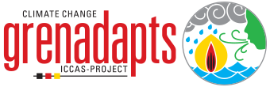
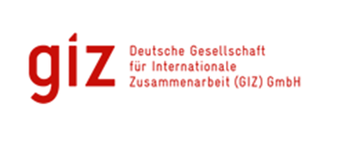
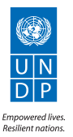

THEMATIC REPORT: ICCAS PROJECT

Education & Communication
Raising Awareness of Climate Change and Adaptation Strategies

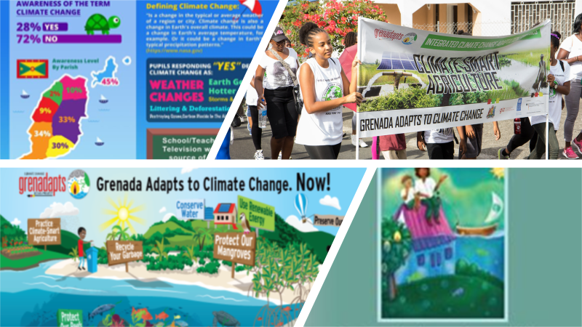

Submitted
By
David A. Simmons
92A Benjamin St., Diego Martin
Trinidad and Tobago
Email: davidAsimmons@outlook.com
Integrated Climate Change Adaptation Strategies (ICCAS): Thematic Report
Thematic Area: Climate Change Education & Awareness |  | Period: January 2016 – August 2017
IMPLEMENTING AGENCIES
United National Development Programme (UNDP) | The Environment Unit of the Ministry of Agriculture, Lands, Forestry, Fisheries and the Environment |  | German Development Cooperation (GIZ), BMUB

Context | The objective of the ICCAS programme was to enhance the resilience of Grenada’s population and its ecosystems that are particularly vulnerable to the effects of climate change. Component 4.2 of ICCAS focuses on strengthened understanding and awareness of climate change risks. The research done on the Grenadian populations knowledge attitudes and practices about climate change suggests very low performance on all indices. Many Grenadians still do not understand the link between the climate change impacts they feel, climate change and what they can do to be less vulnerable This means that to integrate climate change adaptation and resilience into the Grenadian society education and awareness building would need to be a key component of the ICCAS program. This was done in several ways including:  - Projects where the main focus was to educate or raise awareness  - Add on training and education components to projects focusing on other areas in the ICCAS framework  - Outreach into the community using a variety of media.  - Use of non-traditional educational methods:  - Theatre Project  - My School and You Project
Projects: Background | - Climate Kids Adventures  - This project consisted of a baseline survey to quantify the knowledge of primary school children in the area of climate change.  - The development of two books and an associated mobile application (app) which reads the book and allows some limited interaction with characters. The project targeted at children between the ages of 5-7 on climate change and climate change adaptation.  - The distribution of the materials in all the primary schools in the country (including private schools)  - Greenz Climate Champion Toolkit  - This project was launched in June of 2016 and included of a teacher manual, a worksheet collection, student passports, stickers and posters. Grenadian illustrator Stacey Byer developed child-friendly images for each unit. To date, 400 posters and 900 student passports including sticker sets were delivered to primary schools.  - Teachers were given workshops in how to use the toolkits and integrate the topics into the school curriculum  - The project has been expanded to include a planned science fair with climate change adaptation as its focus  - Education and awareness components in the funded projects  - Outreach using various media  - Outreach in the creative arts  a. Theatre Project  b. My School and You Project

Overall Success
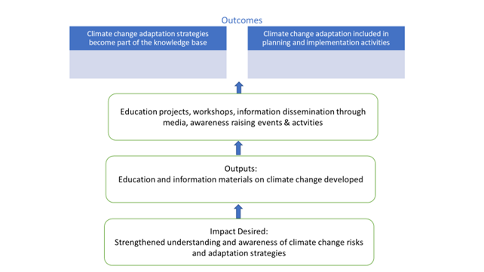

Projects
The books and application were developed, and the books were distributed in 69 schools and approximately 7000 children between the ages of 5-7. The app was made available for distribution through the ICCAS website, and various other social media platforms. The pre and post survey data indicated an overall 27% improvement in awareness among children in the target age-group.
A Grenada specific climate change teaching kit was completed. 49 schools participated in the development of the “Greenz Climate Champion Toolkit”, and 900 children have received their climate change passports. A debate on the subject of climate change was organized among several schools in which over 236 children participated.
Use of Various Media:
Radio Television & Print:
A media strategy was implemented which included radio and TV Public Service Announcements, media coverage of activities of the ICCAS project and the Environment division and a bi-weekly environment radio show on WEE-FM.
12 billboards have been erected around Grenada, Carriacou and Petit Martinique to inform the public on strategies to adapt to climate change as well as to raise awareness on the invasive red lion fish.
Public transport campaign: The Grenada Adapts to Climate Change Now! artwork was placed on 7 public buses travelling in different bus routes in Grenada and Carriacou.
Internet & Social Media:
ICCAS has a website which is the repository of all programme and project information. They also set up various social media platforms including Facebook, Twitter and You-tube to disseminate Information about the actions of ICCAS and Climate Change information in general. A music video was done by a high profile local “Soca” artist on the topic of climate change. It was called “Can’t do it Alone” and has received lots of airing on local television.
Social Events:
Several community and national events have been organized to raise the public’s awareness of climate change:
- Climate Change Walk,
- Climate Change
- Football Competition
- Numerous festivals and events.
Project launches:
- 10 CCCAF projects held launches to raise the level of awareness of the projects and to demonstrate how adaptation is working at community level.
- Telling the ICCAS story through Adaptation Videos: Video footage covering activities on the implementation of the projects.

Lessons Learnt:
- Small expenditures well targeted can have a very big impact on education and awareness. The music video was a very good example of this
- A key message coming out of most of the projects is the need for ongoing education on climate change impact and adaptation strategies. One-time presentations etc. are not adequate to relay the information, to build the knowledge base and create commitment.
- Education awareness on the impacts of climate change and adaptation measures to build resilience should form an integral part of projects being implemented as it helps to promote acceptance and commitment.
- Use of different media to convey the message is a good strategy because different demographics in the population respond better to different media.
- However, there have been issues when using technology-based media like the internet and the social media app. The website has had functionality problems and continues to do so. The app had difficulties being launched. Both problems have their source in incomplete knowledge before the setting up and use of the particular medium. Better access to technical resources is the key to avoiding these problems in the future.

Best Practice(s) Identified:
- Targeting of the media to suit the demographic works (as in the case of interactive mobile app for young children and music video done by popular artiste) to raise acceptance of the message.

- Integration of climate change adaptation and resilience through the use of various interactive media can be an effective means of reaching school kids and mainstreaming climate change adaptation. This was aptly demonstrated through the efforts of the Ministry of Education, Curriculum Department as they undertook several activities in that regard including presenting the Tool-kit at several Principal’s District meetings across the country, convening a workshop for training of teachers in the use of the Tool-kit, development of some fun interactive games, and, organizing a Science Fair at which the information in the books could be distributed.
Recommendations based on the Lessons Learnt and Best Practices Analysis:
- Broad use of various communication and awareness raising media is a good way to ensure that different demographics are made aware of and are responsive to the message.
- When technology is being used, ensuring understanding and access to the appropriate technology and support is essential for long term functionality.
- Engaging the stakeholders involved in groups to whom the message is being delivered is the best way to make sure the message is tailored to that group (for example teachers and students targeted in the climate change books and mobile app).

Author: David Simmons & Christina Barradas-Brewster/ Consultants/ Caribbean/
Contact: davidasimmons@outlook.com
Location of Project: Caribbean/OU/Grenada/St Andrew
MHT: What is the Major Habitat Type for this partnership? National
Types of Partners: Government, Place-based NGO, International NGO, Community Based Organization.
Priority: Education
Date: May 2018
Links: http://www.iccas.gd/?q=about-iccas
https://www.greenclimate.fund/-/climate-resilient-water-sector-in-grenada-g-crews-
http://www.adaptation-undp.org/projects/japan-caribbean-climate-change-partnership http://www.gov.gd/egov/news/2017/oct17/10_10_17/item_1/green-climate-fund-approves-readness-preparatory-support-programme-grenada.html

