‘Look at them, they will no longer have Bilharzia’’
A success story on the provision of water to the Zabugu Kpalugu Community
By Adaption Fund Project, Ghana

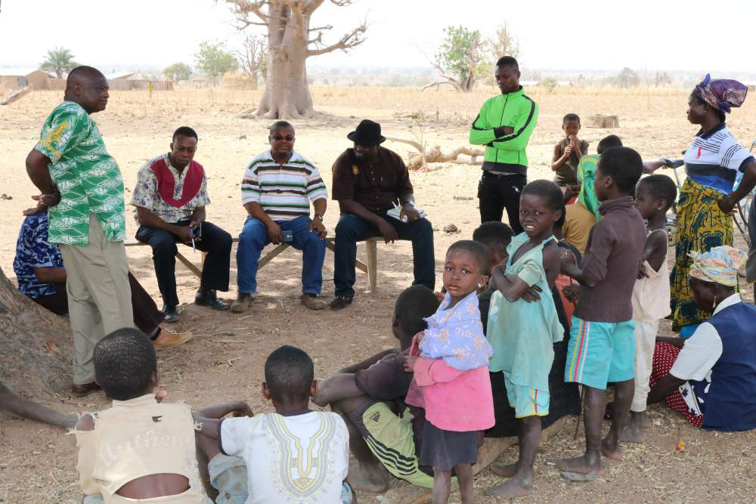
Community Engagement with parents and children

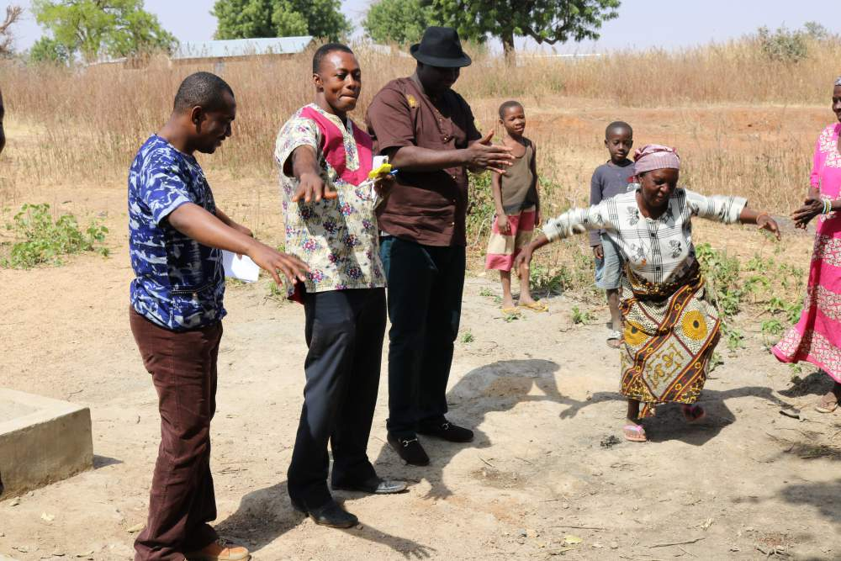
Madam Ndebugri showing gratitude to the PMU team with a traditional dance

“No more itching body, dirty water for cooking, washing…. we no longer share our water with cattle’’
Madam Ndebugri, leader of the community water facility management committee in Zabugu Kpalugu.

Zabugu Kpalugu is one of the five beneficiary y communities of the “Increased resilience to climate change in Northern Ghana through the management of water resources and diversification of livelihoods” project (Adaptation fund project) project in the Bawku Central Municipal that had recently benefitted from a borehole facility constructed by the project. The community is made up of about 2000 residents. The main occupation of the people is predominantly agriculture along the two major seasons, namely the dry and raining seasons.
Lack of potable water for multiple uses and users was identified as one of the many challenges which confronted Zabugu community during the project inception phase. Prior to the construction of the borehole by the project, the community, mainly women and girls had to trek for an average of 3 hours in search of water from nearby streams every morning and in many cases compete with cattle and other livestock for the same water.
In a recent interaction with the community by the Project Management Unit (PMU) during a post construction follow up visit to discuss the immediate results of the borehole, Madam Asamalsim Ndebugri, a beneficiary of the project, exclaimed out of excitement, and pointed at a group of children who joined the PMU interaction with the community, thus, ’Look at them, they will no longer have bilharzia’’.
One after the other, the women and men alike, with beaming smiles recounted how the project has reduced their traveling time to fetch water, reduced the water-related diseases amongst several adverse conditions before the borehole construction.
“…during the period that the community did not have a borehole, children had infections from water borne diseases such as continuous skin itching and bilharzia; evidenced by children urinating blood periodically. This was because the community had to trek for 3 hours to fetch water from the closest streams and in worse cases scoop water with their hands and basins from the same river bed during the dry season. We therefore had to compete with livestock such as cattle for the scarce water. But now the story is different, a round trip to fetch a safe potable water is 20 minutes’’ Madam Asamalsim Ndebugri recounted.
Madam Ndebugri added ‘‘before the borehole intervention, our children had to trek for 3 hours (around trip) to the nearest stream to fetch water in order to bath and support cooking of food before going to school. This made children arrive in school very late and tired and therefore could not concentrate well during teaching and learning sessions in class. This intervention could not have come at any better time than this !’’.
The lack of potable and safe water sources had affected the health of children with community members reporting that often children scratched their bodies as result of reaction from the stream water on their skin. Most children had also contracted bilharzia infections from the same water sources. While children had to trek for 3 hours (round trip) to fetch unsafe water to bath before going to school.
It was recounted by the women that ‘‘even our clothings and sometimes some cooked food was a little discoloured by the colour of the unsafe water sources’’.
Currently, it worth noting that for all the people that were engaged during the community visit, they are emphatic about the effects of the borehole on the health and education of their children, the livelihoods and domestic roles of women in the community. With the drilling of a borehole at community level, travel time to source of drinking water for usage is now 20 minutes. Children can now go to school early and in a most relaxed and prepared state to be engaged by the class teachers. There is sufficient water for multi uses; to support domestic uses as well as livelihoods of women.
This story was generated from findings from field monitoring visits to the Adaptation Fund project beneficiary communities in the Bawku Central Municipal Assembly.
The Government of Ghana (GoG), with funding from the Adaptation Fund Board Secretariat is implementing a four-year project dubbed “Increased resilience to climate change in northern Ghana through the management of water resources and diversification of livelihoods”. The project also known as the Adaptation Fund Project is being executed by the Ministry of Environment, Science, Technology and Innovation (MESTI) of Ghana in partnership with the United Nations Development Project(UNDP), with close cooperation with sectoral ministries and agencies, NGOs and the private sector. The Project is supporting 50 communities in 10 districts of the 3 Northern regions of Ghana.

The community has planned to strengthen their current Water Management Committee to support the community with periodic maintenance and sustainability of the borehole facility. The Adaptation Fund Project intends to support this community further by mechanizing their high yielding borehole to serve a wider community for multiple users and uses.

The Adaptation Fund project focuses on enhancing the resilience and adaptive capacity of rural livelihoods to climate impacts and risks on water resources in Northern Ghana. This is intended to be achieved through key results centered on the improvement of water access and also increase institutional capacity and coordination for integrated water management to support other uses of water resources especially for the diversification of livelihoods by rural communities.

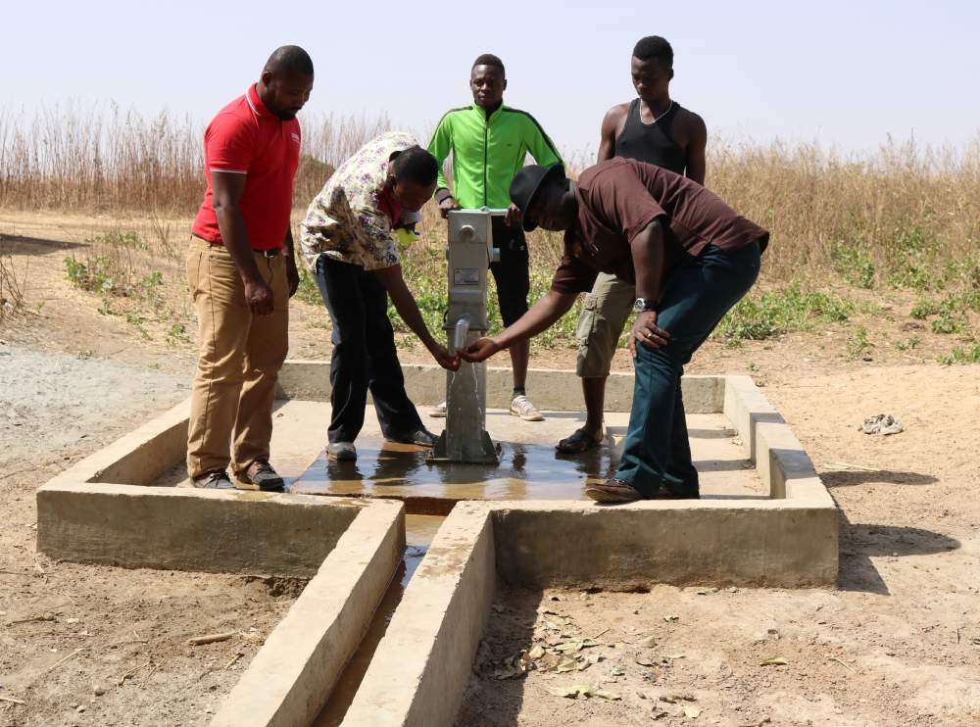
PMU team taking turns to drink from the Zabugu Kpalugu community borehole.

