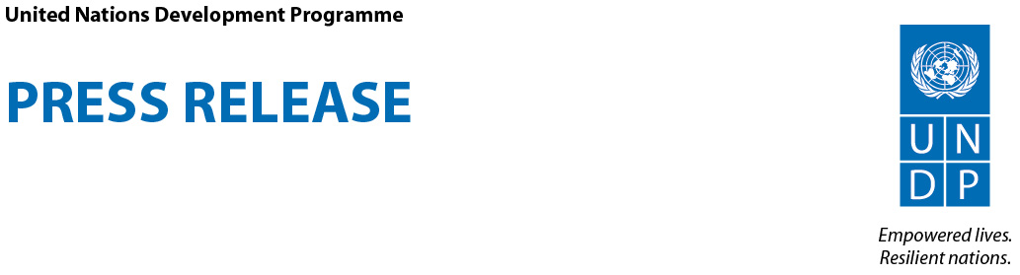

UNDP Last Mile Workshop in Livingstone to Strengthen Climate Information Systems Across 11 Sub-Saharan African Nations
Workshop Addresses Issues of Saving Lives, Improving Livelihoods and Increasing Resiliency with Tailored Weather Information Services for a Changing Climate
Livingstone, Zambia, 15 March, 2016 – The United Nations Development Programme (UNDP) kicked off a meeting today in Livingstone on “The Last Mile - Saving lives, improving livelihoods and increasing resiliency with tailored weather information services for a changing climate.”
The workshop brings together delegates from 10 African nations as well as representatives of the Zambian government. Also in attendance at the workshop are James Kapyanga, Deputy Minister of Transport and Communications, and Martim Maya, Country Director of UNDP Zambia. In attendance also are the Director of the Zambia Meteorological Department (ZMD), Jacob Nkomoki, and the Regional Coordinator for the Disaster Management and Mitigation Unit, Pumulo Mubita.
“Climate information and early warning systems can save lives, improve livelihoods and build resiliency across Africa,” said Bonizella Biagini, Programme Manager for the UNDP Programme on Climate Information for Resilient Development in Africa (CIRDA).
“In order to seize this opportunity, timely, accurate and actionable weather and climate information must be delivered from data collection and creation sources across the ‘Last Mile’ to uninformed and vulnerable end-users,” Maya said at the opening ceremony today.
The social, economic and human imperative to build working early warning systems and improve climate and weather monitoring are clear: better information on weather and climate saves lives and protect livelihoods.

“Over the past three decades, floods and droughts have cost Zambia US$13.8 billion, which is equivalent to a 0.4 percent loss in annual economic growth,” said Nkomoki. “It is estimated that rainfall variability alone could keep an additional 300,000 Zambians below the poverty line and cost Zambia US$4.3 billion in lost Gross Domestic Product over the next decade.”

Through early alerts and effective planning, some of these costs could be avoided. These will rely on improved access to climate information, better weather services and effective early warning systems, according to the Zambia Meteorological Department.

The ZMD is currently engaged in a Climate Information and Early Warning Systems Project supported by the United Nations Development Programme that is working to update Zambia’s national meteorological system, strengthen capacity in the ZMD, engage with weather service providers and other potential partners in the private sector, and build a reliable and sustainable national weather monitoring and reporting system. The project began in 2013 and will run through 2017, with US$4 million in financing from the Global Environment Facility and over $23 million in co-financing.
Climate Action Hackathon Side Event
Learn More

The CIRDA Programme
UNDP’s Programme on Climate Information for Resilient Development in Africa (CIRDA) supports Climate Information and Early-Warning Systems Projects in 11 of Africa’s Least Developed Countries in their missions to save lives and improve livelihoods. By building capacity to issue extreme weather warnings, sharing new technological advances in weather monitoring and forecasting, and facilitating innovative partnerships with the private sector, the programme works to foster regional cooperation, support strong institutions and build resiliency to climate change.

### ### ###
UNDP partners with people at all levels of society to help build nations that can withstand crisis, and drive and sustain the kind of growth that improves the quality of life for everyone. On the ground in more than 170 countries and territories, we offer global perspective and local insight to help empower lives and build resilient nations.

