# Standard Operating Procedures (SOP) for Multi-Hazard Early Warning System (MHEWS) in Cambodia

# Background and Objectives of SOP for MHEWS

During April 2014, Cambodia’s National Committee for Disaster Management and the Asian Disaster Preparedness Center (ADPC) compiled the first Standard Operating Procedures (SOP) document for flood Early Warning System (EWS) in Cambodia. Developed through the World Bank project “Strengthening the Disaster Management System in Cambodia through Risk Assessment, Early Warning System and Developing Building Codes” (2011 – 2014). During a flood, the EWS constitutes is based upon the effectiveness of the SOP in Cambodia.

## Early Warning Systems

The Sendai Framework includes the improvement of Early Warning Systems directly in one of its seven global targets:

7) substantially increase the availability of and access to multi-hazard early warning systems and disaster risk information and assessments to people by 2030.

An Early Warning System monitors climatic and environmental data on a real-time basis, to detect adverse trends and reliably predict the possible impacts from natural hazards. Henceforth, an effective EWS would enable timely response to natural hazards and extreme weather events, as well as risk-informed development planning.

## Multi-Hazard Approach

The National Committee for Disaster Management in Cambodia recognizes the following Disaster Types in its Disaster and Loss database:

|  |  |
| --- | --- |
| * Flood | * Press Outbreak |
| * Storm | * River Bank Collapse |
| * Drought |  |

Although there is a wide range of natural disasters, there are several similarities in the process of issuing and disseminating warnings. Therefore, SOPs can be applied to a number of different hazard types. When using similar dissemination systems and processes for all hazard warnings, these systems and processes are tested on a more frequent basis. Henceforth, local populations and agencies increase their knowledge and experience on the dissemination, corresponding with fewer chances of miscommunications or misunderstandings[1].

Between 1980 and 2011, 65% of the total number of disasters occurred in Cambodia were flood related. Secondly, droughts were 22%. Also, 75% of the disasters experienced were “water related hazards” (flood 65% and storm 13%). Similarly, flooding affected 62% of the total population, and drought affected 37%. 100% of the death toll from disasters were because of “water related hazards” (flood and storm), and most of the estimated damage cost were due to flood (87%) and drought (13%). Henceforth, it is safe to say that flooding, storms, and droughts are the major disasters in Cambodia[2].

## Intent of the SOP for MH-EWS

The purpose of the Standard Operating Procedures (SOP) for Multi-Hazard Early Warning System (MH- EWS) is to promote resilience to multi-hazards and to improve the policy and institutional arrangements at national, district, and community levels through integrated and effective standard operating procedures for multi-hazards EWS.

Therefore, the SOP for Multi-Hazard EWS aims at becoming a practical guide for stakeholders who can refer to it in the event of a forecasted or existing disaster – or during any if its identified stages (Normal Stage, Alarm Stage, Warning Stage) – in Cambodia, and take adequate actions accordingly.

SOPs shall help to ensure that people involved in the EWS take the most effective and efficient steps during a natural disaster emergency to provide life-saving information and direction when needed, by:

* Providing, in a concise and convenient form, a **list of major executive actions involved in Multi-Hazard early warning** system;
* Ensuring that all concerned Ministries, Departments, Organizations of the Government and all the levels of the Administrative system ***are informed clearly about their respective roles and responsibilities***;
* Ensuring that a **systematic early warning system is clearly outlined** for different hazards in Cambodia.

## Process

The process of Early Warning System revolves around four key components[3]: risk knowledge, monitoring and warning, dissemination and communication, and response capacity. The SOP comes after monitoring and warning, when the early warning requires to be channelized to different users through different media.

**EARLY WARNING SYSTEM (EWS)**

Technical Process (MOWRAM, DHRW and DOM)

Administrative Process NCDM

**STANDARD OPERATING PROCEDURES (SOP)**

Administrative Process NCDM

While MOWRAM are responsible for the technical part of an early warning system. The administration part of early warning lies within the National Committee for Disaster Management (NCDM). When it comes to SOP – an administrative process – it is taken care of by DHRW/MOWRAM and NCDM at national level, and by PCDM, DCDM, CCDM and other stakeholders from provincial to village level.

# Users of SOP for EWS in Cambodia

The main government bodies mandated to observe, understand and to predict the above disasters are (i) the Ministry of Water Resources and Meteorology (MOWRAM), and (ii) the National Committee for Disaster Management (NCDM). Besides, sub-national authorities, vulnerable communities, and NGOs play an important role on disaster relief.

## MOWRAM

Two departments of the MOWRAM, namely, Department of Hydrology and River Works (DHRW) and Department of Meteorology (DOM) are mandated to observe, understand and predict weather and climate and flooding for Cambodia. These services provide meteorological, hydrological and EW information which contribute to the safety of life and property and the socio-economic benefit and welfare of their communities through the reduction of the impact of natural hazards.

This SOP is mainly developed for MOWRAM and these two technical departments, they are to ensure the effectiveness of Early Warning Forecast reaching to the end users timely and in an understandable language so that most suitable or appropriate actions can be put in place with responding organizations. The role of MOWRAM is **vital** in the generation of an early warning, in this sense it is equally important that MOWRAM also ensures that early warning messages are relevant for the community (or end users) to take any further action based upon message received. The SOP provides a clear understanding within MOWRAM and NCDM.

## NCDM

The NCDM chaired by the Prime Minister and group of 21 Ministers are responsible and focal for the Disaster Risk Management in Cambodia. NCDM provides the strategic guidance to disaster management. Moreover, PCDM, DCDM and CCDM have been established at provincial, district and village level respectively.

The NCDM assists the Royal Government in its mission to lead disaster management in the Kingdom of Cambodia. It is the focal point agency from national to community level with regards to addressing disaster risk management in the country. This SOP specially provides emphasis on how to bring MOWRAM and NCDM together so that in response to early warning the can take appropriate actions. This SOP provides clear cut role of each Disaster Committee from national to village levels (**NCDM, PCDM, DCDM and CCDM**); in order to respond to the impending disaster risk beforehand.

## Provincial Authorities and focal units

The provincial authorities require much guidance in terms of utilization of early warning messages as well as timely dissemination to district level to respond. As per the institutional arrangements are concerned both the Department of Water Resources and Meteorology (PDOWRAM) and PCDM are well established at the provincial level. This will make communication of EW easier and effective as well. The SOP describes clearly the roles and responsibilities of PDOWRAM and PCDM in all three different time scales; normal, alert and warning times for early warning.

## District Authorities and focal units

After getting the EW message from provincial focal unit (PCDM), it is time for the District Committee for Disaster Management (DCDM) to take necessary actions. The SOP describes clearly the role of district level agencies in all three different time scales as mentioned above.

## Vulnerable Communities

At the commune and village levels, the Commune Committee for Disaster Management (CCDM) along with relevant community-based organizations have been made responsible agencies to disseminate early warning messages and at the same time organize appropriate response as well.

## International Non-Government Organization/Non-Government Organization (NGOs)

As an important stakeholder, INGOs have given high priority in this SOP who would facilitate community, government agencies and other relevant stakeholders to respond to the early warning message. The most important role that I/NGO would play under this SOP would be in terms of assisting provincial authorities to activate the disaster management plans, resources as well as translate the early warning messages for different stakeholders.

# Internal and External Communication Channels for EWS

The internal and external communication channels provide an understanding to both MOWRAM and NCDM with regards to operationalize SOP from national to village levels. It is vital that all of sections work well together. Figure 1 reveals all the stakeholders in disaster governance, their role and identifying whether they are internal or external. With a given disaster, Figure 2 shows how Cambodia would react to a disaster. The quick and effective passing of information facilitates a fast transfer of knowledge to the communities/villages, whom are most at risk.

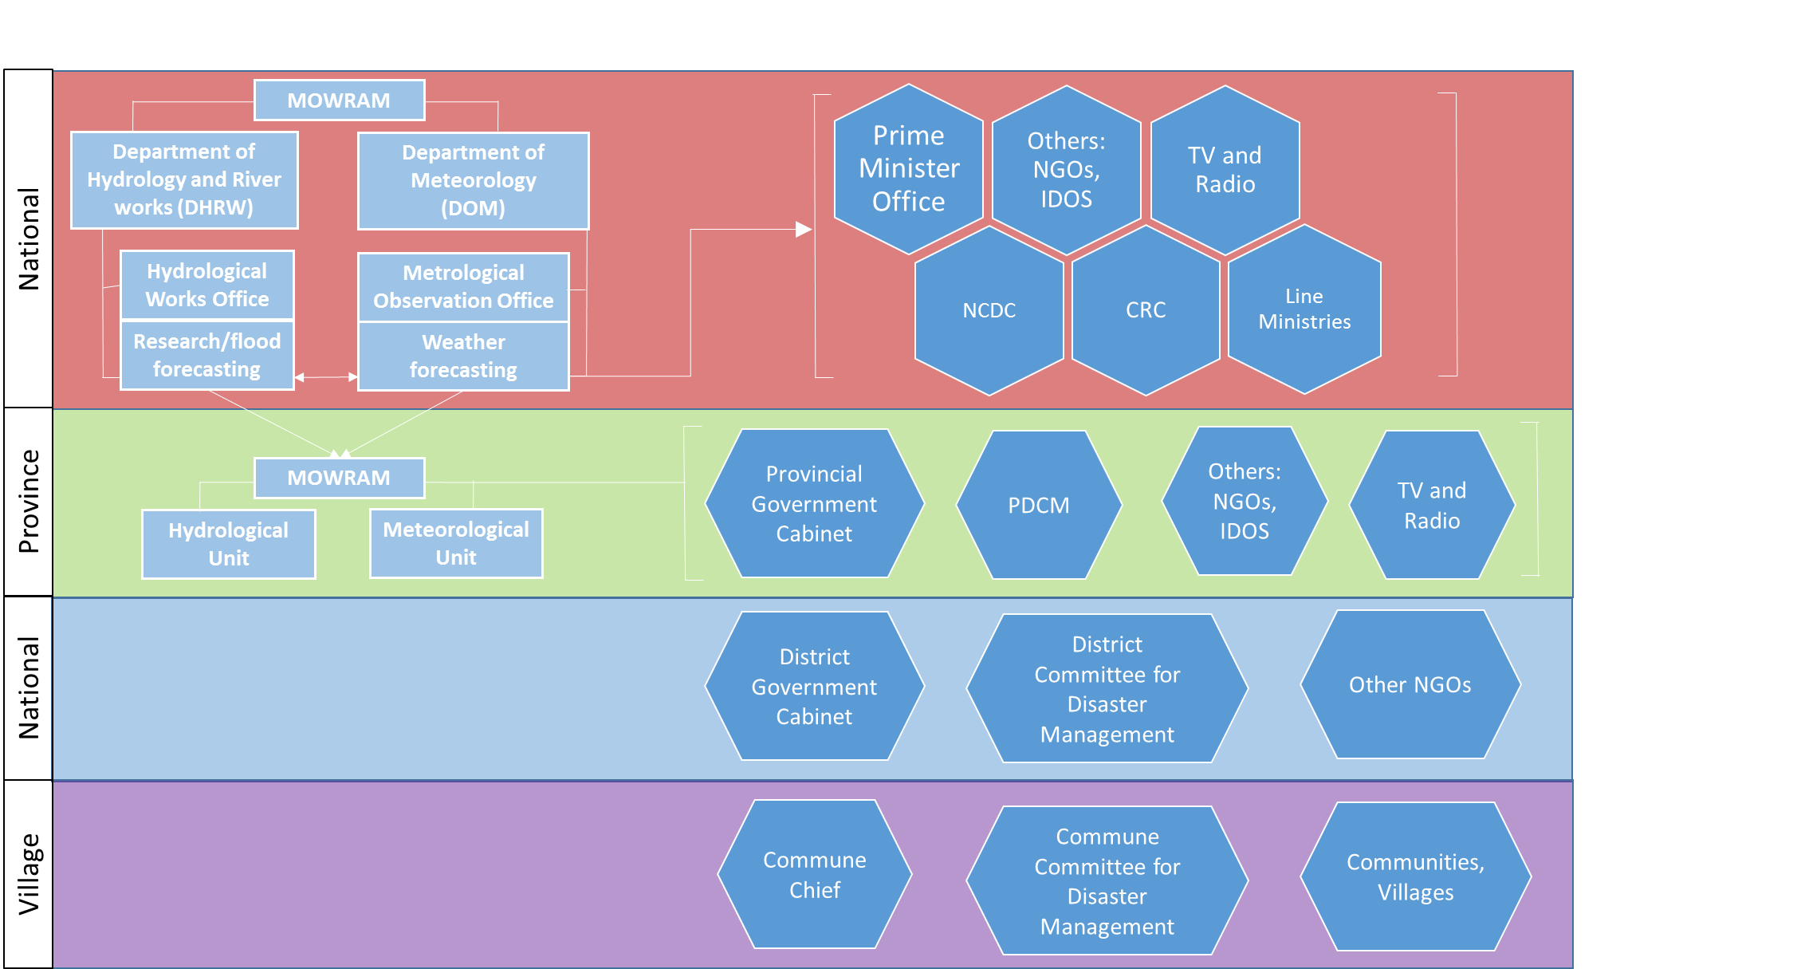

Figure Internal and External Communication of EWS in Cambodia. The boxes are internal. Hexagons are external.

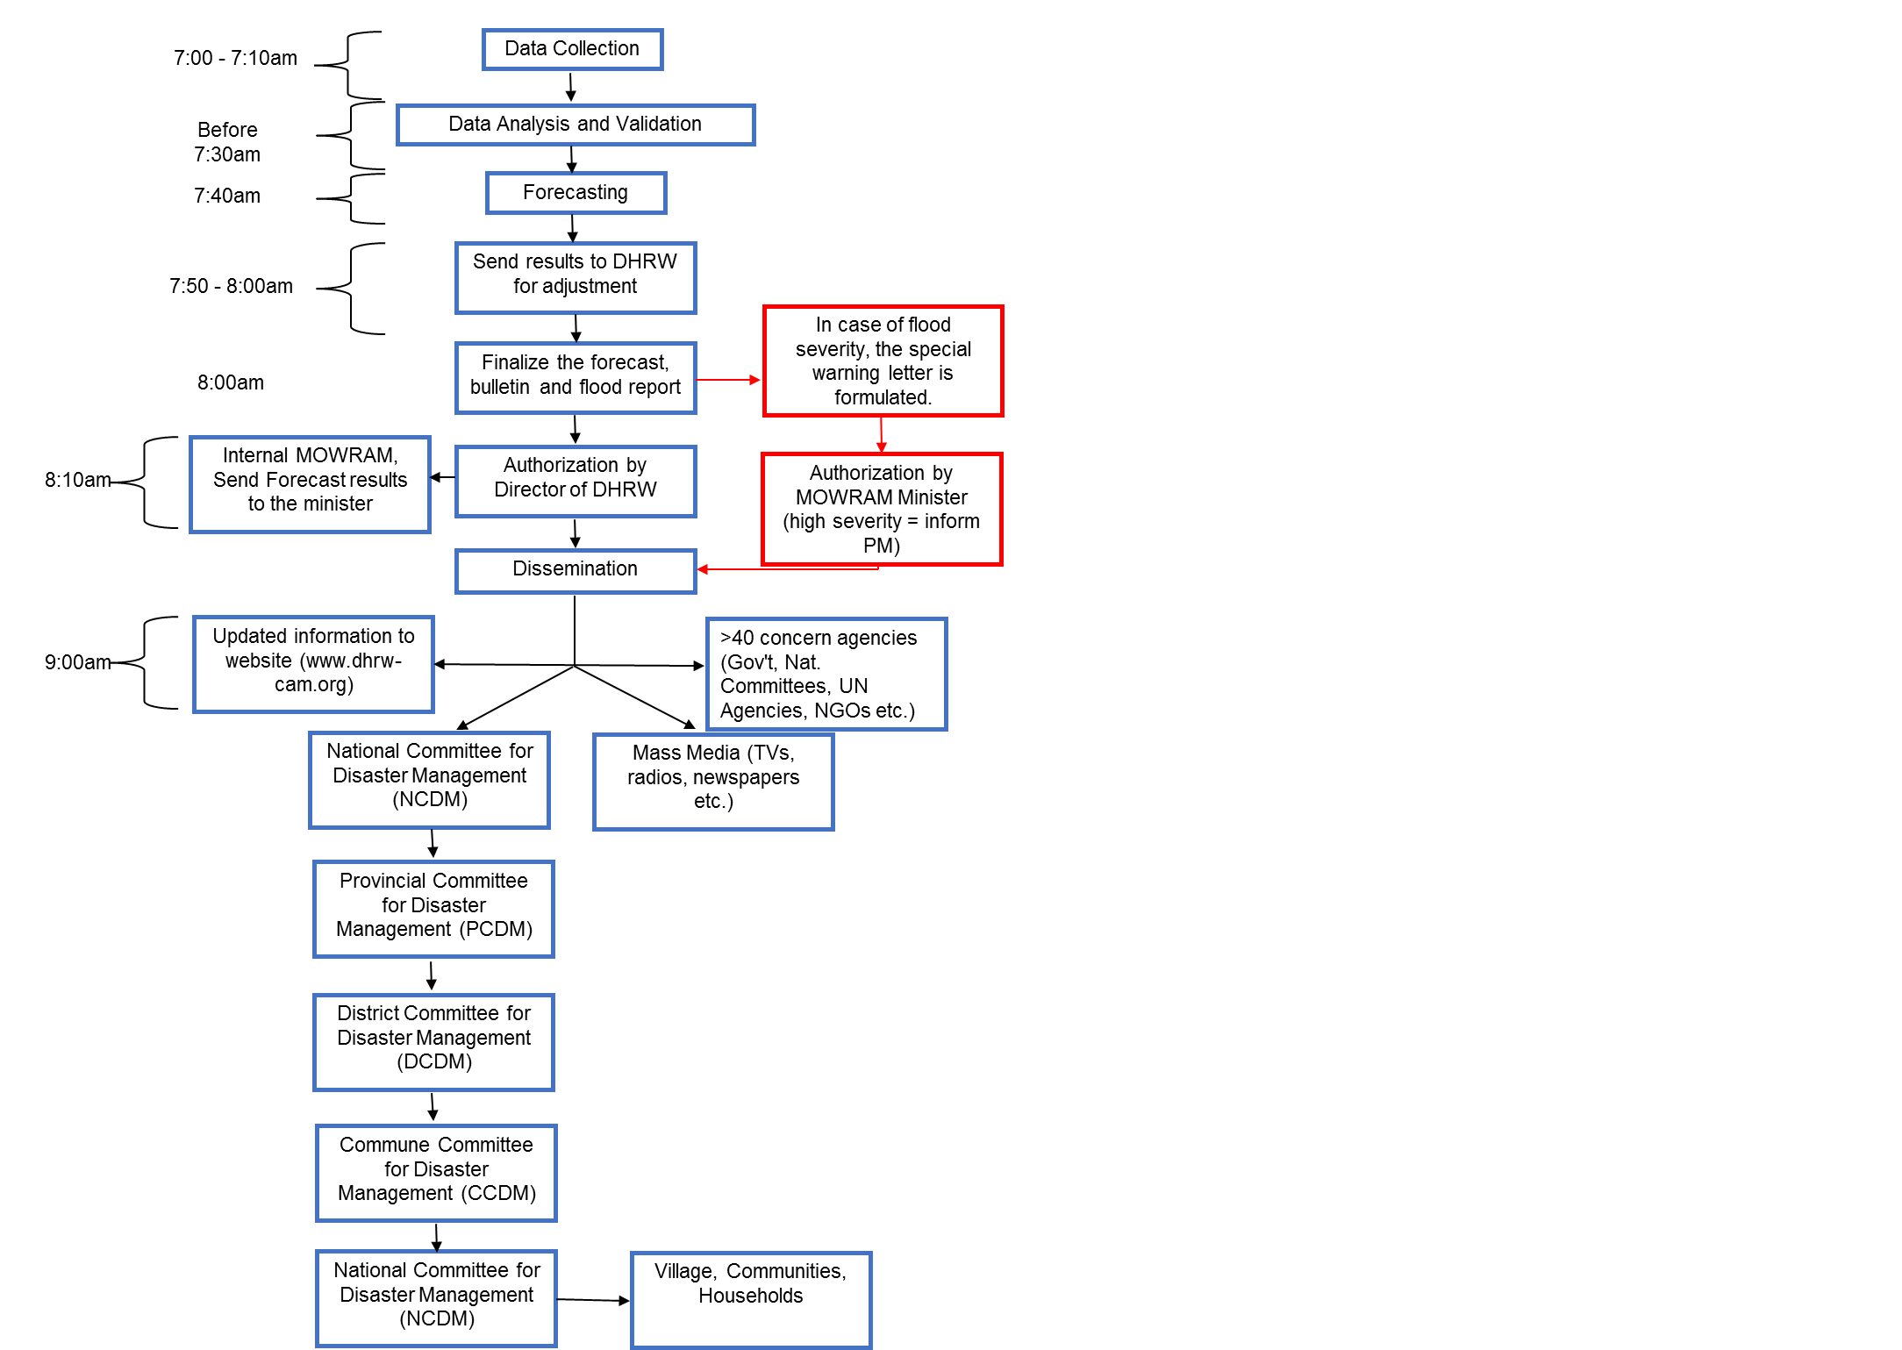

Figure Communication System for Dissemination of Floods

# Early Warning Communication and Dissemination System

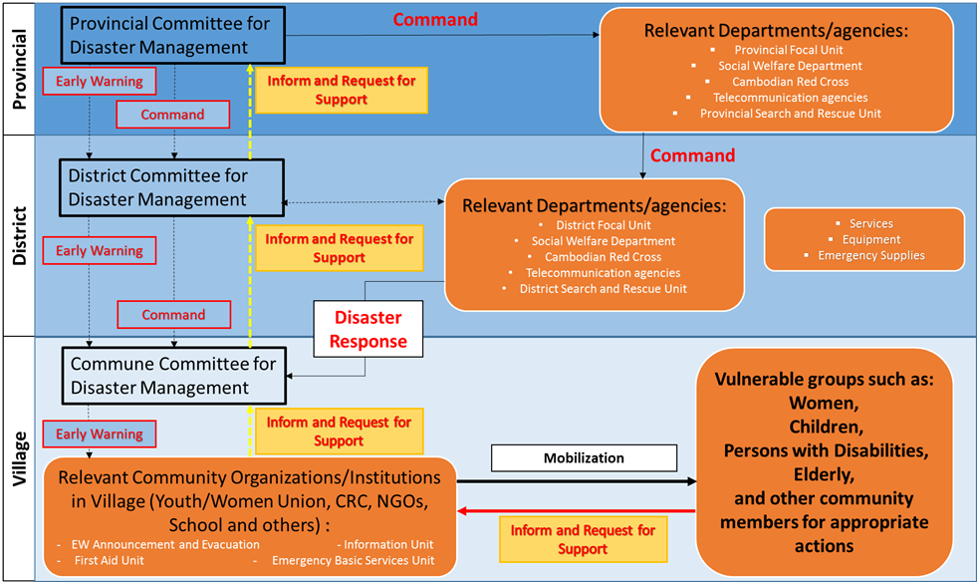Early warning communication and dissemination is all about operationalizing the SOP. Figure 3 indicates how SOP is integrated from a national level to a local level. It describes how MOWRAM would send an early warning to a number of ‘Institutional Interfaces’ through a variety of methods. This would allow quick and effective EWS, that can help the most at risk, the **community** of Cambodia.

Figure 4 Disaster Management System and Response

Figure 3 Concept of EWS Communication and Dissemination for Cambodia

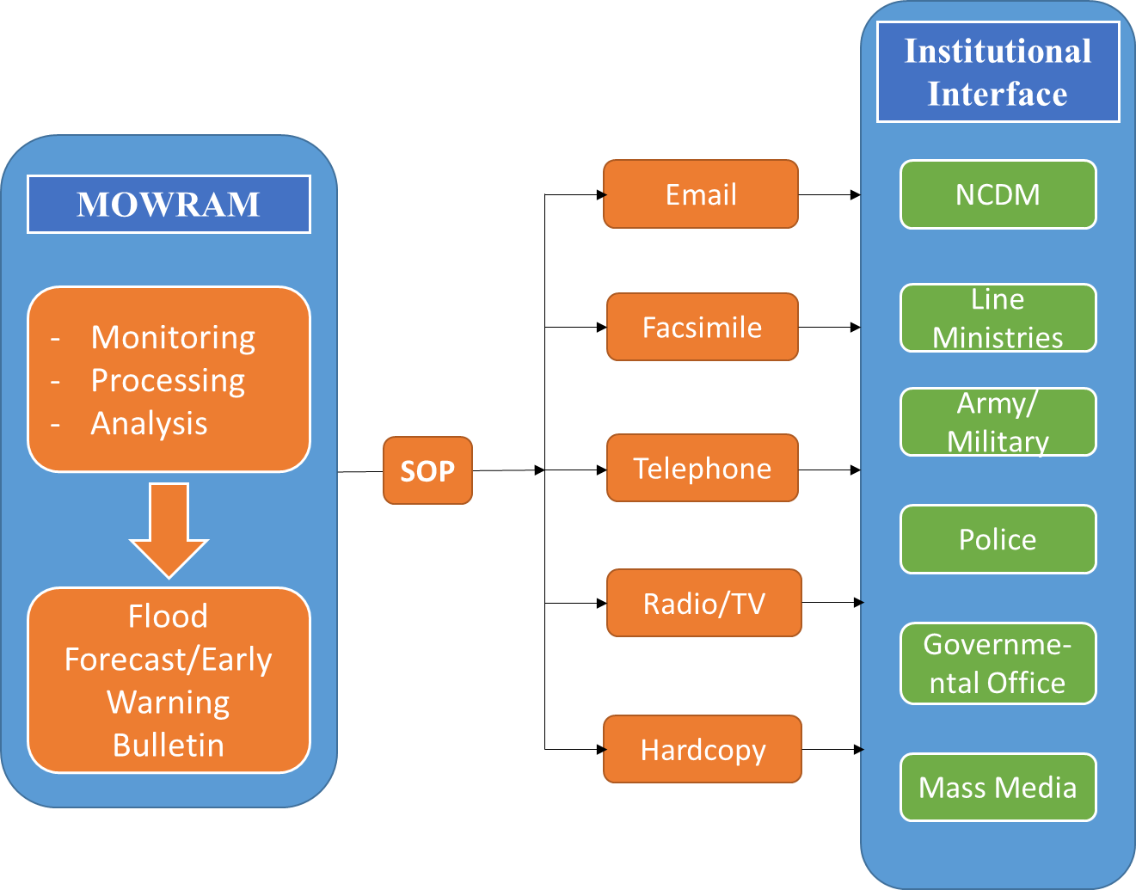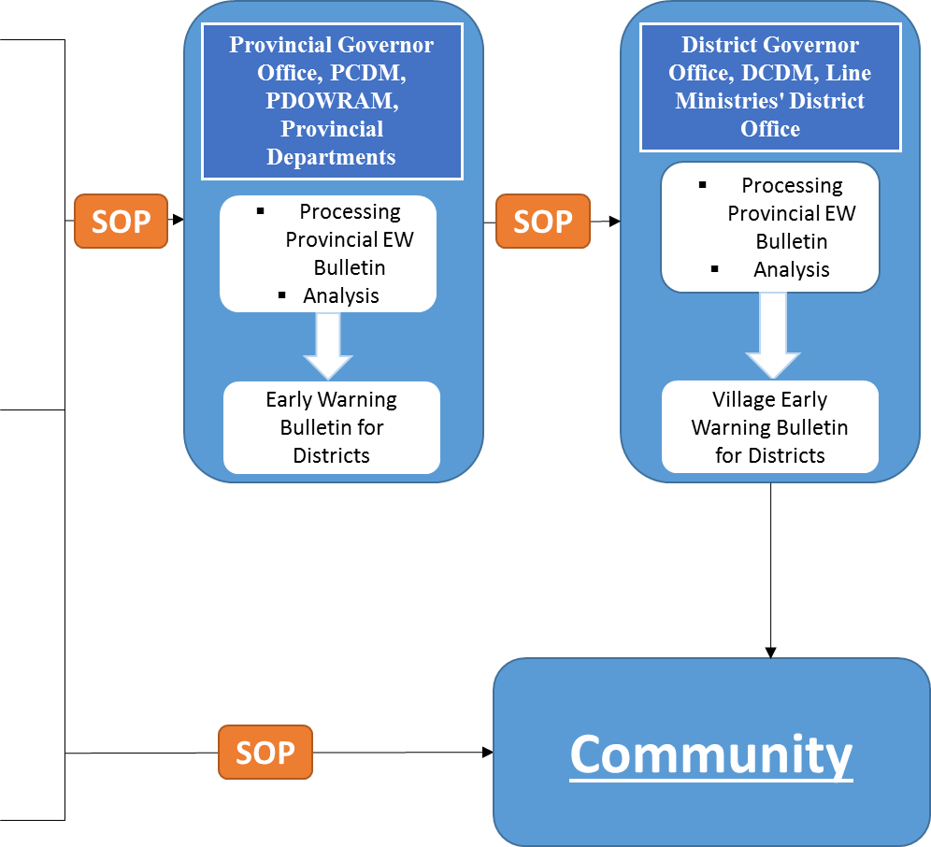

Figure 4 shows the detail process of Disaster Management System and Response from Province to Village levels. It is important to understand how the PCDM can communicate and provide information all the way to village levels. Specifically, how ‘*Vulnerable groups*’ can ask for support for natural disasters mitigation, and this request can be passed back up through to PCDM. This system allows fluidity of information from the provincial to the village level. This is **vital** for Disaster Risk and Reduction and EWS.

# Feedback Mechanism

Feedback mechanism should include self-assessment as well as responses from stakeholders and communities. Feedback helps to review EWS and assess its reliability, accuracy and usefulness.

Table 1 template may be used for self-assessment of predictions including the level of uncertainty.



Communities need to be asked about their impressions about the usefulness of EWS. Interaction programs may be used as platforms to ask participants to complete the survey in Table 2. Communication with communities should also be established via phone for obtaining field-level data and information useful for updating flood forecasts during a flood watch situation. Pre-rainy season meetings and post-rainy season meetings could be organized on a regular basis to obtain feedback from stakeholders.







1. MANUAL ON SYNERGIZED STANDARD OPERATING PROCEDURES (SSOP) FOR COASTAL MULTIHAZARDS EARLY WARNING SYSTEM
2. AHA CENTRE & Japan International Cooperation Agency, March 2015
3. International Strategy for Disaster Reduction Third International Conference on Early Warning (EWC-III) from Concept to Action, 27-29 March 2006, Bonn, Germany report