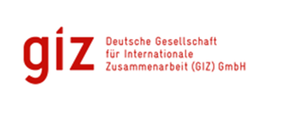

**THEMATIC REPORT: ICCAS PROJECT**

**AGRICULTURE:**

***Shifting the Focus to using Climate Smart Agricultural Techniques***

 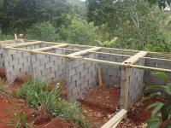

**Submitted**

By

**David A. Simmons**

92A Benjamin St., Diego Martin

Trinidad and Tobago

**Email:** [**davidAsimmons@outlook.com**](mailto:davidAsimmons@outlook.com)

|  |  |  |  |
| --- | --- | --- | --- |
| **Integrated Climate Change Adaptation Strategies (ICCAS): Thematic Report** | | | |
| **Thematic Area:** Agriculture: Shifting the Focus to Using Climate Smart Agriculture | | **Period:** January 2016 – August 2017 | |
| **IMPLEMENTING AGENCIES** | | | |
| United National Development Programme (UNDP) | The Environment Unit of the Ministry of Agriculture, Lands, Forestry, Fisheries and the Environment | | German Development Cooperation (GIZ), BMUB |

|  |  |
| --- | --- |
| **Context** | The objective of the ICCAS programme was to enhance the resilience of Grenada’s population and its ecosystems that are particularly vulnerable to the effects of climate change. Agriculture, including fisheries, currently accounts for 5% of Grenada’s gross domestic product (GDP) and employs 13% of the economically active population. The sector contributes 2.4% and 11.2% to the total value of the country’s total exports and imports, respectively (2007–2011). Despite its small size, the agricultural sector has experienced more growth over the past few years than other sectors. Known world-wide as the Spice Island, spices such as nutmeg and mace have been the country’s principal export. However, hurricanes Ivan and Emily in 2004 and 2005 destroyed 90% of the nutmeg plantations on the island, and production has still not recovered to pre-hurricane levels. Additionally, Grenada has very little surface water and due to climate change is experiencing a reduction in rainfall levels which of course has a direct impact on agricultural production. In fact, in 2010, the country suffered the first drought in its history, with serious effects on agricultural production. The climate change impacts and resulting challenges require that the country take cognizance of its vulnerabilities and adopt strategies which would build resilience in the agricultural sector. |
| **Agricultural Projects: Background** | Climate Smart Agriculture (CSA) is defined by the Food and Agricultural Organisation (FAO) as “Agriculture that sustainably increases productivity, resilience (climate change adaptation), reduces/removes greenhouse gases (climate change mitigation), and enhances achievement of national food security and development goals.” These practices present opportunities for addressing climate change challenges, as well as for economic growth and development of agriculture sectors. As such the program included several projects attacking the issue of sustainable and adaptive practices from several angles. A brief description of those projects follows:   1. **Climate Smart Agriculture Training**: This project focused on training the trainers (the Agricultural Extension Officers) so that they would be equipped to go into the field and change the practices of the local farmers 2. **Grenada Organic Agriculture Movement (GOAM)**: The GOAM project embarked on a process of changing the agricultural practices of its members as well as the members of three farming organization towards practices that are climate smart and friendly to the environment. It will provide farmers with the skills, knowledge and practices necessary to practice climate smart agriculture, such as the formulation and use of organic pesticides and use of cultural practices in pest and disease control and soil and water management. 3. **Maricullture**: The Seamoss Farmers of Grenville earned a living through cultivation of wild edible sea moss for several years. However, one of the most detrimental impacts of climate change is the increase frequency and severity of storm systems and hurricanes which destroyed the substrate which nurtured sea moss. This loss significantly affected the villagers’ source of income. The project introduced sea moss mariculture as an adaptation strategy to climate change. The project included training in the operation and construction of drying tables and solar dryers and provides a more reliable supply and improved quality of sea moss. |

**Overall Success**

The projects undertaken in the agricultural sector have all been successful in awakening many of those involved in agriculture to the impacts of climate change and the need to adapt by changing the way they earn their livelihood to be more resilient to that impact. In fact, the addition of agriculture to the project has addressed component 3., namely the increased adaptive capacity of the communities particularly those involved in agriculture since approximately 40% of Grenada is under agriculture. Additionally, the initial projects have focused on training and capacity development with the intention of raising awareness, improving technical capacity and thereby changing behaviour which will in the longer term increase the likely use of CSA practices.

Some of the achievements in the shift in approach to agriculture are as follows:

* The training of 45 agricultural extension officers who have trained their counterparts and have gone into the field and begun training farmers in CSA techniques. Some of those techniques adopted include the following:
  + Construction of contour drains
  + Rainwater harvesting for irrigation
  + Mulching and composting
  + Biological pest control
  + Shade houses
  + Production and use of biogas (using pig manure)
  + Use of drought resistant crops
* Successful establishment of a model farm using the CSA techniques outlined previously.
* The Grenada Organic Agriculture Movement (GOAM) group has also established similar systems on some of their members’ farms and have begun to teach others who are interested in the approach to farm in this way.
* The successful development of farmed sea moss mariculture system to protect wild stock and to continue to provide a sustainable livelihood to coastal villages.
* Several of the ICCAS projects in rainwater harvesting were using harvested rainwater for drip irrigation for the farming communities.

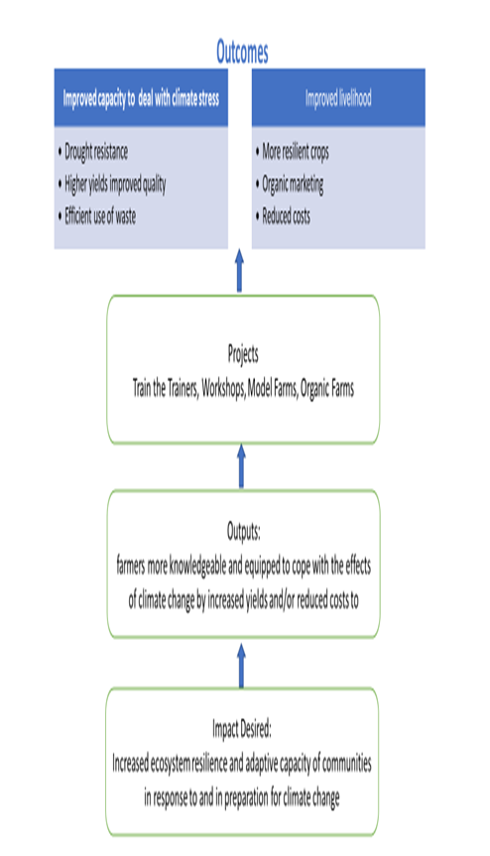

The major impact of the CLA projects in the short term has been to demonstrate that this approach to farming can provide a sustainable livelihood. It can also provide a competitive advantage for consumers who are interested in organically grown produce. Moreover, the training and modelling has focused on showing farmers the long-term benefits to their farming environment of using this approach, in terms of resilience against climate change by effective use of water, maintenance of top soil, and reduction of waste (through mulching etc). the approach also has a direct long-term cost impact by reduced fertilizer and pesticide purchase.

Moreover, the longer-term impact of the CSA pilots is clearly seen in that the approach has been integrated into the policy and planning activities of the Government of Grenada and the Ministry of Agriculture as follows:

1. GIZ-ICCAS project took advantage of a mainstreaming opportunity to integrate CSA into the National Agriculture Plan 2015 which in turn has been integrated into the National Adaptation Plan.
2. Climate change issues were also integrated into other sections of the National Agriculture Plan 2015.
3. CSA actions were integrated into the 3 year (2016-2018) Corporate plan of Ministry of Agriculture, Lands, Forestry, Fisheries and the Environment which then further informed mainstreaming interventions into the Action plan and Work Plan 2016.
4. A CSA agriculture project is one of four projects submitted for funding to the GCF. The primary objective of that project is to upscale and widen the application of the model farm techniques used under the ICCAS project.
5. In 2017, IFAD provided loan funding for an agriculture project called Climate Smart Agriculture and Rural Enterprise Programme (SAEP), that includes demonstration plots using CSA techniques. as a first phase and is focusing on marketing agricultural products.

**Lessons Learnt**

1. These projects suffered delays in the initial phases and had issues of stakeholder buy in as well as legal issues (in terms of land rights etc.). However, it was demonstrated that stakeholder commitment at all levels is necessary for the sectoral transformation required to make CSA the preferred choice among farmers.
2. Integration of CSA at all levels of the agricultural planning process from policy to annual work plan is the approach being used to ensure the techniques filter down to the farmer and he is encouraged to use them.
3. The training the trainers approach has helped to promote buy in among those guiding the farmers in the sector. However, the issue of scarce human resources has resulted in more experienced technical staff leaving as their retirement become due. The solution which is being implemented is more training of younger and recently acquired staff as quickly as possible.
4. The barrier to farmer commitment is the perception that CSA agriculture is more expensive, and that commercial fertilizer and pesticide are required to obtain better yields and hence profits. The model farm and the GOAM farms utilising the CSA techniques have demonstrated the financial viability of CSA. This demonstration is the route to convincing the larger farming community.

**Best Practice(s) Identified**

The use of pilot projects in a controlled environment to identify lessons learnt and demonstrate success before upscaling is a significant best practice that has resulted from the pilot projects identified.

The provision of an alternative but familiar climate adaptive livelihood based strategy (like sea moss farming) allows quick adoption by the community.

**Recommendations based on the Lessons Learnt and Best Practices Analysis**

The government can consider linking the receipt of financial incentives/subsidies to the use of CSA techniques. This would significantly improve the likelihood of uptake among the larger farming population.

Author: David Simmons & Christina Barradas-Brewster/ Consultants/Caribbean/ [davidasimmons@outlook.com](mailto:davidasimmons@outlook.com)

Location of Project: Caribbean/OU/Grenada

MHT: What is the Major Habitat Type for this partnership? Farmland

Types of Partners: Government, Place-based NGO, International NGO, Community Based Organization.

Priority: National

Date: June 2018

Links: <https://youtu.be/i7s_hX7Y6kQ>

<http://www.iccas.gd/?q=community-projects/120/GOAM>

<http://www.iccas.gd/?q=community-projects/72/Climate%20Smart%20Agriculture%20%28CSA%29>

<http://adaptation-undp.org/projects/bf-grenada>

<http://www.napglobalnetwork.org/wp-content/uploads/2016/06/sNAPshot-Grenada-June2016-Letter-1.pdf>

<https://www.ifad.org/web/operations/project/id/2000001475/country/grenada>