
Community Based-Adaptation
FAST FACTS

KAZAKHSTAN
Grantee: PA Taldykorgan Oblast Germans Society Widergeburt
Type of organization: NGO
Number of participants: about 1,300 (20 households directly benefit)
Location: Almaty Oblast, Kazakhstan
CBA Contribution: 50,000 USD
Project Partners: GTZ (German Technical Cooperation), Burlutobinsk State Forestry Management Office
Co-financing: 158,601 USD
Project Dates: March 2009-April 2011
Climate resistant reforestation to adapt to increased aridity and protect pastureland

BACKGROUND
The Community-Based Adaptation Programme (CBA) is a five-year United Nations Development Programme (UNDP) global initiative funded by the Global Environmental Facility (GEF). Partners include the GEF Small Grants Programme (SGP), the Government of Japan, AusAID, UN Volunteers, and local NGOs. The CBA’s goal is to strengthen the resiliency of communities to adverse climate change impacts.

This CBA project focuses on three villages in the Sarkand District of southeastern Kazakhstan, near the border with China. Livestock-raising is the primary livelihood in the area. The region’s climate is extremely dry, with long, cold winters and hot summers. The only agriculturally useful precipitation is winter snow that contributes to soil moisture and groundwater as it melts. Summer precipitation generally evaporates before it can be absorbed by plants. Like much of Kazakhstan, the area faces increasing aridity in addition to man-made environmental pressures. The clearing of the hardy sauxal tree has disturbed soil cover, expanded sandy areas, and reduced the diversity of native plants and animals. Disruption of traditional pasture management practices, in addition to a growth in private livestock herds, has led to overgrazing. Mismanagement of grazing land and the deterioration of a Soviet-built irrigation dyke has contributed to the degradation of pastoral ecosystems. Declining productivity from livestock-raising has decreased incomes, and the lack of alternative income sources in this poor region has forced many villagers to poach and fish illegally.
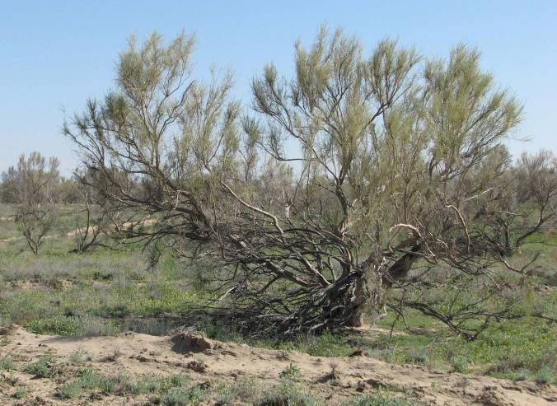
Sauxal (Haloxylon ammodendron) trees.
CLIMATE CHANGE RISKS
Long-term climate change projections for Kazakhstan and Central Asia include temperature increases, especially in winter, and more evaporation in summer. In the project area, these trends are already being observed. The local meteorological station indicates that average temperatures and aridity have increased since the 1960s and 1970s. As winter temperatures increase, snow decreases and there is less soil moisture is available for fodder growth during the spring. Less fodder translates into less food for livestock and contributes to pasture degradation. In recent years, low levels of precipitation and increasing aridity have negatively affected pastoral productivity in the area. Natural pastures have degraded and water levels in the nearby Lepsy River have fallen. The deficit of winter forage has increased vulnerability to climate change. Increased aridity will further deteriorate the pastoral plant composition, making the land unusable for grazing. Unable to sustain livestock off the land, climate change will make it increasingly difficult for residents of this economically depressed area to make a living.
Contact information: CBA Project Management Unit at cba@undp.org
304 East 45th St., 9th Floor New York, NY 10019 Tel: (212) 906-5006

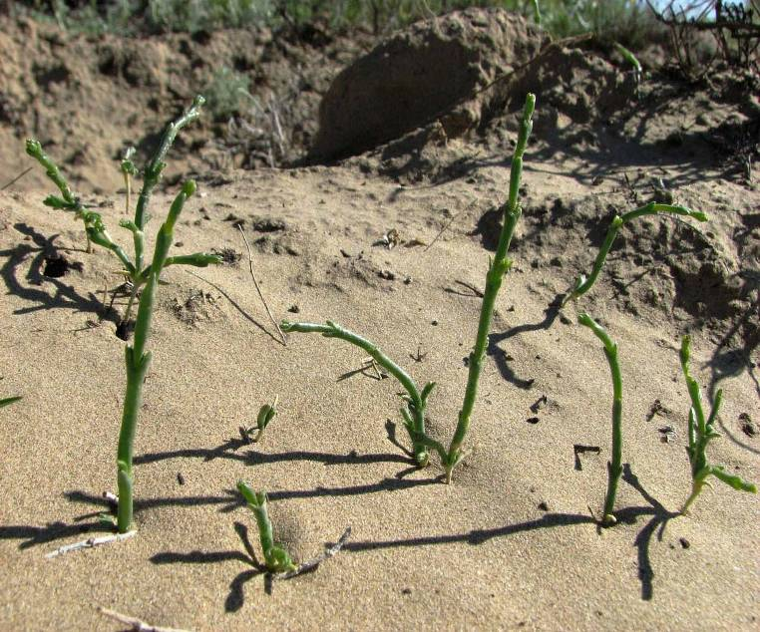
PROJECT DESCRIPTION
Sauxal seedlings planted as part of project activities.
The project focuses on reforestation with sauxal – a local drought-resistant shrub. Sauxal serves to aggregate wind-blown snow during the winter, preserving it for the spring melt and thereby improving summer fodder. The project builds upon ongoing efforts to irrigate local haymaking lands and rehabilitate the agricultural dam on the nearby Lepsy River. The project will also help introduce new pasture management systems and disseminate good practices. The project’s objective is to reduce the impact of increasing aridity as a result of climate change through planting of sauxal and the enhancement of local pastoral resources. Activities for achieving this objective include:

- Piloting new technologies for hayfield management to accumulate moisture, increase productivity, and store fodder to support cattle during winter, thereby reducing unsustainable grazing practices
- Improving the sustainability of local pastures by establishing a nursery and planting 80 hectares of sauxal trees that will conserve soil moisture and combat erosion
- Disseminating information about project, so it can be replicated by the other local communities through field visits, demonstration workshops, and the publication of a booklet detailing techniques that improve pasture fertility

FOCUS ON…
Livelihood benefits
Because the area is too arid to grow cereal crops, residents depend primarily on livestock. The productivity of local pastures has declined in recent years due to a combination of both human pressures, such as the disappearance of traditional pasture management systems and deforestation, and climate change pressures, such as increased aridity. By introducing techniques for maintaining and improving the productivity of pastures, the project will help the community secure their livelihoods despite the threat posed by climate change.

New management techniques
In this region of Kazakhstan, the viability of pasturelands depends on trees. As native trees disappear, desertification intensifies, thereby reducing the pastureland available for grazing. Planting trees will help preserve the humid microclimate, reduce the loss of soil moisture, mitigate the risk of erosion, and protect against fires. Reforestation efforts will be complimented with new techniques for capturing snow during the winter while encouraging water retention to take full advantage of the area’s limited precipitation.






For more information about CBA or CBA projects visit: www.undp-adaptation.org/project/cba
Further information, lessons learned, and experiences gathered from climate change adaptation activities globally can be found at the Adaptation Learning Mechanism: www.adaptationlearning.net

