UNDP GEF Community-Based Adaptation Project
Country Programme Strategy
SAMOA
2008-2011

This document will guide the Samoan National Coordinating Committee to implement the Community-Based Adaptation Programme. It determines action guidelines and criteria to support eligible projects.
The strategy also helps various stakeholders understand the CBA rationale and complementarities with existing programmes.

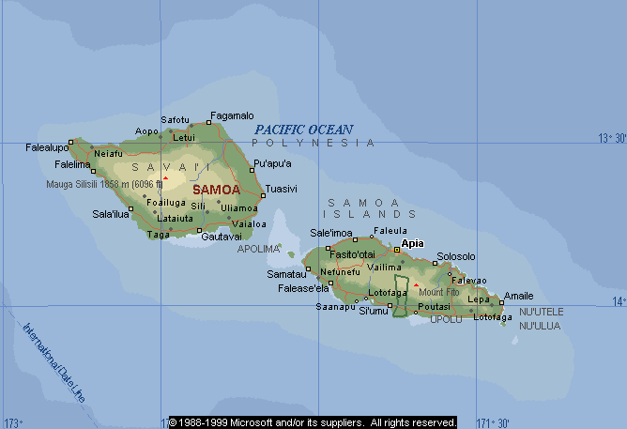

1. Introduction: Country Situation Analysis

Samoa, a small island developing state in the South West Pacific, faces significant climate change risks. These include sea level rise, increasingly intense storms, changing rainfall patterns, and impacts to ecosystems. As a semi-subsistence nation with approximately 70% of the population and infrastructure located in low-lying coastal areas, these impacts will pose significant risks to community livelihoods and to Samoa’s sustainable development. Awareness of climate change impacts has been particularly increased since the impact of tropical cyclones Ofa (1990) and Val (1991), which caused damage costing approximately four times Samoa’s gross domestic product.

Samoa’s climate is tropical and marked by distinct wet and warm (November-April) and dry and cool (May-October) seasons. Temperatures are typically tropical (ranging from 24-32° C daily) and generally uniform throughout the year with little seasonal variation. The rainfall and humidity are usually high, with the average annual rainfall about 3,000mm. Approximately 66% of precipitation occurs during the wet season.

Samoa and other Pacific Island Countries have observed increasing average temperatures (0.3-0.8°C) during the 20th century, with a mean increase in Samoa of 0.59°C. The maximum and minimum temperature has also increased by 0.67°C and 0.18°C respectively, while precipitation has decreased by 49.28mm over the same period. Climate change projections suggest that this pattern will continue and accelerate, with increasingly frequent drought events, and increasingly intense rainfall events. Recent studies of cyclones in and around Samoa’s region have found that there has been an increase in the frequency of tropical depressions, gale wind forces, and tropical cyclones during the cyclone season (December to February).

In addition to these observed changes, climate change scenarios for Samoa – prepared for the NAPA, the National Communications to the UNFCCC, and from the IPCC fourth assessment report – project the following:
- Reduced overall annual rainfall
- Higher occurrences of high-intensity rainfall events
- Increased average temperature
- Rising sea-levels, and
- Increased tropical cyclone frequency and intensity.

These projected climate changes are expected to pose significant and interlinked risks to communities and ecosystems across Samoa. For example, droughts will increase forest fire risks, and in turn increase erosion risks. Erosion from increasingly erratic rainfall poses significant risks to mangrove ecosystems and to near-shore corals. Damage to coastal ecosystems, from sedimentation as well as coral bleaching, increases vulnerability to cyclones, large waves, and storm surges. Cyclones, large waves and storm surges have the potential to damage and salinize community water resources and agricultural land. CBA projects will address these climate change risks though improved natural resource management, with the aim of increasing the resilience of ecosystems and ecosystem services in the face of climate change.

2. Goal, Objective(s), Outcomes and Impact indicators

In line with the thematic areas (TA) of the UNDP-GEF Portfolio on Adaptation, the CBA Program for Samoa will adopt the goal in TA (6) on, “Loss of natural resources and associated damage to livelihoods, ecosystems and economy reduced”, by addressing the following two objectives;

- Enhance resilience of natural resources and livelihoods sensitive to climate change impacts through improving community adaptive capacities to sustainably manage natural resources;
- Through lessons learned from community projects, provide support to national adaptation policies and strategies, to reduce community vulnerabilities to the long-term effects of climate change and variability.

The following impact indicators will support these objectives, and will be assessed at the portfolio level, for the CBA program in Samoa:
- Percentage change in natural resource-dependant population with access to alternative or supplementary livelihood options (UNDP TA6 Adaptation indicator 2.4) ,
- Number of measures deployed as part of sustainable resource management activities (UNDP TA6 Adaptation indicator 4.2).

The indicators will be measured through CBA community projects, and aggregate to serve as a measure of the success of the overall CBA program in Samoa.

3. Sectoral Focus

Several reports have documented the detailed the sectoral climate change vulnerabilities and adaptive capacity gaps in Samoa, including; The Samoa First National Communication (FNC) to the UNFCCC (1999); The Coastal Infrastructure Management Plans and Strategy (CIM, 2001); and the National Adaptation Programme of Action (NAPA, 2005). The FNC for Samoa shows that 70% of the population and infrastructure is situated in the coastal zone, thus establishing the need for adaptation measures to be focused in these areas. The CIM plans focused on resilience of coastal infrastructure and communities to natural hazards. The NAPA document had identified 9 priority sectors for adaptation including; agriculture and food security, water, biological diversity, health, forestry, coastal infrastructure and environment, tourism, urban settlement, and village communities.

From these nine sectors identified in the NAPA, the focus of the CBA project will target “village communities,” whose climate change risks include damage to homes and properties; threatened water supply and quality; damage to subsistence and commercial; coastal erosion; flooding and degradation of ecosystems, and damage to cultural and heritage assets (NAPA, 2005). This crosscutting approach will also address components of the other NAPA priority sectors, such as coastal infrastructure and environment, agriculture and food security, water and biodiversity.

4. Vulnerability Assessment

Studies assessing vulnerability and adaptation options for Samoa include the NAPA (2005), and the national communication to the UNFCCC (1999). Information concerning climate change projections for the Pacific region is available in the IPCC Fourth Assessment Report.

Coastal communities in Samoa are dependent on climate-sensitive natural resources for their survival and livelihood. Agriculture and livestock form cornerstones of community subsistence and income, and coastal springs and rivers are essential for water supply and sanitation. Ecosystems provide interlinking services to each of these sectors, regulating runoff and stabilizing streamflow, providing protection against storms, as well as several other key services.

Climate change will increase pressures on these sectors. Agriculture faces increasing drought risks, as well as erosion risks associated with increasingly intense rainfall. Water resources are threatened by changing rainfall patterns, as well as storms and sea-level rise, which have the potential to salinize coastal springs. Homes and other community assets (schools, churches, malae, bridges etc) are also at risk of increasing extreme climate events (tropical cyclones, flooding, landslides, and intense coastal erosion). Coastal ecosystems such as coral reefs and mangrove forests provide a key defense for communities, their assets and infrastructure from increasing climate change impacts. Increased erosion pressures can cause coastal sedimentation of these ecosystems, while coral reefs are increasingly at risk of bleaching – a phenomenon caused by stresses including sedimentation and increased water temperature. Both of these ecosystems are key ecological pillars of local fisheries, while also protecting beaches from erosion and coastal infrastructure from storms. Their deterioration will lead to increased community vulnerability and reduced potential from tourism-related livelihood activities.

Sea level rise is another key climate change vulnerability. Data indicate that the local change in sea level is, and will be, higher than the global projections of 0.9 and 0.88m between the years 1990 and 2100 (IPCC, 2001). The South Pacific Sea Level and Climate Change Monitoring project shows a projected rise of 3.8mm per year for Samoa (Meteorological Division – MNREM 2004). These figures have the potential be substantially higher, as they do not include several important processes, including potentials for rapid melting of land-based glaciers.

Climate change will also alter patterns of shorter-term climate variability. Samoa suffers from long dry spells that coincide with the El Nino Southern Oscillation (ENSO) phenomenon. Major droughts and forest fires occurred in 1982-83, 1998, 2002 and 2003. Globally, interannual climate variability linked to ENSO is projected to increase in intensity as climate change progresses. In addition, climate change projections for Samoa predict both increased intensity of individual rainfall events, but less annual rainfall overall, particularly in the dry season. Increased risk of drought, combined with increased interannual and intra-annual variability will likely lead to increased risks of forest fires, which will contribute to climate change-related intensifications of erosion pressures.

Table 1. Vulnerabilities of Communities
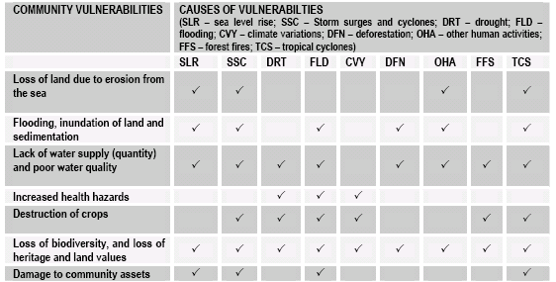
Table 1 summarizes community vulnerability in Samoa and associated causes (NAPA 2005). As shown in Table-1, community vulnerability is strongly tied to ecosystem vulnerability within coastal communities.

5. Baseline-Additionality Reasoning

The concentrated population and infrastructure along Samoa’s coastal areas has impacted many natural ecosystems, due to conversion of coastal and mangrove areas for expansion of community settlement areas, and other development. These have consequently contributed to community exposure to climate impacts, due to reduced natural barriers between the ocean and properties, plantations, and public assets. This vulnerability will increase with climate change and potentially exacerbate these pressures to include coastal erosion reaching residential areas, and significant drought damage to crops. As such, the impacts of climate change will build upon many existing baseline pressures.

Many climate change impacts in Samoa represent an intensification of baseline pressures, while others represent novel threats. CBA projects in Samoa will address ecosystem and development baseline pressures with co-financing, using CBA resources to proactively address climate change vulnerabilities. The following table summarizes key baseline and additional drivers of ecosystem damage in Samoa.

Baseline Pressure | Additional Pressure
Coastal Erosion  Baseline Drivers:  - Coastal deforestation  - Cyclones | Coastal Erosion  Additional Drivers  - Sea-level rise  - Decreasing mangrove resilience  - Decreasing protection from large waves cause by coral reef damage
Mangrove Ecosystem Depletion  Baseline Drivers  - Mangrove deforestation  - Pollution from dumping/mismanagement etc  - Coastal infrastructure which restricts tidal flushing of lagoon ecosystems | Mangrove Ecosystem Depletion  Additional Drivers  - Sedimentation caused by climate change-driven erosion  - Sea-level rise
Coral Reef Ecosystem Degradation  Baseline Drivers  - Baseline sedimentation (from dumping, etc)  - Baseline cyclone damage  - Human-caused damage to reefs | Coral Reef Ecosystem Degradation  Additional Drivers  - Coral bleaching  - Sedimentation from increased, climate-related erosion  - Increased wave damage from increasingly intense cyclones
Agricultural Erosion (leading to coastal Sedimentation  Baseline Drivers  - Intense rainfall (baseline)  - Agricultural practices  - Forest fires (baseline) | Agricultural Erosion (leading to coastal Sedimentation  Additional Drivers  - Increasingly intense rainfall  - Increasingly severe and common forest fires  - Increasingly erosion-prone soils (due to increasing drought risk)

6. Focal areas

Biodiversity

Samoa is rich in biodiversity and endemic species. The island’s natural ecosystems include coastal forest, lowland and upland forest ecosystems, wetland areas, mangroves and swamps. The island holds 500 species of native flowering plants, with about 25% of them endemic to Samoa. The International Council for Bird Conservation List categorizes Samoa to be one of the world’s “Endemic Bird Areas” in need of urgent conservation attention.

Samoa’s biodiversity is facing a crisis of species loss and ecosystem clearance. Approximately one third of the country’s forest was cleared between 1977 and 1990. The rate of clearance is about 3% per annum, making it one of the highest in the world. These figures were recorded about nine years ago, and since then no updated data on how much forest remains have been prepared. A growing population has added pressure to the islands ecological resources. Land clearance and coastal pollution are also significant drivers of biodiversity loss. In addition, introduced species have contributed to the decline in native fauna, either as predators or competitors.

Climate change impacts will also have a significant impact on Samoa’s biodiversity. Reefs, providing habitat for numerous fish species, serve as a keystone ecosystem. However, as water temperatures increase with climate change, coral bleaching events are likely to grow more common, while increasingly intense tropical cyclones pose significant wave-related risks to reefs. In addition to ecological value, degradation of coral reefs poses increased risks to coastal infrastructure and increases beach erosion, as the reefs serve as wave breaks and beach nourishers.

In addition, climate change impacts will have several indirect impacts on coastal biodiversity in Samoa. Increasing risk of drought stemming from declining annual rainfall and increasingly intense dry seasons, in combination with natural inter-annual climate variability related to ENSO, will all contribute to increased forest fire risk. These same factors, together with projected increases in the intensity of rainfall, have the potential to increase erosion from farms, and contribute to the sedimentation of coral reefs and mangrove ecosystems – both of which serve as important protections from cyclones and strong waves, which are expected to increase in intensity in the face of climate change. Sedimentation can smother corals, mangrove seedlings, and habitat for several species of marine animals.

Sustainable Land Management

Land degradation in Samoa is associated both with unsustainable agricultural practices and climate impacts (in the form of droughts and heavy rainfall). The most serious types of land degradation include deforestation, nutrient depletion, as well as soil erosion by rainwater. Approximately of Samoa’s land resources 14 % have few limitations to agricultural use, 42 % moderate limitations to agricultural use and few limitations to forestry, 21 % has severe limitations to agricultural use and moderate to severe limitations to forestry and lastly about 22 % is unsuitable for agriculture and forestry. Much of these areas are fallow land left unused because of poor soil fertility as a result of previous cultivation. Prolonged droughts and heavy rains also exacerbate the stress on land resources.

Climate change scenarios suggest that land degradation in Samoa will be adversely affected through intensifications of drought and increasingly intense rainfall events, which also will have downstream effects on biodiversity as described above. The CBA programme will mainly focus on integrating climate change risk considerations into sustainable land management. This will include development sustainable natural resources management practices that incorporate additional climate change impacts. This includes improving crop resilience, limiting land and coastal erosion, as well as protecting the shoreline by replanting coastal forests and other vegetation.

7. Local priorities

Maintaining the balance in control over land use between traditional village councils and the government in the context of CBA will be a key consideration over the course of project implementation. In Samoa, 80% of all land is under customary ownership. Villagers retain a high degree of autonomy over coastal lands, and almost all activities on these lands take place with the explicit approval of the village councils, composed of the traditional leaders (Matai). The inter-tidal zone and adjacent marine areas are in principle public lands; however, most villages retain the right to use marine areas bordering the village land regardless of official policy. A common land use pattern in the villages consists of a residential area with a village common ground or malae on a kilometer wide strip of land along the coastline. Next inland is a mixed cropping zone of fruit trees, bananas and coconuts, and further inland is a zone of primary food crops of taro, taamu and yams.

It is widely understood that the tenure system in Samoa complicates any commitment from financial agencies to use these as collateral for lending. Some of the customary land is being left unattended to, because owners live in town or overseas. Disputes over ownership of some lands result in these land being overgrown with weeds and scrub. Fortunately though, when the village council conducts its clean up for beautification of the village these overgrown lands are also maintained. There are also village-based reserves particularly in forestry where the villages are charged with maintenance of the forests. Since the Samoan economy is growing at a very fast rate, there is considerable pressure to open up coastal areas to tourism, industry and resource extraction. In view of the high degree of autonomy held by the villages, there is a need to ensure that these communities are able to make informed choices on sustainable development in their areas. There is a delicate understanding between government and traditional village authority. Village authority must recognize the government and its legislative powers; governments must reciprocate by recognizing it as the traditional power base of the communities. Therefore there must be a solid foundation on which to build interaction between village councils and government agencies to ensure culture and traditions are not compromised, and that legislation and policies are adhered to.

A gender focus will also be an important consideration for CBA activities in Samoa. While there is no gender-disaggregated data about climate change vulnerability in Samoa, women experience a specific vulnerability to climate change, as many women (particularly in rural areas) play a key role in natural resources management, Therefore, it will be critical to ensure that women are involved in all stages of CBA projects. This will be done by advocating the presence of women in the projects’ committees, by doing group focused VRAs including women, and by promoting the presence and decisional role of women during the training and awareness activities.

8. Geographic focus

As Samoa is a relatively small country, the geographic focus of the CBA project will cover the coastal areas of both Savai’i and Upolu islands. The geographic focus will target the coastal lowland areas with sites ranked highly vulnerable to extreme events and to the adverse impact of climate change including variability.

9. Community project typologies

A core value of the CBA is that projects will emphasize community ownership, in partnership with relevant government ministries, NGOs, academic institutions and the private sector. CBA funds are earmarked towards initiatives that build long-term resilience to the effects of climate change including variability, which essentially means piloting new livelihoods strategies that will be sustainable in the face of expected climate change impacts. The National Coordinating Committee will select and recommend projects eligible under the SPA criteria, with technical and financial clearance from UNDP EEG.

Projects will target resilience building in both ecosystem resilience and community adaptive capacity. All projects will include raising awareness and capacity building activities. A detailed list of criteria is attached as Annex 3.

Examples of activities that may be supported under the CBA are:
- Reducing climate change-driven coastal erosion through tree and mangrove planting;
- Establish conservation areas (marine or terrestrial), coral gardens to reduce climate change-driven coastal erosion and increase resilience to coral bleaching;
- Increase the resilience of water resources through the restoration of natural springs and more efficient water uses;
- Secure food production through the introduction of new varieties and more resistant crops, or rezoning agriculture and training farmers on sustainable land management in the face of climate change;
- Raise awareness in the communities and limiting casualties of cyclones by implementing early warning systems; (with co-financing)
- Improve coastal assets where they represent a climate change maladpation;
- Promote alternative sources of energy, (where alternative energy reduces the stresses ecosystems threatened by and providing defenses in the face of climate change, or with co-financing)
- Assist in relocating most exposed populations (with co-financing)
- Climate-proofing eco-tourism enterprises
- Introduce improved fishing methods in the face of climate change impacts to marine ecosystems

The CBA programme will take an integrated approach, where different solutions are mixed to promote ecosystem resilience, and where different sectors are targeted in the same project.

10. Policy Strategy

The CBA programme is expected to generate lessons that will be integrated into national and local policies. Lessons learned from projects should help design better policies in order to strengthen adaptive capacity and resilience to climate change impacts. Government bodies hopefully will understand the foremost importance of community level consultation and participation in adaptation projects. One should get optimum results when all stakeholders are represented.

The CBA programme also seeks to build capacity and awareness to design adaptation policies. In particular, projects should show a wide range of adaptation interventions, for maximal lesson-learning, and to seek unique approaches to particular community issues. This will parallel the need for flexibility in designing and implementing community-based projects.

At the policy management level, we hope to demonstrate how coordination is critical to replication of benefits, that is to say provision of national and global benefits from community actions. Coordination will also really help promote integrated approaches of climate change projects. For instance, projects should include several types of solutions, various stakeholders, and cover one or more GEF focal areas.

Development of the CBA team

11. NCC formulation

The CBA NCC composition will be exactly the same as the NSC for the GEF-SGP, with the addition of one expert member on climate change issues and adaptation. In Samoa, the new member has already been selected from a one of the interested candidate’s who express interest to sit on the NCC for the CBA and the GEF SGP. The appointment of Mr. Taulealeausumai L. Malua went through the same selection process as existing members of the GEF SGP. The confirmation of his appointment was from the SGP HQ CPMT. The current membership composition for the CBA - NCC has nine members; two government representatives, one academic, four members representing NGO’s and CBO’s and one member from the UNDP-CO, the RR or the ARR Environment and Energy Unit.

Identification and Capacity Building if potential NGO/CBO grantees

12. NGO/CBO identification

In Samoa, the family and the feeling of belonging is integral part of the Samoan way of life (or faa-samoa), and communities are tightly knit. Therefore, community groups such as women’s committees, youth groups, churches, village councils and farmers associations represent just about every facet of Samoan society. Partnerships with such groups have been proven fruitful in many other projects. Working with these groups provides advantages such as a high level of community participation and feeling of ownership (ensuring awareness which in turn guarantees in a way the sustainability of the project). These community groups can also contribute as sources of information during the project planning and development as well as volunteerism towards the achievement of project outcomes.

The CBA in Samoa will target registered NGOs and Academic Institutions. There is no legal framework in place for CBOs to be registered, however existing mechanisms is used to acknowledge the participation of CBOs through their formal recognition within village councils verified by village mayors. The CBOs constitute the majority of economically poor and marginalized groups in rural communities. Non-eligible groups for CBA grants include government ministries and corporations, and profit-making entities such as the private sector and individuals. NGOs and CBOs can subcontract private consultancy firms and individuals whose work is related to environment programmes to help them with project design, implementation, management, and monitoring and evaluation. Partnership between target stakeholders (Academic Institutions for research, NGOs and CBOs) for project implementation is highly encouraged as part of knowledge sharing and management.

Partnerships at this level are encouraged with Government Ministries such as the MNREM, the Ministry of works, transport and infrastructure, the Samoa Tourism Authority, Ministry of Agriculture and Fisheries, and Regional Organizations such as SPREP. Affiliations with NGOs have proven successful in the past especially with project concerning tourism and environment. These organizations include for instance the SUNGO, Women in Business, O le Siosiomaga Society and METI.

The possible role of church groups and youth groups cannot be emphasized enough especially when they are project beneficiaries. Village councils can advise groups and enforcements of laws whereas the role of non-government organizations can be more administrative. Roles for these NGO’s will advocacy programmes in capacity building, education and Information dissemination, resource pooling, and monitoring and evaluation (this role can be shared with the community involved).

13. NGO capacity building

CBA for Samoa seeks to incorporate sustainable livelihoods, poverty alleviation and strengthened the participation of NGOs, CBOs and civil society in decision making for the enhancement of their adaptive capacity for sustainable development in the face of climate change impacts. Based on previous awareness and educational programmes conducted for adaptation programmes in Samoa, the need to raise awareness and conduct capacity building on climate change and adaptation is critical for the effective implementation of the programme, given the limited capacity and knowledge of its target beneficiaries.

The CBA will follow the same modality of the GEF SGP in its funding disbursement for projects. The theme for the first year of the CBA is “Capacity building” for NGO’s and Community-based Organizations on climate change and adaptation. In this way target proponents for the CBA will have to be capacitated first with knowledge and skills’ on effective adaptation measures to undertake and at the same time strengthened their adaptive capacity and improve on appropriate traditional coping strategies to address their vulnerabilities to climate change. Therefore, similarly to the GEF SGP, the planning grant of $2,000.00 USD will be allocated first to eligible proponents, with project concepts that meet the criteria’s of the CBA to conduct capacity building programmes and demonstrative micro-projects before they are eligible for the full-grant of $50,000.00 USD to implement a full project.

References
Government of Samoa, Department of Lands, Surveys and Environment (1999), First National Communication to the UNFCCC
Government of Samoa, Ministry of Natural Resources, Environment and Meteorology (2005), National Adaptation Programme of Action
Government of Samoa, Ministry of Natural Resources, Environment and Meteorology (2006), National Capacity Self Assessment, Thematic assessment report to the UNFCCC
Government of Samoa (2006), Pacific Adaptation to Climate Change Project, In-Country consultation report, Samoa

Annex 1: Vulnerability Areas for Samoa

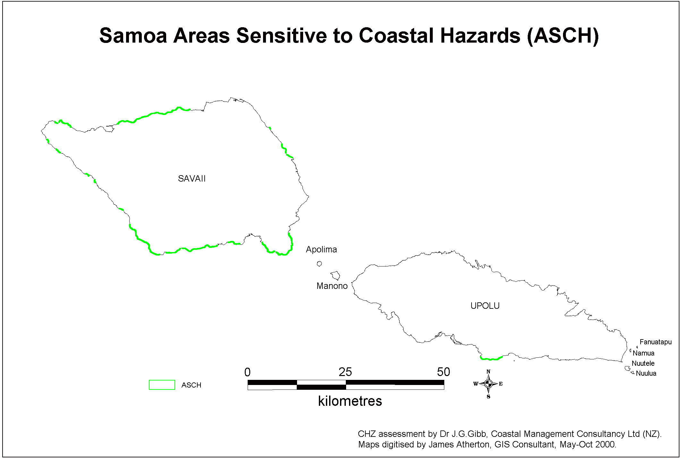

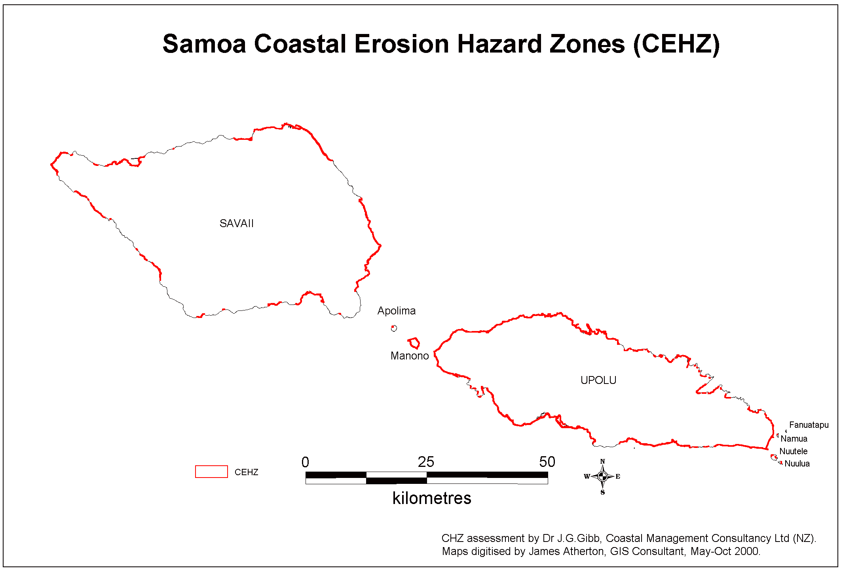

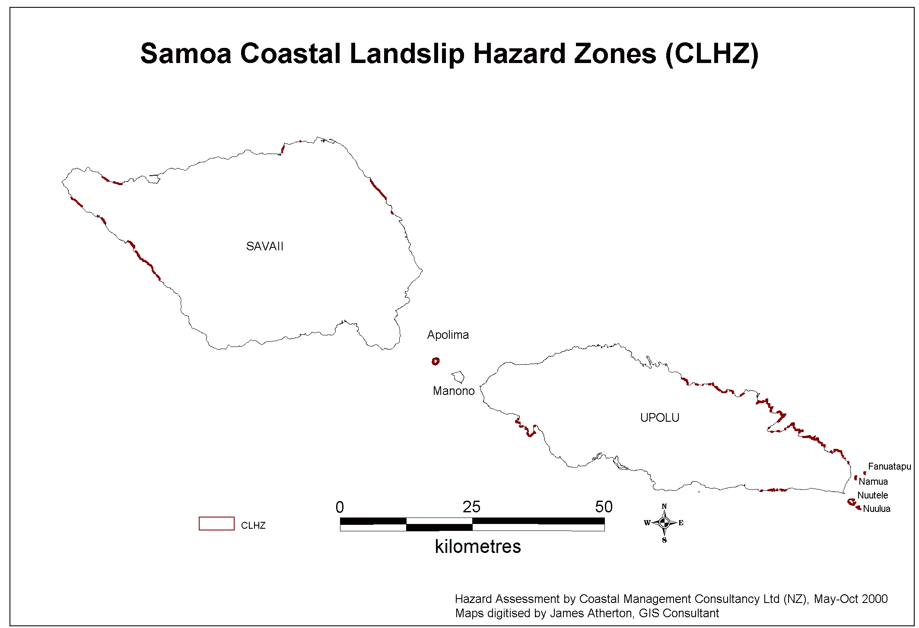
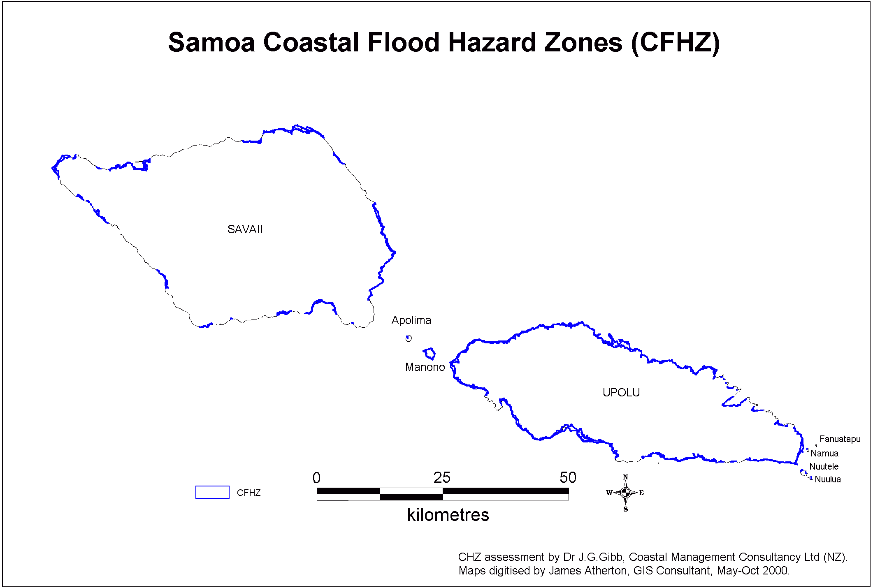

Annex 2
GEF Community-Based Adaptation Programme
Samoa
Eligibility Criteria

- Organization carrying out the project
  - Registered NGO or recognized CBO in the village
  - Existence and effectiveness of decision-making structures/ board
  - Existence of a bank account
  - Required administrative attachments
  - Description of past experience and lessons learned from them
  - Other groups in the village involved in the project
  - Grassroots ownership (potential tensions for ownership of the project?)
  - Identification of potential risks and barriers to the implementation

- Local vulnerability and resilience analysis
  - Identification of climate related risks
  - Analysis of ecosystems current and future vulnerability
  - Analysis of community current and future vulnerability

- Adaptive capacity and resilience building
  - Assessment of current and future adaptive capacity
  - Analysis of available coping strategies
  - Previous attempts to tackle environmental issues
  - Different options have been explored
  - Technical / scientific survey conducted
  - Viability of chosen option
  - Promotion of indigenous coping practices

- Compliance of the goal with targeted environmental areas
  - GEF focal areas [operational programme]
    - Climate Change adaptation under SGP Samoa CPS 2007-2010
    - CBA programme overall goal = “enhance the ability of communities to proactively assess current and future climate risks on ecosystems upon which they depend, as well as capacity to respond to those risks in a proactive and evolving manner”
  - Samoa CBA Country Programme Strategy
    - Geographical sector identified
    - Thematic area identified
  - Other National and Local Policies

- Benefits of the project
  - Beneficiaries
    - Most vulnerable groups (youths, women, fishermen, other disadvantaged etc)
    - Future generations
    - Other secondary beneficiaries via capacity building / raising awareness activities
    - Respect of gender equality, balance between socio economic groups, human rights etc
  - Measurable benefits
  - Long term benefits
  - Sustainable livelihoods provision
  - Provision of Global Environmental Benefits
  - Resilience building of these GEB

- Consistency of the project proposal
  - The goal, outcomes, and activities are consistent with each other
  - The activities are feasible by the community
  - The budget is realistic and cost effective
  - Complementarities with other activities conducted in the village or district
  - Potential to create synergies with other projects
  - Sustainability: environmental and project sustainability (exit strategy)

- Resources
  - GEF 1:1 co funding principle
  - Other partners: actual and potential co-financing
  - Contribution of the community in cash / in kind
  - Commitment to financial reports, receipts keeping…

- Monitoring
  - Initial VRA completed
  - Monitoring planning (reports, other VRAs, participatory methodologies)
  - IAS indicators chosen

- Pilot project criteria
  - Replication potential
  - Potential for integrating lessons in national policies
  - Quota of CBA projects respected (8-20)
  - Grant requested in the margin of allowable grants
  - Duration of the project (1-3 years)
  - Potential for sharing / comparison with other CBA pilot projects
  - Project is representative of national issues [Samoa being part of the CBA programme as a SIDS]
  - Complementarities with Samoa SGP country strategy
  - Innovativeness

NAPA, p 14

