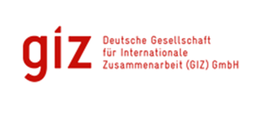

**THEMATIC REPORT: ICCAS PROJECT**

**Coastal Zone Management :**

***Protecting Fragile Coastal Mangrove Eco-systems***

** **

**Submitted**

By

**David A. Simmons**

92A Benjamin St., Diego Martin

Trinidad and Tobago

**Email:** [**davidAsimmons@outlook.com**](mailto:davidAsimmons@outlook.com)

|  |  |  |  |
| --- | --- | --- | --- |
| **Integrated Climate Change Adaptation Strategies (ICCAS): Thematic Report** | | | |
| **Thematic Area:** Coastal Zone Management: Protecting Fragile Coastal Mangrove Eco-systems | | **Period:** January 2016 – August 2017 | |
| **IMPLEMENTING AGENCIES** | | | |
| United National Development Programme (UNDP) | The Environment Unit of the Ministry of Agriculture, Lands, Forestry, Fisheries and the Environment | | German Development Cooperation (GIZ), BMUB |

|  |  |
| --- | --- |
| **Context** | The objective of the ICCAS programme was to enhance the resilience of Grenada’s population and its ecosystems that are particularly vulnerable to the effects of climate change. Component 2 of ICCAS specifically refers to Improved planning management and efficient use of water and coastal zone resources. Small island states which are depend on their coastal areas for their livelihood particularly in the areas of tourism and fisheries, so a comprehensive and sustainable coastal zone management policy is essential. Coastal zone protection against the adverse effects of climate change such as storm surges and sea-level rise is critical. Some areas of the coastline are experiencing heavy erosion, and the mangrove system, which acts as the natural first line of defence, is being reduced by deforestation and unsustainable harvesting for charcoal production. |
| **Project Background** | Sector specific pilot projects were developed and implemented to assist in  Coastal Zone Management and particularly in mangrove rehabilitation and conservation. The ICCAS approach is to pilot best practices and to build capacity of key actors in the local communities so that they can act as knowledge multipliers and pilots were carried out in coastal zone management specifically Mangrove rehabilitation. These pilots can be used as models for replicating and upscaling:   1. **The Simon/Paradise Mangrove Regeneration and Livelihood Project – Location – Eastern Coast -**   Due to extensive flooding, saltwater invasion and indiscriminate disposal of household items, there has been serious degeneration of the mangrove area. The project’s main aim is to regenerate the mangrove, cleaning up and maintaining the waterway that leads into the mangrove, as well as, planting appropriate trees along the approximate 400 plus feet banks. It is hoped that the regeneration of the mangrove would encourage the return of birds and other species of wildlife.   1. **The Restoration and Community Co-management of Mangroves Project** (**RECCOMM). Location Northern Coast- Telescope**   The area is experiencing heavy coastal erosion partially due to past sand mining activities. Additionally, the mangroves are being reduced by deforestation and unsustainable harvesting practices in order to produce  Charcoal. Under the project, 1900 mangrove seedling have been replanted, the community has been trained to sustainably harvest the mangrove for charcoal; bee hives have been installed, a community group has been trained to produce mangrove honey that is already marketed in Grenada and finally, a boardwalk and bird watching platform is being built, and community members have been trained as local eco-tourism guides. Both these areas are among the poorest on the island and as such provision of livelihood alternatives is key.   1. **Ramsar Levera**: **Location: Northern Grenada**   This project is located in the largest mangrove area in Grenada. It was established to manage, conserve and protect a significant part of the biodiversity of Grenada as well as provide opportunities for environmental education and interpretation while at the same time contributing to the livelihoods of persons from the surrounding communities. The project objective was to develop and implement, monitoring protocol for each ecosystem; building capacity for ecosystem management; facilitate the education, awareness and implementation of short-term actions recommended by the Monitoring Plans. |

**Overall Success**

An Integrated Coastal Zone Policy was developed in a participatory manner and approved by Cabinet. A multidisciplinary coastal zone task force spearheaded the development of appropriate coastal zone legislation. This provides the backdrop for project implementation in the mangrove areas.

Restoration of the mangrove in these communities provided a host of benefits:

* Coastal zone protection from extreme weather events
* Maintenance of wildlife populations and rare flora and fauna
* Opportunities for learning new skills in the area of environmental management and monitoring.
* Alternative livelihood opportunities for communities that are linked to nature conservation. Communities’ habitats are enhanced, and members trained and equipped to conduct beekeeping, ecotourism, birds watching and herbal medicine to name a few.

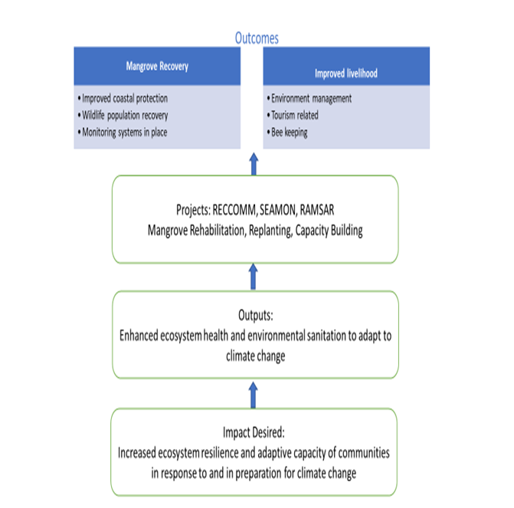

Specific activities carried out were as follows:

* Replanting of mangrove trees using local species.
* Training in bee keeping
* Establishment of monitoring systems for fragile ecosystems; recording of valuable data related to flora and fauna particularly at the RAMSAR site.
* Development of skills in eco-tourism related activities
* Construction of the boardwalk at RECCOMM site
* Sensitization of the communities to the deleterious effects of environmental degradation and the need to conserve the natural environment

**Lessons Learnt**

1. Building a co management approach – the first pilot (RECCOMM) developed the project using a board that consisted of five persons from the community and five from government, and this helped to build community commitment and buy in.
2. Developing a roadmap for the project and where it needed to go, ensured that all those involved were aware of the overall goals and objectives and was responsible for keeping the project on track.
3. All the projects included training and capacity building elements which (in the context of the low-income levels in these communities), enhanced community commitment and helped to ensure sustainability:
   1. The community group in RECCOMM then went through registration without GIZ help which is a measure of the competency acquired by members of the community who participated in the project.
   2. Community groups partnered with others (e.g. Ocean Spirits for turtle awareness training, RECOMM to improve project implementation at RAMSAR), illustrating their improved project implementation capacity, environmental awareness and the concept of model replicating which is an essential part of this program.
   3. Use of the RAMSAR project as a teaching and awareness raising tool among the youth including the concept of the environmental ranger. Fifty people from the community received training in baseline data collection and continue monitoring species over time.
4. Focus must be on policy and its application in the area of private sector project development, ensuring that private sector developers take into account the fragile nature of the ecosystem and ensure it is protected prior to development and implementation of new projects. This has met with resistance given shorter term cost implications and the necessity it places on the developer to do the relevant environmental studies.

**Best Practice(s) Identified**

1. Indigenous seedlings were used for planting at the site - These seedlings are already adapted to conditions and manpower, and transportation was reduced
2. The climate change adaptation activity was linked to livelihood generation which is key to project acceptance particularly in low income areas like the ones where these projects were introduced.

**Recommendations based on the Lessons Learnt and Best Practices Analysis**

1. The RAMSAR model of using community members including school children as environmental rangers could be widely replicated and used to promote buy in, in the communities. Commitment to environmentally sound practices by the youth is key to ensure long term sustainability.
2. The training programs in all projects that improved eco-tourism skill sets is key to get communities to commit to climate change adaptation strategies that include conservation and rehabilitation of environmentally sensitive areas.
3. The general enhancement of community skill sets (e.g. in bee keeping for example) provides positive linkages with improved livelihood and therefore increases the community’s commitment to the projects.
4. The use of the projects in community outreach to schools is an excellent method for education and awareness building and the resulting long-term commitment to climate change adaptation strategies.

Author: David Simmons & Christina Barradas-Brewster/ Consultants/ Caribbean/

Contact: [davidasimmons@outlook.com](mailto:davidasimmons@outlook.com)

Location of Project: Caribbean/OU/Grenada/St Andrew

MHT: What is the Major Habitat Type for this partnership? Farming community, school

Types of Partners: Government, Place-based NGO, International NGO, Community Based Organization.

Priority: Freshwater

Date: May 2018

Links: <http://www.iccas.gd/?q=community-projects/73/Restoration%20and%20Community%20Co-Management%20of%20Mangroves%20%28RECCOMM%29>

<http://www.grenadafundforconservation.org/projects>

<http://www.iccas.gd/?q=community-projects/181/Seamoon>

<https://youtu.be/4D-6AniO9pM>

<https://youtu.be/F7bTzEcALm4>