Strengthening Climate Information and Early Warning System in Cambodia

Drought Baseline Study in Cambodia

Drought Baseline Study in Cambodia

Author: Dr. Chhin Nyda, Consultant

Technical Advisor:
Muhibuddin Usamah, EWS Project Manager, UNDP Cambodia

Edited by:
Muhibuddin Usamah, EWS Project Manager, UNDP Cambodia
Dr. Senaka Basnayake, Asian Disaster Preparedness Center
Lalit Kumar Dashora, Asian Disaster Preparedness Center
Kelsea Clingeleffer, Monitoring and Evaluation Consultant, UNDP Cambodia

Suggested reference:
UNDP (2019), Drought Baseline Study of Cambodia, Strengthening Climate Information and Early Warning System, United Nations Development Programme.

Contents
List of Tables i
List of Figures ii
Abbreviations iii
Executive Summary v
1. Introduction 1
2. Drought Theories and Indicators 2
2.1. Drought Vulnerability 4
2.2. Drought Indicators 6
2.3. Relevant Drought Indicators in Cambodia 9
3. Historical Drought in Cambodia 10
3.1. Linking Drought in Cambodia to ENSO 12
3.2. Agricultural Context for Drought Analysis 14
3.3. Cambodia’s Meteorological Drought 15
3.3.1. Methods for Analyzing Meteorological Drought 16
3.3.2. Meteorological Drought in Kampong Cham 17
3.4. Cambodia’s Agricultural Drought 20
3.4.1. Methods and Data for Agricultural Drought Analysis 20
3.4.2. Agricultural Drought in Kampong Cham 21
3.5. Cambodia’s Hydrological Drought 23
3.5.1. Methods and Data for Hydrological Drought Analysis 24
3.5.2. Hydrological Drought in Kampong Speu 26
3.6. Drought Prone/Hotspot Provinces 27
3.6.1. Methods and Data for Identifying Drought-Prone Provinces 27
3.6.2. Meteorological Drought-Prone Provinces in Cambodia 27
3.6.3. Drought Vulnerable Provinces in Cambodia 28
3.7. Drought Early Warning Design 29
4. Drought EWS Platform Assessment 31
4.1. GDO and GDACS 31
4.2. SERVIR Mekong and LMB 33
4.2.1. Assessing CHIRPS Rainfall Data 33
4.2.2. Drought Assessment Using CHIRPS Rainfall Data 36
4.2.3. Meteorological Drought 37
4.2.4 Agricultural Drought 41
4.2.5. Hydrological Drought 41
4.2.6. Combined Drought Index 42
5. Drought Mechanism 44
6. Discussion 45
7. Recommendation 46
8. Conclusion 46
References 48
Appendices 53
Appendix 1: Meteorological Drought in Kampong Cham 53
Appendix 2: Meteorological Drought in Kampong Speu 54
Appendix 3: Meteorological Drought in Kampong Thom 55
Appendix 4: Meteorological Drought in Prey Veng 56
Appendix 5: Meteorological Drought in Battambang 57

List of Tables
Table 1: Classification criteria of types of drought 3
Table 2: Categories of the Combined Drought Indicator 7
Table 3: Paddy rice area damaged by drought from 1990-2018 12
Table 4: El Niño occurrence measuring at 3.4, 1980-2018 (Source: https://origin.cpc.ncep.noaa.gov/products/analysis_monitoring/ensostuff/ONI_v5.php) 13
Table 5: Paddy rice damaged by drought in 2004 (in thousand hectares) 13
Table 6: Rice ecosystems and impact by different temporal drought 14
Table 7: Rainfall data availability for drought analysis in Cambodia 16
Table 8: Wet and Dry classification based on the SPI index 17
Table 9: Intra-seasonal droughts at drought-prone province in Cambodia 20
Table 10: Drought early warning 30
Table 11: Annual Chirps rainfall data for drought analysis in Cambodia, 1981-2018 34
Table 12: Correlation of CHIRPS and Observed rainfall data in Cambodia 36
Table 13: SPI drought occurrence based on observed and CHIRPS data 37
Table 14: Drought events based on SPI3 using SERVIR Mekong in Kampong Speu, 2004 39
Table 15: Drought events based on SPI12 using SERVIR Mekong in Kampong Speu, 2004 40
Table 16: Drought events based on average 5-days CDI Kampong Speu, 2004 44

List of Figures
Figure 1: The relationship between drought types 3
Figure 2: Framework of Pressure and Release Model 5
Figure 3: Spatial distribution of annual average rainfall in Cambodia, 1980-2019 6
Figure 4: Drought Processes, impacts, and linkage (Adamson & Bird, 2010) 8
Figure 5: Flood and drought damage by paddy area in Cambodia, 1984-2018 10
Figure 6: Area damaged by drought in 2004-05 and distribution of drought frequency by the province in Cambodia, 1988-2018 11
Figure 7: Overview of rice crop calendar in Cambodia 15
Figure 8: SPI value for Kampong Cham in Early Wet Season, 1983-2018 18
Figure 9: SPI value for Kampong Cham in Aug and Sept 1983-2018 18
Figure 10: SPI value for Kampong Cham in Oct and Nov 1983-2018 19
Figure 11: MODIS data path in true color over Cambodia 21
Figure 12: Agricultural drought study sites 22
Figure 13: Changes of NDVI value over Chrey Vien and Tong Ron commune, 2000-2018 23
Figure 14: Hydrological drought study site in Kampong Spue Province 25
Figure 15: Hydrological changes in February of Chhan Thnal dam, 2001-2019 26
Figure 16: Meteorological drought-prone areas in Cambodia, 2004 28
Figure 17: Drought vulnerability provinces 29
Figure 18: Simple drought early warning application 31
Figure 19. Risk of Drought Impact for Agriculture, October 2015 32
Figure 20: Observed and Chirps data for Phnom Penh Station, 1981-2018 35
Figure 21: Observed and Chirps data for Kampong Speu Station, 1983-2018 35
Figure 22: Monthly SPI3 for selected years for Kampong Speu Province 38
Figure 23: Monthly SPI12 for selected years for Kampong Speu Province 40
Figure 24: Monthly SMDI for selected years for Kampong Speu Province, 2000-2006 41
Figure 25: Monthly SRI3 for selected years for Kampong Speu Province, 2000-2006 42
Figure 26: Level of early warning, indicators, and criteria for drought early warning 42
Figure 27: Weekly drought Early Warning Lower Mekong Basin, 24-11-2019 43
Figure 28: Drought early warning mechanism 45

Abbreviations
ADI | Aggregate Drought Index
ADPC | Asian Disaster Preparedness Center
AKP | Agent Kampuchea Press
ANOM | Anomaly
AOI | Area of Interest
AVHR | Advanced Very-High-Resolution Radiometer
CCC | Cooperation Committee for Cambodia
CDI | Combined Drought Index
CHIRPS | Climate Hazards center InfraRed Precipitation
CMI | Crop moisture index
CRED | Centre for Research on the Epidemiology of Disaster
CSI | Critical Success Index
CTD | Chan Thnal Dam
CWSI | Crop Water Stress Index
EM-DAT | Emergency Events Database
DC | Drought Condition
DEW | Drought early warning
DEWS | Drought early warning systems
DI | Drought Index
DRR | Disaster Risk Reduction
DS | Dry Spell
DSI | Drought Stream Flow Index
ECMWF | European Centre for Medium-Range Weather Forecasts
ENSO | El Niño Southern Oscillation
ES | Early Season
ETDI | Evapotranspiration Deficit Index
EWS | Early Warning System
FAPAR | Fraction of Absorbed Photosynthetically Active Radiation
GDACS | Global Disaster Alert and Coordination System
GDO | Global Drought Observatory
GIS | Geographical Information System
GPM | Global Precipitation Measure
IUCN | International Union for Conservation of Nature
JICA | Japan International Cooperation Agency
KPC | Kampong Cham
KPS | Kampong Speu
LMB | Lower Mekong Basin
LMR | Lower Mekong Region
LS | Late Season
MAFF | Ministry of Agriculture, Forestry, and Fishery
MoE | Ministry of Environment
MODIS | Moderate Resolution Imaging Spectroradiometer
MoWRAM | Ministry of Water Resources and Meteorology
MRC | Mekong River Commission
MS | Mid-Season
NCDM | National committee for disaster management
NCEP | National Centers for Environmental Prediction
NDVI | Normalized Difference Vegetation Index
NDWI | Normalize Difference Water Index
NIR | Near Infrared
NMME | North American Multi-Model Ensemble
NWI | Normalized Water Index
ONI | Ocean Nino Index
PAR | Pressure and Release
PDSI | Palmer proposed Palmer Drought Severity Index
PSDI | Palmer Drought Severity Index
RDI | Runoff Drought Index
RGC | Royal Government of Cambodia
RHEAS | Regional Hydrologic Extremes Assessment System
RZSM | Root Zone Soil Moisture
SDI | Stream flow drought index
SDMI | Synthesized Drought Monitoring Index
SERVIR | to Serve in Spain
SGI | Groundwater Level Index
SMA | Soil Moisture Anomaly
SMAP | Soil Moisture Active Passive
SMDI | Soil Moisture Deficit Index
SMOS | Soil Moisture Ocean Salinity
SPI | Standardized Precipitation Index
SRI | Standardized Runoff Index
SST | Sea Surface Temperature
STD | Standard Deviation
SWAT | Soil & Water Assessment Tool
SWDI | Surface-water drought index
SWIR | Short-wave infrared
SWSI | Surface Water Supply Index
UNDP | United Nations Development Programme
UNFCCC | United Nations Framework Convention on Climate Change
UNISDR | United Nations secretariat of the International Strategy for Disaster Reduction
UNTAC | United Nations Transition Authority in Cambodia
WFP | World Food Programme
WMO | World Meteorological Organization

Executive Summary
Drought is a slow onset hazard and known as a silent killer. The biggest challenge for drought mitigation is its complexity. First, it begins with the definition of drought. There are four major drought definitions, including meteorological, agricultural, hydrological, and socioeconomic drought. Those definitions are derived from the implications of demand and supply of water. Scholars argued that any interpretation of drought must be served for a purpose.
To manage drought, we must monitor drought development in a locality. There are many approaches to monitor drought onset and cessation. While some approaches are more robust than others, some approaches will come with more complicated including the demand of data and the complexity of calculation. In a country like Cambodia, Standardized Precipitation Index (SPI) is recommended for monitoring meteorological drought, Normalized Difference Vegetation Index (NDVI) is recommended for agricultural drought, and Surface Water and Ground Water Level Index recommended for hydrological drought. These indices are easy to calculate and require fewer data to compute so that we can identify drought onset and cessation.
While the first three types of drought are mainly associated with physical factors such as the deficit of rainfall, soil moisture and the depletion of surface water, the socio-economic drought is highly related to socio-economic condition of the household, community, local and national government, there are several theories to explain drought risk which is mainly the underlying cause of drought disaster. For example, if there are early warning systems of drought onset and on-time intervention, there would not be a socio-economic drought.
In Cambodia, droughts have hit very hard in the rural community where the households are dependent on subsistence agriculture such as paddy. So far, Cambodia has experienced all types of drought, but it is reported when impacts are manifested through the loss of paddy and/or severe lack of water supply to the community and/or hydropower operation. Coupling the current drought vulnerability with the climate change context, Cambodia should have drought early warning systems especially drought monitoring by using rainfall-SPI, Soil moisture -NDVI, and Surface water and groundwater level as an indicator to identify drought onset.
There are several drought occurrences and caused extensive damages mainly to the agricultural sector. Recent drought episodes went beyond agricultural sectors but domestic water consumption, such as in the 2015-2016 droughts. In the past, reports on drought impacts in Cambodia were mainly related to agriculture areas affected and damaged by the hazard, for example, 2004 which was among the worst year of drought impacts.
In this study, droughts are categorized as meteorological, agricultural, and hydrological drought. The analysis of each type of drought is based on different data set, including rainfall and remotely sensed data.
Data suggested that Cambodia experienced less meteorological drought in the 2010s compared to the 2000s. While the former experienced more late-season drought (October-November), the latter were more early-season droughts (June-July). There was not much change between the two periods for mid-season drought. In general, Battambang province was profoundly impacted by the meteorological drought.
This study successfully used remotely sensed data to identify changes in vegetation phenology to determine agricultural drought. If, based on late-season (between October-November) vegetation greenness changes, paddy that have no access to supplementation irrigation is likely to be less healthy (which could lead to low yield). Between 2011-2013, late-season drought in Kampong Cham has changed the greenness of rice plants, especially in Tong Rong commune, compared to 2014-2018.
In terms of hydrological drought, the study is based on remotely sensed data to estimate the change in surface water in Kampong Speu province, notably Chhan Thnal Dam, built during the Pol Pot regime and restored in 1995. The study assessed the changes in surface water during hydrological drought years, such as in 2004 and 2019.
Based on these findings, we can design a drought early warning (DEW) system by using a model as shown in Figure 18. It is highly recommended to carry out further studies to ensure that the threshold is well set to correspond to the locality, primarily for agricultural and hydrological drought.
There are approaches to identify drought onset and could be used to monitor drought development. To provide reliable early warning especially meteorological drought, 1) weather forecast should be used in the proposed model, 2) integrated regional climate factor mainly El Nino Southern Oscillation, and 3) underlining local vulnerability to drought.
There are drought monitoring facilities available on the global and regional platforms. In this study, SERVIR Mekong data/models – regional drought platform which has the potential for drought early warning (DEW) for Cambodia are assessed and verified with drought events occurring mainly during the 2000s. It should also be noted that the inputs data that SERVIR Mekong uses, such as CHIRPS were also tested to check if the dataset resembles ground observation.
Based on our analysis, CHIRPS has normally overestimated ground observation statistically significant. Only some ground station data matched the CHIRPS dataset corresponding to the ground observation. For SERVIR Mekong data models, almost no dataset reflected ground observation and/or the drought onset in Cambodia. We believed that almost all models/data supplied from SERVIR Mekong are not yet mature enough to reflect the ground information. Most of the time, the data were not sensitive to change, including Combined Drought Index – known as CDI (which is mainly used for DEW in the Lower Mekong Region). It appears that CDI is sensitive to the early months of the year mainly from January to March, while it shows normal during the wet season.
So far, the assessment concluded that if DEW is applied to Cambodia, observed data in Cambodia stations should be used. Meteorological drought should employ SPI between mid-May to mid-November, Normalize Different Vegetation Index (NDVI) for agricultural drought and calculate between October-November when SPI showing Negative Value 1, and NDWI should be calculated for hydrological drought in December-January to estimate the water balance for domestic consumption and/or other activities (See Section 2 for more discussions on these indices). Those indices are very important for drought monitoring. When approaching the early warning, El Niño Southern Oscillation (ENSO) should be used to check regional climate influence as there is time-lag, and ENSO is almost always linked to the Cambodia climate. Another window for DEW in Cambodia is to use weather forecasts from global data sources such as Global Precipitation Measure (GPM), where they provide data with three months' lead time.
Last but not least, the current drought Notification from the Ministry of Water Resource and Meteorology (MoWRAM) is also based on ENSO onset, but it is not necessarily about the drought conditions in the country. Since the platform is available at the MoWRAM, integrating SPI, NDVI and NDWI into the current mechanism is the best option.

1. Introduction
Cambodia is facing mounting development challenges due to climate change. The observed longer dry seasons and shorter and more intense rainy seasons have become a common observation in Cambodia. Also, climate change exacerbates the frequency and severity of natural hazards (such as floods and droughts), as well as impacts agricultural production, which is dependent on seasonal rainfall. Recovery from such events puts a strain on the least developed country’s limited resources and forces shifts in development priorities - hindering Cambodia’s ability to progress and to achieve its development goals.
In terms of rainfall availability in the agricultural context, Cambodia has experienced three types of change. They include the late onset of the wet season, prolonged dry spells during the wet season, and early cessation of the wet season. While there has been no comprehensive scientific study of rainfall patterns carried out for the whole country (Helmers K & Jegillos S, 2004; Nguyen & Shaw, 2011), variations to normal rainfall patterns have been observed regularly (Geres-Cambodia, 2009; Ministry of Environment & UNDP, 2011) and updated online via national institution (National Institute of Statistics, u.d)
The impact on agricultural production, as the mainstay of the Cambodia economy, has been enormous. Based on the Ministry of Environment (MoE) study in 2001, rice production loss due to the flood was more than 70 percent and drought about 20 percent of total production from 1996-2000 (Ministry of Environment, 2001). The study did not capture the most severe drought in 2004 and others. According to Agricultural Statistics compiled by the Ministry of Agriculture, Forestry, and Fishery (MAFF), it was estimated that about 300,000 hectares of paddy were effected, and 82 percent was damaged (MAFF, 1999). With the limitation in providing irrigation facilities, drought is found to be a disaster after flooding in Cambodia (Ministry of Environment & UNDP, 2011), and it is consistent with the argument posted by the World Bank (Aaheim & Schjolden, 2004).
Coupling the climate variability with further climate change scenarios lead to an uncertain risk in Cambodia. The Early Warning System (EWS) is one of the priorities of the Royal Government of Cambodia (RGC). The purpose of an EWS is to monitor climate and environmental data on a real-time basis, detect adverse trends and conduct reliable predictions of possible impacts in the form of early warning information. An early warning, therefore, refers not only to advisories in emergencies but also to information related to the changing climatic trends revealed after tracking and analyzing climate and weather data over time. An effective EWS would thus enable timely response to natural hazards and extreme weather events, to support the implementation of the risk-informed development.
The project “Strengthening climate information and early warning systems in Cambodia to support climate-resilient development and adaptation to climate change” (henceforth “the EWS project”) is being implemented to assist the Government in achieving the early warning system gaps and challenges in the country. The project seeks to address the current barriers through three complementary outcomes:
- Increased institutional capacity to assimilate and forecast weather, hydrological, climate, and environmental information.
- Climate and weather information available and utilized for national, sectoral, and sub-national planning as well as for trans-boundary communication in the region.
- Strengthened institutional capacity to operate and maintain EWS and climate information infrastructure, both software and hardware, to monitor weather and climate change.
To meet the above three outcomes, the project ensures and increases the availability of hydrological and meteorological data through the installation of automatic weather and hydro stations in Cambodia for climate analysis. Various application of climate analysis is also implemented, including the implementation of climate change adaptation through local-level drought mitigation.
The main objective of this study is to conduct a national drought study of Cambodia and develop nationally adopted drought indicators in Cambodia, integrating global academic literature on drought and technical reports on drought in Cambodia. Specifically, this study also includes the localization of existing regional drought platform and validation of the information from the regional drought platform with the available data from Cambodia.
The study is divided into three parts: 1) drought theories, 2) historical drought in Cambodia, and 3) drought model examination.

2. Drought Theories and Indicators
Back in 1949, drought theories were not well developed (Tannehill, 1947). Tannehill posited that ‘We have no good definition of drought. We may say truthfully that we scarcely know a drought when we see one.’ Palmer (1965, p. 3) attempted to provide ground theory on drought as ‘A drought period may now be defined as an interval of time, generally of the order of months or years in duration, during which the actual moisture supply at a given place rather consistently appropriate moisture supply. Further, the severity of drought may be considered as being a function of both the duration and magnitude of moisture deficiency’. Based on that drought definition, Palmer proposed Palmer Drought Severity Index (PDSI) with four major indicators, including precipitation, soil moisture, runoff, and potential evaporation. The theories are being critiqued that it is versatile for long term drought only (D. A. Wilhite & M. H. Glantz, 1985). In their review from 150 published drought definitions, (D. A. Wilhite & M. H. Glantz, 1985) posited that there is meteorological, agricultural, hydrological, and socioeconomic drought. These types of drought were not debated among scholars as confirmed by (Zargar, Sadiq, Naser, & Khan, 2011) and practitioners (UNISDR, 2009), but methods and indicators for each type of drought vary from one scholar to another depending on data availability (country context).
Meteorological drought, defined as precipitation deficiency, is computed based on precipitation deficit and frequently known as drought index (DI). There are several popular DI formulas, for example, Palmer Drought Severity Index (PDSI) developed by Palmer (1965), Standard Precipitation Index (SPI) proposed by McKee et al. (1993), and China-Z index by We et al. (2001). There are other methods used to identify drought events such as the Deciles proposed by Gibbs and Maher agreed on drought definition ‘severe water shortage’ (1967). Percent of normal is another simple method, but it faced challenges on normal in statistics terms. Outliers influence the value of the 'mean.' While the demand for water may fix, the high/low value of any data points will impact on the mean. It should be noted that meteorological drought in the monsoon context would be calculated within the wet season, including the onset, middle, and cessation of rainfall. It could be misleading if one calculated meteorological drought for Cambodia, for example, from December to April.
Agricultural drought, by the terms itself, refers to the conditions of water shortages to meet the demand of the plants to grow, which attributed to meteorological drought (Figure 1). Precipitation is, therefore, closely linked to agricultural drought in many aspects (D.A. Wilhite & M.H. Glantz, 1985). According to Kulik, cited by Wilhite and Glantz (1985), drought intensity is the difference between plant water demand and available soil water. Sharing the assumption of soil layers, which is critical to plants among Kulik and Palmer, Palmer (1968) modified PDSI to reflect agricultural drought and known as ‘Crop moisture index (CMI)’. Palmer (1968) simplified agricultural drought as ‘transpiration deficit,’ and the CMI is the summation of the evapotranspiration anomaly index and the wetness index. PDSI could be modified to monitor drought onset in the context of the existence of irrigation facilities, as done by (Yu et al., 2019). In the new equation, the authors replaced one indicator ‘potential evaporation’ with ‘potential evapotranspiration’ using the Penman-Monteith model and introduced a new variable ‘irrigation’ into the PDSI equation.
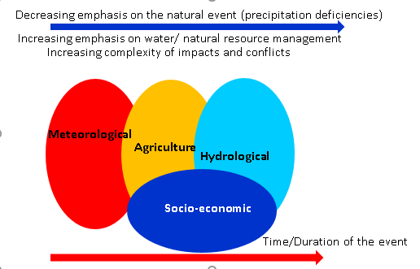
Figure 1: The relationship between drought types. Adapted from A. D. Wilhite and Bruchanan-Smith (2005)
Hydrological drought refers to the reduction of streamflow, inflow to reservoir, lakes, and ponds (surface water) and groundwater. According to Linsley et al. cited by Wilhite and Glantz (1985), hydrological drought is ‘a period during which stream flows are inadequate to supply established uses under a given water management system. Streamflow is the major hydrological drought indicator, and it could be turned into Drought Stream Flow Index (DSI) by using the principle of SPI (Nalbantis & Tsakiris, 2009). It should be noted that natural stochastic climate variables couple with time lag will lead to drought from meteorological drought to hydrological drought, and each stage of drought would be associated with socio-economic impact (which also called socio-economic drought). The practical use of hydrological drought (which could isolate precipitation) is during the long dry season, such as in Cambodia. In this case, surface and groundwater availability should be the monitor as argued by (Van Loon, 2015). There is a misleading concept on drought during the dry season, such in Cambodia, as they posited that how can it be said there is a drought when there is hardly rainfall. This mainly means that they were referring to a meteorological drought (for comprehensive drought indices review see World Meteorological Organization (2016).
Table 1 shows the types of drought and some indicators (suitable for the Cambodia context). In Cambodia, drought definitions are yet to be set, for the one quoted by (Leng, 2014) ‘the drought condition – primarily a result of erratic rainfall – is exacerbated by limited coverage of irrigation facilities’ cannot be operationalized. More explanation on the selection of indicators and indices are discussed in the following sections.

Table 1: Classification criteria of types of drought
Drought type | Characteristics or description
Meteorological drought | Definition: it is a meteorological drought when actual precipitation departures to average amounts on monthly, seasonal, water year, or annual time scales.  Indicators: Rainfall  Indices for Cambodia: Standardized Precipitation Index (SPI)  Timeframe: May-November (wet season)
Agricultural drought | Definition: Agricultural drought occurs when the conditions of water shortages to meet the demand of the plants to grow. An operational definition of agricultural drought should account for the variable susceptibility of crops at different stages of crop development.  Indicators: Soil Moisture  Indices for Cambodia: Normalized Difference Vegetation Index (NDVI)  Timeframe: It should be within the wet season, which could be distinguished by the early wet season, middle wet season, and end of the wet season.
Hydrological drought | Definition: Hydrological drought triggers by the reduction of streamflow, inflow to reservoir, lakes, ponds, and groundwater.  Indicators: Surface water and groundwater  Indices for Cambodia: Surface Water Supply Index (SWSI) and Groundwater Level Index (SGI)  Timeframe: November-May

2.1. Drought Vulnerability
Socio-economic drought, as the term suggests, occurs when meteorological, agricultural, and hydrological drought impact the socio-economic sector (Figure 1). Only if human failed to address those physical hazards, there would be a socio-economic drought (World Bank, 2010). As a natural hazard, any drought is highly associated with precipitation, just a matter of time (duration). Given that there are many definitions of drought, Wilhite and Buchanan-Smith (2005, p. 26) confirmed that definitions should be ‘impact-oriented, combining both physical and socioeconomic aspects’ and ‘reflect the unique regional climatic characteristics’ or we can argue that there is a lot of spatial variations in term of drought impacts depending on its exposure.
Wilhite and Glantz (1985) asserted that drought is not a disaster; it becomes a disaster depending on its impacts on local people and the environment. World Bank (2010) echoed that drought is a natural hazard, but it becomes a disaster if people are not prepared for it. Also, there is a need to understand its natural and social dimensions to get the big picture of drought impacts. In terms of the social dimension, it should be the analysis of the drought impacts estimations, which are 1) increasing in production costs, 2) reduction paddy rice yield, and 3) damages of harvested area. Byun and Wilhite (1999) argue that the study of drought usually falls into four broad categories 1) drought cause (mainly related to the water shortage ‘meteorological drought’), 2) frequency and intensity of drought, 3) the impact of drought which associated with economic loss, and 4) response to drought made by all stakeholders.
Preparedness for drought requires an understanding of the progression of vulnerability as posited by Blaikie et al. (1994). In the Pressure and Release model or PAR model, (estimates risk as to the function of hazards and vulnerability), authors categorized the progression vulnerability into Root Causes, Dynamic Pressure, and Unsafe Conditions followed by different indicators.
In the PAR model, there are attributes to vulnerability including the Root Cause, Dynamic Pressures, and Unsafe Condition. The root causes referred to the most distance contributing to the disaster, especially related to the allocation and distribution of resources between different groups of people provided by society as a whole. The dynamic of pressure is described as an enabling environment that will help to reduce unsafe conditions. For example, the lack of training such as agricultural extension services will let farmers face with drought, for they have fragile (unsafe conditions) soil. Therefore, the enabling environments that will undo the dynamic pressure turn the unsafe condition to resilience with the hazards.
Drought vulnerability can be viewed from the PAR model with some modifications. The modification is on the progression of vulnerability that is from root causes, dynamic pressures, and unsafe conditions to policy, plan, support, and apply by involving all stakeholders who are supposed to deal with drought.
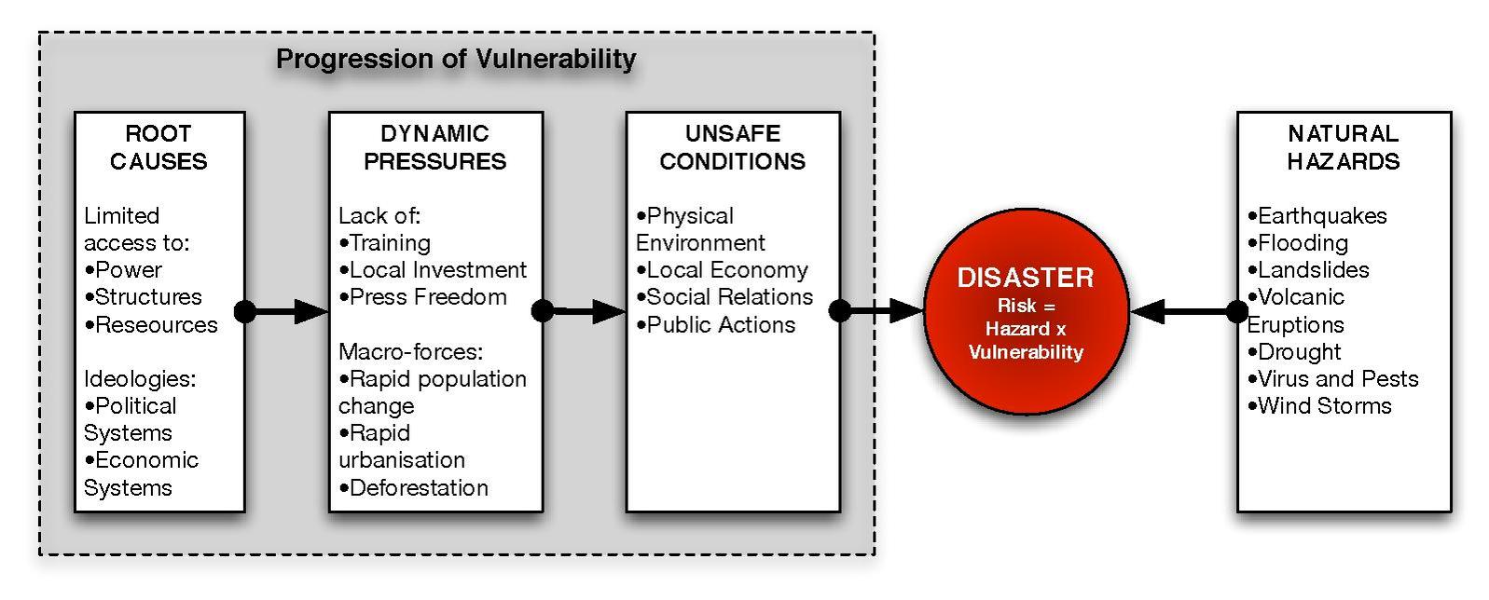
Figure 2: Framework of Pressure and Release Model (Blaikie, Cannon, Davis, & Wisner, 2014)
Climate variability both spatial and temporal, as shown in Figure 3 in terms of changing in rainfall distribution, will impose drought and flood in rain-fed agriculture. In previous discussions, there are different kinds of drought (see Table 1, which is added). Each drought definition reflects the impact or is based on the impacts of drought. For example, meteorological drought is the deficiency of precipitation, which means due to lack of precipitation. This is one to one linear relationship of definition (meteorology) and the impact (the least). Other definitions, such as socio-economic drought, the implications are not linear, and more impacts involving with water shortages and time (duration). While water shortages and duration can be measured, the impacts on people and the environment are broad and cannot be completed within a study such as this one. By holding the same degree of water shortage and within the same period (say per crop season), drought impacts on people are different depending upon their adaptive capacity.
The study of drought impacts based on the above assumption is, more, a study of adaptive capacity to drought. To measure the adaptive capacity to drought, the study must measure within two periods, drought and non-drought year (or crop season) of the same household or farmer. The same household would not have the same adaptive capacity within two periods if drought and the non-drought year is based on physical measurement such as rainfall (e.g. SPI). Then, it is a miss leading to calculate yield difference in drought and non-drought year based on the same adaptive capacity.
In the rain-fed rice ecosystems, farmers experienced drought and non-drought period. While there is on and off of drought and non-drought period, people are gradually taking actions but may not be well prepared for the worst one due to their current adaptive capacity and as well knowing how much the intensity of the drought will be. As a result, the damage is disastrous. In supplementary irrigated rice ecosystems, on the other hand, farmers have access to the water security for their paddy production; which leads to overproduction by expending cultivating areas. When the water supply capacity is stretched coupled climate variability. In short, in whatever exiting conditions of paddy rice cultivation (rain-fed, supplementary) there is a likelihood of drought.
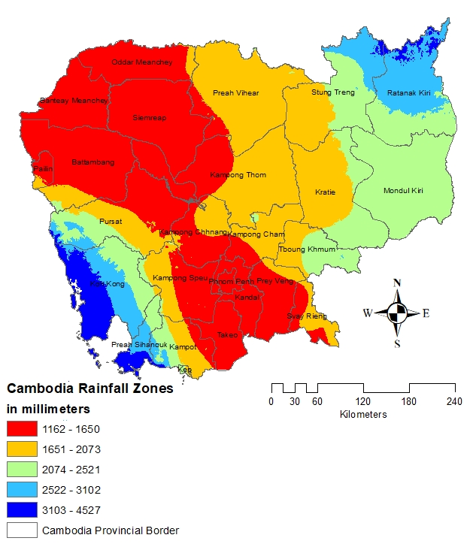
Figure 3: Spatial distribution of annual average rainfall in Cambodia, 1980-2019
Source: Author’s calculation
By examining each paddy ecosystem (rainfed or supplementary irrigation), for example, paddy productions will suffer from any departures of drought (climate variability and crop drought tolerant). The farmers who suffer first are those with minimum coping capacity. The coping mechanism to drought can be viewed not only for the drought but increase in paddy rice production. Therefore, it can be termed as the vulnerability of farmers to describe the dynamic of farmer households within their locality to be more specific and their country to be broader.

2.2. Drought Indicators
Different approaches can quantify many facets of drought. Some authors, in Cambodia, quantify drought using meteorological data such as the Palmer Drought Severity Index, such as Buckley (2010). Nguyen and Shaw (2011) and MoE (2005) used people's perceptions. National Committee for Disaster Management (2003) used productivity loss due to water deficiency through normalized difference vegetation index (NDVI), based on Landsat remote sensing data. While their studies are informative, the knowledge gaps are large. Meteorological drought does translate into agricultural drought, but not in all cases. It is highly associated with local development and household characteristics to mitigate drought and livelihood strategies to go beyond drought impacts. Then, setting indicators for drought monitoring and early warning must reflect all type of drought (as summary in Figure 4). In Europe, Sepulcre-Canto, Horion, Singleton, Carrao, and Vogt (2012) proposed Combined Drought Indicators (CDI) for drought monitoring and early warning (as in Table 2). It should be noted that CDI is also used for drought management in Mekong Region by Asian Disaster Preparedness Center (ADPC) including Lower Mekong Region.
Table 2: Categories of the Combined Drought Indicator (Sepulcre-Canto et al., 2012)
Category | Characteristics | Definition
Watch | Precipitation deficit | SPI-3 < -1
Warning | Soil moisture deficit | Anomaly pF > 1+SPI-3<-1
Alert 1 | Vegetation stress following precipitation deficit | Anomaly fAPAR < -1+SPI-3<-1
Alert 2 | Vegetation stress following precipitation/soil moisture deficit | Anomaly fAPAR < -1+ Anomaly pF > 1+SPI-3<-1

It is said that the meteorological drought would be associated with a decrease in rainfall. Literature suggests several approaches in the form of drought index (DI) to quantify the rainfall variations (seasonal, annual, decadal and/or interdecadal) for example Palmer Drought Severity Index (PSDI) (Palmer, 1965), Percent of Normal, Deciles (Gibbs & Maher, 1967), Surface Water Supply Index (Shafer & E., 1982), and Standardized Precipitation Index (McKee et al., 1993).
Among the indices proposed here, SPI is found to be the most popular and more accurate (Cancelliere, Mauro, Bonaccorso, & Rossi, 2007; Guttman, 1998; Patel, Chopra, & Dadhwal, 2007). SPI is found to be appropriate, as the equation is based on precipitation only, and it can calculate for different time scales from 1, 3, 6, 12, or more months period depending on data availability. Moreover, SPI has been proved to be suitable in many regions not just for monitoring drought but also flood (Seiler, Hayes, & Bressan, 2002; A. D. Wilhite & Bruchanan-Smith, 2005; Zhang, Xu, & Zhang, 2009). For more discussion on using SPI in the Cambodia context, see Chhinh and Millington (2015). It should be noted that in the United States, seven drought indices were used to monitor drought (Quiring, 2009).

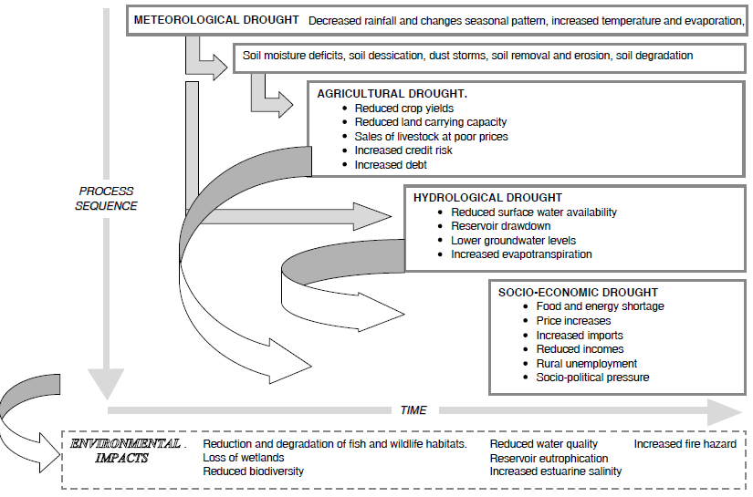
Figure 4: Drought Processes, impacts, and linkage (Adamson & Bird, 2010)
Agricultural drought is driven from meteorological drought. Normally, the limitation of meteorological drought is associated with data (observed data to run a model including SPI is less available spatially and temporally) that could be used to monitor agricultural drought. Then, the authors suggest using a distributed hydrological model such as SWAT to simulate soil moisture and evapotranspiration from daily weather station data (Narasimhan & Srinivasan, 2005). Some other models such as Crop Moisture Index (CMI) developed by Palmer (1968) is also well employed in many countries. To address further data constrains, some models take remotely sensed data to detect drought development, for example, NDVI (A AghaKouchak et al., 2015; Tucker & Choudhury, 1987). Some authors even suggest if for drought early warning (Kogan, 2000). Since remote sensing data is freely available and it could help with drought monitoring, it becomes a standard data source to monitor agricultural drought as vegetation is highly responsive to soil moisture deficit (Anderson et al., 2011).
The indicator for hydrological drought is mainly associated with streamflow. So far, scholars developed streamflow drought index (SDI) with different methods of calculation (Nalbantis & Tsakiris, 2009; Tabari, Nikbakht, & Talaee, 2013). Some authors argued that rainfall runoff could also be used to calculate hydrological drought. They applied the concept of SPI to calculate Runoff Drought Index (RDI) (Shukla & Wood, 2008). The study of drought, especially related to hydrology generally faced with a lack of data and too short time-series data for a particular location such as in developing countries. Some rich data location, groundwater, is used as an indicator to measure hydrological drought (Van Loon, 2015). It has been argued that measuring drought severity always face shortcomings. Keyantash and Dracup (2004) proposed an aggregate drought index (ADI) by combing meteorological, agricultural, and hydrological drought indices. To do so, it will require intensive data, which is not possible for developing countries. It is best to measure hydrological drought in this context by using surface water (Nagarajan, 2009).

2.3. Relevant Drought Indicators in Cambodia
Rainfall and paddy rice damage per season could hardly be correlated on a one-to-one basis. Assuming that total annual rainfall and drought are highly associated, meaning that the less the rain in a given year, the more the drought impacts, then, data does not allow establishing this relationship except the extreme meteorological drought as in 2004 in some provinces. For example, KPS province experienced the most severe damage on paddy production in 2004 at 38,257 hectares (ha) of area cultivated and received total rainfall at 921 millimeters (mm). However, the least precipitation was not in 2004 but 1997 at 770 mm but damage to the cultivated area was 14,962 ha.
Further investigation is required to examine how rainfall in the wet season, not total annual rainfall, impacts on paddy rice production. So far, there is no such study found in the literature. Moreover, the wet season in Cambodia is from May-November, and the distribution of rainfall varied greatly. Frequently, farmers use different rice varieties (3-, 4- and 6 months) to suit their locality, mainly water availability in their paddy fields. Then, it is worthy of investigating if there is an influence of rainfall distribution during the wet season on paddy production of different varieties of rice. Attempts have been made to study drought in Cambodia in the above context.
The earliest literature related to drought studies in Cambodia was done by Steyaert et al. (1981). They used an econometric model to predict yield in developing countries in South and Southeast Asia, including Cambodia. However, the case of Cambodia was not well elaborated on yield prediction and meteorological drought (the report used the Palmer Drought Severity Index (PDSI)). However, they were able to identify drought years based on soil moisture deficit.
NCDM and WFP were trying to map vulnerability to disasters in Cambodia. Natural hazards that were focused on included flood and drought. In terms of drought, they used 30-year precipitation with 0.5-degree resolution (about 50K), and NDVI was taken from an AVHR Satellite (National Committee for Disaster Management, 2003). Given that they can point where the drought-prone communes are located, the study could not confirm the degree (intensity and frequencies) of impacts by drought, meaning that only part of the equation is explained.
A series of study related to climate change was conducted by Ministry of Environment (MoE) in Cambodia and included in their reports ‘Vulnerability and Adaptation Assessment to Climate Change in Cambodia’ (Ministry of Environment, 2001) which were used as inputs to report to UNFCCC in 2002 (Ministry of Environment, 2002) titled ‘Vulnerability and adaptation to climate hazards and to climate change: A survey of rural Cambodia households’ (Ministry of Environment, 2005). The information of the UNFCCC Report was used as inputs to design the ‘National Adaptation Program of Action to Climate Change’ (MoE, 2006), and Cambodia Second Communication to UNFCCC (Ministry of Environment, 2015). None of the studies have been associated with physical data, such as rainfall, with physical damages, such as the impact on paddy rice production. However, they associated the paddy damaged by drought. In the study on household surveys in 2005 of MoE, they tried to understand the nature of drought perceived by the rural community, especially the water availability for their paddy rice production and household consumption. There is a report on flood and drought damage in 1984, 1995, 2001, 2002, and 2011 (MAFF, 2014) but no severity of the drought was reported. Once again, to the author's best knowledge, there are no comprehensive studies on drought in the country done by MoWRAM but there are reports on measures to mitigate drought in Cambodia (MoWRAM, 2014).
In their study, Nguyen and Shaw (2011) attempted to identify rainfall variability in a province, Svay Rieng province, and how people be ready for drought coping mechanisms. Given that the number of years that received less rainfall than long term average has been identified, they failed to associate the implication of those years with drought impacts in the study sites. In other words, the relationship between drought years and the effects from those years were not well described in the study.
Based on people's experience, they said that rice yield increased in 2008 due to good rainfall (Cambodian Development Resource Institute, 2012). In a drought-prone area such as in Kampong Thom province, farmers usually expressed that they faced either flood and/or drought. According to CCC (2007), farmers differentiate drought as a normal drought and severe drought, and they experienced severe drought once every five years. The frequencies of normal drought that farmers experienced, however, are not well identified by the study. This is again confirmed that significant deficiency in rainfall will have a high impact and can be seen through the loss of paddy production.

3. Historical Drought in Cambodia
In the International Disaster Database, which is also called the Centre for Research on the Epidemiology of Disaster (CRED), the disaster criteria include at least one of the following: 10 or more people killed, 100 or more people are affected, declaration of a state emergency or call for international assistance. According to the CRED records, since 1900, Cambodia has experienced flood (Flash flood-3 and riverine-13) 16 times, drought six times, and tropical cyclones three times (EM-DAT, 2019). The drought impact records, however, contain more events than the CRED data. The following data is based on socio-economic drought (which drought already affected and destroyed paddy production in Cambodia). In any drought years, there were no proper studies on meteorological, agricultural, and/or hydrological drought in the country.
Damage to paddy rice caused by flood and drought is recorded in the MAFF’s Agricultural Statistics, especially since 1994. However, data was compiled on damage by drought and flood from various sources – mainly data before 1994, as shown in Figure 5. In total, drought caused 1.09 million hectares of damage and flood caused twice between 1984 and 2018.
It should be noted that Cambodia was experiencing civil war from the 1960s until the 1980s. Political stability has improved since 1993 when there was a general election supported by United Nations agencies known as UNTAC (United Nations Transition Authority in Cambodia). Therefore, while data related to the discussion in this study may not fully reflect reality, it is grounded in media reports, for example, articles from the local newspaper AKP and the Archive Agricultural Statistics at National Library.

Figure 5: Flood and drought damage by paddy area in Cambodia, 1984-2018
Sources: Author’s compilation
Natural hazards had a considerable impact on Cambodia during the 2000s. The year 2000-01 and 2001-02 had the most severe flooding in the period analyzed, as floods hit the farmers hard in two consecutive years, while drought was worst in 2004-05. As shown in Figure 5, between 2000 and 2005, Cambodia was impacted by both flood and drought. Flooding caused extreme damage to paddy rice again in 2011.
The World Bank ranked drought as a more deadly disaster than earthquakes, floods, or storms (World Bank, 2010). However, there is no global agreement on the definition of drought, as mentioned earlier. In Cambodia, drought is recorded based on damage to areas of rice production caused by a lack of water. [Agricultural] drought in 2004 (Figure 6) caused the most damage to paddy rice between 1988-2018. The top four provinces affected by drought 2004 were Kampong Speu, Kampong Cham, Pursat, and Prey Veng. Prey Veng appears to be prone to both flood and drought, for the two worst disaster events in 2000-01 and 2004-05 badly damaged the paddy fields in that region.

Figure 6: Area damaged by drought in 2004-05 and distribution of drought frequency by the province in Cambodia, 1988-2018
Sources: Author’s compilation

Based on annual drought information recorded by provinces in Cambodia between 1988 and 2018, the Kampong Speu, Takeo Banteay Meanchey, and Svay Rieng provinces were considered the most affected provinces while the Koh Kong, Pailin, Kep, and Kratie provinces were considered the least concerned (Figure 6). Given that there are no studies on why some provinces were damaged more than the others while cultivating a rain-fed rice ecosystem, the literature suggests that yield loss and water availability are the main factors contributing to the variability of yield loss (Inthavong, Tsubo, & Fukai, 2012). It should be noted that drought in 2015-2016 impacts some provinces to the northern part such as Banteay Meanchey.
From this section, we can conclude that climatic calamities have highly impacted many provinces in Cambodia. Some provinces, such as the Kampong Speu province, experienced drought almost every year between 1988 and 2018. Within the same period, flood-affected the Kandal province similarly. With data availability and based on total paddy rice damages, the most severe flood occurred in 2000-01 and drought in 2004-05. Some authors claim that while Cambodia is rich in water resources, including rivers, lakes, ponds, aquifers, and stream flows, drought is increasingly affecting food security, future livelihood, and commercial property (Turner, Pangare, & Mather, 2009). Some government reports, especially from the Ministry of Environment (MoE), have confirmed that flood and drought are going to be significant threats and require urgent interventions in addressing climate change impacts in Cambodia (MoE, 2005) and [hydrological] drought is going to be more intense (Ministry of Environment, 2017) and suppressed the economic growth (Ministry o Economy and Finance & National Council for Sustainable Development, 2018).

3.1. Linking Drought in Cambodia to ENSO
Based on drought impact reports in Cambodia from 1980-2019, there were drought events in almost every year. The exceptional drought impact should be in 2004, followed by 1994 and 1991, with the effects ranging from 200,000 in 1991 ha to 247,336 ha in 2004 (Table 3). It is worth discussing about El Niño Southern Oscillation (ENSO) and associated drought impacts in Cambodia. In Table 1, years underlined to indicate the ENSO year. During Exceptional, Extreme, and Severe drought, there was always ENSO occurrence, but some of the moderate drought years are not necessarily driven by ENSO (Table 3). It should also be noted that weak or strong ENSO is not a one-to-one relationship with the degree of severity of drought damage on rice production in Cambodia. For example, in the year 2004, drought impacts were the most severe, but it was in the weak ENSO year. There are cases that the strength of ENSO is highly associated with drought impact in Cambodia, such as in 1997-1998. During the very strong ENSO year 2015-2016, it did not manifest the substantial effects on rice production too. In these cases, rainfall distributions (early, middle, and end) are very critical on the paddy production. Other aspects of drought damaged rice production are related to a microclimate. These are the cases in 2012, 1999, 2000, and 2008 drought.
Table 3: Paddy rice area damaged by drought from 1990-2018
Exceptional drought |  | Extreme drought |  | Severe drought |  | Moderate drought
Year | Damage (ha) | Year | Damage (ha) | Year | Damage (ha) | Year | Damage (ha)
2004 | 247,336 | 1997 | 100,971 | 2003 | 55,782 | 2014 | 20,289
1994 | 230,900 | 1998 | 92,757 | 2001 | 55,622 | 2012 | 19,420
1991 | 200,000 | 2018 | 78,470 | 2002 | 52,000 | 2006 | 9,347
 |  |  |  | 2015 | 41,469 | 1999 | 9,119
 |  |  |  |  |  | 1995 | 8,774
 |  |  |  |  |  | 2005 | 6,720
 |  |  |  |  |  | 2000 | 6,675
 |  |  |  |  |  | 2007 | 5,653
 |  |  |  |  |  | 2009 | 3,754
 |  |  |  |  |  | 2010 | 2,934
 |  |  |  |  |  | 2008 | 1,653
Sources: Author’s compilation
The full pictures of (meteorological, agricultural, and hydrological) drought occurrence in Cambodia could be understood by analyzing rainfall, soil moisture, and surface water, which are discussed in the following section. Those drought occurrences will also be associated with paddy rice damages and the ENSO occurrence. In the earlier section, there was an emphasis that drought analysis using meteorological, agricultural, and hydrological data could be used for drought monitoring, and the ENSO occurrence would be used for drought forecasting. Then, it is strongly emphasized that ENSO must be used to warn the future drought, for there is a lag time from ENSO occurrence in the Pacific and the impacts. Every ENSO years, there should be a shift/reduction in rainfall in Cambodia.
Table 4: El Niño occurrence measuring at 3.4, 1980-2018
Weak | Moderate | Strong | Very Strong
2004-05 | 1986-87 | 1987-88 | 1982-83
2006-07 | 1994-95 | 1991-92 | 1997-98
2014-15 | 2002-03 |  | 2015-16
2018-19 | 2009-10
Source: https://origin.cpc.ncep.noaa.gov/products/analysis_monitoring/ensostuff/ONI_v5.php
A note on ENSO events are defined as five consecutive overlapping 3-month periods at or above the +0.5º anomaly for warm (El Niño) events and at or below the -0.5 º anomaly for cold (La Niña) events. The threshold is further broken down into Weak (with a 0.5 to 0.9 SST anomaly), Moderate (1.0 to 1.4), Strong (1.5 to 1.9), and Very Strong (≥ 2.0) events. For this report for an event to be categorized as weak, moderate, strong, or very strong; it must have equaled or exceeded the threshold for at least three consecutive overlapping 3-month periods.
Table 5: Paddy rice damaged by drought in 2004 (in thousand hectares)
No | Province | Area Cultivated | Area Harvested | Area Damage | % Damages | Rank
1 | Banteay Meanchey | 200.711 | 187.974 | 12.7 | -6% | 8
2 | Battambang | 235.73 | 212.766 | 22.9 | -10% | 5
3 | Kampong Cham | 214.339 | 175.793 | 38.5 | -18% | 1
4 | Kampong Chhnang | 116.98 | 108.781 | 8.2 | -7% | 12
5 | Kampong Speu | 83.134 | 44.808 | 38.3 | -46% | 2
6 | Kampong Thom | 157.44 | 124.397 | 33.1 | -21% | 3
7 | Kampot | 121.908 | 108.448 | 13.5 | -11% | 7
8 | Kandal | 96.608 | 88.905 | 7.7 | -8% | 13
9 | Koh Kong | 8.476 | 8.326 | 0.2 | -2% | 23
10 | Kratie | 39.705 | 28.831 | 10.9 | -27% | 9
11 | Mondulkiri | 13.068 | 4.191 | 8.9 | -68% | 11
12 | Phnom Penh | 6.635 | 6.118 | 0.5 | -8% | 20
13 | Preah Vihear | 24.39 | 22.74 | 1.7 | -7% | 17
14 | Prey Veng | 276.899 | 248.22 | 28.8 | -10% | 4
15 | Pursat | 91.488 | 77.221 | 14.3 | -16% | 6
16 | Ratanak Kiri | 22.452 | 16.037 | 6.4 | -29% | 14
17 | Seam Reap | 187.305 | 182.84 | 4.5 | -2% | 15
18 | Sihanoukville | 11.721 | 11.499 | 0.2 | -2% | 22
19 | Stung Treng | 21.301 | 18.351 | 3.0 | -14% | 16
20 | Svay Rieng | 165.935 | 164.776 | 1.2 | -1% | 18
21 | Takeo | 233.405 | 224.433 | 9.0 | -4% | 10
22 | Oddar Meanchey | 40.71 | 39.82 | 1.0 | -2% | 19
23 | Kep | 2.91 | 2.91 | 0 | 0% | 24
24 | Pailin | 0.93 | 0.655 | 0.3 | -30% | 21

Since 2004 was the major drought, it is worth exploring the provinces which were hardest hit. Based on the area affected by drought, Kampong Cham, Kampong Speu, Kampong Thom, Prey Veng, and Battambang lost the most cultivated area (Table 5). In 2004, provinces with a more significant area of the paddy field area, included Prey Veng, Battambang, Takeo, Kampong Cham, and Banteay Mean Chey. Banteay Mean Chey and Takeo ranked 8 and 10 in the ranking of the impact (based on the area damage) respectively. The analysis could be carried out to explore why the two provinces were not impacted given that Takeo is near Kampong Speu and Banteay Mean Chey is a shared border with Battambang Province.

3.2. Agricultural Context for Drought Analysis
Since drought is a slow onset hazard, the characteristics (early-, middle-drought onset, and early rainfall cessation) of drought must be well understood related to the rice ecosystem in Cambodia. The ecosystems of rice could be distinctively divided into three: cultivating rice without any irrigation system (rain-fed rice), with supplementary irrigation, and dry rice (totally dependent on irrigation). Those without any irrigation system (about 90 percent of total paddy area) would start cultivating their rice from August and harvesting the crop by late November and/or early December (Figure 7). Farmers, having access to supplementary irrigation, would cultivate their rice two times a year by starting the first crop in the early wet season (Late April) and harvesting mid-July, and the same varieties will be from late August to mid-November. Dry season rice is dependent on irrigation (engaging land about 10 percent of total paddy area), and the cultivation is from December to early March.
It should also be noted that farmers have changed their rice production practices from transplanting (required fully soil moisture or highly soaked soil) to direct seedling (very minimum moisture without any muddy). These changes could be driven by three major factors, including lack of labor forces (young rural dwellers are migrating to the city and other countries for work), yields (direct seedling yield higher than transplanting), and cost (direct seedling cost less). Another noticeable change of agrarian way of farming is the replacement of human and animal forces by mechanization in the farming processes - from land preparation to transporting crops to doorsteps. These changes have happened since the early 2010s.
Table 6: Rice ecosystems and impact by different temporal drought
 | Early-onset  (May-Jun) | Middle Season  (Jul-Aug) | Early cessation  (Oct-Nov) | Dry Season  (Dec-Feb)
Early wet season rice | Yes | Yes | No | No
Wet season rice | No | Yes | Yes | No
Dry Season rice | No | No | No | Yes
Vegetation | No | No | Yes | Yes

If early wet season rice is to be cultivated in June – July, it would be impacted by early drought onset. The first few rainfalls during late April would enable farmers to cultivate their early wet season rice. Since this cultivation must not be only depending on precipitation, farmers would have their water supply from their nearby storage (including groundwater) if there are severe droughts in late May and/or June. Regional drought forecasting would be very informative for this early rice cultivation. This crop could also face drought if there is a severe dry spell in July. The cultivation should not be done if there is no supplementary irrigation.
Wet season rice, if based on current practices of rice cultivation (direct seeding), would not require good rainfall in July-August. Too much rain would disturb the rice production. It has been confirmed that there is a severe problem with good rain and bad for cultivation during this period, while more prolonged dry spell would enable farmers to do their medium maturity variety of rice cultivation. Farmers reported that they could not cultivate their rice when there is too much rainfall in this period. Some were trying new techniques by throwing the seed very hard into the saturated soil, expecting that the seeds would get into the ground and remained in the soil. But that technique was not successful. Farmers expressed that when dry spell in the mid-season is more than two weeks, they could start their cropping with ease, or it becomes detrimental to cultivation.
Late-April
May
June
Mid-July
Early Wet Season
Late-Aug
Sept
Oct
Mid-Nov
Wet Season
Late-Dec
Jan
Feb
Mid-Mar
Dry Season
Early maturity Variety Rice
(90 Days from seedling to
harvesting)
Late-April
May
June
July
Early Wet Season
Aug
Sept
Oct
Nov
Wet Season
Mid-Mar
Dry Season
Medium maturity Variety Rice
(120 Days from seedling to
harvesting)
Feb
Early Apr
Dec
Jan
Figure 7: Overview of rice crop calendar in Cambodia
Source: Fieldwork survey
Code for rice cultivation: Layer 1, 2, 3, and 4 are for seedling, vegetative, maturing, and harvesting, respectively. Layers without color are idle land during the month

3.3. Cambodia’s Meteorological Drought
The historical meteorological drought analysis is based on rainfall data from 19 provinces of Cambodia with various lengths (Table 7), but the primary focus is on regions that experienced high drought damaged and the one that has big rice area as shown in Table7. In Table 7, some descriptive statistics are provided. In terms of drought context, these statistics are very crucial, and the most informative one is Standard Deviation (SD). The bigger the SD of rainfall in a province, the more sensitive to meteorological drought (as it is too much rainfall variation) such as Koh Kong. Given that minimum and distribution through the year of rainfall should also be considered, for these will impact on drought severity.

Table 7: Rainfall data availability for drought analysis in Cambodia
No. | Name | Period | Min | Max | Average | SD
1 | Banteay Meanchey | 1985-2018 | 566 | 1542 | 1149 | 198
2 | Battambang | 1981-2018 | 878 | 1707 | 1288 | 188
3 | Kampong Cham | 1983-2018 | 995 | 2165 | 1460 | 247
4 | Kampong Chhnang | 1982-2018 | 1027 | 2853 | 1580 | 361
5 | Kampong Speu | 1983-2018 | 868 | 1768 | 1256 | 231
6 | Kampong Thom | 1981-2018 | 899 | 3212 | 1472 | 406
7 | Kampot | 1985-2018 | 875 | 2775 | 1894 | 381
8 | Kandal | 1985-2018 | 833 | 1907 | 1215 | 268
9 | Koh Kong | 1999-2018 | 2310 | 5432 | 4213 | 802
10 | Kratie | 1980-2018 | 895 | 3325 | 1751 | 429
11 | Phnom Penh | 1981-2018 | 1065 | 2134 | 1416 | 236
12 | Prey Veng | 1984-2018 | 682 | 2136 | 1280 | 295
13 | Pursat | 1981-2018 | 870 | 2056 | 1414 | 276
14 | Siem Reap | 1987-2018 | 1097 | 2250 | 2987 | 265
15 | Preah Sihanouk | 1985-2018 | 1878 | 4340 | 2863 | 590
16 | Stung Treng | 1980-2018 | 1175 | 4050 | 1897 | 546
17 | Svay Rieng | 1981-2018 | 1002 | 2640 | 1673 | 333
18 | Takeo | 1982-2018 | 898 | 1771 | 1271 | 211
19 | Pailin | 1985-2018 | 453 | 1911 | 1177 | 270

3.3.1. Methods for Analyzing Meteorological Drought
The meteorological drought analyzing tool will be based on the Standardized Precipitation Index (SPI), which is employed to show the degree of drought and wetness frequencies and severity. SPI is one of the most popular and can be used in different climate regions. Based on Hao et al. (2014), SPI is listed as one of the indicators for global drought monitoring. SPI is also found to be appropriated, for the equation is based on precipitation only, and it can be calculated for different time scales from 1, 3, 6, 12, or more months depending on data availability. Moreover, SPI has been proved to be suitable in many regions not just for monitoring drought but also floods (Seiler et al., 2002; A. D. Wilhite & Bruchanan-Smith, 2005; Zhang et al., 2009). SPI is also listed in a manual by World Meteorological Organization (WMO) among the other drought indices for drought monitoring (Monacelli, Galluccio, & Abbafati, 2005) and it is used in drought monitoring in the United States and India (Heim Jr, 2002; Pai, Sridhar, Guhathakurta, & Hatwar, 2011; World Meteorological Organization, 2012).
The SPI, developed by McKee et al. (1993), of a particular precipitation time scale, is a value derived from a normally distributed probability density function with a mean of zero and standard deviation of unity. SPI is the probability related to the precipitation point. The standardized precipitation (SP) is the value derived from dividing the variation from the mean of a specific period (or at different time scales: 1, 3, 6, 12, or 48 months) and the standard deviation of the data set. The calculation of the 3-month time scale, for example, June 2004, is the total rainfall of April, May, and June 2004. The corresponding SP and amount of rainfall can also be graphed to understand their distribution. To estimate the probability of the distribution, the Gamma function is used as it fits meteorological data very well and has zero in its lower bound value (McKee et al., 1993; Thom, 1966).
The SPI value is relative to the respective month. The less value of SPI indicates the drought severity of any time scale, and the more value of SPI indicates the wetness intensity based on precipitation (Table 8).
Table 8: Wet and Dry classification based on the SPI index. Adapted from (Cancelliere et al., 2007)
Classification | Index Value | Intensity | Probability
Wet | SPI 2.00 | Extremely wet | 0.977-1.000
 | 1.50 SPI < 2.00 | Very wet | 0.933-0.977
 | 1.00 SPI < 1.50 | Moderately wet | 0.841-0.933
Normal | - 1.00 SPI < 1.00 | Near normal | 0.159-0.841
Drought | - 1.50 SPI < -1.00 | Moderately dry | 0.067-0.159
 | - 2.00 SPI < -1.50 | Severe dry | 0.023-0.067
 | SPI < - 2.00 | Extremely dry | 0.000-0.023

3.3.2. Meteorological Drought in Kampong Cham
Kampong Cham (KPC) province experienced drought impacts higher than other provinces in 2004 (Table 9). This year, drought destroyed 17,647ha of paddy fields in Banteay Meanchey province, 7,723ha in Battambang, 7,563ha in Kampong Thom, and 5,398ha in Kampong Cham (Khor, 2019). In 2018, Battambang and Kampong Cham were the major drought-stricken provinces with damage of more than 10 hectares in five districts of Kampong Cham, including Srey Santhor, Prey Chhor, Chherng Prey and Kampong Siem (Sen, 2018). The following sub-section is to examine the nature of drought; mainly meteorological drought occurred based on rainfall using SPI 3-months.
Early Wet Season Drought
Figure 8 shows early (May, Jun, and July) meteorological drought occurrences in Kampong Cham (the longer the bar chart with a negative number, the more severe the drought). Kampong Cham experience early onset drought a few consecutive years from 2014 to 2018. While between 2006-2013, there was good rainfall during the early rice cultivation season. It should be noted that farmers would cultivate their paddy when there was good rainfall during the early wet season. That paddy with supplementary irrigation would be secure the whole season given there would be a long dry spell in mid-wet season.
Some extreme drought events in Kampong Cham would be in 1992-1993, 2002, and 2015 where there was ENSO occurrence in the Pacific Ocean. In meteorological terms, those events would cause water shortage everywhere. It should be noted that this may not impact on rice cultivation as farmers would not start any agricultural activities. Given that this drought would interrupt those farmers who have access to supplementary irrigation, and they took the risk to start their cultivation as usual.

Figure 8: SPI value for Kampong Cham in Early Wet Season, 1983-2018
Source: Author’s compilation
Figure 8 also shows flood or too much water during the early wet season. For example, in 2009, there would be a lot of water in the paddy field starting from April to June and continued to July. Drought from this event implies that if farmers were fully cultivated their rice (as they have enough water in the field), the long dry spell in the mid-wet season would lead to a lot of rice damages.
Mid Wet Season Drought
Given good rainfall in the early season in 2009, drought could impact on rice field (as explained by meteorological condition) for SPI value in August, and September 2009 (Figure 9) were negative (given it is not significant). For more details value, see Appendix 1.

Figure 9: SPI value for Kampong Cham in mid wet seasons Aug and Sept 1983-2018
Source: Author’s compilation
Figure 9 shows the mid-wet season drought or known as a dry spell. It appears that there were fewer frequencies of a dry spell during the last decades compared to the 1980s except in 2015, where the dry spells were so extreme. If linked with early-onset drought, 2015 were meteorologically extreme.
In many cases, there should be no rice cultivation with this drought intensity. Given that dry spell in 2015 was not the only case in Kampong Cham, there was an extreme dry spell in 1993. It should be noted that both the years 1993 and 2015 were the strong ENSO year.
Late Wet Season Drought
Late meteorological drought and associated with agricultural activities is between October and November. There is no significant sign of late-season meteorological drought in Kampong Cham. It should be noted that when there is good rainfall in the late season, farmers would still cultivate their paddy with short-maturing varieties. Based on SPI3 (3 month-SPI value), the late-season meteorological drought would be more often in the 1980s and 2000s but not in the 2010s. It appears that rainfall is shifting, or wet season is extending longer into November, such as the case of the last three years.

Figure 10: SPI value for Kampong Cham in Oct and Nov 1983-2018
Source: Author’s compilation
Meteorologically, late-season drought in Kampong Cham would occur severely in 2002-2004, where SPI was negative more than one. This is well explained why Kampong was experience drought extremely. It should be noted that any rainfall deficit in the late wet season would impact farmers severely especially those who do not have access to supplementary irrigation.
Comparison of Meteorological Drought in Drought-Prone Provinces
Based on meteorological terms, the province that experience drought the most is Battambang, where late-season drought occurred more often, followed by Kampong Thom, Kampong Speu, Kampong Cham, and Prey Veng (Table 9). This also means that Battambang, located in the north-west of the country, experienced more erratic rainfall during the late wet season, and there are tendencies of more and more late-season drought. In literature, Kampong Speu is well known as a drought-prone province in Cambodia, but in meteorological terms, it is not. It should be noted that Battambang province has more irrigation facilities than another province (based on the discussion in a workshop on “Needs and Technical Capacity Assessment on Agro-Meteorological Services and Drought Risk Management” in Cambodia in August 2019) – given the figure was not consistent among government agencies. This can be translated that better water management would lead to drought impact reduction, given more drastic rainfall variabilities.
In a nutshell, there is a certain degree of connection between drought impacts on paddy cultivation and rainfall deficiency, and especially it holds when the provinces have less access to supplementary irrigation during wet season rice production. There is an active link between ENSO occurrence and rainfall deficiency in Cambodia, given some meteorological droughts occur without the ENSO occurrence (but not the case of strong ENSO years). This is consistent with the literature on ENSO and rainfall in Southeast Asia (Singhrattna, Rajagopalan, Kumar, & Clark, 2005), and drought vulnerability could be reduced through proper water management (Donald A Wilhite, 2012; World Bank, 2010).

Table 9: Intra-seasonal droughts at drought-prone province in Cambodia
Year | K. Cham | K. Speu | K. Thom | P. Veng | Battambang
2000 | - | - | - | LS | -
2001 | - | - | MS | ES, MS, LS | LS
2002 | ES, MS, LS | ES, MS, LS | - | - | ES
2003 | LS | LS | LS | - | LS
2004 | MS, LS | LS | ES | - | ES, LS
2005 | ES | ES | LS | ES, MS | MS
2006 | LS | LS | LS | - | LS
2007 | LS | LS | MS | - | LS
2008 | - | - | ES, MS | - | -
2009 | - | - | MS | LS | MS
2010 | - | - | ES | - | -
2011 | - | - | - | - | -
2012 | - | - | ES | - | MS
2013 | MS | MS | - | LS | -
2014 | - | - | ES, LS | - | ES, MS, LS
2015 | ES, MS | ES, MS, LS | MS, LS | - | ES
2016 | ES | ES | ES | - | ES, MS, LS
2017 | - | - | - | - | -
2018 | - | - | LS | MS | LS
Note: ES – Early season, MS – mid-season, and LS – late season (these intra-seasonal droughts are scored 1, 2, 3 respectively with the implication of paddy damage and lead to low rice production).

3.4. Cambodia’s Agricultural Drought
Agricultural drought in Cambodia is reported by the Department of Agricultural Statistics into two forms: area affected (e.g., paddy is getting dry due to lack of rainfall) by drought and area damaged (longer dry spell damage the crop) by drought (See Section 1 for the drought report). In theories, agricultural drought occurs when soil moisture is insufficient to maintain average plant growth and yields. Then, it is imperative to identify the change of soil moisture in a particular location during the agricultural activities, especially toward the end of the cropping season, which is October and/or November. With the limitation of obtaining data from the ground for a large extended area, remoted sensing data is used to monitor agricultural drought for example (Peters et al., 2002), (Gu et al., 2008), and (Son, Chen, Chen, Chang, & Minh, 2012) who measure agricultural drought between November-April from 2001 to 2010. This is dry season rice. The measurement was based on two remote sensed approach, NDVI, and CWSI (crop water stress index). They found that the two datasets have a strong correlation. Given that the study may bring some misleading results in the Cambodia context as there are not many agricultural activities (mainly rice) in Cambodia during the dry season. To maximize the benefits from agrometeorological drought monitoring, the monitoring activities should be done during the late-season drought (as explained in Table 4).

3.4.1. Methods and Data for Agricultural Drought Analysis
The most common approach to monitoring vegetation development, Normalized Difference Vegetation Index (NDVI) is used to augment drought monitoring techniques. The NDVI is calculated as (NIR-RED)/(NIR+RED), where NIR is the reflectance radiated in the near-infrared waveband, and RED is the reflectance radiated in the visible red waveband of the satellite radiometer. For more comprehensive on the application of remotely sensed data for drought monitoring, see (Annyamba, Tucker, Huete, & Boken, 2005) or recent discussion by (A. AghaKouchak et al., 2015).
With the more substantial extent of an agricultural area such as the paddy rice field, NASA’s Moderate Resolution Imaging Spectroradiometer (MODIS) is recommended as the spatial resolution is at 250 meters, and temporal resolution is eight days. MODIS Terra MOD09A1 Version 6 product provides an estimate of the surface spectral reflectance of Terra MODIS Bands 1 through 7 corrected for atmospheric conditions such as gasses, aerosols, and Rayleigh scattering. The following is the data process (ERDAS Imagine is used in Step 1 and 2, and the rest is based on ESRI ArcMap):
- Download MODIS09A1 data from 2000-2018 during October and November
- Convert from Sinusoidal Coordinate System to WGS 1984 Geographic System
- Rescale digital number from 16 bits to 8 bits unsigned with clipping AOI covering in Cambodia (Figure 11)
- Calculate NDVI
- Export NDVI value using Zonal Statistics as Table using commune boundary as shapefile

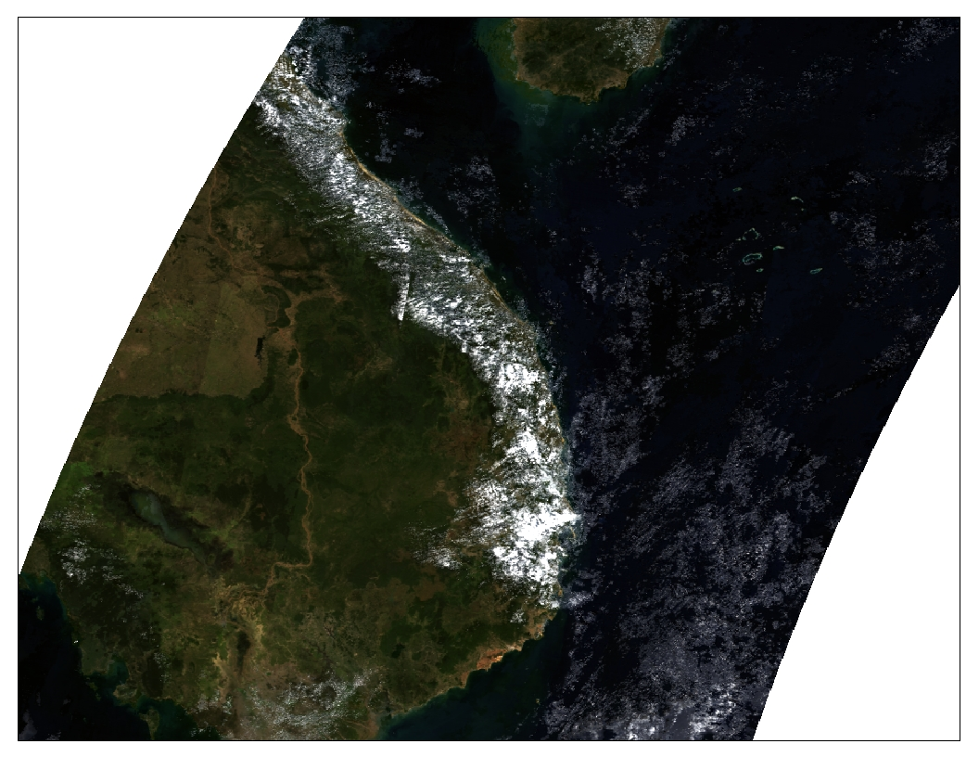
Figure 11: MODIS data path in true color over Cambodia
Source: https://modis.gsfc.nasa.gov/data/dataprod/

3.4.2. Agricultural Drought in Kampong Cham
Since Kampong Cham province was profoundly impacted by drought in 2004, this study selected two communes Chrey Vien and Tong Rong (Figure 12), to examine the changes of NDVI during October/November from 2000-2019 (based on the availability of remotely sensed data). The two months are selected based on the cloud cover the area during image acquisition. It should be noted that NDVI processing should be done only when there are strong indications of meteorological drought in a particular locality.
The two communes are adjacent, but they are different in terms of landscape characteristics. Chrey Vien has access to supplementary irrigation, and there are more trees between rice fields. Almost all plots of residential land have fruit trees and small farming activities. The two communes are active rice productions with the commune total land area 2,343 ha and 1408 ha, respectively. The Chrey Vien has rice ecosystems of 2,311 ha, and Tong Rong has 915 ha.
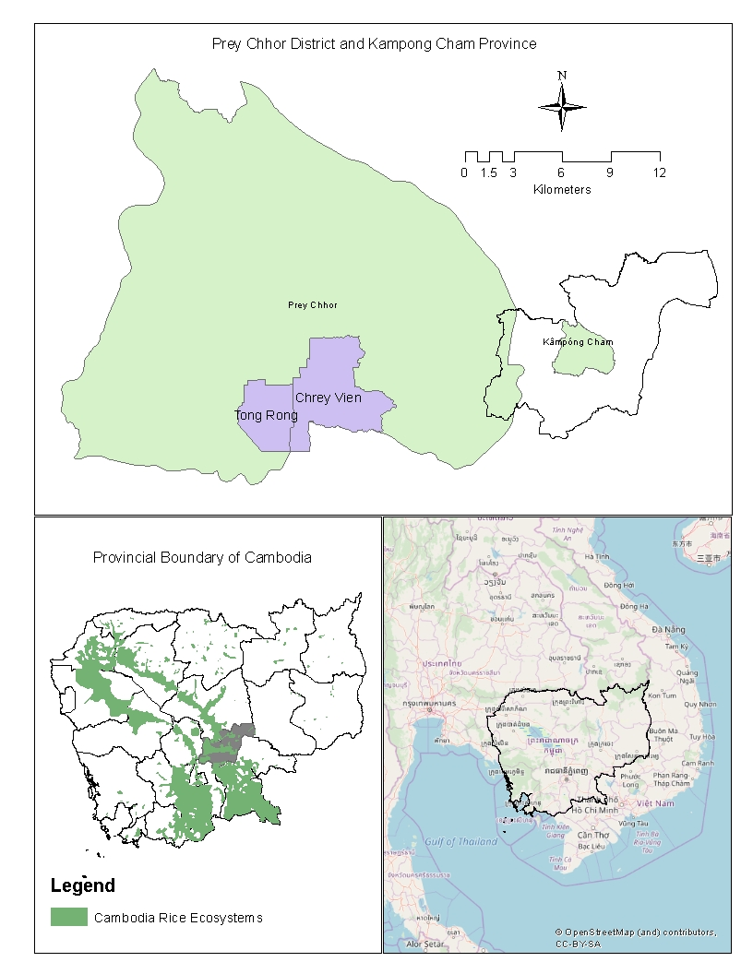
Figure 12: Agricultural drought study sites
Source: https://data.opendevelopmentcambodia.net/en/dataset/map-rice-ecosystem
Based on NDVI value, as shown in Figure 13, the greenness over Chrey Vien and Tong Ron commune increase overtime. During October and November, it is normal to have positive NDVI since it is during the wet season. The landscape would be full of green vegetation, including fruit trees around the house and trees in the paddy fields (one the levee of paddy field). This greenness would change significantly if there is a deficiency of soil moisture. As the figure suggests, the NDVI of the two communes drops together on 8 October 2002 (Julian data 2002281). This is consistent with the Meteorological drought condition in Kampong Cham. The Chrey Vien, however, is greener than Tong Ron due to the former has access to irrigation systems, and more trees are found in the former than the latter.

Figure 13: Changes of NDVI value over Chrey Vien and Tong Ron commune, 2000-2018
Source: Author’s compilation
Based on Figure 13, fieldwork observation, and key informant interview in the two communes, it appears that Tong Rong is very sensitive to drought conditions compare to Chrey Vien, for example, in 2011 and 2013 Tong Rong exhibits a more drastic change of NDVI while Chrey Vien experiences minimal changes. It should be noted that Kampong Cham would experience mid-season drought in 2013 but not in 2011. This also means that Tong Rong has a unique microclimate (higher evapotranspiration, which leads to drought). In 2015 where there was widespread drought impact, which included Tong Rong but not much found in Chrey Vien if based on NDVI as agricultural drought indicator. It could be the fact that supplementary irrigation could significantly reduce drought impact (no agricultural drought) in the commune.

3.5. Cambodia’s Hydrological Drought
Hydrological drought in Cambodia could be related to the depletion of streamflow, surface water, and groundwater that undermine the water supply for household consumption, animal, and/or dry season farming. In many occasions, data of streamflow for significant rivers such as Stung Sen in Kampong Thom or Stung Prek Thnot in Kampong Speu is available, and it could be calculated using methods similar to SPI calculation called ‘Streamflow Drought Index (SDI)’ (Vicente-Serrano et al., 2011). For groundwater data, it is not possible to analyze any Groundwater Drought Index (Bloomfield & Marchant, 2013) since there is very limited data. Given that Surface water availability could be used as a proxy indicator (Garen, 1993) to understand hydrological conditions in many communities for their water supply, where they are depending on surface and groundwater supply.

3.5.1. Methods and Data for Hydrological Drought Analysis
The most common approach to monitor surface water changes by using remote sensing is Normalize Difference Water Index (NDWI). Like NDVI, the NDWI is based on an index approach by deploying different wavelengths (Green – SWIR 1) / (Green + SWIR 1). In the context of hydrological drought in Cambodia where surface water body is small, Landsat (Landsat 8, 7, 5, and 4) data is used as the spatial resolution of the remotely sensed data is 30 meters with the temporal resolution is 16 days. Due to cloud cover over the dam site in data of some years in February such as 2005, 2017, the alternative dataset explored was MODIS and/or early dates of the image were used to estimate the extent of surface water of the site.
To examine hydrological drought in Cambodia, one surface water body in Kampong Speu province (as one of the drought-prone province) was studied to explore the change of its area and link to the drought condition between 1995-2019 in February. The Chan Thnal Dam (CTD) built during the Pol Pot regime and being restored in 1993 and put to operation in 1995 was studied. The Dam supplies water to 300 hectares paddy field and supplementary irrigation to about 1,000 hectares of paddy. About 8 villages of Krang Chek commune, Udong District depends on that dam for the whole year around. The dept of the water could be as much as 2.5 meters at the measurement points. If the water is higher than that elevation, it will spill out through a check-dam on the south-west dike. It should be noted that the source of water of the dam is just the collection of rainfall-runoff within a small sub-basin and dammed in L shape-dikes (as in Figure 14). Toward it north-west, there is another dam (O Ksar).
The dam has many floating plants and some flooded trees. Normally, the open water would be significant in size and dept during the wet season. The water would start to recede after the ease of rainfall or from late October and/or early November. The permanent area of surface water is about 56 hectares (based on GIS data from JICA Land Use in 2002).

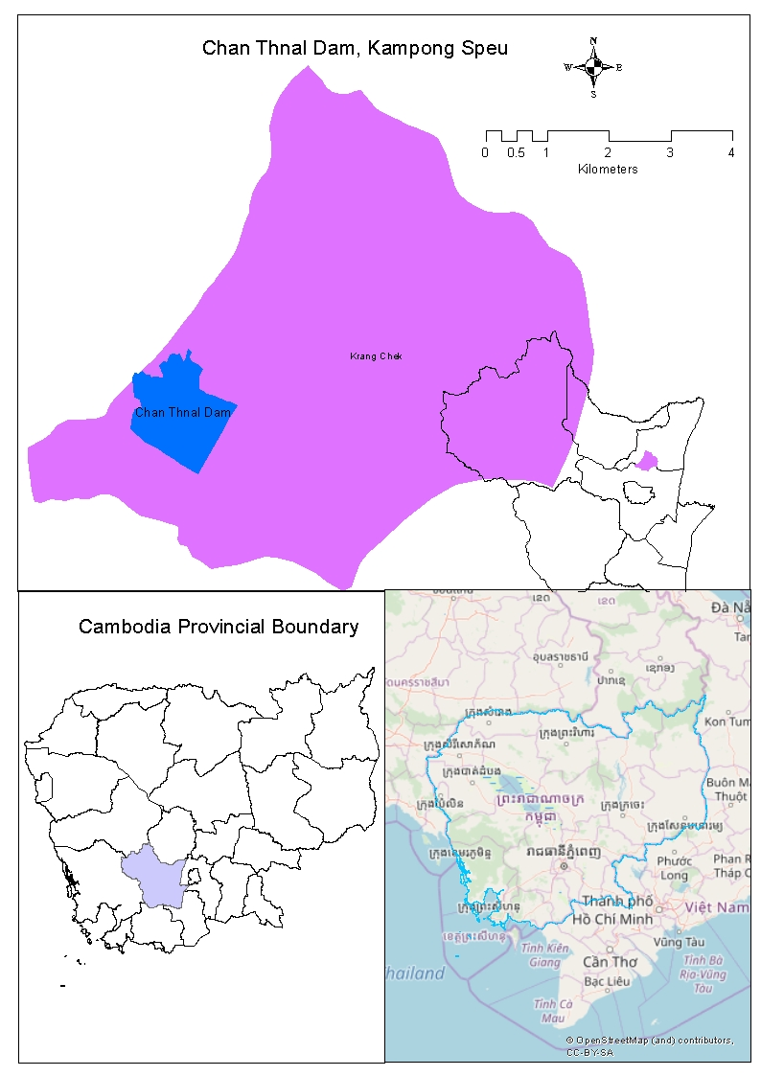
Figure 14: Hydrological drought study site in Kampong Spue Province
Source: Author’s boundary lineation from Landsat Data for Chan Thnal Dam

3.5.2. Hydrological Drought in Kampong Speu
Four years of hydrological condition (area of surface water) in February is presented in Figure 15. It should be noted that there was a big flood in 2001 throughout Cambodia, and the area covered by the water in Chan Thnal Dam (CTD) was about 247.5 hectares. The hydrological condition changed in 2004, where there was a severe drought and reduced the size of surface water to 141 hectares by February 2. The changes in the water surface in 2019 was very similar to 2004 at 147 hectares. It should be noted that there was a drought in 2018 that could lead to water shortage in early 2019.
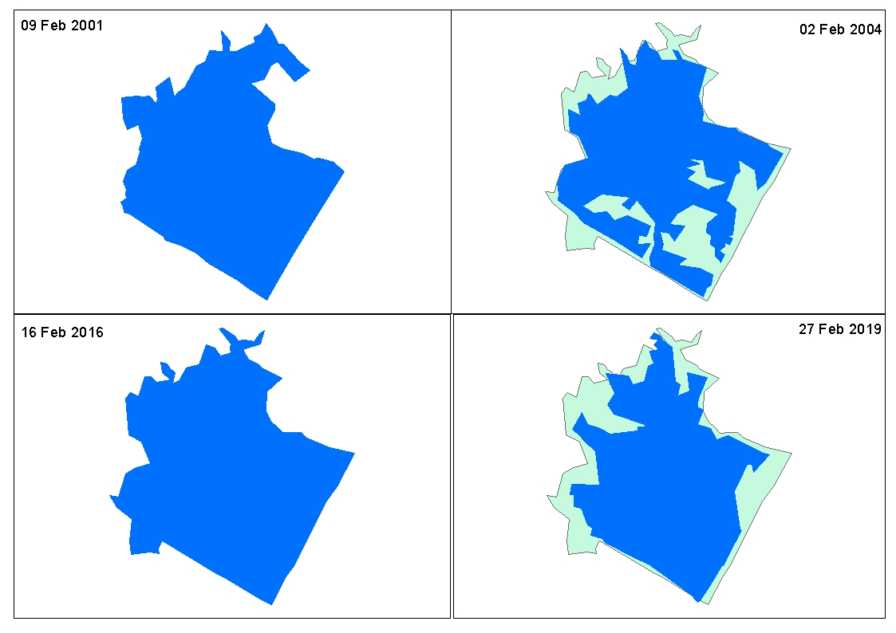
Figure 15: Hydrological changes in February of Chhan Thnal dam, 2001-2019
Source: Author’s boundary lineation from Landsat Data for Chan Thnal Dam

In 2004 and 2019 could be a hydrological drought as the water body receded to the minimum area. Given that the early warning related to this should be combined with the demand of the communities and/or other agricultural activities such as dry rice.
Limitation of using remote sensing data to estimate small open water body:
- The water body normally has vegetation
- Coarse spatial resolution
- Cloud over the sites
- Not sure about the volume of water, especially when the sites accumulate sedimentations
- User must be aware of the site and edit the shapefiles to match ground conditions especially the dike so ensure consistency, and
- The results of classification could be used to classify other land use land cover with strict supervision and should be conducted with ground truth a few times to ensure that the results are reliable.

3.6. Drought Prone/Hotspot Provinces
Drought hotspot provinces could be identified differently depending on their interests. For example, if it is focusing on meteorological drought, we could use SPI value of certain years for each province-where there are rainfall data available (mainly drought years) by interpolating the value in Geographical Information System. Figure 10 shows drought hotspots in Cambodia based on SPI value in 2004 (one of the latest and most severe drought impacts in Cambodia).

3.6.1. Methods and Data for Identifying Drought-Prone Provinces
Rainfall data from 19 provinces (as shown in Table 7) is used to calculate SPI. Only SPI3 (3-months moving average) values of 2004 early (May-Jun), mid- (Jul-Aug), and end (Sept-Oct) season is used to interpolate in ArcGIS (Geographical Information System software by ESRI). 2004 is selected for identifying meteorological drought as that is the most recent year with extreme drought impacts on rice production. Table 8 shows the SPI value of each province for each period. A higher value of SPI in any each period is selected for interpolation since this value already caused the damage to the paddy production, especially in the drought context.

3.6.2. Meteorological Drought-Prone Provinces in Cambodia
It is generally believed that Cambodia is prone to drought and flood. The two climate hazards are associated with a high variation of rainfall within different rainfall zones in the country. Figure 16 (top left) shows a different climate zone in Cambodia. Provinces alone Tonle Sap from South-east to North-west are expecting less rainfall then those in the west (coastal zone) and the north-east (the mountainous area).
Early Season (ES) drought occurred in the western part of Cambodia, mainly Koh Kong, Pailin, and Battambang and some other areas in Kampong Thom and Kampong Chhnang. In some parts of the southern Kampot province would experience ES drought. With this phenomenon, it can be well explained that there was less rainfall than normal in those provinces in 2004.
Mid-season (MS) drought in 2004 (Bottom left of Figure 16) was not widespread, but there was some persistent severity in Pailin and a small part in Kampot province. However, the whole province of Prey Veng experienced a very extreme mid-season drought.

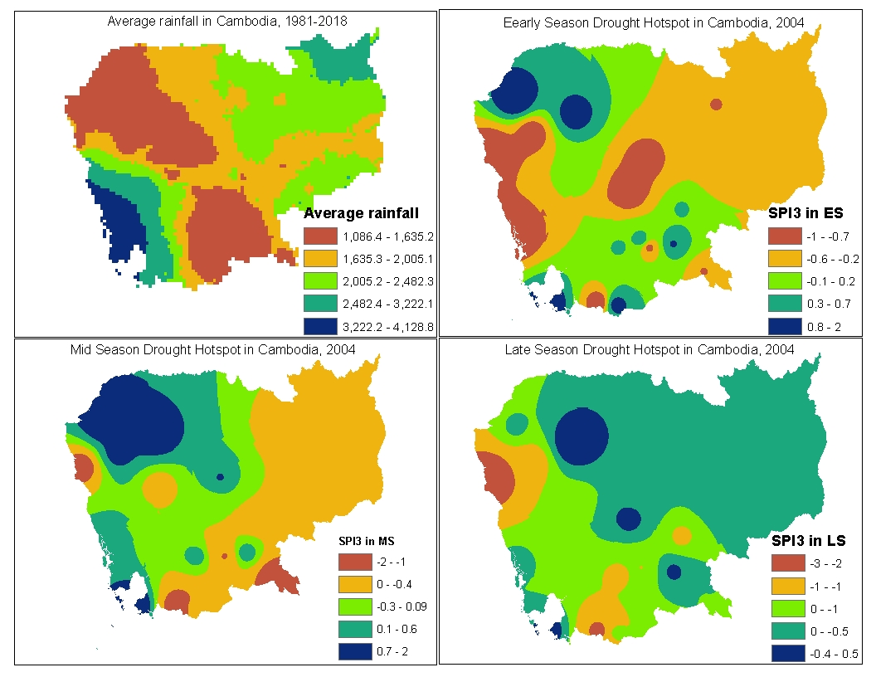
Figure 16: Meteorological drought-prone areas in Cambodia, 2004
Source: Author’s calculation using rainfall data interpolation

Late season (LS) drought (Bottom right) was not much especially for Prey Veng and many of the eastern part of Cambodia. Given that Pailin, some parts of Battambang and Kampot would have severely impacted by drought in 2004.
Given Figure 16 is successfully identified drought hotspots, the maps of meteorological drought hotspots should be updated regularly as the patterns could change depending on many factors, mainly microclimate. Based on the above map, many provinces, such as Kampong Speu and Kampong Cham where usually drought occurs are not appearing in the hotspots. Therefore, it is essential to capture drought vulnerability. Other cases could change the hotspots pattern when we have more rainfall stations. In this analysis, the spatial resolutions of the stations are relatively large.

3.6.3. Drought Vulnerable Provinces in Cambodia
Drought vulnerability was discussed in section one. The map shown in Figure 17 is based on historical drought impacts by province and the meteorological drought, as shown in Table 7 (information from other provinces are included in the analysis). Based on Figure 17, the most vulnerable provinces (in the case of sizeable damage) to drought is Battambang as total drought damages were corresponding to the total drought occurrences. Province such as Takeo and Siem Reap are susceptible to the drought as there was a relatively high number of drought occurrences. Other provinces, such as Banteay Mean Chey, Kampong Thom, Kampong Cham, and Kampong Speu, are also vulnerable to drought.
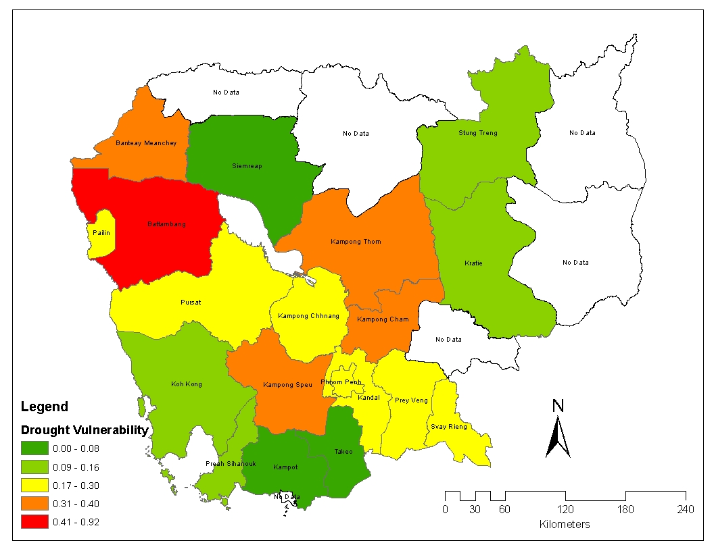
Figure 17: Drought vulnerability provinces
Source: Author’s calculation
Once again, this vulnerability map could change depending on the variable factored into the equation. In literature, the vulnerability map is the backbone of early warning systems, especially when the early warning leads to drought mitigation measures.

3.7. Drought Early Warning Design
Drought early warning (DEW) is still in the development stage. There was an effort by World Meteorological Organization (WMO) to hold an Early Warning Conference in 2000 and concluded that there is no single early warning product that is ready to use (Donald A. Wilhite, Sivakumar, & Wood, 2000). The Conference suggested that DEW must follow by drought monitoring (as drought is slow onset phenomena). It seems that (Sepulcre-Canto et al., 2012) based on WMO recommendation drought monitoring should be based on Precipitation Shortage (WATCH) > Soil Moisture Deficit (WARNING) > Reduced Vegetation Production (ALERT). There is also a recommendation by WMO that the early warning should be part of DRR Framework comprise of four priorities: understanding disaster risk reduction, strengthening disaster risk governance to manage disaster risk, investing in disaster risk reduction for resilience, and enhancing disaster preparedness for effective response and to ‘Build Back Better’ in recovery, rehabilitation, and reconstruction (WMO, 2018).
DEW tools are developed by the Asian Disaster Preparedness Center (ADPC) as part of the SERVIR-Mekong Program. The last update data on drought-related information is in January 2019. There is similar information related to drought developed for Lower Mekong Basin, and the latest update was 13 October 2019. The website provides information related to drought as following, but some information is out of date for example Drought Condition was on 31 May 2018:
- Combined Drought Index (CDI)
- Soil Moisture Deficit Index (SMDI)
- Standardized Precipitation Index (SPI1)
- Standardized Runoff Index (SRI1)
- Dry spell (DS)
- Drought Condition (DC)
- Days without rainfall (DR)
While the website of Lower Mekong Basin (LMB) is informative, there is no ground check and not specific to meet the condition of Cambodia. As elaborated in this report, drought monitoring should be done by having three different indicators with specific purposes. For example, meteorological drought should be based on SPI; agricultural drought should be based on NDVI and hydrological drought based on NDWI. In the case of providing early warning information, it is highly recommended to combine with regional climate indicators, mainly ENSO.
The design of the application would be more complicated, mainly related to more inputs. For example, the DEWS should include SPI, ENSO, and NDVI results (Table 10). This may be complicated when producing a result with automation (Figures 5 and 6). It should be noted that currently, there is no technology available to produce this result yet. So far, there are remotely sensed data analysis for drought monitoring such as in Thailand, but not with the combination of all the three drought triggers.
Table 10: Drought early warning
Trigger | Comments
ENSO | ENSO is telling about regional drought. When ANOM is more significant than 0.5, it signified a possible drought onset in Cambodia. From this indicator, drought in Kampong Speu committee should be alerted and be ready for drought early warning.
SPI | When SPI negative from 1 (or depending on calibration on the ground), it is showing the meteorological drought. It can also reflect the water availability on the ground, too, if the time scale is set for a particular usage.
NDVI | NDVI is mainly agricultural drought, which is based on the greenery of the agricultural field. The usage of NDVI value in a particular region/area must be contextualized depending on the crop varieties and stages of growth.
For a more versatile application, there should be included drought interventions according to the crop (or other drought impact outcomes such as health) impact by drought. This requires building a database on drought interventions depending on drought severity and the crop impact by drought. Example of the early warning: if SPI is less than negative 0.99, the pumping machine should be checked and ready for pumping water if SPI was getting less than negative 1.2 (this threshold should be checked with locality as shown in Figure 18).
ENSO > 0.5?
SPI < - 0.99
NDVI < 0.5
Meteorological drought
Agricultural drought
Yes
Yes
No
Yes

Figure 18: Simple drought early warning application
For the hydrological drought monitoring, it must be more specific to the locality. The fact that remotely sensed data could estimate the area of surface water, it is a must to estimate the volume that is available for domestic demand. Moreover, other sources of water supply should also be considered, such as groundwater and/or stream. Since this data is not available, especially groundwater, it is not possible to design and groundwater drought monitoring.
This report aims to assess regional drought platforms and provide recommendations for drought early warning development in Cambodia. Four major drought platforms are in the public domain and covering Cambodia, namely Global Drought Observatory (GDO), Global Disaster Alert and Coordination System (GDACS), SERVIR Mekong, and Lower Mekong Basin (LMB). GDACS is a platform that extracts drought information from GDO by focusing on a few mainland countries in Southeast Asia including China, India, Laos, Myanmar, Thailand, and Vietnam. Similar GDACS, LMB extracts data from SERVIR Mekong and display drought information for countries Cambodia, Laos, Thailand, and Vietnam.

4. Drought EWS Platform Assessment
This section aims to assess regional drought platforms and provide recommendations for drought early warning development in Cambodia.

4.1. GDO and GDACS
This GDO is a global platform providing drought forecasting information since 2013. There are three major indicators designated for meteorological drought - Standardized Precipitation Index (SPI), and agricultural drought - Soil Moisture Anomaly (SMA), and Fraction of Absorbed Photosynthetically Active Radiation (FAPAR).
The GDO computes the Standardized Precipitation Index (SPI) to forecast Extreme Wet and Dry by using data from the long-range (i.e. seasonal) forecast system (SEAS5) of the European Centre for Medium-Range Weather Forecasts (ECMWF). SPI-1, SPI-3, and SPI-6 are computed monthly with the spatial resolution of 1 degree (~110 Square Kilometers).
SMA is computed from three main datasets involving with the hydrological model, remotely sensed data - MODIS11C2, and Skin Moisture Product. It is argued that the lower the SMA, the drier the soil condition and lead to drought. The spatial of the SMA dataset from GDO is at 10 Kilometers and released every 10-day of the month.
FAPAR anomaly is mainly based on remotely sensed data – MODIS15A2H, collection 6. The computation of FAPAR was from 2001 and made available every 10th day of the month. The spatial resolution is like SMA, given that the MODIS15A2H is 500 m resolution.
The warning of extreme events will be publicized when the result is robust (Linacre, 1992). There is three degrees of warming: 1, 2, and 3 for the wet and dry condition. If it is level 1, it means that degree of severity is in a 10-year return period, 2 is a 20-year return period, and 3 the maximum level but it is based on the 36-year re-forecasting period of the SEAS5 data.
Besides the limitation disclosed by GDO (dependence on the quality of SEAS5 forecasts, coarse spatial resolution (Figure 19), and limited data period), there are other challenges for local application. First, we are not sure if the threshold set by the systems are reflecting the ground mainly in Cambodia as it was done in the European context. Second, rainfall data are not calibrated to reflect the ground. It is much better to conduct a rigorous study to check the validity and reliability of data sources so that the early warning is reflecting the locality. Moreover, these indicators are the same as SERVIR Mekong Services with a better temporal and spatial resolution (see the following discussion on SERVIR Mekong drought early warning services).
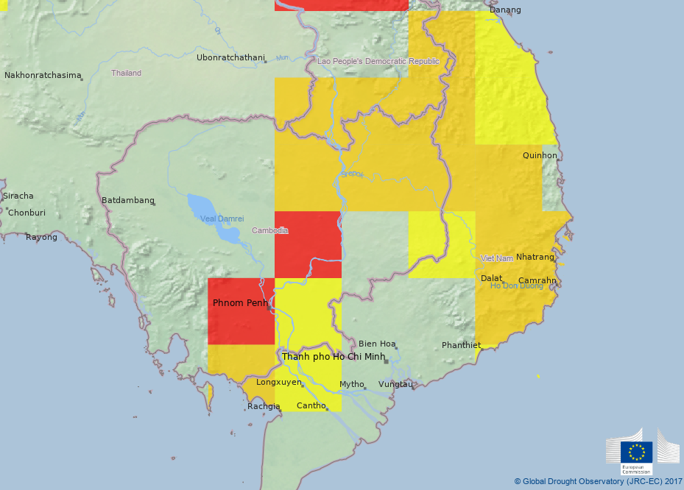
Figure 19. Risk of Drought Impact for Agriculture, October 2015
Source: https://edo.jrc.ec.europa.eu/gdo/php/index.php?id=2001
GDACS made some more efforts to ensure higher accuracy in their designated countries by focusing the only drought based on GDO warning data. GDACS uses color codes to indicate drought severity, ‘Green,’ ‘Orange,’ and ‘Red.’ It seems that given that the onset of drought ‘Green’ status, no specific action would be envisaged by international aid providers, for there is no evidence of impact. When it goes to ‘Red,’ they will issue foreign aid, for there are life-threatening impacts on people. This drought platform is, again, not for the local intervention, and there are limitations, as mentioned in the early paragraph.

4.2. SERVIR Mekong and LMB
SERVIR Mekong develops and produces drought data for early warning in Lower Mekong Region (LMR), which are including Cambodia, Myanmar, Laos, Thailand, and Vietnam. All datasets (which will highlight in the following) were in raster and masked into the country administrative area. The datasets are generated from the RHEAS modeling framework using CHIRPS rainfall, NCEP temperature, and wind, SMAP/SMOS soil moisture, NMME seasonal forecast products in 0.25-degree resolution to cover LMR. The various temporal and spatial scale data can be downloaded for free from the Climate Hazards Center.
While other datasets are not possible to check, CHIRPS rainfall is a potential candidate to verify with observed data in Cambodia to prove that is reliable, it worth of examining to check how much it is accurate and reliable in Cambodia given that it has been argued that CHIRPS can be used in the Greater Horn of Africa to measure the hydrological impacts of lower rainfall and rising air temperatures. Using the Variable Infiltration Capacity model, the authors show that CHIRPS can support successful hydrological forecasts and trend analyses in south-eastern Ethiopia (Funk et al., 2015).
The following sub-sections are assessing the drought-related data and models available in Cambodia. It should be noted that the LMB platform does not provide raw data for further verification as it is just the interface of SERVIR Mekong, which means that after processing all data, LMB is deployed to display results. There is no drought early warning related information for a certain location provided by SERVIR Mekong.

4.2.1. Assessing CHIRPS Rainfall Data
Monthly global raster CHIRPS (0.05⁰ resolution) rainfall data is downloaded from the website and masked into the Cambodian boundary. There are multiple temporal scales for the CHIRPS dataset, but the data is two months latency. Zonal Statistics is used to extract CHIRPS monthly rainfall at the provincial border by using ArcMap (Geographical Information Systems Software). The CHIRPS data is examined with observed rainfall data from 19 provinces in Cambodia that have long time series data. Only five provinces with drought-prone are comprehensive analysis (SPI) in this report namely: Battambang, Kampong Speu, Kampong Cham, Kampong Thom, and Prey Veng.

Table 11: Annual CHIRPS rainfall data for drought analysis in Cambodia, 1981-2018
No. | Name | CHIRPS data |  |  |  | Observed data |  |  |  | p-value
 |  | Min | Max | Average | STD | Min | Max | Average | STD
1 | Banteay Meanchey | 1240 | 1380 | 1310 | 99 | 566 | 1542 | 1149 | 198 | 0.001
2 | Battambang | 1567 | 1707 | 1637 | 98 | 878 | 1707 | 1288 | 188 | 0.000
3 | Kampong Cham | 1557 | 1672 | 1614 | 81 | 995 | 2165 | 1460 | 247 | 0.000
4 | Kampong Chhnang | 1683 | 1783 | 1733 | 71 | 1027 | 2853 | 1580 | 361 | 0.043
5 | Kampong Speu | 1858 | 1995 | 1927 | 97 | 868 | 1768 | 1256 | 231 | 0.000
6 | Kampong Thom | 1584 | 1792 | 1688 | 147 | 899 | 3212 | 1472 | 406 | 0.000
7 | Kampot | 1985 | 2142 | 2063 | 111 | 875 | 2775 | 1894 | 381 | 0.006
8 | Kandal | 1296 | 1325 | 1310 | 21 | 833 | 1907 | 1215 | 268 | 0.016
9 | Koh Kong | 3375 | 3606 | 3491 | 163 | 2310 | 5432 | 4213 | 802 | 0.000
10 | Kratie | 1700 | 2018 | 1859 | 225 | 895 | 3325 | 1751 | 429 | 0.028
11 | Phnom Penh | 1406 | 1455 | 1430 | 34 | 1065 | 2134 | 1416 | 236 | 0.371
12 | Prey Veng | 1357 | 1394 | 1376 | 26 | 682 | 2136 | 1280 | 295 | 0.012
13 | Pursat | 2205 | 2266 | 2236 | 44 | 870 | 2056 | 1414 | 276 | 0.000
14 | Siem Reap | 1388 | 1458 | 1423 | 50 | 1097 | 2250 | 2987 | 265 | 0.213
15 | Preah Sihanouk | 2915 | 3262 | 3088 | 245 | 1878 | 4340 | 2863 | 590 | 0.081
16 | Stung Treng | 1980 | 2094 | 2037 | 81 | 1175 | 4050 | 1897 | 546 | 0.000
17 | Svay Rieng | 1467 | 1599 | 1533 | 93 | 1002 | 2640 | 1673 | 333 | 0.301
18 | Takeo | 1318 | 1375 | 1346 | 40 | 898 | 1771 | 1271 | 211 | 0.033
19 | Pailin | 1409 | 1703 | 1556 | 208 | 453 | 1911 | 1177 | 270 | 0.000
Source: Author’s calculation
Table 11 shows descriptive statistics of CHIRPS and observed data and a p-value derived from the t-test. The t-test is used to check if the annual observed and CHIRPS data are statistically significant. The test is based on two tails test with ‘t-Test: Two-Sample Assuming Equal Variances’ at Alpha 0.05 of a significant level. When the p-value is more than 0.05, the CHIRPS data could be assumed that it is no different from observed data; in other words, it could be used to represent the observed data.
Based on Table 11, the CHIRPS data for each province is statistically different from ground data (observed data) except some locations such as Phnom Penh, Siem Reap, and Preah Sihanouk Ville, where CHIRPS is good to represent observed data. It could be the fact that ground stations of CHIRPS data are derived from those locations. Figure 20 illustrates how the two data behaves between 1981-2018 in Phnom Penh rainfall station. The two datasets have resembled each other except 2008 and 2015, where CHIRPS data over and underestimate the observed data, respectively.
It seems that CHIRPS data is very conservative as the minimum and maximum values are much higher and low than the observed data. For example, in Table 1, the observed minimum-maximum in Kampong Speu data between 1983-2018 was 878-1707 millimeters, while the CHIRPS is 1858-1995 millimeters. Another aspect that could impact statistical test is the average and standard deviation (STD) of data where CHIRPS data is far different from observed such as Kampong Cham where STD are 81 and 247, respectively.

Figure 20: Observed and CHIRPS data for Phnom Penh Station, 1981-2018
Source: Author’s calculations
The CHIRPS data is generally overestimated observed one, as shown in Figure 20. Given that the two datasets converged in 2001, the trended deviated since 2002. The use of the dataset must be careful when they are converted into an index such as the Standardized Precipitation Index (SPI) as they represented very similar values.

Figure 21: Observed and CHIRPS data for Kampong Speu Station, 1983-2018
Source: Author’s calculations

Since CHIRPS data is corresponding very well with observed data (Table 12), many benefits could be yielded from using CHIRPS data. First, it could be used the do the same jobs as observed data after we calibrate it based on empirical data from those rainfall stations. Then, the calibrated data could be used to assess drought conditions for other locations where there are no rainfall stations and/or filling data gaps for those stations with shorter data lengths. Also, the CHIRPS data is available in near real-time with longer time series data. As suggested by Table 12, some stations have a very strong correlation coefficient, such as Koh Kong and Banteay Mean Chey at 0.90 and 0.83 respectively.

Table 12: Correlation of CHIRPS and Observed rainfall data in Cambodia
No. | Name | Correlation Efficient | R Square
1 | Banteay Meanchey | 0.83 | 0.68
2 | Battambang | 0.80 | 0.64
3 | Kampong Cham | 0.79 | 0.62
4 | Kampong Chhnang | 0.74 | 0.55
5 | Kampong Speu | 0.75 | 0.56
6 | Kampong Thom | 0.75 | 0.56
7 | Kampot | 0.73 | 0.53
8 | Kandal | 0.74 | 0.54
9 | Koh Kong | 0.90 | 0.80
10 | Kratie | 0.76 | 0.57
11 | Phnom Penh | 0.82 | 0.66
12 | Prey Veng | 0.76 | 0.58
13 | Pursat | 0.70 | 0.49
14 | Siem Reap | 0.79 | 0.62
15 | Preah Sihanouk | 0.87 | 0.76
16 | Stung Treng | 0.81 | 0.65
17 | Svay Rieng | 0.78 | 0.61
18 | Takeo | 0.75 | 0.56
19 | Pailin | 0.74 | 0.55

4.2.2. Drought Assessment Using CHIRPS Rainfall Data
Table 13 shows the SPI values derived from Kampong Speu between 1983-2018 but trimmed to 2000-2018. During this period, drought events occurred by using observed SPI were 13 times, and CHIRPS were 10. CHIRPS estimated more early-season drought while observed data resulted in more late-season drought. There are many years that CHIRPS failed to identify drought events such as 2005 and 2016 when there were also drought impacts on the ground. In 2001, it was the flood year, but CHIRPS identified as drought year for the whole cropping period. The calculation of Critical Success Index (CSI) from Table 13 found that the CHIRPS data could predict drought onset in Kampong Speu at about 16 percent the remaining are either Missed (drought occurred, but CHIRPS failed to identify) or False alarms (drought occurred, but CHIRPS was unable to identify as drought period).

Table 13: SPI drought occurrence based on observed and CHIRPS data
Year | Observed | CHIRPS | Year | Observed | CHIRPS
2000 | - | - | 2010 | - | ES
2001 | - | ES, MS, LS | 2011 | - | -
2002 | ES, MS, LS | ES, MS, LS | 2012 | - | -
2003 | LS | - | 2013 | MS | -
2004 | LS | LS | 2014 | - | -
2005 | ES | - | 2015 | ES, MS, LS | ES
2006 | LS | - | 2016 | ES | -
2007 | LS | - | 2017 | - | -
2008 | - | - | 2018 | - | LS
2009 | - | -
Note: ES – Early season, MS – mid-season, and LS – late season
The products of SERVIR Mekong and displayed by LMB related to drought early warning are Combined Drought Index (CDI), Soil Moisture Deficit Index (SMDI), Standardized Precipitation Index (SPI), Standardized Runoff Index (SRI1), Dryspell (DS), Drought Condition (DC), Days without rainfall (DR). As discussed in the secondary Report, only CDI is updated regularly and displayed in the LMB website. The following models were assigned for different drought types:
- SPI (1,3,6,12): Standardized Precipitation Index > Meteorological drought
- SMDI (daily and 5-day average): Soil Moisture Deficit Index > Agricultural drought
- SRI (1,3,6,12): Standardized Runoff Index > Hydrological drought
- Dry Spells: Number of dry spell events with at least 2-week duration > Agricultural drought
- RZSM: Root Zone Soil Moisture > Agricultural drought
- Drought Severity > Agricultural drought
Then, raw data of daily SPI3, SRI3, and SDMI from 1981-2018 is downloaded from the SERVIR Mekong website and verified in the form of meteorological, agricultural, hydrological drought, respectively. Daily data is averaged for respectively month of the year then Compared to the actual drought condition in Cambodia. The following are the process of calculating drought events in Cambodia.
In this study, we download SPI, SRI, SMDI, and CDI > then using ArcMap to extract Raster Value (GIS-Zonal Statistics as Table as dbf format) with provincial boundary Shapefile > Convert *.dbf file (from Zonal Statistics) to Excel > Average SPI, SRI, SMDI, and CDI value to Monthly Value between 1981-2018. Daily data on the year 2004 was also examined to check if they reflected any ground information since it was one of drought disaster years.

4.2.3. Meteorological Drought
As demonstrated in Section 1 and 2, the provinces that were hard hit by drought and prone to drought are Battambang, Kampong Speu, Kampong Thom, Kampong Cham, and Prey Veng. Then, meteorological drought events derived from the models will be verified for those regions, and the assessment details will be done for Kampong Speu Province only, as there is more information related to the province.
Figure 22 illustrates the monthly SPI3 in Kampong Speu. Based on the figure, it is misleading information as there is no drought at all during those years, given that the province has experienced drought impacts during the 2000s. It seems that drought occurs only in the early years or in the dry season but not in the wet season. Averaging SPI values for monthly value is not practical in this case. Given that it is also not practical to have daily SPI3 (moving average of consecutive days for three days) value as drought is a slow onset.

Figure 22: Monthly SPI3 for selected years for Kampong Speu Province
Source: Author’s calculation
Table 14 shows the daily values of SPI3 extracted from the SERVIR Mekong Model for 2004 in Kampong Speu province. Based on the value, it seems that there is a major agreement between Figure 22 and Table 14, for there were many days with negative daily SPI3 value between Jan-April while positive value from May to November. This is to confirm that daily rainfall is not suitable for drought monitoring and/or forecasting. Since SERVIR Mekong also provides a daily five-day moving average of SPI12 (the longest period of the dataset provided by SERVIR Mekong for drought monitoring and forecasting), the following sections are also examining these data models.

Table 14: Drought events based on SPI3 using SERVIR Mekong in Kampong Speu, 2004
Day | Jan | Feb | Mar | Apr | May | Jun | Jul | Aug | Sep | Oct | Nov | Dec
1 | -0.36 | -1.62 | -1.65 | -1.35 | -0.81 | -0.12 | 0.46 | 1.20 | 1.30 | 1.47 | 0.90 | 0.36
2 | -0.44 | -1.62 | -1.65 | -1.29 | -0.80 | -0.10 | 0.50 | 1.20 | 1.30 | 1.50 | 0.88 | 0.36
3 | -0.48 | -1.62 | -1.61 | -1.27 | -0.77 | -0.08 | 0.51 | 1.20 | 1.29 | 1.57 | 0.87 | 0.34
4 | -0.55 | -1.40 | -1.57 | -1.23 | -0.81 | -0.07 | 0.53 | 1.22 | 1.28 | 1.62 | 0.85 | 0.33
5 | -0.63 | -1.40 | -1.56 | -1.21 | -0.78 | -0.03 | 0.50 | 1.17 | 1.24 | 1.67 | 0.85 | 0.28
6 | -0.66 | -1.40 | -1.56 | -1.16 | -0.76 | 0.00 | 0.50 | 1.15 | 1.26 | 1.66 | 0.85 | 0.27
7 | -0.66 | -1.40 | -1.56 | -1.12 | -0.68 | 0.06 | 0.52 | 1.14 | 1.23 | 1.64 | 0.84 | 0.27
8 | -0.66 | -1.45 | -1.56 | -1.12 | -0.62 | 0.10 | 0.53 | 1.11 | 1.21 | 1.59 | 0.80 | 0.27
9 | -0.69 | -1.64 | -1.56 | -1.12 | -0.60 | 0.15 | 0.56 | 1.10 | 1.20 | 1.58 | 0.83 | 0.22
10 | -0.78 | -1.64 | -1.59 | -1.12 | -0.56 | 0.16 | 0.60 | 1.14 | 1.19 | 1.55 | 0.84 | 0.16
11 | -0.82 | -1.64 | -1.67 | -1.09 | -0.53 | 0.18 | 0.61 | 1.14 | 1.17 | 1.57 | 0.79 | 0.13
12 | -0.92 | -1.64 | -1.67 | -1.08 | -0.53 | 0.23 | 0.63 | 1.11 | 1.16 | 1.57 | 0.79 | 0.09
13 | -0.96 | -1.64 | -1.70 | -1.05 | -0.53 | 0.31 | 0.66 | 1.10 | 1.15 | 1.54 | 0.79 | 0.08
14 | -1.03 | -1.65 | -1.70 | -1.06 | -0.48 | 0.35 | 0.66 | 1.10 | 1.12 | 1.54 | 0.76 | 0.04
15 | -1.21 | -1.66 | -1.70 | -1.04 | -0.42 | 0.40 | 0.70 | 1.10 | 1.14 | 1.51 | 0.68 | -0.02
16 | -1.31 | -1.66 | -1.71 | -1.03 | -0.42 | 0.45 | 0.70 | 1.13 | 1.19 | 1.49 | 0.60 | -0.07
17 | -1.50 | -1.65 | -1.71 | -1.03 | -0.41 | 0.45 | 0.73 | 1.21 | 1.22 | 1.46 | 0.58 | -0.11
18 | -1.52 | -1.65 | -1.84 | -1.03 | -0.39 | 0.46 | 0.75 | 1.28 | 1.24 | 1.42 | 0.58 | -0.16
19 | -1.53 | -1.65 | -1.84 | -1.09 | -0.39 | 0.46 | 0.77 | 1.26 | 1.28 | 1.36 | 0.57 | -0.19
20 | -1.51 | -1.65 | -1.84 | -1.04 | -0.39 | 0.45 | 0.81 | 1.24 | 1.30 | 1.32 | 0.57 | -0.20
21 | -1.60 | -1.65 | -1.83 | -1.03 | -0.34 | 0.45 | 0.87 | 1.24 | 1.30 | 1.31 | 0.53 | -0.21
22 | -1.60 | -1.65 | -1.65 | -1.03 | -0.31 | 0.45 | 0.90 | 1.22 | 1.31 | 1.28 | 0.53 | -0.22
23 | -1.60 | -1.65 | -1.65 | -1.01 | -0.30 | 0.46 | 0.90 | 1.23 | 1.31 | 1.25 | 0.50 | -0.26
24 | -1.60 | -1.65 | -1.65 | -0.97 | -0.27 | 0.46 | 0.91 | 1.23 | 1.33 | 1.22 | 0.48 | -0.30
25 | -1.60 | -1.65 | -1.65 | -0.95 | -0.24 | 0.43 | 0.94 | 1.26 | 1.36 | 1.22 | 0.52 | -0.35
26 | -1.60 | -1.65 | -1.65 | -0.95 | -0.24 | 0.42 | 0.97 | 1.27 | 1.36 | 1.20 | 0.49 | -0.38
27 | -1.60 | -1.65 | -1.57 | -0.94 | -0.24 | 0.42 | 0.96 | 1.27 | 1.38 | 1.15 | 0.45 | -0.39
28 | -1.60 | -1.65 | -1.50 | -0.92 | -0.23 | 0.43 | 0.98 | 1.27 | 1.38 | 1.09 | 0.44 | -0.45
29 | -1.62 | -1.60 | -1.42 | -0.91 | -0.23 | 0.43 | 1.00 | 1.27 | 1.38 | 1.01 | 0.42 | -0.48
30 | -1.62 |  | -1.35 | -0.85 | -0.18 | 0.44 | 1.03 | 1.28 | 1.36 | 0.91 | 0.38 | -0.73
31 | -1.62 |  | -1.35 |  | -0.11 |  | 1.11 | 1.28 |  | 0.92 |  | -0.96
Source: Author’s Calculation
Figure 5 shows the average monthly SPI12 for flood and drought periods in Kampong Speu province. Major drought year was in 2001, but the SPI12 shown a drought period from August to December. Another miss leading figure is in 2006 where there was a drought in Kampong Speu, but the model suggested as flooding year where SPI12 value is above positive 1. One could argue that averaging SPI12 as monthly may not be appropriated. Then, Table 15 illustrates daily SPI12 for Kampong Speu in 2004. One again, SPI12 daily in 2004 in Kampong Speu is not reflecting the ground information as there was a severe drought during the late season. Based on Figure 23 and Table 15, it can be argued that SPI12 values are not necessarily showing ground information. Given that SPI12 is more sensitive than SPI3.

Figure 23: Monthly SPI12 for selected years for Kampong Speu Province
Source: Author’s calculation

Table 15: Drought events based on SPI12 using SERVIR Mekong in Kampong Speu, 2004
 | Jan | Feb | Mar | Apr | May | Jun | Jul | Aug | Sep | Oct | Nov | Dec
1 | 0.35 | 1.03 | 0.96 | 0.25 | 0.18 | 0.22 | 0.40 | 0.87 | 0.78 | 0.38 | 0.18 | 0.28
2 | 0.96 | 1.03 | 0.95 | 0.29 | 0.17 | 0.29 | 0.49 | 0.86 | 0.76 | 0.46 | 0.18 | 0.32
3 | 0.96 | 1.03 | 0.89 | 0.31 | 0.11 | 0.33 | 0.51 | 0.91 | 0.74 | 0.66 | 0.18 | 0.32
4 | 0.96 | 1.10 | 0.85 | 0.36 | 0.08 | 0.35 | 0.46 | 0.95 | 0.69 | 0.85 | 0.10 | 0.32
5 | 0.96 | 1.09 | 0.86 | 0.39 | 0.07 | 0.44 | 0.23 | 0.96 | 0.63 | 0.97 | -0.05 | 0.30
6 | 0.96 | 1.09 | 0.86 | 0.45 | 0.02 | 0.51 | 0.22 | 0.94 | 0.54 | 0.83 | -0.07 | 0.25
7 | 0.96 | 1.09 | 0.86 | 0.49 | 0.05 | 0.62 | 0.16 | 0.91 | 0.32 | 0.78 | -0.07 | 0.25
8 | 0.96 | 1.13 | 0.86 | 0.47 | 0.16 | 0.72 | 0.02 | 0.91 | 0.32 | 0.64 | -0.07 | 0.24
9 | 0.96 | 1.13 | 0.76 | 0.43 | 0.07 | 0.78 | 0.08 | 0.87 | 0.22 | 0.59 | 0.00 | 0.24
10 | 0.96 | 1.13 | 0.76 | 0.44 | 0.09 | 0.79 | 0.26 | 0.91 | 0.29 | 0.49 | 0.01 | 0.24
11 | 0.97 | 1.04 | 0.75 | 0.48 | 0.14 | 0.68 | 0.19 | 0.82 | 0.29 | 0.43 | 0.01 | 0.23
12 | 0.97 | 1.04 | 0.68 | 0.49 | 0.10 | 0.76 | 0.20 | 0.63 | 0.29 | 0.39 | 0.01 | 0.24
13 | 0.97 | 1.04 | 0.67 | 0.53 | 0.05 | 0.91 | 0.21 | 0.71 | 0.33 | 0.29 | 0.01 | 0.20
14 | 0.97 | 1.00 | 0.63 | 0.53 | 0.06 | 0.93 | 0.15 | 0.71 | 0.29 | 0.27 | 0.09 | 0.20
15 | 0.97 | 1.00 | 0.58 | 0.54 | 0.18 | 0.97 | 0.15 | 0.60 | 0.34 | 0.26 | 0.11 | 0.20
16 | 0.97 | 1.00 | 0.53 | 0.50 | 0.14 | 0.96 | 0.06 | 0.74 | 0.42 | 0.11 | 0.09 | 0.20
17 | 0.97 | 0.99 | 0.49 | 0.42 | 0.12 | 0.96 | 0.07 | 0.90 | 0.50 | 0.08 | 0.09 | 0.20
18 | 0.97 | 0.99 | 0.42 | 0.34 | 0.13 | 0.94 | 0.07 | 0.96 | 0.48 | 0.08 | 0.09 | 0.20
19 | 0.96 | 0.96 | 0.40 | 0.35 | 0.04 | 0.83 | 0.08 | 1.04 | 0.38 | 0.08 | 0.09 | 0.20
20 | 1.04 | 0.97 | 0.40 | 0.41 | 0.00 | 0.78 | 0.23 | 1.05 | 0.39 | 0.08 | 0.09 | 0.20
21 | 1.04 | 0.97 | 0.41 | 0.34 | 0.06 | 0.76 | 0.39 | 1.05 | 0.40 | 0.08 | 0.09 | 0.20
22 | 1.04 | 0.97 | 0.35 | 0.23 | 0.12 | 0.75 | 0.40 | 0.90 | 0.35 | 0.08 | 0.09 | 0.20
23 | 1.04 | 0.97 | 0.34 | 0.18 | 0.12 | 0.69 | 0.35 | 0.84 | 0.27 | 0.08 | 0.09 | 0.20
24 | 1.04 | 0.97 | 0.30 | 0.19 | 0.15 | 0.61 | 0.39 | 0.78 | 0.26 | 0.09 | 0.09 | 0.20
25 | 1.03 | 0.97 | 0.26 | 0.21 | 0.17 | 0.50 | 0.49 | 0.85 | 0.24 | 0.08 | 0.19 | 0.20
26 | 1.03 | 0.97 | 0.13 | 0.13 | 0.09 | 0.41 | 0.46 | 0.82 | 0.25 | 0.08 | 0.22 | 0.20
27 | 1.03 | 0.97 | 0.13 | 0.06 | 0.05 | 0.41 | 0.40 | 0.84 | 0.22 | 0.08 | 0.28 | 0.21
28 | 1.03 | 0.97 | 0.16 | 0.06 | -0.03 | 0.39 | 0.30 | 0.79 | 0.11 | 0.08 | 0.28 | 0.21
29 | 1.03 | 1.02 | 0.21 | 0.04 | -0.06 | 0.29 | 0.36 | 0.92 | 0.15 | 0.08 | 0.28 | 0.21
30 | 1.03 |  | 0.26 | 0.13 | 0.06 | 0.31 | 0.49 | 0.92 | 0.09 | 0.14 | 0.28 | 0.21
31 | 1.03 |  | 0.25 |  | 0.21 |  | 0.61 | 0.73 |  | 0.18 |  | -0.87
Source: Author’s calculation

4.2.4 Agricultural Drought
Based on the SERVIR Mekong description, agricultural drought is based on the Soil Moisture Deficit Index (SMDI), which can be used as an indicator of short-term drought. Useful for identifying and monitoring drought affecting agriculture. This product is generated from the RHEAS modeling framework using CHIRPS rainfall, NCEP temperature, and wind, SMAP/SMOS soil moisture, NMME seasonal forecast products in 0.25-degree resolution to cover LMR.
Based on the daily data of SMDI, Figure 24 shows monthly data between 2000-2006. Very similar to SPI3, there were drought onsets during the early of the year and no drought event during wet season events during a drought year in 2004 or 2006. Then, this is a missed leading indication. It could be argued that it is not appropriate to aggregate daily SMDI for monthly. Given that the daily SMDI in 2004 shows very similar trends were there is no drought in the late season while early days in 2004 (between January-March) they experienced drought. Similar trends are also found among the average SDMI 5 days. The trends are not reflecting the ground data but also not sensitive; in other words, there is no negative number less than 1.
In conclusion, the SMDI is not a good indicator to monitor drought in Cambodia provided by SERVIR Mekong.

Figure 24: Monthly SMDI for selected years for Kampong Speu Province, 2000-2006
Source: Author’s Calculation

4.2.5. Hydrological Drought
As described in the SERVIR Mekong platform, hydrological drought is based on 3 months Standardized Runoff Index (SRI3). It helps to identify the short- and medium-term potential to complement existing climate indices and local hydro-climatological information. This product is generated from the RHEAS modeling framework using CHIRPS rainfall, NCEP temperature, and wind, SMAP/SMOS soil moisture, NMME seasonal forecast products in 0.25-degree resolution to cover LMR.
Based on daily 3-month SRI as in Figure 25, it appears that between 2000 and 2006, early years from Jan to Jun, there were drought events and none from July to December. This is very similar to SPI value. It is unlikely that the indicator is good for representing the hydrological drought in Cambodia. For daily SRI3 in 2004, there is a similar value where an early year from late January to early June, SRI3 has native values while the rest SRI3 value was positive between late June to December.

Figure 25: Monthly SRI3 for selected years for Kampong Speu Province, 2000-2006
Source: Author’s Calculation
With this demonstration, SRI3 would be a misleading indicator of hydrological drought monitoring in Cambodia.

4.2.6. Combined Drought Index
Combined Drought Index (CDI), as indicated by SERVIR Mekong Website, will help to identify agricultural drought over LMR based on a combination of three indicators. Anomalies of precipitation (SPI-3), soil moisture and the fraction of Absorbed Photosynthetically Active Radiation (fAPAR) are used as the basic indicators to design a prototype of the so-called Combined Drought Indicator (CDI), characterizing the different stages of the agricultural drought cause-effect relationship. The CDI depicts the spatial extent of a drought situation and gives an overview of the possible consequences for agriculture, classifying the affected areas with a watch when there is a precipitation deficit, a warning when this precipitation deficit leads to a soil moisture deficit, and an alert when the two previous conditions result in a reduction of the vegetation production. This product is generated from the RHEAS modeling framework using CHIRPS rainfall, NCEP temperature, and wind, SMAP/SMOS soil moisture, NMME seasonal forecast products in 0.25-degree resolution to cover LMR. CDI is mainly used in European countries (Sepulcre-Canto et al., 2012).
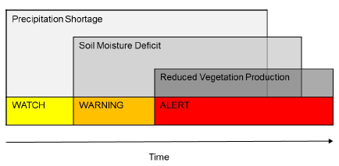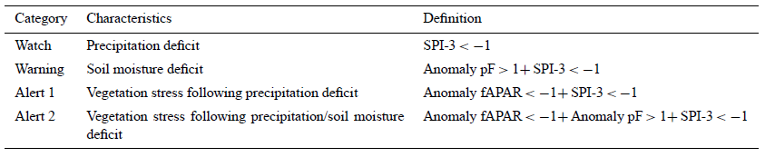
Figure 26: Level of early warning, indicators, and criteria for drought early warning
The CDI indicator has daily average 10-days CDI, daily average 5-days CDI, and daily CDI. Since this CDI is updated up to the current date, this could mean that it is the most reliable indicator for drought monitoring over the lower Mekong region. It should be iterated that CDI from SERVIR Mekong is updated in https://mekong2.tengirri.com/, and Figure 27 shows the drought condition over LMB on the 22 November 2019 (accessed date). It should be noted that there is a similar map produced by the Mekong River Commission, but saying that it is was a 3-months indicator (www.mrcmekong.org/news for more information).
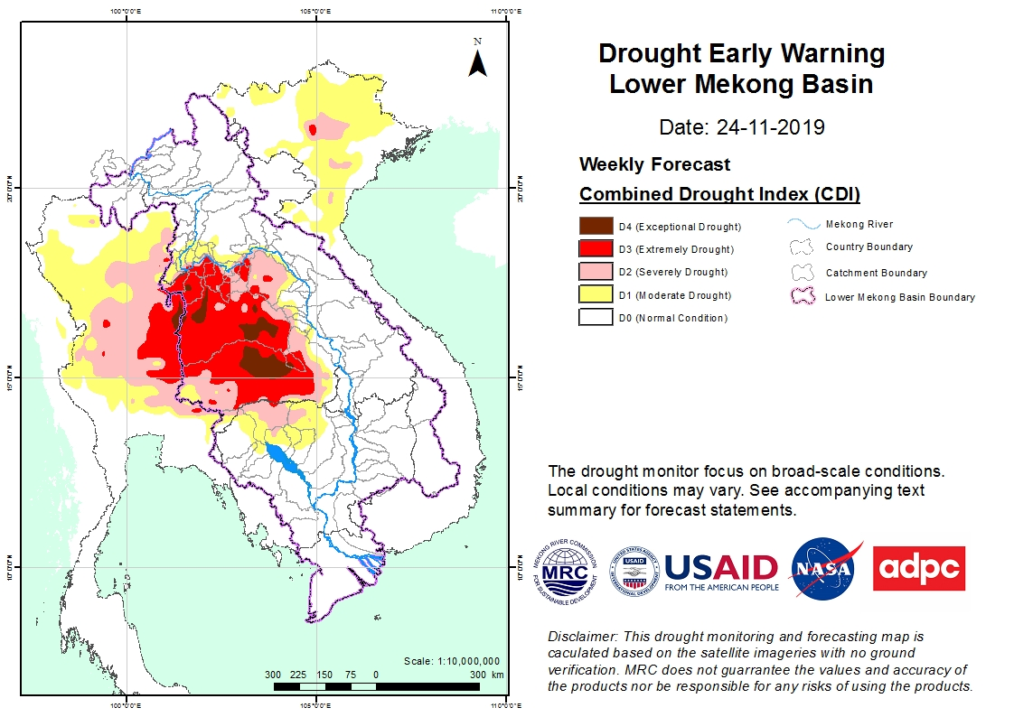
Figure 27: Weekly drought Early Warning Lower Mekong Basin, 24-11-2019
Then after extracting daily CDI for Cambodia between 1981-2018 and averaging to monthly value, there was no drought within those periods. This is true since SPI3 and SMDI values (shared by SERVIR Mekong) were not significant. As shown in Appendix 3, even daily CDI value in 2004, there was no drought indication, which means that the daily CDI is not appropriate for drought monitoring in Cambodia. It should be noted that CDI = 0 is normal, 1 = Watch, 2 = Warning, and >=3 Alert.
Since daily CDI is not practical, average 5-days and 10-days CDI for 2004 were extracted from the SERVIR Mekong platform. Once again, Table 16 shows no drought event in January-March and late December. The rests are normal conditions. This is not true based on historical drought in Cambodia, mainly in Kampong Speu province. It can be argued that average 5-days CDI is very sensitive to the dry period but not in the wet season. The result of average 10-days CDI is very similar to its peers, meaning that drought occurred only early year while wet season months are normal.

Table 16: Drought events based on average 5-days CDI Kampong Speu, 2004
 | Jan | Feb | Mar | Apr | May | Jun | Jul | Aug | Sep | Oct | Nov | Dec
1 | 0.00 | 1.11 | 2.00 | 0.89 | 0.44 | 0.00 | 0.00 | 0.00 | 0.00 | 0.00 | 0.00 | 0.00
2 | 0.00 | 1.11 | 2.00 | 0.84 | 0.41 | 0.00 | 0.00 | 0.00 | 0.00 | 0.00 | 0.00 | 0.00
3 | 0.00 | 1.11 | 2.00 | 0.80 | 0.25 | 0.00 | 0.00 | 0.00 | 0.00 | 0.00 | 0.00 | 0.00
4 | 0.00 | 1.11 | 2.00 | 0.77 | 0.20 | 0.00 | 0.00 | 0.00 | 0.00 | 0.00 | 0.00 | 0.00
5 | 0.08 | 1.22 | 2.00 | 0.77 | 0.13 | 0.00 | 0.00 | 0.00 | 0.00 | 0.00 | 0.00 | 0.00
6 | 0.10 | 1.36 | 2.00 | 0.75 | 0.07 | 0.00 | 0.00 | 0.00 | 0.00 | 0.00 | 0.00 | 0.00
7 | 0.28 | 1.54 | 2.00 | 0.80 | 0.00 | 0.00 | 0.00 | 0.00 | 0.00 | 0.00 | 0.00 | 0.00
8 | 0.53 | 1.72 | 2.00 | 0.84 | 0.00 | 0.00 | 0.00 | 0.00 | 0.00 | 0.00 | 0.00 | 0.00
9 | 0.86 | 1.89 | 2.00 | 0.89 | 0.00 | 0.00 | 0.00 | 0.00 | 0.00 | 0.00 | 0.00 | 0.00
10 | 1.01 | 1.96 | 2.00 | 0.93 | 0.00 | 0.00 | 0.00 | 0.00 | 0.00 | 0.00 | 0.00 | 0.00
11 | 1.45 | 2.00 | 2.00 | 1.00 | 0.00 | 0.00 | 0.00 | 0.00 | 0.00 | 0.00 | 0.00 | 0.00
12 | 1.68 | 2.00 | 2.00 | 1.00 | 0.00 | 0.00 | 0.00 | 0.00 | 0.00 | 0.00 | 0.00 | 0.00
13 | 1.95 | 2.00 | 2.00 | 1.00 | 0.00 | 0.00 | 0.00 | 0.00 | 0.00 | 0.00 | 0.00 | 0.00
14 | 2.13 | 2.00 | 2.00 | 0.96 | 0.00 | 0.00 | 0.00 | 0.00 | 0.00 | 0.00 | 0.00 | 0.00
15 | 2.35 | 2.00 | 2.00 | 0.91 | 0.00 | 0.00 | 0.00 | 0.00 | 0.00 | 0.00 | 0.00 | 0.00
16 | 2.40 | 2.00 | 1.98 | 0.91 | 0.00 | 0.00 | 0.00 | 0.00 | 0.00 | 0.00 | 0.00 | 0.00
17 | 2.38 | 2.00 | 1.96 | 0.81 | 0.00 | 0.00 | 0.00 | 0.00 | 0.00 | 0.00 | 0.00 | 0.00
18 | 2.27 | 2.00 | 1.94 | 0.71 | 0.00 | 0.00 | 0.00 | 0.00 | 0.00 | 0.00 | 0.00 | 0.00
19 | 2.16 | 2.00 | 1.92 | 0.66 | 0.00 | 0.00 | 0.00 | 0.00 | 0.00 | 0.00 | 0.00 | 0.00
20 | 2.11 | 2.00 | 1.89 | 0.60 | 0.00 | 0.00 | 0.00 | 0.00 | 0.00 | 0.00 | 0.00 | 0.00
21 | 2.00 | 2.00 | 1.89 | 0.49 | 0.00 | 0.00 | 0.00 | 0.00 | 0.00 | 0.00 | 0.00 | 0.00
22 | 2.00 | 2.00 | 1.89 | 0.48 | 0.00 | 0.00 | 0.00 | 0.00 | 0.00 | 0.00 | 0.00 | 0.00
23 | 2.00 | 2.00 | 1.89 | 0.47 | 0.00 | 0.00 | 0.00 | 0.00 | 0.00 | 0.00 | 0.00 | 0.00
24 | 2.00 | 2.00 | 1.85 | 0.44 | 0.00 | 0.00 | 0.00 | 0.00 | 0.00 | 0.00 | 0.00 | 0.05
25 | 2.00 | 2.00 | 1.78 | 0.44 | 0.00 | 0.00 | 0.00 | 0.00 | 0.00 | 0.00 | 0.00 | 0.15
26 | 1.89 | 2.00 | 1.78 | 0.44 | 0.00 | 0.00 | 0.00 | 0.00 | 0.00 | 0.00 | 0.00 | 0.15
27 | 1.75 | 2.00 | 1.78 | 0.46 | 0.00 | 0.00 | 0.00 | 0.00 | 0.00 | 0.00 | 0.00 | 0.24
28 | 1.57 | 2.00 | 1.60 | 0.52 | 0.00 | 0.00 | 0.00 | 0.00 | 0.00 | 0.00 | 0.00 | 0.47
29 | 1.40 | 1.79 | 1.46 | 0.49 | 0.00 | 0.00 | 0.00 | 0.00 | 0.00 | 0.00 | 0.00 | 0.65
30 | 1.22 |  | 1.33 | 0.47 | 0.00 | 0.00 | 0.00 | 0.00 | 0.00 | 0.00 | 0.00 | 0.80
31 | 1.15 |  | 1.11 |  | 0.00 |  | 0.00 | 0.00 |  | 0.00 |  | 1.04
Source: Author’s calculation
It can be concluded that CDI could not be a good indicator of drought monitoring in Cambodia as it could not reflect the ground condition such as the year 2004, where there was severe drought damage in the country.

5. Drought Mechanism
At the national level, the Ministry of Water Resources and Meteorology (MoWRAM) is the key stakeholder in managing drought/flood and other water management issues. At the same time Ministry of Agriculture, Forestry and Fisheries (MAFF), National Committee for Disaster Management (NCDM), and Ministry of Environment (MoE) are also playing a critical role in disaster risk reduction (Figure 28). It should be noted the authorities at the provincial level are more concentrated on Provincial Administration especially the Provincial Disaster Committee for Disaster Management (PCDM). The PCDM is designated as the central coordination and leadership body for DRR and DM at the provincial level. Its line agencies are from national to the village level. The PDA and PDoWRAM are also the members of the PCDM. It should be noted that each authority (PDA and PDoWRAM) has its line authorities with different officials from the national level to the district level. The special case for PCDM is that their lines authorities extend to the village level. The call for meetings of disaster management members by PDCM is made on-demand. There is no regular meeting among the PDCM’s members.
Earth Network or any platform
ENSO
SPI
Drought Onset/cessation
YES
NO
Archive data and information
Share DEW to line agencies
Share Drought responses to line agencies
Disseminate drought response to Agricultural cooperative and farmers
NGOs and CBO redistribute drought information
Drought Responses
Confirm Drought responses to line agencies
Confirm Drought Responses
MoWRAM
MAFF
NCDM

Figure 28: Drought early warning mechanism
Figure 28 proposes a drought early warning mechanism for Cambodia at the national level. Drought onset/cessation should be monitored closely by the MoWRAM. Once drought onset/cessation is identified (as in Figure 18), the MoWRAM must inform its vertical and horizontal authorities. At the same, PDoWRAM and the Provincial Department of Agriculture (PDA) must work together to design drought responses (based on locality). PDA, then, shares drought response to line agencies. Given the government agencies, there are NGOs who also work closely with local communities. Then, DEW and drought response should be shared with those NGOs and CBO.

6. Discussion
Based on the model’s assessment of drought episodes in Cambodia produced by SERVIR Mekong, there are some limitations of the models. When we aggregate daily data into monthly one (using the readily processed SPI3 data), almost all months in the wet season have no drought episodes. Given some days of the wet season in the month, there are some negative values, the aggregation of those values of the month results in near zero.
I believed that daily SPI and/or other indicators to monitor drought could be a misleading tool since drought is a slow onset event. It is unrealistic to have an extreme drought in one day (negative SPI 2) and a very wet day in the following day (positive SPI 2). It is possible since SPI value is compared the same day of the month in different years.
Other indicators for agricultural (SMDI), hydrological (SRI), and combined drought index do not well represented Cambodia historical drought events. It should be noted in the second Section that early warning should be grouped into Meteorological, Agricultural, and Hydrological drought. Each drought types must within a time frame such as meteorological drought for mid-May to mid-Nov; agricultural drought should be just October-November and the rest hydrological drought. It is misleading to claim that there is occurring meteorological drought during late November-January, as suggested by the Mekong River Commission (Mekong River Commission, 2019).

7. Recommendation
If SERVIR Mekong datasets are used for drought early warning for Cambodia, it is the must that inputs data be calibrated with observed data mainly rainfall as they are available.
The warning systems should be reflecting the locality, meaning that setting a threshold to match local conditions for Watch, Alert, and Alarm Level.
The data provided by SERVIR Mekong may not be practical for local government level as the spatial resolution of the dataset is at 25km (or 625KM²), which is bigger than many communes in Cambodia. More than 97 percent of communes in Cambodia has less land area than 625 Square Kilometers. It should be noted that local authorities (commune level) are granted more power to manage their resources including Disaster Risk Reduction (DRR). Therefore, it is more practical if the DEW is delineated to the commune level.
- Improve inputs data such as CHIRPS to reflect the ground/observed data so that they can be used for RHEAS models,
- There should be another test on daily of SPI30 (used as monthly SPI), SPI60 (two-month SPI), and SPI90 (3-month SPI) with ground calibration, and
- Improve spatial resolution so that it could cover a commune as drought severity is different from commune to commune, as demonstrated in section 3.
Since Cambodia has its rain gauge networks manual and automatics, it is ready to develop drought monitoring tools as more details were discussed in section 3.

8. Conclusion
Cambodia experienced drought impacts 21 years out of 28 years. Exceptional, extreme, and severe droughts in Cambodia are always associated with ENSO. Four out of 11 moderate drought episodes in Cambodia were not linked with ENSO, which is more on the local climate. Impacted by drought many years, different provinces experienced different degrees of severity in the different time frames and different development such as irrigation facilities. In meteorological terms, Battambang was the worst province to experience it, but the impacts were more in another region, such as Kampong Cham and Kampong Speu.
Toward Drought Early Warning (DEW) establishment, it is a must to have a monitoring system for meteorological, agricultural, and hydrological drought. In terms of meteorological drought, there should be three timeframes to monitor it, including early, mid-, and end of the wet season. The information for each period would be informative for agricultural production. Among the three periods, the most critical one is the end of the wet season as almost all farmers will take a risk to cultivate their rice using short maturing varieties given less rainfall. It is also very informative to link to the water budget for the dry season. There is a potential hydrological drought if the rainfall at the end of the season is low.
For agricultural drought, it could be done by using remotely sensed data known as MODIS to estimate the greenness of paddy. The lower the value, the more moisture deficit. The study suggested that to understand agricultural drought, it must be done with the local condition, mainly setting the threshold for drought occurrence. This is also applied to hydrological drought. It is highly recommended that more studies be done to get more robust results given this study successfully estimates the change of NDVI and NDWI for all the study sites.
Through the analysis of ENSO, SPI, NDVI, and NDWI, the study is very positive in designing early warning systems in Cambodia. While SPI, NDVI, and NWI are used to monitoring drought development in the country, ENSO and other weather forecast data could be used to forest drought development and lead to drought early warning.
The assessment concluded that the Early Warning systems prepared by SERVIR Mekong and displayed by Lower Mekong Basin (the institution in Vietnam) are not yet ready for community use. First, it is related to CHIRPS data as the major inputs into the systems. The data is not yet calibrated to the ground observation station. Based on t-Test, the datasets are statistically significantly different from observed data. Next, many drought indicators, mainly Meteorological (SPI), Agricultural (SMDI), and Hydrological (SRI) are not reflecting the Cambodia context. The CDI is no exception, as the Map Authors (Lower Mekong Basin) disclaimed that this drought monitoring and forecasting is calculated based on the satellite imageries with no ground verification. MRC does not guarantee the values and accuracy of the products nor be responsible for any risks of using the products.
If early warning to go ahead for Cambodia, we must:
- Used observed data from each station in Cambodia to calculate SPI for meteorological drought monitoring from mid-May to min-November,
- Use SPI and Normalized Difference Vegetation Index (NDVI) to monitor agricultural drought in October and November,
- Use Surface-water drought index (SWDI) to monitor hydrological drought,
- Use El Niño Southern Oscillation Index (ENSO) to provide an early warning as there is lag time, and where possible, and
- Use weather forecast such as Global Precipitation Measurement (GPM), but yet has to tailor to the country context as the data resolution is very coarse. Data can be access via https://pmm.nasa.gov/data-access/downloads/gpm.
The best way to approach Drought Early Warning in Cambodia, we should ignore point #5 while other opportunities should also be taking into account, such as improving SERVIR Mekong facilities ground verification such as this report.
In the short run, we should integrate any DEW activities with the Ministry of Water Resources and Meteorology (MoWRAM) as they are giving Weather Notification (in some form of Early Warning). The MoWRAM is actively investigating ENSO and links the ENSO events to Cambodia climate, such as this month Notification (November 2019), to save water due to ENSO onset. The missing information that MoWRAM did not declare is the drought condition in the country (whether droughts in onset or not). Since the Ministry holds historical data for all stations in the country, it is not difficult to map drought conditions in the country.
Given that there should be an agreement that we should deploy different timeframe to give drought early warning for different drought types: meteorological, agricultural, and hydrological drought. There should be another study by using all available data from the Ministry to identify historical drought events (the three types) in Cambodia and a trial drought early warning (DEW). It is clear that this study, “Drought Studies in Cambodia” has paved ways to concretize the DEW steps and procedure.

***

References
Aaheim, A., & Schjolden, A. (2004). An approach to utilise climate change impacts studies in national assessments. Global Environmental Change Part A, 14(2), 147-160. doi:DOI: 10.1016/j.gloenvcha.2003.12.003
Adamson, P., & Bird, J. (2010). The Mekong: A Drought-prone Tropical Environment? International Journal of Water Resources Development, 26(4), 579-594. doi:10.1080/07900627.2010.519632
AghaKouchak, A., Farahmand, A., Melton, F., Teixeira, J., Anderson, M., Wardlow, B. D., & Hain, C. (2015). Remote sensing of drought: Progress, challenges and opportunities. Reviews of Geophysics, 53(2), 452-480.
AghaKouchak, A., Farahmand, A., Melton, F. S., Teixeira, J., Anderson, M. C., Wardlow, B. D., & Hain, C. R. (2015). Remote sensing of drought: Progress, challenges and opportunities. Reviews of Geophysics, 53(2), 452-480. doi:10.1002/2014rg000456
Analyzing Development Issue. (2007). Understanding Social Capital in Response to Floods and Droughts: A Study of Five Villages in Two Ecological Zones of Kompong Thom Province. Retrieved from Phnom Penh:
Anderson, M. C., Hain, C., Wardlow, B., Pimstein, A., Mecikalski, J. R., & Kustas, W. P. (2011). Evaluation of drought indices based on thermal remote sensing of evapotranspiration over the continental United States. Journal of Climate, 24(8), 2025-2044.
Annyamba, A., Tucker, C. J., Huete, A. R., & Boken, V. K. (2005). Monitoring drought using coarse-resolution Polar-Orbiting Satellite data. In V. K. Boken, A. P. Cracknell, & R. Heathcote (Eds.), Monitoring and Predicting Agricultural Drought: A Global Study. Oxford: Oxford University Press.
Blaikie, P., Cannon, T., Davis, I., & Wisner, B. (2014). At risk: natural hazards, people's vulnerability and disasters: Routledge.
Blakie, P., Cannon, T., Davis, I., & Wisner, B. (1994). At Risk: Natural Hazards, People's Vulnerability, and Disaster. Londres-Nueva York,: Routledge.
Bloomfield, J., & Marchant, B. (2013). Analysis of groundwater drought building on the standardised precipitation index approach. Hydrology and Earth System Sciences, 17, 4769-4787.
Buckley, B. M., Anchukaitis, K. J., Penny, D., Fletcher, R., Cook, E. R., Sano, M., . . . Hong, T. M. (2010). Climate as a contributing factor in the demise of Angkor, Cambodia. Proceedings of the National Academy of Sciences, 107(15), 6748-6752. doi:10.1073/pnas.0910827107
Byun, R.-H., & Wilhite, A. D. (1999). Objective Quantification of Drought Severity and Duration. American Meteorological Society, 2, 2747-2755.
Cambodian Development Resource Institute. (2012). Understanding poverty dynamics: evidence from nine villages in Cambodia. Phnom Penh: Cambodia Development Resource Institute.
Cancelliere, A., Mauro, G. D., Bonaccorso, B., & Rossi, G. (2007). Drought forecasting using the standardized precipitation index. Water Resources Management, 21(5), 801-819.
Chhinh, N., & Millington, A. (2015). Drought monitoring for rice production in Cambodia. Climate, 3(4), 792-811.
EM-DAT. (2019). Cambodia Country Profile: Natural Disaster. Retrieved from http://www.emdat.be/result-country-profile
Funk, C., Peterson, P., Landsfeld, M., Pedreros, D., Verdin, J., Shukla, S., . . . Hoell, A. (2015). The climate hazards infrared precipitation with stations—a new environmental record for monitoring extremes. Scientific Data, 2, 150066.
Garen, D. C. (1993). Revised surface-water supply index for western United States. Journal of Water Resources Planning and Management, 119(4), 437-454.
Geres-Cambodia. (2009). Public perceptions of climate change in Cambodia. Retrieved from Phnom Penh:
Gibbs, W. J., & Maher, J. V. (1967). Rainfall deciles as drought indicators. Melbourne: Melbourne, Bureau of Meteorology.
Gu, Y., Hunt, E., Wardlow, B., Basara, J. B., Brown, J. F., & Verdin, J. P. (2008). Evaluation of MODIS NDVI and NDWI for vegetation drought monitoring using Oklahoma Mesonet soil moisture data. Geophysical Research Letters, 35(22).
Guttman, N. B. (1998). Comparing the Palmer Drought Index and the Standardized Precipitation Index. JAWRA Journal of the American Water Resources Association, 34(1), 113-121.
Hao, Z., AghaKouchak, A., Nakhjiri, N., & Farahmand, A. (2014). Global integrated drought monitoring and prediction system. Scientific Data, 1. doi:10.1038/sdata.2014.1
Heim Jr, R. R. (2002). A review of twentieth-century drought indices used in the United States. Bulletin of the American Meteorological Society, 83(8), 1149-1165.
Helmers K, & Jegillos S. (2004). Linkages between flood and drought disasters and Cambodian rural livelihoods and food security (Vol. 2010). Phnom Penh: Cambodian Red Cross.
Inthavong, T., Tsubo, M., & Fukai, S. (2012). Soil clay content, rainfall, and toposequence positions determining spatial variation in field water availability as estimated by a water balance model for rainfed lowland rice. Crop and Pasture Science, 63(6), 529-538.
Keyantash, J. A., & Dracup, J. A. (2004). An aggregate drought index: Assessing drought severity based on fluctuations in the hydrologic cycle and surface water storage. Water Resources Research, 40(9).
Khor, S. (2019). Seven provinces hit by drought, ministry uses pumps to save crops. Phnom Penh Post.
Kogan, F. N. (2000). Contribution of remote sensing to drought early warning. In A. D. Wilhite, M. V. K. Sivakumar, & D. A. Wood (Eds.), Early warning systems for drought preparedness and drought management (pp. 75-87). Lisbon, Portugal: WMO.
Leng, H. A. (2014). Country Report of Cambodia Disaster Management. Retrieved from Kobe:
Linacre, E. (1992). Climate data and resources: a reference and guide: Psychology Press.
MAFF. (1999). Agricultural Statistic 1998-2010. Retrieved from
MAFF. (2014). Climate Change Priorities Action Plan for Agriculture, Foresty and Fisheries Sector 2014-2018. Phnom Penh: Ministry of Agriculture, Forestry and Fishery.
McKee, T. B., Doesken, N. J., & Kleist, J. (1993). The relationship of drought frequency and duration to time scales. Paper presented at the Proceedings of the 8th Conference on Applied Climatology.
Mekong River Commission. (2019). Drought continues to hit Mekong countries, risking stress on crop production, water shortages. Retrieved from http://www.mrcmekong.org/news-and-events/news/drought-continues-to-hit-mekong-countries-risking-stress-on-crop-production-water-shortage/?fbclid=IwAR0--SyqrAqrEbPPqfvT0Oh-LnBREtSM2Kn2AHckEpUQADhND92_hqpYLEI
Ministry of Economy and Finance, & National Council for Sustainable Development. (2018). Addressing Climate Change Impactson Economic Growth in Cambodiamay. Phnom Penh.
Ministry of Environment. (2001). Vulnerability and Adaptation Assessment to Climate Change in Cambdia. Phnom Penh: Minstry of Environment.
Ministry of Environment. (2002). Cambodia's Initial National Communication. Retrieved from Phnom Penh:
Ministry of Environment. (2005). Vulnerability and adaptation to climate hazards and to climate change: A survey of rural Cambodian households. Phnom Penh: Ministry of Environment.
Ministry of Environment. (2015). Cambodia's Second National Communication to UNFCC. Retrieved from Phnom Penh:
Ministry of Environment. (2017). National Environment and Strategy and Action Plan. Phnom Penh: Ministry of Environment.
Ministry of Environment, & UNDP. (2011). Building Resilience: the Future for Rural Livelihoods in the Face of Climate Change. Retrieved from Cambodia Human Development Report 2011:
MoE. (2005). Analysis of Policies to Address Climate Change Impacts in Cambodia. Retrieved from Phnom Penh:
MoE. (2006). National Adaptation Programme of Action to Climate Change. Phnom Penh: Ministry of Environment.
Monacelli, G., Galluccio, M., & Abbafati, M. (2005). Drought assessment and forecasting: World Meteorological Organization.
MoWRAM. (2014). Climate Change Strategic Plan For Water Resources and Meteorology (2014-2018). Phnom Penh: MoWRAM.
Nagarajan, R. (2009). Drought assessment. New Delhi: Springer.
Nalbantis, I., & Tsakiris, G. (2009). Assessment of hydrological drought revisited. Water Resources Management, 23(5), 881-897.
Narasimhan, B., & Srinivasan, R. (2005). Development and evaluation of Soil Moisture Deficit Index (SMDI) and Evapotranspiration Deficit Index (ETDI) for agricultural drought monitoring. Agricultural and Forest Meteorology, 133(1–4), 69-88. doi:http://dx.doi.org/10.1016/j.agrformet.2005.07.012
National Committee for Disaster Management. (2003). Mapping vulnerability to natural disasters in Cambodia. Phnom Penh. Phnom Penh: National committee for disaster management (NCDM).
National Institute of Statistics. (u.d). Cambodia Climate Resillience Decision Support Monitoring & Evaluation Framework of Adaptation. Retrieved from http://cam-crds.nis.gov.kh/site/index.php/en/
Nguyen, H., & Shaw, R. (2011). Adaptation to Droughts in Cambodia. Community, Environment and Disaster Management, 8(1), 49-66.
Pai, D., Sridhar, L., Guhathakurta, P., & Hatwar, H. (2011). District-wide drought climatology of the southwest monsoon season over India based on standardized precipitation index (SPI). Natural hazards, 59(3), 1797-1813.
Palmer, W. (1965). Meteorological drought. Washington, D.C: Weather Bureau.
Palmer, W. C. (1968). Keeping track of crop moisture conditions, nationwide: The new crop moisture index.
Palmer, W. C. (1968). Keeping track of crop moisture conditions, nationwide: The new crop moisture index. Weatherwise, 21(4), 156-161.
Patel, N., Chopra, P., & Dadhwal, V. (2007). Analyzing spatial patterns of meteorological drought using standardized precipitation index. Meteorological Applications, 14(4), 329-336.
Peters, A. J., Walter-Shea, E. A., Ji, L., Vina, A., Hayes, M., & Svoboda, M. D. (2002). Drought monitoring with NDVI-based standardized vegetation index. Photogrammetric engineering and remote sensing, 68(1), 71-75.
Quiring, S. M. (2009). Monitoring drought: an evaluation of meteorological drought indices. Geography Compass, 3(1), 64-88.
Schaefer, J. T. (1990). The critical success index as an indicator of warning skill. Weather and forecasting, 5(4), 570-575.
Seiler, R., Hayes, M., & Bressan, L. (2002). Using the standardized precipitation index for flood risk monitoring. International journal of climatology, 22(11), 1365-1376.
Sen, D. (2018). Kampong Cham pumps water to offset drought. Khmer Times.
Sepulcre-Canto, G., Horion, S., Singleton, A., Carrao, H., & Vogt, J. (2012). Development of a Combined Drought Indicator to detect agricultural drought in Europe. Natural Hazards and Earth System Sciences, 12(11), 3519-3531.
Shafer, B. A., & E., D. L. (1982). Development of a surface water supply index (SWSI) to assess the severity of drought conditions in snowpack runoff areas. Paper presented at the Proceedings of the 50th Annual Western Snow Conference, Reno, Nevada.
Shukla, S., & Wood, A. W. (2008). Use of a standardized runoff index for characterizing hydrologic drought. Geophysical Research Letters, 35(2).
Singhrattna, N., Rajagopalan, B., Kumar, K. K., & Clark, M. (2005). Interannual and Interdecadal Variability of Thailand Summer Monsoon Season. Journal of Climate, 18(11), 1697-1708. doi:10.1175/JCLI3364.1
Son, N., Chen, C., Chen, C., Chang, L., & Minh, V. Q. (2012). Monitoring agricultural drought in the Lower Mekong Basin using MODIS NDVI and land surface temperature data. International Journal of Applied Earth Observation and Geoinformation, 18, 417-427.
Steyaert, L. T., Rao, A. V., & Todorov, A. V. (1981). Agroclimatic Assessment Methods for Drought/Food Strategies in South and Southeast Asia. Retrieved from http://www.fao.org/docrep/005/ac120e/AC120e15.htm#P0_0
Tabari, H., Nikbakht, J., & Talaee, P. H. (2013). Hydrological drought assessment in Northwestern Iran based on streamflow drought index (SDI). Water Resources Management, 27(1), 137-151.
Tannehill, R. I. (1947). Drought: its causes and effects. New Jersey: Princeton University Press.
Thom, H. C. S. (1966). Some methods of climatological analysis: Secretariat of the World Meteorological Organization.
Tucker, C. J., & Choudhury, B. J. (1987). Satellite remote sensing of drought conditions. Remote Sensing of Environment, 23(2), 243-251.
Turner, S., Pangare, G., & Mather, R. J. (Eds.). (2009). Water Governance: A situational analysis of Cambodia, Lao PDR and Viet Nam (Vol. 2). Gland, Switzerland: IUCN.
UNISDR. (2009). Drought risk reduction framework and pratices: Contributing to the implementation of the Hyogo Framework for Action (Vol. 2015). Geneva, Switzerland: United Nations secretariat of the International Strategy for Disaster Reduction (UNISDR).
Van Loon, A. F. (2015). Hydrological drought explained. Wiley Interdisciplinary Reviews: Water, 2(4), 359-392.
Vicente-Serrano, S. M., López-Moreno, J. I., Beguería, S., Lorenzo-Lacruz, J., Azorin-Molina, C., & Morán-Tejeda, E. (2011). Accurate computation of a streamflow drought index. Journal of Hydrologic Engineering, 17(2), 318-332.
Wilhite, A. D., & Bruchanan-Smith, M. (2005). Drought as hazard: Understanding the natural and social context. In A. D. Wilhite (Ed.), Drought and water crises: Science, technology and management issues (pp. 406). Boca Raton: Taylor &​ Francis.
Wilhite, D. A. (2012). Drought Assessment, Management, and Planning: Theory and Case Studies: Theory and Case Studies (Vol. 2): Springer Science & Business Media.
Wilhite, D. A., & Glantz, M. H. (1985). Understanding the drought phenomenon: The role of definitions. Water International, 10(3), 111-120.
Wilhite, D. A., & Glantz, M. H. (1985). Understanding: the drought phenomenon: the role of definitions. Water International, 10(3), 111-120.
Wilhite, D. A., Sivakumar, M. V. K., & Wood, D. A. (2000). Early Warning Systems for Drought Preparedness and Drought Management. Paper presented at the Expert Group Meeting held in Lisbon, Portugal, 5-7 September 2000, Geneva, Switzerland.
WMO. (2018). Multi-hazard Early Warning Systems: A Checklist. Retrieved from Geneva:
World Bank. (2010). Natural hazards, unnatural disasters: the economics of effective prevention. Washington, D.C.: World Bank and United Nations.
World Meteorological Organization. (2012). Standardized Precipitation Index: User Guide (Vol. WMO-No. 1090). Switzerland: World Meteorological Organization.
World Meteorological Organization. (2016). Handbook of Drought Indicators and Indices (Vol. 2). Geneva: World Meteorological Organization and Global Water Partnership.
Wu, H., Hayes, M. J., Weiss, A., & Hu, Q. (2001). An evaluation of the Standardized Precipitation Index, the China-Z Index and the statistical Z-Score. International journal of climatology, 21(6), 745-758.
Yu, H., Zhang, Q., Xu, C.-Y., Du, J., Sun, P., & Hu, P. (2019). Modified Palmer Drought Severity Index: Model improvement and application. Environment international, 130, 104951.
Zargar, A., Sadiq, R., Naser, B., & Khan, F. I. (2011). A review of drought indices. Environmental Reviews, 19(NA), 333-349.
Zhang, Q., Xu, C.-Y., & Zhang, Z. (2009). Observed changes of drought/wetness episodes in the Pearl River basin, China, using the standardized precipitation index and aridity index. Theoretical and applied climatology, 98(1), 89-99.

Appendices

Appendix 1: Meteorological Drought in Kampong Cham
 | Early Season |  |  | Mid-Season |  | Late Season
Year | May | Jun | Jul | Aug | Sep | Oct | Nov | Drought
1983 | -0.49 | -0.55 | 0.7 | 1.57 | 1.08 | 1.56 | 0.94 | No drought
1984 | -0.47 | 0.2 | 0.29 | -0.03 | 0.52 | 0.99 | 0.8 | No drought
1985 | 2.44 | 2.75 | 1.34 | -1.06 | -0.05 | -0.61 | 0.08 | Mid
1986 | -0.44 | -0.23 | -0.74 | -1.37 | -0.77 | -0.35 | 0.29 | Mid
1987 | -1.08 | -0.78 | -0.71 | -0.94 | -0.6 | -0.87 | -1.21 | Early, late
1988 | 0.04 | 0.72 | 0.44 | 0.36 | -1.1 | -1.3 | -1.22 | Mid, late
1989 | 0.19 | -0.74 | -0.15 | -0.78 | -0.11 | -1.54 | -0.65 | Late
1990 | -0.47 | -0.55 | -0.34 | -0.71 | -1.22 | -2.07 | -1.58 | Mid, late
1991 | -0.86 | 0.08 | 0.72 | 1.77 | 0.78 | -0.38 | -1.25 | Late
1992 | -1.98 | -1.32 | -0.01 | 0.46 | -0.08 | -0.86 | -0.95 | Early
1993 | -1.52 | -1.76 | -1.89 | -2.05 | -1.73 | 0.17 | 0.48 | Early, mid
1994 | -0.23 | -1.32 | 0.07 | 0.86 | 1.34 | 0.14 | -0.61 | Early
1995 | -0.69 | -0.94 | -0.32 | -1.18 | 0.41 | 1.08 | 1.02 | Mid
1996 | 0.4 | 0.62 | -0.05 | -0.48 | -0.05 | 0.88 | 1.61 | No drought
1997 | -0.39 | 0.93 | 1.28 | 0.93 | 0.4 | 1.14 | 0.87 | No drought
1998 | 0.24 | 0.38 | -0.14 | 0.36 | 1.54 | 1.9 | 1.72 | No drought
1999 | 1.36 | 1.49 | 2.08 | 2.08 | 2.48 | -0.03 | -0.83 | No drought
2000 | 0.52 | 0.39 | 0.34 | 0.89 | 0.5 | 1.52 | 1.73 | No drought
2001 | 1.07 | 0.43 | 0.37 | 1.35 | 1.46 | 1.95 | 1.1 | No drought
2002 | 0.15 | -1.19 | -2.96 | -1.07 | -1.42 | -0.67 | -1.16 | Whole season
2003 | 0.69 | 0.31 | 1.27 | 0.24 | 0.18 | -1.26 | -1.3 | Late
2004 | -0.03 | 0.21 | 0.46 | -0.73 | -1.57 | -1.44 | -0.84 | Mid, late
2005 | -1.28 | -1.2 | 0.04 | 0.26 | -0.1 | -0.32 | 0.19 | Early
2006 | 1.19 | 1.17 | -0.27 | 0.73 | 0.69 | 0.03 | -1.71 | Late
2007 | 0.67 | 0.77 | 0.41 | 0.27 | -0.64 | -1.03 | -0.76 | Late
2008 | 0.35 | 0.18 | -0.98 | -0.18 | -0.18 | 0.41 | 0.34 | No drought
2009 | 2.14 | 2.2 | 0.95 | -0.11 | -0.27 | -0.01 | -0.6 | No drought
2010 | 1.12 | -0.05 | 0.33 | -0.15 | -0.5 | -0.26 | -0.51 | No drought
2011 | 0.89 | 0.27 | -0.23 | 1 | -0.44 | 0.88 | 0.32 | No drought
2012 | 0.54 | 0.03 | 0.97 | 0.26 | 2.11 | 0.74 | 1.06 | No drought
2013 | 0.28 | 0.66 | 0.42 | 1.06 | -1.59 | -0.97 | 0.1 | Mid
2014 | -0.89 | -0.49 | -0.95 | -0.32 | -0.32 | -0.22 | -0.45 | No drought
2015 | -1.49 | -1.95 | -2.42 | -2.24 | -0.31 | -0.59 | 0.37 | Early, mid
2016 | -1.53 | -0.39 | 0.78 | 0.12 | -0.14 | 0.74 | 1.73 | Early
2017 | 0.06 | -0.33 | -0.51 | -0.32 | 0.59 | 0.12 | 0.1 | No drought
2018 | -0.56 | -0.05 | -0.48 | -0.81 | -0.88 | 0.53 | 0.76 | No drought

Appendix 2: Meteorological Drought in Kampong Speu
 | Early Season |  |  | Mid-Season |  | Late Season
Year | May | Jun | Jul | Aug | Sep | Oct | Nov | Drought
1983 | -0.49 | -0.55 | 0.7 | 1.57 | 1.08 | 1.56 | 0.94 | No drought
1984 | -0.47 | 0.2 | 0.29 | -0.03 | 0.52 | 0.99 | 0.8 | No drought
1985 | 2.44 | 2.75 | 1.34 | -1.06 | -0.05 | -0.61 | 0.08 | Mid
1986 | -0.44 | -0.23 | -0.74 | -1.37 | -0.77 | -0.35 | 0.29 | Mid
1987 | -1.08 | -0.78 | -0.71 | -0.94 | -0.6 | -0.87 | -1.21 | Early, late
1988 | 0.04 | 0.72 | 0.44 | 0.36 | -1.1 | -1.3 | -1.22 | Late
1989 | 0.19 | -0.74 | -0.15 | -0.78 | -0.11 | -1.54 | -0.65 | Late
1990 | -0.47 | -0.55 | -0.34 | -0.71 | -1.22 | -2.07 | -1.58 | Severe drought
1991 | -0.86 | 0.08 | 0.72 | 1.77 | 0.78 | -0.38 | -1.25 | Late
1992 | -1.98 | -1.32 | -0.01 | 0.46 | -0.08 | -0.86 | -0.95 | Early
1993 | -1.52 | -1.76 | -1.89 | -2.05 | -1.73 | 0.17 | 0.48 | Severe drought
1994 | -0.23 | -1.32 | 0.07 | 0.86 | 1.34 | 0.14 | -0.61 | Early
1995 | -0.69 | -0.94 | -0.32 | -1.18 | 0.41 | 1.08 | 1.02 | Mid
1996 | 0.4 | 0.62 | -0.05 | -0.48 | -0.05 | 0.88 | 1.61 | No drought
1997 | -0.39 | 0.93 | 1.28 | 0.93 | 0.4 | 1.14 | 0.87 | No drought
1998 | 0.24 | 0.38 | -0.14 | 0.36 | 1.54 | 1.9 | 1.72 | No drought
1999 | 1.36 | 1.49 | 2.08 | 2.08 | 2.48 | -0.03 | -0.83 | No drought
2000 | 0.52 | 0.39 | 0.34 | 0.89 | 0.5 | 1.52 | 1.73 | No drought
2001 | 1.07 | 0.43 | 0.37 | 1.35 | 1.46 | 1.95 | 1.1 | No drought
2002 | 0.15 | -1.19 | -2.96 | -1.07 | -1.42 | -0.67 | -1.16 | Severe drought
2003 | 0.69 | 0.31 | 1.27 | 0.24 | 0.18 | -1.26 | -1.3 | Late
2004 | -0.03 | 0.21 | 0.46 | -0.73 | -1.57 | -1.44 | -0.84 | Late
2005 | -1.28 | -1.2 | 0.04 | 0.26 | -0.1 | -0.32 | 0.19 | Early
2006 | 1.19 | 1.17 | -0.27 | 0.73 | 0.69 | 0.03 | -1.71 | Late
2007 | 0.67 | 0.77 | 0.41 | 0.27 | -0.64 | -1.03 | -0.76 | Late
2008 | 0.35 | 0.18 | -0.98 | -0.18 | -0.18 | 0.41 | 0.34 | No drought
2009 | 2.14 | 2.2 | 0.95 | -0.11 | -0.27 | -0.01 | -0.6 | No drought
2010 | 1.12 | -0.05 | 0.33 | -0.15 | -0.5 | -0.26 | -0.51 | No drought
2011 | 0.89 | 0.27 | -0.23 | 1 | -0.44 | 0.88 | 0.32 | No drought
2012 | 0.54 | 0.03 | 0.97 | 0.26 | 2.11 | 0.74 | 1.06 | No drought
2013 | 0.28 | 0.66 | 0.42 | 1.06 | -1.59 | -0.97 | 0.1 | Mid
2014 | -0.89 | -0.49 | -0.95 | -0.32 | -0.32 | -0.22 | -0.45 | No drought
2015 | -1.49 | -1.95 | -2.42 | -2.24 | -0.31 | -0.59 | 0.37 | Severe drought
2016 | -1.53 | -0.39 | 0.78 | 0.12 | -0.14 | 0.74 | 1.73 | Early
2017 | 0.06 | -0.33 | -0.51 | -0.32 | 0.59 | 0.12 | 0.1 | No drought
2018 | -0.56 | -0.05 | -0.48 | -0.81 | -0.88 | 0.53 | 0.76 | No drought

Appendix 3: Meteorological Drought in Kampong Thom
 | Early Season |  |  | Mid-Season |  | Late Season
Year | May | Jun | Jul | Aug | Sep | Oct | Nov | Drought
1981 | -0.61 | -0.59 | -0.84 | -1.83 | -1.2 | -0.29 | 0.33 | Mid
1982 | -0.42 | 0.34 | -0.2 | -0.19 | -0.75 | 0.1 | 0.14 | No drought
1983 | -0.87 | -0.22 | 0.09 | 0.05 | -0.15 | 0.74 | 0.93 | No drought
1984 | 0.91 | 0.34 | -0.18 | -0.59 | 0 | 0.32 | 0.12 | No drought
1985 | 3.32 | 3.76 | 3.17 | 1.35 | 2.77 | 2.86 | 2.94 | No drought
1986 | -0.07 | 0.14 | -0.12 | 0.96 | 1.34 | 1.84 | 1.03 | No drought
1987 | -0.54 | -0.39 | -1.39 | -1.78 | -1.17 | -0.6 | 0.62 | Early, Mid
1988 | 1.05 | 2.53 | 2.41 | 3.09 | 2.57 | 1.89 | 1.65 | No drought
1989 | -0.43 | -0.72 | -0.61 | 0.05 | 1.04 | 0.72 | 0.58 | No drought
1990 | -0.03 | 0.25 | -0.31 | -0.92 | -1.74 | -1.88 | -1.55 | Mid, Late
1991 | -0.64 | -0.88 | -0.53 | 0.01 | 0.83 | 0.43 | 0.09 | No drought
1992 | -1.09 | -1.25 | -1.83 | 0.34 | -0.24 | 0.24 | -0.94 | Early
1993 | -0.39 | -0.02 | 0.39 | 0.05 | -0.45 | -0.38 | -0.18 | No drought
1994 | 1.05 | 0.76 | 0.93 | 0.78 | 0.06 | -0.04 | -0.53 | No drought
1995 | -0.24 | -0.43 | -0.31 | -0.3 | 0.42 | 0.95 | 0.84 | No drought
1996 | 1.46 | 1.43 | 1.13 | -0.28 | -0.06 | 0.41 | 0.73 | No drought
1997 | 0.63 | -1.11 | -1.35 | -1.71 | -1.18 | -1.36 | -1.27 | Whole Season
1998 | -1.32 | -1.16 | -0.5 | 0.83 | 0.48 | -0.14 | -0.32 | Early
1999 | 1.23 | 1.29 | 0.53 | -0.32 | -1.21 | -0.75 | 0.69 | Mid, Late
2000 | -0.6 | 0.62 | 1.25 | 1.46 | 0.9 | 0.47 | 0.34 | No drought
2001 | 1 | -0.41 | -0.65 | -0.53 | -1.06 | 0.6 | 0.56 | Mid
2002 | -0.77 | 0.38 | -0.25 | 0.03 | 0.39 | 0.45 | 0.5 | No drought
2003 | 1.19 | 0.45 | 0.97 | 0.22 | -0.38 | -0.9 | -1.06 | Late
2004 | -1.01 | 0.86 | 0.11 | 0.64 | -0.92 | -0.65 | -0.89 | Early
2005 | -0.79 | -0.79 | 0.48 | 0.11 | 0.03 | -1.04 | -0.2 | Late
2006 | 0.29 | -0.65 | -0.86 | 0.43 | -0.05 | -0.92 | -2.26 | Late
2007 | 0.89 | -0.08 | -0.89 | -1.46 | 0.2 | 0.23 | 0.56 | Mid
2008 | 0.63 | -0.49 | -1.19 | -1.48 | -0.54 | 0.47 | 0.26 | Early, Mid
2009 | 0.8 | 0.18 | -0.81 | -1.41 | 0.46 | 0.37 | 0.26 | Mid
2010 | -1.22 | -0.63 | 0.05 | 0.63 | -0.4 | 0.32 | 0.01 | Early
2011 | -0.48 | -0.17 | 0.3 | 0.98 | 1.5 | 0.8 | 0.61 | No drought
2012 | 0.17 | -1.19 | -0.37 | -0.93 | 0.64 | -0.13 | 0 | Early
2013 | -0.15 | 0.23 | 0.86 | 0.73 | 0.6 | -0.15 | 0.1 | No drought
2014 | -1.15 | -0.8 | 0.51 | 0.66 | -0.43 | -1.41 | -1.53 | Early, Late
2015 | -0.61 | -0.92 | -1.34 | -0.7 | -1.74 | -1.86 | -1.87 | Mid, Late
2016 | -1.97 | -0.38 | 0.13 | 0.4 | -0.15 | 0.37 | 0.45 | Early
2017 | 0.17 | -0.39 | 0.49 | 0.36 | -0.14 | -0.38 | -0.32 | No drought
2018 | 0.46 | -0.08 | 0.67 | 0.26 | -0.32 | -1.72 | -1.45 | Late

Appendix 4: Meteorological Drought in Prey Veng
 | Early Season |  |  | Mid-Season |  | Late Season
Year | May | Jun | Jul | Aug | Sep | Oct | Nov | Drought
1984 | -1.14 | -0.54 | -1.97 | -1.58 | 0.48 | -0.27 | -0.29 | Early, mid
1985 | 0.85 | 1.18 | 0.52 | -0.24 | -0.95 | -0.48 | -0.12 | No drought
1986 | -0.19 | 0.04 | -0.14 | -0.17 | -0.24 | 0.89 | 0.94 | No drought
1987 | -2.59 | -2.78 | -2.05 | -1.08 | 0.54 | 0.99 | 1.21 | Early, mid
1988 | -0.14 | 0.25 | 0.47 | 0.14 | -0.23 | -1.45 | -0.27 | Late
1989 | 0.07 | -0.16 | 0.54 | 0.19 | 0.58 | -0.88 | -0.77 | No drought
1990 | 0.15 | 0.16 | 0.54 | 0.68 | 0.35 | 0.16 | -0.22 | No drought
1991 | -0.57 | -0.05 | 0.34 | 0.37 | -1.03 | -1.63 | -1.49 | Late
1992 | -0.54 | -0.73 | -1.2 | -0.72 | -1.73 | -0.23 | -0.67 | Early, mid
1993 | 0.28 | 0.03 | 1.36 | 0.6 | 0.64 | 0.37 | 0.67 | No drought
1994 | -0.11 | 0.07 | -0.14 | 0.33 | 0.38 | 0.27 | -0.55 | No drought
1995 | -1.11 | -0.13 | 0.2 | 0.23 | -0.18 | -0.85 | -0.35 | Early
1996 | -1.74 | -0.83 | 0.02 | 0.26 | -1.43 | -0.27 | 0.18 | Early, mid
1997 | -0.74 | -1.87 | -1.24 | -2.04 | -1.32 | -1.67 | -1.67 | Whole season
1998 | 0.35 | -0.59 | -0.61 | -2.14 | -0.29 | -0.06 | 0.87 | Mid
1999 | -1.07 | -1.17 | -0.63 | -0.54 | 0.01 | -0.38 | -0.07 | Early
2000 | -0.99 | -0.61 | 0.45 | 0.47 | -0.64 | -1.39 | 0.14 | Late
2001 | 0.03 | -1.49 | -3.06 | -1.52 | -2.16 | -0.72 | -1.4 | Extreme
2002 | 0.35 | 0.57 | 0.11 | -0.49 | -0.9 | -0.84 | 0.02 | No drought
2003 | 1.02 | 0.3 | 1.15 | 0.63 | 2.24 | 1.87 | 1.06 | No drought
2004 | 0.25 | 0.73 | 0.57 | 0.04 | -0.32 | -0.2 | -0.34 | No drought
2005 | -1.99 | -1.71 | -1.25 | -1.3 | -0.45 | 1.01 | 1.43 | Early, mid
2006 | -0.15 | 0.2 | -0.33 | 0.64 | -0.06 | 0.03 | -0.78 | No drought
2007 | 0.04 | -0.05 | -0.33 | 0.64 | -0.06 | 0.03 | -0.78 | No drought
2008 | 0.43 | 0.16 | 0.21 | 1.04 | 1.52 | 1.21 | 1.2 | No drought
2009 | 2.01 | 1.53 | 0.67 | -1.25 | -0.76 | -1.23 | -1.19 | Late
2010 | 0.78 | 0.1 | 0.36 | 1.05 | 1.4 | 2.42 | 1.71 | No drought
2011 | 1.19 | 0.92 | 0.83 | 0.91 | 1.37 | 0.38 | -0.6 | No drought
2012 | 1.66 | 1.36 | 0.34 | 0.55 | 1.18 | 0.94 | 1.12 | No drought
2013 | 0.41 | 0.24 | -0.04 | 1.6 | 0.55 | -0.21 | -1.34 | Late
2014 | 1.05 | 2.34 | 2 | 1.96 | 0.68 | -0.48 | 0.01 | No drought
2015 | -0.31 | 0.4 | 0.55 | 1.41 | 1.18 | 0.69 | -0.42 | No drought
2016 | 0.42 | 0.84 | 0.86 | 0.28 | 0.87 | 2.2 | 2.95 | No drought
2017 | 1.5 | 0.94 | 0.78 | 0.26 | 0.26 | 0.19 | 0.15 | No drought
2018 | 0.66 | 0.41 | 0.26 | -1.19 | -1.49 | -0.46 | -0.41 | Mid

Appendix 5: Meteorological Drought in Battambang
 | Early Season |  |  | Mid-Season |  | Late Season
Year | May | Jun | Jul | Aug | Sep | Oct | Nov |  | Drought
1981 | 1.58 | 1.42 | -0.69 | -1.55 | -1.67 | -2.47 |  | -0.65 | Mid, Late
1982 | -0.64 | -0.45 | -0.56 | -0.36 | 0.37 | 0.06 |  | 0.05 | No drought
1983 | -0.76 | -1.15 | -0.17 | 0.28 | 0.06 | 0.39 |  | 0.77 | Early
1984 | 0.06 | -0.06 | 1.28 | 0.76 | 0.55 | -0.87 |  | -1.17 | Late
1985 | 1.29 | 0.95 | 1.02 | -0.19 | 1.67 | 0.7 |  | 0.9 | No drought
1986 | -0.75 | -1.09 | 0.26 | 1.23 | 1.76 | 0.46 |  | -0.2 | Early
1987 | -0.74 | -0.2 | -0.29 | -0.1 | 0.38 | 0.07 |  | 0.06 | No drought
1988 | -0.85 | -1.23 | -0.24 | 0.22 | 0.03 | 1.01 |  | 1.61 | Early
1989 | 0.75 | 0.07 | -0.5 | 0.89 | 1.78 | 1.26 |  | -0.18 | No drought
1990 | -0.63 | 0.01 | 0.23 | 0.15 | -0.3 | 0.67 |  | 1.26 | No drought
1991 | 0.09 | -1.97 | -1.66 | -1.8 | -0.52 | -0.2 |  | -0.37 | Early, Mid
1992 | -1.28 | -0.5 | 0.25 | 1.36 | -0.52 | 0.21 |  | -0.75 | Early
1993 | -0.94 | -0.53 | -0.13 | -0.06 | 0.5 | 1.11 |  | 1.23 | No drought
1994 | 2.31 | 2.77 | 3.11 | 1.53 | 0.73 | 0.52 |  | -0.92 | No drought
1995 | -0.04 | -0.42 | -0.19 | -0.04 | 1.6 | 1.26 |  | 0.9 | No drought
1996 | 1.06 | 0.42 | 0.14 | -1.8 | -1.04 | 1.04 |  | 1.2 | Mid
1997 | -0.17 | 0.25 | 0.94 | 1.31 | 1.87 | 0.43 |  | -0.5 | No drought
1998 | -2.18 | -1.59 | -1.52 | -0.65 | -1.2 | -0.74 |  | 0.13 | Early
1999 | 1 | 1.62 | 1.13 | 0.69 | 0.11 | -1.02 |  | 0.43 | Late
2000 | 0.43 | 0.72 | 0.99 | 1.04 | -0.01 | 0.25 |  | -0.23 | No drought
2001 | 0.27 | 0.39 | 0.16 | 0.2 | -1.93 | -1.45 |  | -1.48 | Late
2002 | -0.33 | -0.26 | -2.33 | -0.06 | -0.45 | 1.22 |  | 1.24 | Early
2003 | 0.51 | 0.84 | -0.73 | 0.2 | -1.06 | -1.12 |  | -2.11 | Late
2004 | -1.2 | 0.21 | 0.93 | 0.96 | -0.67 | -1.81 |  | -1.9 | Early, Late
2005 | 0.8 | 0.24 | -0.84 | -2.08 | -1.03 | 0.07 |  | 0.46 | Mid
2006 | -0.07 | -0.04 | 0.84 | 1.58 | 0.6 | -0.59 |  | -1.7 | Late
2007 | 0.93 | 1.04 | 1.09 | -0.82 | -0.71 | -1.08 |  | 0.11 | Late
2008 | 1.17 | 1.2 | 0.67 | 0.34 | -0.44 | -0.38 |  | 0.42 | No drought
2009 | 1.39 | 1.15 | -0.33 | -1.05 | -0.26 | 0.71 |  | 0.49 | Mid
2010 | -0.7 | -0.87 | 0.12 | 1.11 | 1.09 | 0.79 |  | 0.29 | No drought
2011 | 0.75 | 0.52 | 0.18 | 0.78 | 1.73 | 2.19 |  | 1.52 | No drought
2012 | 0.33 | -0.45 | -0.47 | -1.75 | 0.35 | 0.49 |  | 1.07 | Mid
2013 | -0.98 | 0.48 | 0.84 | 0.49 | 0.29 | 0.54 |  | 1.19 | No drought
2014 | -1.17 | -1.71 | -1.38 | -0.58 | -1.25 | -1.36 |  | -1.45 | Whole Season
2015 | -1.58 | -1.13 | -1.64 | -0.71 | -0.1 | 0.37 |  | 0.46 | Early
2016 | -1.17 | -1.3 | -0.6 | -1.2 | -0.96 | -1.13 |  | -0.58 | Whole Season
2017 | 0.66 | 0.61 | 0.18 | 0.49 | -0.81 | -0.32 |  | -0.29 | No drought
2018 | 0.78 | 0.02 | -0.08 | -0.78 | -0.57 | -1.25 |  | -1.33 | Late

The platform could be accessed through: https://mekong2.tengirri.com/
As the term suggest: Observed precipitation are divided by normal (mean) precipitation (usually based on 30 years of data and the result is expressed as a percentage.
EM-DAT is an emergency event database and can be accessed online at http://www.emdat.be/database.
‘Year 2000-01’ is indicative of how rice production is recorded in national statistics. Rice is produced in Cambodia from June, July, August, September, October, November and December (wet season rice) in one calendar year followed January, February and March (dry season rice) of the following calendar year. See Figure 6 for more details.
The annual drought recorded is based on a number of sources including National Agricultural Statistics, newspaper reports, Government Disaster Declarations, National Disaster Committee Management, Asian Disaster Preparedness Centre and the Natural Disaster Database (can you give link to this natural disaster database?
Exception drought damaged paddy more than 200,000 ha, Extreme drought >70,000 ha, Severe drought > 40,000 ha, and 1,000 ha < Moderate drought < 40,000 ha. This threshold is arbitrary. It is subjected to discuss and agreed among stakeholder. Grouping those number is to be consistent with drought severity calculation by using Standardized Precipitation Index (SPI).
This note is extracted from (https://ggweather.com/enso/oni.htm).
For Software http://drought.unl.edu/MonitoringTools/DownloadableSPIProgram.aspx and easy to read manual http://www.wamis.org/agm/pubs/SPI/WMO_1090_EN.pdf
https://modis.gsfc.nasa.gov/data/dataprod/
http://data-servirmekong.opendata.arcgis.com/datasets/1d078d8775914d6dbc7a24ae1171cffb
https://mekong2.tengirri.com/
https://edo.jrc.ec.europa.eu/gdo/php/index.php?id=2001
https://www.gdacs.org/Knowledge/models_DR.aspx
URL: https://www.chc.ucsb.edu/data/chirps or ftp://ftp.chg.ucsb.edu/pub/org/chg/products/CHIRPS-2.0
For methods see: (Schaefer, 1990)
Raw data can be accessed at ftp: IP: 203.170.246.170 port 21, User name: ftpuser, Password: _ftpuser_. The 3 months Standardized Precipitation Index (SPI3). It helps to identify the short- and medium-term moisture conditions. The SPI3 depicts the spatial extent of drought situation and it can be used as seasonal estimation of precipitation. This product is generated from RHEAS modeling framework using CHIRPS rainfall, NCEP temperature and wind, SMAP/SMOS soil moisture, NMME seasonal forecast products in 0.25-degree resolution to cover LMR.

