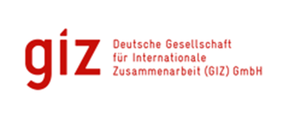
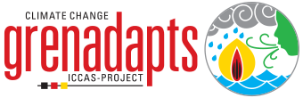

THEMATIC REPORT: ICCAS PROJECT
FORESTRY:
Reforestation Activities in ICCAS

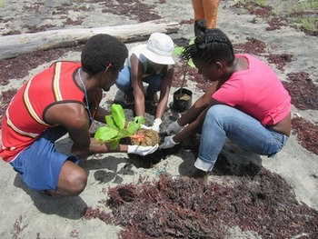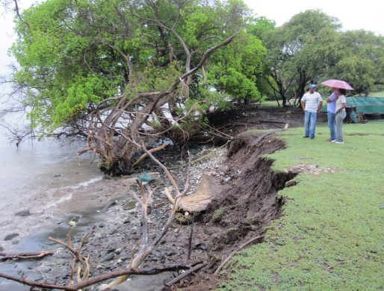

Submitted
By
David A. Simmons
92A Benjamin St., Diego Martin
Trinidad and Tobago
Email: davidAsimmons@outlook.com
Integrated Climate Change Adaptation Strategies (ICCAS): Thematic Report
Thematic Area: Forestry: Reforestation Activities in ICCAS |  | Period: January 2016 – August 2017
IMPLEMENTING AGENCIES
United National Development Programme (UNDP) | The Environment Unit of the Ministry of Agriculture, Lands, Forestry, Fisheries and the Environment |  | German Development Cooperation (GIZ), BMUB
Context | The overall aim of the ICCAS project is to increase resilience of vulnerable communities and ecosystems to climate change risks on all three islands: Grenada, Carriacou and Petite Martinique. Heavy rains and storm systems have had a deleterious effect on top soil erosion, clearing of forested areas for housing and industry, and improper agricultural techniques (slash and burn agriculture) have further aggravated the problem. Top soil erosion affects agricultural productivity in the long term, and also has a very negative effect on coastal areas particularly reefs because of the dumping of large amounts of soil into the sea. Reforestation assists in maintaining the top soil and of course the increase in trees also improves air quality. Forest and mangrove areas include much of the critical habitat important for Grenadian wildlife and, most notably include much of the habitat range for all at risk species of concern in Grenada. As a result, while reforestation was not a primary focus of the ICCAS program it was incorporated in some projects.
Forestry: Background | There were three projects, two in Grenada and one on Petite Martinique, which incorporated reforestation as a key part of the project activities;  Mangrove Reforestation: Two projects in the north and east of Grenada (The Simon & Paradise Project & the RECCOMM Project) have addressed the destruction of mangrove habitats and the resulting loss of flora and fauna and erosion of coastal areas, by the replanting of mangrove trees.  Restoring Forest habitat on Petit Martinique: Petite Martinique is the most northerly of the tri state country with a population of just under 1000 people and an area of 500 acres. Due to the loss of tree cover on the north-eastern side of the island of Petite Martinique and negative farming practices over the years, mass erosion is visible in the Madam Pierre area. The loss of soil into the sea also has a significant negative impact on the surrounding reef systems. Therefore, a significant part of the Petit Martinique project was replanting of forest trees to mitigate against soil erosion

Overall Success
In northern and north-eastern Grenada, more than 1,900 mangrove seedlings have been planted as part of the mangrove reforestation exercise. This is expected to have a very positive effect on the recovery of fauna and flora that thrive in the mangrove eco-system. It will also provide a barrier against coastal erosion.
The following has taken place in Petit Martinique to address the soil erosion problem:
- Reforestation of Madam Pierre.
- Training farmers in soil and water conservation.
- Local knowledge was used to construct Construction and fencing of a hoop nursery, which was used to propagate the plants for the reforestation component of the project.
- Hiring of a forest ranger.
- Check dams were built to prevent further soil erosion when the rains came.

Most importantly in all the projects undertaken there has been a community awareness raising component with Community awareness meetings being held and training carried out in the use of more climate sensitive techniques in farming and livestock management.

The focus on reforestation as a climate change adaptation activity in Grenada has led to a larger scale UNDP funded project aimed at maintaining bio diversity and reducing land degradation called the “Ridge to Reef” approach. This project has a significant forestry component and is ongoing.

Grenada has also set up a Pilot Program for Climate Resilience (PPCR) with international partners who have provided grant funding ofUSD$8 million. This PPCR includes as Investment Project 2 Forest Rehabilitation with the following objectives:
- The Development of a nursery
- Production and propagation of seedlings
- Acreage restored or brought under forests
- Forest roads upgraded

Additionally, Grenada has been well represented at the regional level in various consultations with international agencies on land use, reforestation and bio-diversity and as a result arresting land degradation, reforestation, a promoting bio-diversity have become part of the National Adaptation Plan (NAP).

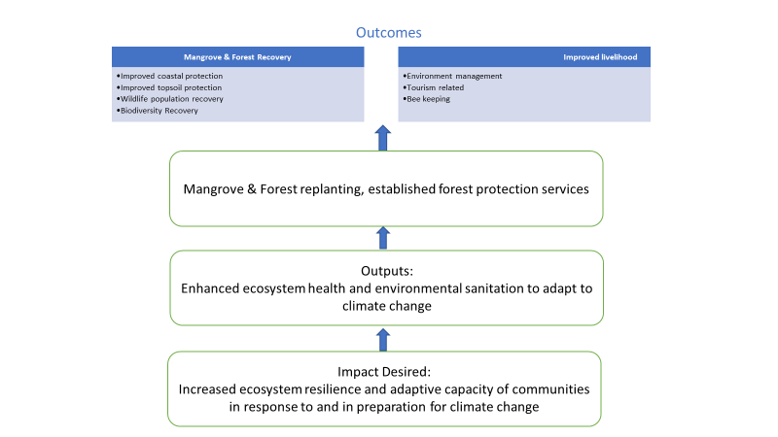

Best Practice(s) Identified
The use of local knowledge and local plant materials in the setting up and cultivating of seedlings is a best practice since it provides a low cost and sustainable approach to reforestation.

Recommendations based on the Lessons Learnt and Best Practices Analysis
- Community awareness and education is the first step to acceptance of climate change adaptive practices
- Community involvement in the program and project development facilitates acceptance and ongoing sustainability (the example of using local knowledge and labour to establish the nursery is a very good instance of this).
- The linkages created between the different parts of the ecological system (forest maintenance and bio diversity and reef health for example) is a critical part of stakeholder education and acceptance of the need to change behaviour.
- The need to create the link between damaging the eco system and the loss of livelihood in the long term is also key since most of the damage is done by short term efforts to improve the livelihood (slash and burn agriculture is a good example of this).
- The need for a national land use policy that is part of the NAP and includes climate change adaptation as part of its land use plans, programs and projects is the basis for long term sustained forest recovery.

Author: David Simmons & Christina Barradas-Brewster/ Consultants/Caribbean/
Contact: davidasimmons@outlook.com
Location of Project: Caribbean/OU/Grenada
MHT: What is the Major Habitat Type for this partnership? Forest
Types of Partners: Government, Place-based NGO, International NGO, Community Based Organization.
Priority: National
Date: June 2018
Links: http://www.iccas.gd/?q=community-projects/petite-martinique-project
http://www.iccas.gd/?q=community-projects/73/Restoration%20and%20Community%20Co-Management%20of%20Mangroves%20%28RECCOMM%29
http://www.iccas.gd/?q=community-projects/181/Seamoon
http://www.nowgrenada.com/2016/07/usaid-supports-reforestation-exercise-grenada/
http://www.fao.org/technical-cooperation-programme/success-stories/detail/en/c/357016/

