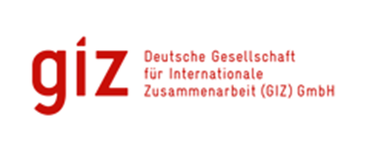

**THEMATIC REPORT: ICCAS PROJECT**

**Mainstreaming Climate Change Adaptation in the Public Sector**

** **

**Submitted**

By

**David A. Simmons**

92A Benjamin St., Diego Martin

Trinidad and Tobago

**Email:** [**davidAsimmons@outlook.com**](mailto:davidAsimmons@outlook.com)

|  |  |  |  |
| --- | --- | --- | --- |
| **Integrated Climate Change Adaptation Strategies (ICCAS): Thematic Report** | | | |
| **Thematic Area: Mainstreaming Climate Change Adaptation** | | **Period:** January 2016 – August 2017 | |
| **IMPLEMENTING AGENCIES** | | | |
| United National Development Programme (UNDP) | The Environment Unit of the Ministry of Agriculture, Lands, Forestry, Fisheries and the Environment | | German Development Cooperation (GIZ), BMUB |

|  |  |
| --- | --- |
| **Context** | The objective of the ICCAS programme was to enhance the resilience of Grenada’s population and its ecosystems that are particularly vulnerable to the effects of climate change. Component one of ICCAS is to Integrate Climate Change Adaptation Strategies. This was achieved by taking an integrated approach across different sectors and levels and facilitated through the preparation of a National Adaptation Plan (NAP) which enables Grenada to identifying medium and long-term adaptation needs and develop and implement strategies and programmes to address those needs. This integrated approach began in 2015, with actions taken toward reducing vulnerability and strengthening the resilience of its land and people included development of several initiatives, such as, Grenada‘s Intended National Development Contributions (INDCs), setting up institutional structures for direct access to the Green Climate Fund, and advancing with the NAP process (also being supported through ICCAS – GIZ implemented components that follows methodology established by GIZ and UNDP through the NAP Global Support Programme). |
| **Background** | The NAP is a continuous, progressive and iterative process which follows a country-driven, gender-sensitive, participatory and fully transparent approach. (UNFCCC NAP Guidelines). This was realised through the implementation of several initiatives which were aimed at the following:   * Strengthening the institutional structure to support coordination, integrating and implementation of climate change adaptation action; * Integration of Climate Change Adaptation in the National Sustainable Development Plan 2030 formulation and implementation; * Mainstreaming of climate change considerations systematically in the design and budgets of new government projects; * Mobilizing funding for the implementation of actions focusing on reducing the risk posed by extreme weather events; * Establishing a climate-responsive water governance structure; * Building the institutional, professional and technical capacity for integrated coastal zone management; and * Strengthening institutional arrangements for the collection, analysis and provision of climate-related data for use in decision-making. |

**Overall Success**

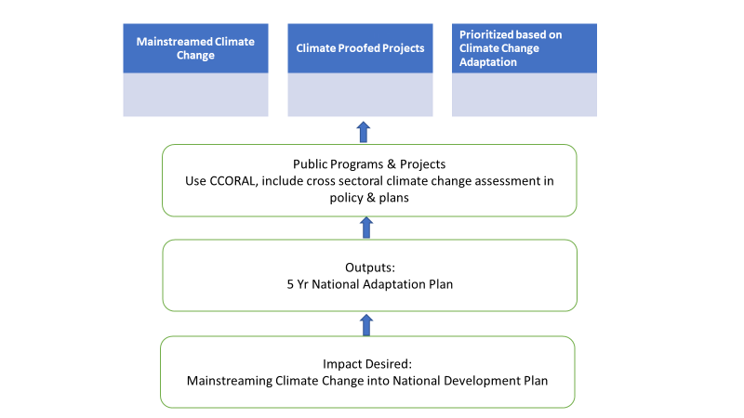

Grenada is the first country in CARICOM to integrate climate change into its national planning process by adopting a National Adaptation Plan (NAP). The document was officially approved by Cabinet decision in November 2017 after two years of development and involves key aspects of Grenada’s national strategic development target, Grenada’s draft National Sustainable Development Plan 2030, priority sectoral corporate plans, and the Public-Sector Investment Programme (PSIP).

The NAP served as one of Grenada’s main mechanisms for accessing external climate finance, but more importantly, as a vehicle for identifying and undertaking strategic investments in Grenada’s climate-resilient development.

The NAP is seen as providing the framework for further integration of climate change considerations into planning across the public sector (12 Ministries/Agencies have Climate Change Focal Points), the budgetary process (Public Sector Investment Programme) to not only “climate-proof” public and private investments, but also to ensure efficient spending of scarce financial resources. In that regard climate risk and adaptation consideration have been systematically integrated in main policy documents such as the Grenada's National Growth and Poverty Reduction Strategy (2014-2018), the National Agriculture Plan, the Strategic Health Plan, and in the Ministry of Agriculture Corporate plan (2016-2018). It is also a requirement that all new projects under the Government’s Public-Sector Investment Programme now must conduct a CCORAL (Caribbean Climate Online Risk and Adaptation Tool) screening, which gives an indication whether the planned project is climate-influenced and a priority for a further climate assessment. About 70 new projects have been screened using the tool.

Evidence of NAP at work can be seen in several sectoral areas:

**Health Sector**:

* The Ministry is developing a Climate smart hospital concept
* Vector borne diseases have been linked to climate change

**Education:** A Toolkit for increasing awareness has been implemented in education. While Initially intended for the primary schools the Ministry of Education has sponsored the idea of a science fair for Secondary Schools focusing on climate change.

**Water Management**:

The Water program has been given access to green climate fund financing totalling USD40 million. This is to be administered by Ministry of Finance and NAWASA.

**Agriculture:**

Agriculture has been identified as a priority sector under the NAP process due to its extreme vulnerability to climate change. As a result, the following actions have been taken:

1. GIZ-ICCAS project took advance of a mainstreaming opportunity to integrate climate smart agriculture (CSA) into the National Agriculture Plan 2015.
2. Climate change issues were also integrated into other sections of the National Agriculture Plan 2015.
3. CSA actions were integrated into the 3 year (2016-2018) Corporate plan of Ministry of

Agriculture, Lands, Forestry, Fisheries and the Environment which then further informed mainstreaming interventions into the Action plan and Work Plan 2016.

**Institutional strengthening**:

* Ongoing through training and mentoring programs
* Use of the Caribbean Climate Online Risk and Adaptation Tool (CCoral) screening is now compulsory ensuring that all public-sector investment programs consider the climate change implications of new investment. More than 60 public officers have been trained to use the tool, more than 70 projects have been screened, and four government projects were selected demonstrate how to integrate adaptation measures into the project documents using CCORAL.

**Lessons Learnt**

1. Broad consultation on the NAP, involving the public and private sector agencies, which commenced in 2015 was critical in ensuring buy-in.
2. After the launch Sectoral Workshops (9 sectors identified including agriculture, water, tourism, infrastructure, health, fisheries, forestry, Carriacou/Petit Martinique) were held to producing sector plans and to ensure stakeholders in those sectors contributed to and were part of the NAP development process.
3. NAP has identified 12 programs of action with their associated goals and indicators. This promotes focus and guides Stakeholder activities.
4. The Sustainable Development Council has been reinvigorated to facilitate stakeholder buy in to the actions being proposed, and it meets monthly –

* Attendees include public private sector employees, NGOs, ministries, school children sometimes, once a month – 2hours (operates like a town hall).

1. The NAP has been set up as a 5-year plan with clear and realistic targets which makes it more achievable and more sustainable. Early successes motivate and encourage continued adoption of the approach and the five-year time frame allows for flexibility and modifications as learning occurs.
2. Budget labelling is a critical component to success as it allows the budget review to identify what percentage of the budgeted activity is vulnerable to climate change and what percentage is dedicated to adaptive activities. This analysis shows that about 50% of budgetary activity vulnerable to climate change but has that amount is not necessarily dedicated to adaptive activities.
3. There have been delays at all stages of implementation due to resource scarcity (financial and human), lack of stakeholder commitment at various stages and problems with inter-ministerial communication.
4. It is therefore clear that for buy-in and behaviour change to be realised stakeholder awareness at all levels must be improved and that requires ongoing awareness raising exercises, and the use of built in processes and procedures like those in the NAP.
5. In 2016, a National Designated Authority (NDA) was set up within the Department for Economic and Technical Cooperation in the Ministry of Finance to coordinate activities regarding the Green Climate Fund and develop guidelines for project development and national consultations.

**Best Practice(s) Identified**

Grenada has provided a model for small island states to integrate climate change adaptation into their decision making at the governmental policy and program planning level using the CCORAL tool. Also, by establishing a Climate Change Adaptation Focal Point in each governmental ministry a mechanism was created for ensuring that these policies and programme interventions were adopted and a means for monitoring implementation created. The model is home grown and tailored to its local context but can serve as a guide to other small island states with similar vulnerabilities.

Climate change adaptation policy needs a home and a champion to ensure its integration into the policy and program planning process.

**Recommendations based on the Lessons Learnt and Best Practices Analysis:**

1. Integration of the climate change adaptation approach at the national policy level is necessary for vulnerable states where future wellbeing will be adversely affected if climate change is not recognized.
2. It is important to put in place stakeholder consultation mechanisms early to ensure buy in at all levels and thereby reduce delays in the integration process
3. Capacity building in climate change adaptation and in the use of tools and techniques related to climate change is an essential component to integration and transformation of the approach to policy and program development and implementation.

Author: David Simmons & Christina Barradas-Brewster/ Consultants/ Caribbean/

Contact: [davidasimmons@outlook.com](mailto:davidasimmons@outlook.com)

Location of Project: Caribbean/OU/Grenada

MHT: What is the Major Habitat Type for this partnership? All

Types of Partners: Government, Place-based NGO, International NGO, Community Based Organization.

Priority: National

Date: June 2018

Links: <https://www.international-climate-initiative.com/fileadmin/Dokumente/landingpages/CB03_Building_capacity_for_NAPs.pdf>

<http://www.napglobalnetwork.org/wp-content/uploads/2016/06/sNAPshot-Grenada-June2016-Letter-1.pdf>

<https://www.nowgrenada.com/2018/05/moving-forward-with-the-national-adaptation-plan/>

<http://www.adaptation-undp.org/resources/videos/community-climate-change-fund-launch-undp>