Better decisions thanks to Cost Benefit Analysis in the Pacific
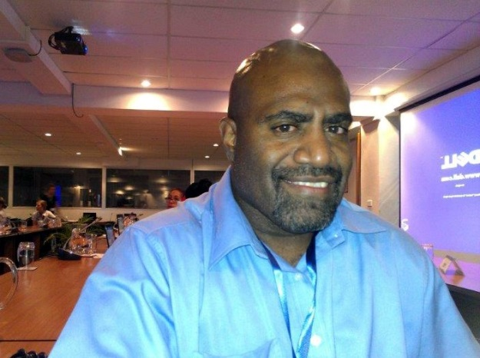
“The most useful aspect of this meeting and the P-CBA initiative is that we can share information on economic analysis with other countries and learn from each other. This will help us to do better planning and institutionalize Cost Benefit Analysis (CBA) into government processes”
Malcolm Dalesa, Scientific Officer - Meteorology and Geohazards Department, Vanuatu.
With these enthusiastic words Mr Malcolm Dalesa, the scientific officer of the Meteorology and Geohazards Department of Vanuatu concludes one of the final sessions of the P-CBA Planning Meeting held at South Pacific Secretariat (SPC) offices in Suva from the 29th to the 31st of January 2014.
Along with him other 18 representatives from Federates States of Micronesia, Fiji, Kiribati, Samoa, Solomon Islands, and Tuvalu attended this 3 days launch of P-CBA, a joint capacity building initiative of ADB, GIZ, PIFS, SPC, SPREP, USAID/ADAPT, USP and UNDP which aims to assist Pacific Island Countries governments to better prioritise, design and implement their projects and policies taking into account climate and disaster risks.
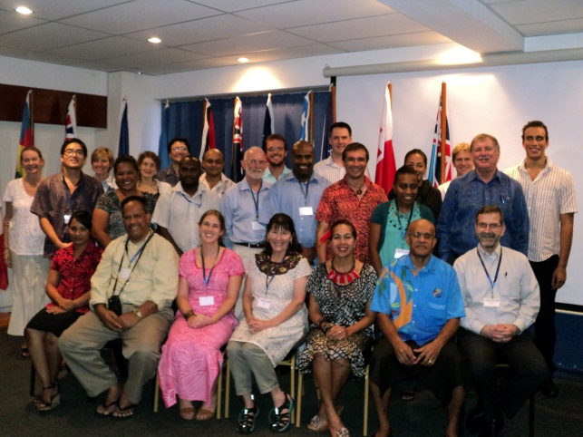
“The aim of the meeting” says Scott Hook (PIFS), one of the organizers “is to ensure that countries can shape the initiative on their needs so that the training activities will be fully aligned with countries priorities”. Countries had the possibility to work side by side to identify participants for the trainings and case studies for their CBA, and to discuss methods to institutionalize these economic tools in government processes.
P-CBA Planning Meeting participants.
One of the main messages that arose from the discussions is that participant-countries have a strong in this field, but given the heterogeneity of governments’ capacities, there is a need for different and tailored trainings. Moreover, the “capacity of USP to integrate CBA trainings in their courses” as delineated by Professor John Bythell, has been welcomed by countries that see USP as an important actor to facilitate knowledge sharing and to give sustainability to the initiative.
Next Steps:
By the end of February 2014 countries are expected to submit their P-CBA Workplans that will outline proposed case studies and participants to the trainings that are expected to be delivered starting from June 2014 to September 2015. By the end of the programme, around 160 government officials will be trained and will carry out more than 7 case studies contributing to build the knowledge of the Pacific upon evidence based decision making.
For any additional information please contact the P-CBA Coordinator: marco.arena@undp.org

