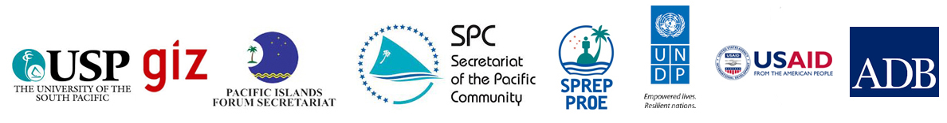

**Summary report**

Planning Meeting for the Pacific Cost Benefit Analysis Initiative  
Suva, Fiji, 2014 January 2014   
  
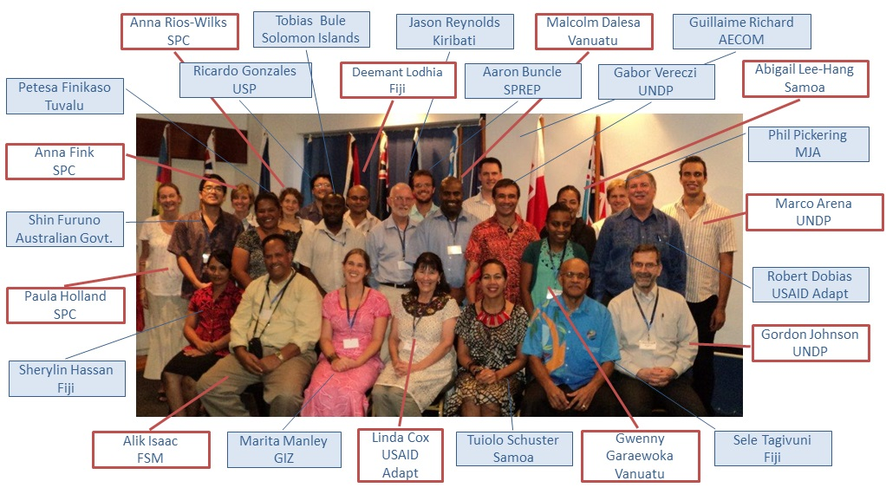

**The Planning Meeting**At the P-CBA Planning Meeting in January 2014, Suva, government officials from Finance, Planning and Environment Ministries of 7 Pacific Island Countries (PICs) gathered to shape P-CBA on countries’ needs and existing capacities and identify further support from donors. All the presentations and relevant materials can be found at the [P-CBA website](http://undp-alm.org/resources/programme-related-events/p-cba-planning-meeting-29-31-january).

**P-CBA Process**P-CBA is a joint capacity-building initiative to address the increasing needs of Pacific Island countries to access tools that can support their climate-resilient decisions and adaptation strategies such as cost benefit analysis. This regional and systematic initiative is a direct response of countries demand in this area and it draws from the lessons learnt of the [PACC CBA Work Programme](http://sprep.org/publications/informing-climate-resilient-development-the-application-of-cost-benefit-analysis-cba-in-the-pacific-adaptation-to-climate-change-pacc-programme-experiences-and-lessons-learned-on-capacity).

**Table of Content**

## 

## Introduction of P-CBA

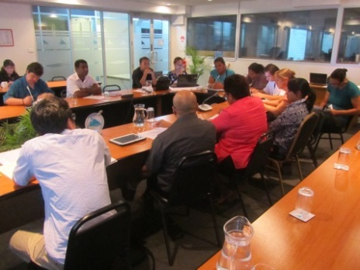P-CBA is a joint initiative to address the increasing needs of Pacific island countries to access tools that can support their climate-resilient decisions and adaptation strategies. This increasing need has been recently highlighted at the Pacific Climate Change Roundtable in July 2013 where many officials in Pacific island governments recognized the value of economic analysis to assess options and shape and their work. Partners include the Asia Development Bank (ADB), the Pacific Islands Forum Secretariat (PIFS), the Secretariat of the Pacific Community (SPC), the Secretariat of the Pacific Regional Environment Programme (SPREP), UNDP, Deutsche Gesellshaft für Internationale Zusammenarbeit (GIZ), the USAID ADAPT Asia-Pacific Project and the University of the South Pacific (USP).

The P-CBA initiative builds on existing experiences such as the cost-benefit analyses conducted as part of the Pacific Adaptation to Climate Change (PACC) programme and the related trainings carried out by SPC, to capture lessons learned and to strengthen capacities in a consistent and strategic manner.

P-CBA targets government officials from Central planning or Finance ministries that are involved in project management and climate resilient development activities and it has a learning-by-doing approach: theoretical trainings will be followed by the mentoring of government officials to conduct cost-benefit analysis on project proposal(s) or on-going initiatives. The results of these analyses will serve as concrete support to government activities providing guidance on project formulation and implementation.

## Overview of the report

This report provides an evaluation of the P-CBA Planning Meeting and summarizes the key messages of this event. The meeting was held from the 29th to the 31st of January 2014 at SPC in Suva and gathered government officials from Finance, Planning and Environment Ministries of 7 Pacific Island Countries (PICs). Its main aims were to launch P-CBA, a regional capacity building programme on cost benefit analysis, and shape it on countries’ needs and existing capacities.

During the 3 days, representatives from Federate State of Micronesia, Fiji, Kiribati, Samoa, Solomon Islands, Tuvalu, Vanuatu worked side by side to make sure that the P-CBA activities will be fully aligned with their priorities and that strategies will be adopted to make the initiative sustainable over time.

The first part of the report (Section 5-7) focuses on the outcomes of countries’ discussions summarizing the key messages for P-CBA, countries’ baselines on needs and existing capacities, and country workplans. The last part (Section 8) is dedicated to the evaluation of the meeting based on a questionnaire that was distributed to the participants at the final session of the meeting. The overall results of the evaluation show that participants were satisfied with the meeting stating that it was “well-structured and useful for the purpose of informing the design of P-CBA”.

Please note that all the materials here mentioned can be found on the [P-CBA website](http://undp-alm.org/projects/ecca-pacific) in the page dedicated to the [P-CBA Planning Meeting](http://undp-alm.org/resources/programme-related-events/p-cba-planning-meeting-29-31-january-2014-suva-fiji).

### Objectives and Structure

First step of the evaluation is a clear definition of the objectives of the meeting. As also mentioned in the [Planning Meeting Agenda](http://undp-alm.org/resources/programme-related-events/planning-meeting-agenda) the event had three main objectives:

1. Inform the overall design of the P-CBA initiative (course content, delivery mechanism and long term sustainability strategy);
2. Define preliminary Country Workplans;
3. Identify further support by donors and development partners.

Table 1, below, outlines the structure of the meeting and shows how each day was focused to meet one or multiple objectives of the meeting. While Day 1 was dedicated to the presentation of the initiative, Day 2 and 3 focused on working sessions where countries could express their preferences for the initiative.

|  |  |  |
| --- | --- | --- |
| P-CBA Planning Meeting | | |
| Day 1 | Day 2 | Day 3 |
| Overview of the initiative  Countries Presentation on Needs and Existing capacities  Related projects presentations | Discussion on the overall design of P-CBA  Presentation of key recommendations for the design for P-CBA | Internal discussion on Country Workplans  Presentation of Country Workplans and Next Steps |
| *Objective 1* | *Objectives 1 and 2* | *Objectives 2 and 3* |

Table summarizes the activities of P-CBA Planning Meeting day by day

### Key Messages for P-CBA

During Day 2 participants were divided into two groups to discuss how to shape P-CBA on their needs and existing capacities. The discussion was framed around three main topics:

1. Course Content: What subject and topics should the in-country trainings cover?
2. Delivery Strategy: How and Whom should deliver the trainings?
3. Sustainability Strategy: Which measures should be adopted to make sure that the results of the initiative will be sustainable overtime?

Table 2, below, summarizes the main messages that arose from these discussions divided for the three main topics:

|  |  |  |
| --- | --- | --- |
| Key Messages | | |
| Course Content | Delivery Strategy | Sustainability |
| Trainings have to be tailored on country needs  Trainings should be composed by different modules  A module should focus on environmental evaluation  One half day general module should be tailored to senior staff | Trainings should be in-country and should target practitioners policy makers and senior officials  Training should be delivered by USP and should provide an official qualification/certificate  Mentoring support should be tailored on country needs and be consistent overtime | P-CBA should train the trainers  (A trained participant from Country 1 could provide part of the trainings in Country 2)  Internet Database for CBA resources to facilitate knowledge sharing  Facilitate institutionalization of CBA and institutional memory |
|  |  |  |

Table summarizes the key messages for P-CBA that emerged at the Planning Meeting

As a response to the request of a multi-modules training the Technical Working Group (TWG) is developing full package of training materials that include:

* half-day refreshment course for senior staff;
* 2,5 days general course on CBA for policy makers and practitioners;
* 2 days module on environmental evaluation;
* half-day module on how to produce a workplan;
* half-day module to prepare government officials to communicate the results of a CBA.

### Baseline – Current Country Capacities

On Day 1 participant countries had the possibility to make a short presentation about their current needs and capacities on Cost Benefit Analysis. The results of these presentations are summarized in the table below that provides an idea of the heterogeneity among the Pacific countries in term of knowledge and application of CBA into decision making.

|  |  |  |  |  |
| --- | --- | --- | --- | --- |
| Presentations on Country Needs and Existing Capacities | | | | |
| Countries | **Existing Capacities** | **Current use of CBA** | **Past Trainings** | **Reference** |
| FSM | Limited capacities on CBA. Currently few government officials can conduct CBA on a systematic way. | Limited use of CBA To date few CBAs have been applied and most of them are designed by external consultant | To date no in-country trainings have been conducted on FSM. 2 representatives from PACC FSM participated to the PACC regional workshop | [FSM Baseline Presentation](http://www.undp-alm.org/resources/programme-related-events/session-1-day-1-federated-states-micronesia-presentation-current) |
| Fiji | Average capacities on CBA MOF[[1]](#footnote-1) and MSP[[2]](#footnote-2) have good knowledge of CBA | Average use of CBA  CBAs are conducted by the MSP on Capital Projects for the Govt. | The PACC CBA work programme provided an in-country training in Fiji | [Fiji Baseline Presentation](http://www.undp-alm.org/resources/programme-related-events/session-1-day-1-fiji-presentation-current-needs-and-capacities) |
| Kiribati | Limited capacities on CBA Limited number of government officials have an economics background and can conduct solid CBA | Limited use of CBA  Simple Qualitative CBA are conducted by the MOF | SPC CBA Training Early 2013 | [Kiribati Baseline Presentation](http://www.undp-alm.org/resources/programme-related-events/session-1-day-1-kiribatis-presentation-current-needs-and) |
| Samoa | Average capacities on CBA A limited number of officials from MOF and MNRE have good knowledge of CBA | Average use of CBA Simple Qualitative CBA and financial CBA are conducted by the MOF | PACC CBA Training 2012 ISP (ADB) 2006 | [Samoa Baseline Presentation](http://www.undp-alm.org/resources/programme-related-events/session-1-day-1-samoa-presentation-current-needs-and-capacities) |
| Solomon Islands | Limited capacities on CBA Currently few government officials can conduct CBA on a systematic way. | Limited use of CBA To date few CBAs have been applied and most of them are designed by external consultant | SPC training Feb 2014 | [Solomon Islands Baseline Presentation](http://undp-alm.org/resources/reports-and-publications-country-teams/session-1-day-1-solomon-islands-presentation) |
| Tuvalu | Limited capacities on CBA Currently there is limited knowledge about CBA and time constraint is a real problem to conduct CBA. High Staff turnover means that skills are soon lost. | Average use of CBA CBA are used in National Budget Processes and Donor Funded Projects | Trainings on CBA for the PDB | [Tuvalu Baseline Presentation](http://undp-alm.org/resources/reports-and-publications-country-teams/session-1-day-1-tuvalu-presentation-current-needs) |
| Vanuatu | Average capacities on CBA MFEM[[3]](#footnote-3) has some economists who can conduct CBA. However their number is limited and these capacities are not present in other ministries. | Limited use of CBA  Only the MFEM conducts a limited number of CBAs | SPC training 2013 | [Vanuatu Baseline Presentation](http://undp-alm.org/resources/reports-and-publications-country-teams/session-1-day-1-vanuatu-presentation-current-needs) |

Table summarizes Countries presentations on Existing Capacities, Current use of CBA and Past trainings. Please click on the name of the countries to access to the full country presentation.

Table 3 shows that countries practice and capacities in conducting CBA are quite heterogeneous among them. Samoa and Fiji have already internal capacities and they conduct CBAs that are requirements for their internal processes. However this knowledge is limited to certain ministries and might be extended to other government officials so that CBA could be use more systematically.

On the other hand, countries such as FSM, Kiribati, Solomon Islands etc. state that, even though they received trainings, they still need to enhance the skills of their government officials on this topic. The information included in Table 3 together with the Country Workplans will be the guide for the implementation of P-CBA.

### Current Regional Initiatives

Day 1 was dedicated to provide an overview of other regional projects that could inform the design of the initiative and be linked to P-CBA. Below a summary of the presentations that have been given by the representatives of the initiatives. Most of the collaborations are still on a defining phase and the details of the partnerships will be defined in the project document. For more information click on the name of the programme and you will be redirected to the page to download the presentation of the Planning Meeting.

[**Ecca Asia**](http://undp-alm.org/resources/reports-and-publications-relevance-country-teams/session-2-day-1-overview-ecca-asia)

**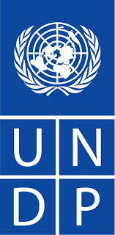**

The Economics of Climate Change Adaptation (ECCA) is the twin project of P-CBA in Asia. This project focuses on a wider range of economics tools and one of the main lessons learnt is to carefully tailor capacity building to countries existing capacities. Interesting collaborations could arise in term of lessons sharing and South-South Cooperation between P-CBA and ECCA.

[**University of the South Pacific**](http://undp-alm.org/resources/reports-and-publications-relevance-country-teams/session-2-day-1-usp-presentation-linkages)

****

USP has a long experience in providing quality courses to students and government officials in more than 10 countries in the Pacific.   
The institution is willing to be a partner of the initiative and support the TWG in the delivery of the trainings

### 

[**PACCSAP**](http://undp-alm.org/resources/reports-and-publications-relevance-country-teams/session-2-day-1-overview-paccsap) **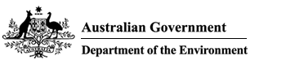**

The CBA component of PACCSAP aims to conduct sectorial analysis in 3 countries in the Pacific. Some of these analyses could complement countries case studies especially in Tuvalu and Vanuatu.

### Options

[**PACC CBA Workprogramme**](http://undp-alm.org/resources/reports-and-publications-relevance-country-teams/session-2-day-1-lessons-learnt-pacc-cba)

**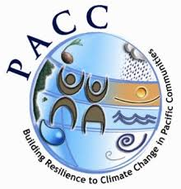**

PACC CBA was the first regional capacity building programme on CBA. The design of P-CBA has been informed by its lessons learnt.

### Country Workplans

On Day 3 participants presented their Country Workplans. These documents are plans for the implementation of P-CBA at the country level and they specify case studies (and existing projects linkages), resource arrangements, timeline, participants for the in-country trainings and a monitor and evaluation strategy. Table 4 below, summarizes the most important elements listing in country training timeline, case studies and focal points. For more specific information please refer to the presentations uploaded on the [P-CBA website](http://undp-alm.org/resources/programme-related-events/p-cba-planning-meeting-29-31-january-2014-suva-fiji).

|  |  |  |  |  |
| --- | --- | --- | --- | --- |
| Summary of Country Workplans | | | | |
|  | **Proposed In-country training timeline** | **Case study** | **Focal Points** | **Reference** |
| FSM | July 2014 | -Revision of Kosrae Shoreline Management Plan  -Other donor funded development water development projects | Alik Isaac Simpson Abraham | [FSM Country Workplan Presentation](http://www.undp-alm.org/resources/reports-and-publications-relevance-country-teams/session-5-day-3-federated-states) |
| Fiji | Jun-Sep 2014 | -Relocation of Communities  -Sea weed Farming  (Maritime Island) | Mereseini Waibuta  Sele Tagivuni  Deemant Lodhia | [Fiji Country Workplan Presentation](http://www.undp-alm.org/resources/reports-and-publications-relevance-country-teams/session-5-day-3-fiji-country-workplan) |
| Kiribati | Apr-Set 2014 or 2015 onwards | -Tourism Economic Development of Kanton Island | Jason Reynolds | [Kiribati Country Workplan Presentation](http://www.undp-alm.org/resources/reports-and-publications-relevance-country-teams/session-5-day-3-kiribati-country-workplan) |
| Samoa | October 2014 | -ICCRIFIS (GEF Forestry Project)  - PPCR Project 2  -Samoa IWRM | Tuiolo Schuster  Abigail Lee-Hang | [Samoa Country Workplan Presentation](http://www.undp-alm.org/resources/reports-and-publications-relevance-country-teams/session-5-day-3-samoa-country-workplan) |
| Solomon Islands | / | -Malaita Hydro project (ADB)  -Undersea Internet Cable (ADB)  -Food Security project for Choiseul Province | Tobais Bule | [Solomon Country Workplan Presentation](http://www.undp-alm.org/resources/reports-and-publications-country-teams/session-5-day-3-solomon-islands-workplan) |
| Tuvalu | Jul-August 2014 | -NAPA Project II  - Construction of the new PUI Building | Lita Molu Petesa Finikaso Simalua Enele | [Tuvalu Country Workplan Presentation](http://www.undp-alm.org/resources/reports-and-publications-country-teams/session-5-day-3-tuvalu-country-workplan) |
| Vanuatu | Apr 2014-Apr 2015 | -V-CAP  -PACC Vanuatu -Climate Change/Disaster Risk Reduction policy | Malcolm Dalesa Wenny Woy Gareawoka | [Vanuatu Country Workplan Presentation](http://www.undp-alm.org/resources/reports-and-publications-country-teams/session-5-day-3-vanuatu-country-workplan) |

Table illustrates the main details of Country Workplans

### Evaluation

At the end of Day 3 participants received a Workshop Feedback form where they could evaluate different aspects of the meeting. The evaluation form had a total of nine questions: the first six were dedicated to the evaluation of the different days of the meeting, while the last four had room for more open comments.

Overall it is arguable that the meeting was well received by the participants that expressed a general satisfaction both in the evaluation feedback form and also informally with the organizers during the meeting. The results of the most relevant questions reported below corroborate the positive impressions received from the participants:

Chart : Question 3-4-5 of the Workshop Feedback Form. 92% of the participants state that the Planning Meeting was well structured for objective 1, 85% for objective 2 and 66% for objective 3.

Participants stated that the Planning Meeting was well structured to meet Objective 1 and Objective 2, while it was less successful in meeting Objective 3 “Identify further support from donors”. From the comments it emerged that identifying further support from donors at this stage could have not be necessary, while others stated that this task would have been facilitated with more time spent on bilateral discussions. Especially on this point a better and earlier coordination of the TWG with the main donors could have facilitated this task.

Chart : Question 6 – 7 of the Workshop Feedback Form. 71% of the participants stated that there was a good balance between presentations and Working sessions, while 85% declared that their suggestion were well captured by the organizers.

From the participants’ answers to the above questions it emerged that there was a good balance between presentation and working sessions and that they felt their voice was listened. However, in more than one evaluation feedback form, participants said that they would have preferred Day 1 to be less intense and they suggested that the presentations could have been much more interesting if they included examples from current issues in the Pacific.

When asked which session of the workshop they liked most, countries indicated the country presentations and the working sessions of Day 1 and Day 2. This, together with the previous comments on the balance between working sessions and presentations should be a lesson learnt for future meetings: even though countries found the meeting helpful there is a need for future regional meetings to be more interactive and focused on working sessions with examples from the Pacific.

### Next Steps

The delivery of the first training is expected to happen in April 2014. The following steps to meet this objective will involve both the TWG and the Participant Countries:

* Countries finalize the Country Workplans (14th of February 2014 first deadline);
* The TWG finalizes the Programme Design Document (28th of February 2014 first deadline);
* The TWG finalizes the Course Materials (end of March 2014)
* The TWG identifies funding opportunities for the project (end of March 2014)

|  |  |
| --- | --- |
| C:\Users\Marco\Dropbox\Lavoro\UNDP 2013\P-CBA Shared Folder\P-CBA Planning Meeting Dropbox\PCBA workshop photos\IMG_4150.JPG | C:\Users\Marco\Dropbox\Lavoro\UNDP 2013\P-CBA Shared Folder\P-CBA Planning Meeting Dropbox\PCBA workshop photos\IMG_4140.JPG |

## Appendix 1. P-CBA Planning Meeting Participants

|  |  |  |  |  |
| --- | --- | --- | --- | --- |
|  | PARTICIPANT | POSITION | INSTITUTION | COUNTRY |
| *Fiji* | | | | |
| 1 | Kaanong Tato | Senior Sector Economist | Ministry of Finance | Fiji |
| 2 | Shrylin Shabnam Hassan | Economist | Ministry of Finance | Fiji |
| 3 | Mereseini Waibuta | Chief Economist | Ministry of Finance | Fiji |
| 4 | Sele Tagiuimi | GEF Programme Manager | Ministry of Local Government, Urban development, Housing and Environment | Fiji |
| 5 | Deemant Lodmia | PO CC Finance | MFAIC-CC Division | Fiji |
| *FSM* | | | | |
| 6 | Simpson Abraham | FSM PACC PMU Co-cordinator | Department of Finance and Administration, | FSM |
| 7 | Alik S. Isaac | Director | Department of Finance and Administration | FSM |
| *Kiribati* | | | | |
| 8 | Kurinati Robuit | Senior Sector Economist | National Economic Planning Office | Kiribati |
| 9 | Jason Reynolds | Director | Ministry of finance | Kiribati |
| *Tuvalu* | | | | |
| 10 | Petesa Finikaso | Project Officer | Department of environment | Tuvalu |
| 11 | Simalua Enela | Assistant Secretary | Public Utilities | Tuvalu |
| 12 | Litia Molu | Aid Advisor | Ministry of Finance and Economic Development | Tuvalu |
| *Samoa* | | | | |
| 13 | Tuiolo Schuster | Principal Capacity Building Officer | Environment | Samoa |
| 14 | Abigail Lee-Hang | Principal Project Planning and Programming Officer | Ministry of Finance, Samoa | Samoa |
| *Solomon Islands* | | | | |
| 15 | Tobais Bule | Chief Finance Officer | Ministry of Finance | Solomon Islands |
| *Vanuatu* | | | | |
| 16 | Malcolm Dalesa | Adaptation/ DRR officers | Meteorology and Geohazards Department | Vanuatu |
| 17 | Wenny Garaewoka | Budget Accountant | Department of Finance and Treasury | Vanuatu |
| *USP* | | | | |
| 18 | Isoa Korovulavula | USAID-C-CAP/USP | PACE-SD USP |  |
| 19 | Seone Lolsin | Statistics | USP |  |
| 20 | Corinne Yee | Program Manager | PICPA, USP |  |
| 21 | Siosiua Utoikamanu | Director | PICPA, USP |  |
| 22 | Ricardo Gonzales | Professor | School of Economics, FBE, USP |  |
| 23 | Desmond Uelese Amosa | Advisor | PICPA, USP |  |
| *Other* | | | | |
| 24 | Jacob Salcone | Technical officer | IUCN |  |
| 25 | Bob Dobias | Team Leader | ADAPT, Asia-Pacific |  |
| 26 | Shin Furuno | Regional Manager | Department of Environment | Australia |
| 27 | Jesus Lavinia | Head of Section | EU |  |
| 28 | Nila Prasad | Programme Officer | JICA |  |
| 29 | G Purdent Richard | Assistant Director | AECOM |  |
| 30 | Phil Pickering | Director | Marsden Jacob |  |
| 31 | Joey Manfredo | Project Manager | USAID C-CAP |  |
| 32 | Maria Paniagua | Unit Head project admin | ADB |  |
| 33 | Shoko Takemoto | Regional technical Advisor | UNDP |  |
| 34 | Gordon Johnson | Regional Team Leader, Environment and Energy | UNDP |  |
| *Support team* | | | | |
| 35 | Marita Manley | Technical advisor | GIZ |  |
| 36 | Aaron Buncle | Mainstreaming Specialist | SPREP |  |
| 37 | Anna Rios Wilks | resource Economist | SPC |  |
| 38 | Anna Fink | Economimist | SPC |  |
| 39 | Paula Holland | Manager | SPC |  |
| 40 | Scott Hook | Economic Infrastructure Advisor | PIFS |  |
| 41 | Gabor Verezci | Regional technical advisor | UNDP |  |
| 42 | Marco Arena | P-CBA Coordinator | UNDP Consultant |  |
| 43 | Linda Cox | Consultant | UNDP Consultant |  |

### 

1. Ministry of Finance [↑](#footnote-ref-1)
2. Ministry of Strategic Planning, National Development and Statistics [↑](#footnote-ref-2)
3. Ministry of Finance and Economic Management. [↑](#footnote-ref-3)