**REPUBLIQUE DU NIGER**



**Fraternité - Travail - Progrès**

**CABINET DU PREMIER MINISTRE**

**----------------**

**PROCEEDINGS OF THE GLOBAL EXCHANGE WORKSHOP ON ADAPTATION FOR FOOD SECURITY AND RESILIENCE**

**Niamey, Niger**

**2-5 March 2015**

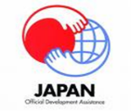

Canwordmark_colour

|  |  |  |  |
| --- | --- | --- | --- |
| **CONSEIL NATIONAL DE L’ENVIRONNEMENT POUR UN DEVELOPPEMENT DURABLE** | **Global Environment**  **Facility** | **United Nations Development Programme** | **Climate Change Adaptation Facility** |
|  |  |  |  |

**Table of Contents**

[Introduction to the Workshop 5](#_Toc415068840)

[I. Background 5](#_Toc415068841)

[II. Objectives 5](#_Toc415068842)

[Day 1: Monday 2 March 2015 7](#_Toc415068843)

[Session 1: Setting the Scene – Introduction, Objective and Structure 7](#_Toc415068844)

[Opening Remarks: 7](#_Toc415068845)

[Introductions: 8](#_Toc415068846)

[Theme A: Innovations through climate related information products and services 9](#_Toc415068847)

[Regional and sub-regional experiences: 9](#_Toc415068848)

[Key points from discussions: 10](#_Toc415068849)

[Key points from discussion: 12](#_Toc415068850)

[Theme B: Innovations in water, soil, energy, crop management technologies and approaches 12](#_Toc415068851)

[Country experiences 12](#_Toc415068852)

[Key points from discussion: 13](#_Toc415068853)

[Plenary: Breakout group report back 13](#_Toc415068854)

[Day 2: Tuesday 3 March 2015 14](#_Toc415068855)

[Session 3: Enabling Framework for Managing Climate-Related Agricultural Risks: Policy, Institution and Finance 14](#_Toc415068856)

[Theme A: Policy and institution: Better integrate agriculture, food security and climate change policies and coordinate their implementation at the national, sectoral and sub-national levels 14](#_Toc415068857)

[Country examples at national and sectoral levels: 14](#_Toc415068858)

[Key points from discussion: 15](#_Toc415068859)

[Country examples at sub-national level (local government and community) 15](#_Toc415068860)

[Key points from discussion: 17](#_Toc415068861)

[Country experiences: 17](#_Toc415068862)

[Theme C: Awareness raising and advocacy 18](#_Toc415068863)

[Country experiences 18](#_Toc415068864)

[Key points from discussion: 18](#_Toc415068865)

[Breakout group report back 19](#_Toc415068866)

[**Training: Communications and Social Media** 20](#_Toc415068867)

**Field Trip:** [Gardening site - community group of Gormi, Gaba Goura, Municipality of Niamey I 21](#_Toc415068870)

[Gardening site - community group of Kondbiah, Municipality of Niamey I 21](#_Toc415068871)

[Soudour Village, Municipality of Niamey I 21](#_Toc415068872)

[**Session 4: In Depth Examination of Innovative Approaches** 22](#_Toc415068873)

[Day 4: Thursday 5 March 2015 24](#_Toc415068874)

[**Session 5: Gender Sensitive Approaches** 24](#_Toc415068875)

[Roundtable on implementing gender-sensitive approaches 24](#_Toc415068876)

[**Session 6: Scaling Up Innovation** 26](#_Toc415068877)

[How to establish partnerships with the private sector to scale up successful innovations such as weather index insurance and climate information products? 26](#_Toc415068878)

[**Session 8: Measuring Impact: Sharing experiences in monitoring the progress of climate adaptation and evaluating their development impacts** 29](#_Toc415068879)

[Hands-on working session: report back of country team on how to improve impact measurement plan 30](#_Toc415068880)

**Acronyms**

AAP: Africa Adaptation Programme

ACA: Africa Climate Adaptation and Food Security project

ACAMAD: African Center for Meteorological Application for Development

CCAF: Canada-UNDP Climate Change Adaptation Facility

CCAFS: Research Programme on Climate Change, Agriculture and Food Security

CGIAR: Consultative Group for International Agricultural Research

CNEDD: National Council of the Environment for Sustainable Development

CONEDD: Conseil National pour l’Environnement et le Développement Durable

COP: Conference of Parties

IIED: International Institute for the Environment and Development

NAP: National Adaptation Plan

NAPA: National Adaptation Programme of Action

NCIP: National Climate Investment Plan

NMS: National Meteorological Service

PCCM: Politique du Changement Climatique du Maroc

RTE: Radio of Education and Technology

TAMD: Tracking Adaptation and measuring Development

ToC: Theory of Change

ToT: Training of trainers

UNCDF: United Nations Capital Development Fund

UNFCCC: UN Framework Convention on Climate Change

WMC: Watershed Management Committees

WMO: World Meteorological Organization

# Introduction to the Workshop

## I. Background

To address the impacts of climate change on food security and other development priorities, two important initiatives were launched by UNDP in 2013: the Canada-UNDP Climate Change Adaptation Facility and the Japan-UNDP “Africa Climate Adaptation Food Security regional project.”

The **Canada-UNDP Climate Change Adaptation Facility (CCAF)** incorporates six national projects that scale up or extend projects previously supported by the Global Environment Facility’s Least Developed Countries Fund (GEF/LDCF). The CCAF projects are being undertaken in Cambodia, Cabo Verde, Haiti, Mali, Niger and Sudan. They all similarly aim to strengthen resilient approaches to agriculture and water management, with an emphasis on gender-sensitive approaches. In 2014, a global component of the CCAF was launched, with the aim to promote south-south cooperation and enhance understanding about adaptation initiatives, especially the gender dimensions, with a focus on the six CCAF projects.

Building on the results of the Africa Adaptation Programme, UNDP, with financial support from the Government of Japan launched the **Africa Climate Adaptation Food Security regional project (ACA)** in June 2013. The project aims to: 1) improve climate information systems for informed decision-making and integrated planning approaches; and 2) test and scale up climate risk management measures including weather index insurance and community based adaptation measures. It also works to enhance capacity to access and manage climate finance.

## II. Objectives

This Global Exchange Workshop aimed to bring together project teams engaged in the CCAF and ACA initiatives in order to share experiences with one another and document critical lessons and emerging successes. Specifically, the objectives include:

1. Support project teams to share insights about their experience with the projects, both successes and challenges, which may be useful for other teams
2. Establish a cohesive community of practice among the CCAF national projects and ACA project countries by providing an opportunity for the teams to meet and get to know each other for future sharing/learning
3. Document concrete lessons learned results and successes for defined knowledge products.

A full agenda is provided in Annex I.

**IV. Participating countries (a full participants list is provided in Annex II)**

|  |  |  |  |
| --- | --- | --- | --- |
| 1 | **Benin** | 7 | **Morocco** |
| 2 | **Burkina Faso** | 8 | **Mozambique** |
| 3 | **Cambodia** | 9 | **Niger** |
| 4 | **Cape Verde** | 10 | **Sudan** |
| 5 | **Haiti** | 11 | **Tanzania** |
| 6 | **Malawi** |  |  |

**Day 1: Monday 2 March 2015**

## Session 1: Setting the Scene – Introduction, Objective and Structure

### Opening Remarks:

The workshop opened with remarks from **Ms. Martine Therer, UNDP-Niger Deputy Resident Representative** and **Dr. Agali Abdoulkader, Deputy Head of the Prime Minister’s Cabinet and Secretary General of the National Council of the Environment for Sustainable Development (CNEDD) of Niger.**

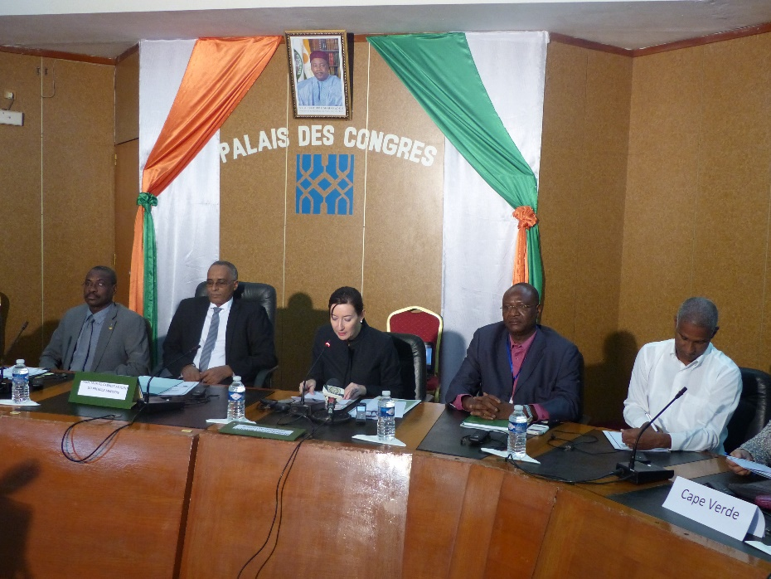**Ms. Therer** first thanked the Government of Niger for hosting this important workshop, and welcomed the participants. She stressed the connection between climate change and poverty, especially in the context of Niger which is frequently threatened by aridity and food insecurity. She said that food security, and MDGs will only be achieved with due consideration and mainstreaming of climate change into national priorities. She then emphasized the commitment of UNDP to climate resilient development, and its position as the partner of more than 140 countries to address this need. She elaborated on UNDP’s interventions to this aim, spanning from the formulation of national strategies on climate change to the implementation of concrete adaptation actions on the ground which focus on the promotion of behavioral change, the collection, processing and diffusion of climate change information, and climate resilient techniques. She provided several examples of climate change adaptation projects being implemented in Niger, and emphasized the ACA and the CCAF as good examples of projects promoting integrated approaches to strengthening climate resilience and mainstreaming adaptation into development policies and strategies. She highlighted the importance of this workshop for the opportunity to share experiences among participants, consistent with UNDP’s goal to promote South-South cooperation for climate change adaptation, and the international community’s efforts to develop a shared vision and achieve an ambitious outcome at the next COP in Paris.

**Dr. Abdoulkader** first elaborated climate change impacts in Africa, and specifically Niger’s vulnerability linked to frequent food shortages. He said that Niger signed and ratified the UNFCCC in order to contribute to the global effort to protect the environment. While recognizing the necessary two-pronged approach to combat climate change, he stressed Niger’s priority on adaptation interventions for poverty alleviation. He said that Niger is therefore grateful to the international community’s support to develop a National Adaptation Programme of Action (NAPA) to address immediate and urgent adaptation needs, and a National Adaptation Plan (NAP) to address needs in the medium and long term. He said that the NAPA is implemented through projects, such as CCAF and ACA projects, aiming to strengthen resilience in the sector of agriculture and water, improve climate change information systems, and test and scale up adaptation measures. He thanked these two initiatives for organizing this workshop that he believed will provide participating countries with new and better adaptation opportunities. On behalf of the Prime Minister, he thanked all the partners of Niger, especially UNDP, Japan and Canada for the continuing support to combat climate change in Niger. He expressed his belief that this workshop will result in concrete recommendations to be translated into concrete actions by decision makers. He then declared open the Global Workshop on Adaptation for Food Security and Resilience.

### Introductions:

More information was provided on the ACA regional project and the CCAF global project.

**Seon-Mi Choi,** Regional Climate Change Advisor, UNDP Regional Center for Africa in Addis Ababa, introduced the ACA regional project. This project builds on the Africa Adaptation Programme (AAP), a large regional project, which UNDP implemented from 2009-2012 in 20 countries in Africa with financing from the Government of Japan. AAP achieved significant results in terms of strengthening long term capacity in the 20 participating countries. The current ACA project builds on this work in 6 of the former AAP countries (Burkina Faso, Niger, Malawi, Morocco, Mozambique and Tanzania). It has two main focuses: 1) climate data and information services for informed and integrated decision-making and 2) innovative climate risks management measures, including weather index insurance. The project also has a regional component, which aims to enhance regional climate services through partnerships with regional and sub-regional institutions, such as the African Center for Meteorological Application for Development (ACMAD) and the AGRHYMET center.

**Jennifer Baumwoll,** Coordinator of the Canada-UNDP Climate Change Adaptation Facility project (CCAF), introduced the CCAF. The Facility brings together six countries working on adaptation related to food security and water management issues, with a strong emphasis on gender-sensitive approaches. In addition to the six national projects, there is a CCAF global component aiming to share experience between countries. The CCAF consists of three components: (1) Community of Practice - bringing the countries together to exchange and share experiences around similar themes and approaches emerging from their national implementation; (2) Analysis and Knowledge Products - to understand and share emerging lessons learned from these experiences ; and (3) Outreach and communication - to share substantive lessons learned more broadly with the global community.

After the introduction of the two regional projects, country team staff introduced themselves and provided a brief overview of the focus of their project[[1]](#footnote-1).

## Session 2: Innovative Technologies and Approaches for Managing Climate-related Agricultural Risks and Improving Resilience

**Theme A: Innovations through climate related information products and services**

#### 

#### Regional and sub-regional experiences:

* [**Climate Smart Agriculture: Actions to reduce agricultural vulnerability to climate**](https://undp.unteamworks.org/node/484430) **-***Patrice Savadogo,**International Centre for Research in*[*Agroforestry (ICRAF)*](http://www.ciesin.org/IC/icraf/icrafmore.html)*, on behalf of Robert Tomore, CCAFS Regional Programme Leader for West Africa.*

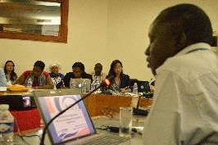This presentation provided an overview of climate change in West Africa, including its specific vulnerabilities and challenges, as well as future climate scenarios, featuring the predicted change in growth period for crops and decrease in productivity. It then introduced the concept and application of climate smart agriculture (at both the farm and landscape levels). This presentation stressed the need to rethink the way manage agriculture in order to sustainably increase production without compromising other assets, while simultaneously increase resilience, reduce GHG emissions, and achieve food security.

* [**Implementation of maproom thematic at Agrhymet Regional Center**](https://undp.unteamworks.org/file/483028/download/526324) **-** *Henri Songoti & Oumar Boukari*, *Agrhymet*

AGRHYMET, with support from the ACA project, is enhancing its existing climate information products and developing new on-line tools such as thematic climate maprooms to strengthen food security and water resources management. The Climate Maproom aims to enhance the availability, access and dissemination of climate information to its CILSS member states as well as those of ECOWAS, in order to increase resilience to climate change. The challenges to the Climate Maproom are low internet connectivity, lack of field data, and limited capacity of users. The demonstration showed participants how to analyze and produce dynamic thematic maps using the Maproom tool. Agrhymet also provided capacity building support for other countries outside of West Africa, including Haiti, to build their capacity in monitoring agricultural campaigns.

* [**ACMAD: From data rescue to climate services**](https://undp.unteamworks.org/node/485795) **-** *Kamga,**Chief of Climate and Environment Department, ACMAD*

In many countries in Africa, there is a need to extract historical climate data that are currently in perishable formats (e.g. paper), in order to provide reliable climate information and services. ACMAD has microfiches for 46 African countries, some dating back to 1900. Under the ACA project, ACMAD is working to convert these microfiches into images, edit them in a structured base called CLIMSOFT to manage data and images at the same time, and translate the information into some examples of climate services. At the end of every month, a “State of climate” summary is done by the meteorological service using this application. For example, the application combined current and historical climate data to show that 2014 was the highest historical temperature in Africa since 1950, and that the last ten years were the hottest year in history, providing evidence of climate change in Africa.

#### Key points from discussions:

* Agrhymet brings together members states and provides financial resources to collect and share the data. Agrhymet does not provide data to individuals, but only information about the data (e.g. whether they are available and for which period). *ACMAD* has two missions: to produce information for Africa and develop applications for different socio-economic sectors. Agrhymet develops applications at the level of ECOWAS. The synergy between the two institutions is on the application of climate data and information for informed decision-making in West Africa.
* *ACMAD*’s strategy is to train people at the country level to rescue the data, and then proceed through crowdsourcing to collect data from countries. To date, only maximum temperature and precipitation data have been digitized.It is important to validate information before it is shared. The data used in the Climate Maprooms are validated as part of the process.
* Seasonal forecasts are also of primary importance, particularly for farmers. These are available in the climate maprooms.
* Several countries reiterated the difficulties in accessing and sharing data due to institutional challenges.
* 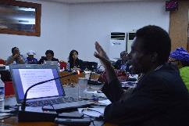*ACMAD’*s CLIMSOFT data include two types of information: synoptic data - available at the international level under WMO conventions, and national data - provided to users by the national meteorological center

**Country experiences:**

* [**Malawi: Mulanje Farmers Climate Change Center**](https://undp.unteamworks.org/file/483029/download/526325) ***–*** *Suzgo Gondwe, Environmental Officer for Mulanje District*

The objective of the District Climate Center of Mulanje in Southern Malawi is to be a one stop information center for climate change, adaptation and resilience for local farmers in the district. Through the ACA project, the center is working to document information and adaptation practices from its different agricultural zones, e.g. crop information. The center aims to provide farmers with reliable, synthesized information that is scientifically validated for informed decision-making. It will conduct consultative stakeholder meetings to raise awareness on climate change, trains staff and farmers, and undertake demonstration activities and open days for visitors.

* [**Burkina Faso: Climate Information System for Agriculture and Cross-sectoral Planning and Decision-Making**](https://undp.unteamworks.org/file/483031/download/526327)– *Kouka Ouedraogo, Coordinator of TICAD V project, National Council for Environment and Sustainable Development*

With support from the ACA project, Burkina Faso is using its climate information to pilot a weather index insurance scheme in the Sahel region. This is done through two initial steps: (1) awareness raising about the concept of climate insurance, its benefits and operations and (2) feasibility study on weather index insurance (agriculture and/or livestock). A partnership was established with Planet Guarantee and its partners (i.e. Oxfam, Ecobank, UCEC-Sahel and Allianz), and the initiative has already received strong support from all the stakeholders, including the local government.

* [**Niger: SMS Messages for Sharing Weather Forecast**](https://undp.unteamworks.org/file/483032/download/526328) **-** *Ousman Baoua, Meteorologist, National Meteorological Service (NMS).*

Building on the work ongoing under the NAPA project, which laid the foundation for sending rainfall data using SMS, additional support from the Government of Canada is helping to provide equipment and training to observer peasants to send rainfall data to the NMS through the agriculture meteorological center. Data received is integrated into a database, and then used to develop a number of products disseminated to farmers. The challenge faced during the NAPA project was that poor village volunteer observers had to pay a high cost for sending SMS. Under this CCAF project, the system has been enhanced through a partnership with a mobile phone company. Today, farmers can send weather related SMS for less than one cent. This data helps monitor the agricultural seasons and assist farmers in their production activities. Now, the challenge is to develop a legal framework to bring together the primary stakeholders of this initiative, i.e. government, private sector, information providers (NMS, CNEDD, etc.) and users.

* [**Niger: Installation of an Information System to Improve the Management of Climate Data**](https://undp.unteamworks.org/file/483030/download/526326) **at CNEDD *-*** *Djibrilla Amadou, GIS Expert, ACA project*

With support from the ACA project, CNEDD has developed a GIS-based, national information system on climate change, which also includes information on biodiversity and desertification. The operational system for the management of the information at the CNEDD incorporates both the database within the CNEDD and data from pilot projects implemented by the government. This project so far has provided key components of the information system, including free and licensed software (ArcGIS and database management system PostGRESQL) and materials (server, computer network equipment).

* [**Mozambique: Climate Data Platform**](https://undp.unteamworks.org/file/483027/download/526323) **-** *Berino Francisco, Technician, Mozambican National Meteorological and Climatological Authority (INAM)*

Under the ACA project, INAM developed a climate data platform that strengthens existing databases by integrating new data from climatic stations. The platform provides a number of climate products to support dissemination of climate information to the agricultural sector - from government officials to local farmers. The project also builds the capacity of technical staff from local governments, committees and radio transmitters on how to use and interpret climate information.

#### Key points from discussion:

* Implementation of weather index insurance in Burkina Faso consists first of establishing a **climate index** which is done in a participatory manner with both direct and indirect beneficiaries.
* With regards to **sustainability of Niger’s SMS platform**, this is ensured through training of local observers who will then carry out this activity after the end of the project. The activities have also been mainstreamed into the budget of the NMS.

### Theme B: Innovations in water, soil, energy, crop management technologies and approaches

#### Country experiences

* [**Sudan: Solar Powered Water Pumps for Small Scale Irrigation**](https://undp.unteamworks.org/node/483082) **–** *Adil Mohamed Ali, Project Manager, Canada-funded adaptation project*

The CCAF project in Sudan is supporting the introduction of solar powered water pumps for improving small scale irrigation. The pumping system is used to capture water underground and store in water tanks to be used for human consumption (household needs), livestock, and irrigation. Women are the principal beneficiary of this intervention. To date, this system has improved water efficiency and increased agricultural productivity by 20-60%. In addition, thanks to the same solar power system, schools in the village are electrified for the first time. Moving forward, the project will carry out a cost/benefit analysis of using solar power for agricultural production to make the case for scaling it up in other states.

* [**Haiti: Watershed Management Committees**](https://undp.unteamworks.org/node/483081) **-***Jean Ked Neptune, Southern Department Coordinator, Ministry of Environment, Haiti*

As part of the CCAF project, Watershed Management Committees (WMCs) have been established in the Southern State in Haiti, to sustainably manage natural resources in watershed areas that cut across administrative boundaries. The WMCs coordinate and monitor the planning process and implementation of a watershed management plan. Challenges to this new approach include the absence of a legal framework which limits WMC’s operations and prevents them from receiving financial support from the government. Competition amongst local authorities to lead the WMC is also a challenge. Nonetheless, WMCs has proven to be a good approach to engage the rural population in decision making processes concerning environmental management. It was also noticed that WMCs managed by women produced more tangible results.

* [**Tanzania: Village Water Resources Management**](https://undp.unteamworks.org/node/483083) **–***Stephen Mariki, ACA Project manager, Vice Prime Minister’s Office, Tanzania*

Under the AAP, local government authorities were asked to propose water management adaptation measures that can increase water availability for human consumption, livestock, and irrigation. Four pilot projects were initiated in the island of Zanzibar, including: the construction of a water tank to supply villages with fresh water, the development of a water canal to separately direct water for either human or animal consumption, and the introduction of a water pump to move water from the catchment and to a machine for the production of electricity.

#### Key points from discussion:

* A **Water Management Committee in** **Tanzania** consists of eleven elected members and presided over by a member of the community assisted by the mayor as first advisor
* In the project area **in Sudan**, the community is willing to pay for water service. The community established a water association and developed a by-law guideline for water use within the community. In addition, criteria to receive the project benefits were defined in consultation with the population at the early stage of the project to prevent conflicts
* **In Cambodia**, a good budget plan was essential for the success of adaptation interventions. In addition, a public-private partnership was established to help maintain of solar panels for pumps.

#### Plenary: Breakout group report back

* [**Summary of report back on Theme A: Climate Information Services**](https://undp.unteamworks.org/node/485796)

***Users of climate change services*** include: communities for informed decisions about when and what to farm; ministries for policy design; donors to allocate funding; and civil society for advocacy.

***Providers of climate information services*** are: research institutions; meteorological services; and communities with traditional knowledge on weather patterns. Specifically, ACMAD, Agrhymet at the regional level and Observatory of Sahel and Sahara.

Some ***good examples of climate products and services*** include: Early Warning System in Sudan informing farmers when to plant; communication outlets (TV, radio, and leaflet) in Tanzania providing seasonal forecast to farmers and pastoralists; the National Outlook Forum in Mozambique, where key stakeholders deliberate on climate change issues; macro and micro weather insurance for farmers in Malawi ; and Early Warning System in Haiti used for vulnerability assessment and need projections (shortages/surpluses).

Most common ***challenges*** include: inappropriate climate information format or language; absence of standards on data collection among weather stations; absence of consensus on operational modalities of weather insurance; absence of clear mandate, roles and responsibilities; availability and access to data; and sensitization and capacity building of users.

***Good practices*** include: coordination and collaboration in policy formulation and implementation and development and adherence to standards for data; consensus seasonal forecasting such as PRESAO, dissemination of information through cell phone, community radio, TV, and forecast and alert bulletins; and maintenance of data collection equipment

* [**Summary of report back Theme B: Integrated Management Approach**](https://undp.unteamworks.org/node/483084)

***Good examples*** of integrated water, soil, energy, crop management include: Water management committees in Haiti for integrated watershed management of natural resources; and establishment of platform to ensure sustainability of interventions beyond the project lifetime.

***Some challenges*** are: high cost associated with adaptation interventions, such as the purchase of solar panels; difficulties related to maintenance and monitoring; and import taxes and custom fees.

***Some success factors*** include: establishment of management committees; ownership of project interventions by the population and beneficiaries; and awareness raising campaigns.

***Good practices*** for scale up are: transparency and accountability; Gender mainstreaming in project’s activities; definition of rules from the beginning; and sharing experience.

***Some constraints*** include: elites’ capture of the management process and misidentification of beneficiaries

# Day 2: Tuesday 3 March 2015

## Session 3: Enabling Framework for Managing Climate-Related Agricultural Risks: Policy, Institution and Finance

### Theme A: Policy and institution: Better integrate agriculture, food security and climate change policies and coordinate their implementation at the national, sectoral and sub-national levels

#### 

#### Country examples at national and sectoral levels:

* [**Burkina Faso: National adaptation plan (NAP)**](https://undp.unteamworks.org/node/483054) **-** *Kouka Ouedraogo, TICAD V projects Coordinator, CONEDD, Burkina Faso*

The Burkina Faso National Adaptation Plan, or NAP, is a medium and long term plan drawing on progress made under the NAPA projects implemented from 2009 to 2013. It encompasses seven sectors considered as the most vulnerable to climate change. It was developed by a multidisciplinary team composed of sectoral experts, assisted by two members of the civil society, under the coordination of a senior consultant. The NAP was validated on February 17, 2014, and will soon be sent to the Ministerial Council. Then, a campaign to generate ownership will target other stakeholders. Mobilizing political, technical and financial support will be essential for the implementation of the NAP, estimated at $8 billion USD.

* [**Malawi: National climate investment plan**](https://undp.unteamworks.org/node/483062) **–** *Sothini Nyirenda, UNDP Malawi*

The National climate investment plan (NCIP) seeks to guide climate change investments in Malawi. The NCIP was developed to ensure that key priority areas are sufficiently supported with resources, are well-coordinated and timely. It provides a framework for monitoring, reporting and accounting for the resources allocated to the sectors for climate change, by providing strategic priorities and targets. The four thematic areas of the NCIP are: adaptation; mitigation; research, technology development and transfer; and capacity development. The adaptation area focuses on integrated watershed management, improving climate change community resilience through agricultural production, climate change proofing for infrastructure development, and enhancing disaster risks management. The total cost of the NCIP is $954.5 million US for six years, of which adaptation interventions represent 48.20%. The NCIP was successfully launched in April 2014 and provides an entry point to all the stakeholders interested in investing in climate change activities in Malawi.

* [**Haiti: GIS-based environmental management plan to inform resilience-focused investments across sectors**](https://undp.unteamworks.org/node/483058) **–** *Jean Ked Neptune, Ministry of Environment of South Department, Haiti*

‘’Plan de co-gestion’’ is a land use management plan that seeks to combine resources from different watershed actors to improve the socio-economic conditions of the population in the short and medium terms. It is built on a GIS map which provides decision makers with reliable data for informed decisions. The maps illustrate different land use types with respect to their potential proposing areas for intensified agriculture, agro-forestry, ecological restauration, natural regeneration, coastal zones, conservation and urban expansion. It also shows that 85% of the area of the South department is in “conflict” between different uses, which are important to regulate in order to facilitate adaptation. To produce this map, an inventory was carried out of all existing information within the department, along with biophysical and socioeconomic studies. This information was then overlaid with other GIS data to illustrate land use. The challenges faced are the high cost of GIS software and related materials.

#### Key points from discussion:

* New priorities were identified during the ***development of the NAP in Burkina Faso***, i.e. infrastructure and housing, health, energy, compared to the priorities defined in the NAPA, i.e. agriculture, environment and natural resources, water and animal resources
* To help further disseminate the information generated for the ***environmental management plan in*** ***Haiti*** across sectors and stakeholder groups, a website ([www.haitienvironnement.org](http://www.haitienvironnement.org)) was developed. In addition, there are meetings convening all the department divisions to share data and validate information

#### 

#### Country examples at sub-national level (local government and community)

* [**Morocco: Regional adaptation planning**](https://undp.unteamworks.org/node/483063) **-** *Amal Nadim, UNDP Morocco*

The Climate Change Policy of Morocco (PCCM) is structured around strategic sectoral issues, which includes adaptation interventions in the areas of water, agriculture, fisheries, and biodiversity conservation. Four integrated adaptation pilot projects have been implemented under this policy, one each in the sector of agriculture, energy, flood risks management and conservation of water resources. Some activities carried out under the ACA project are: the integration of adaptation in municipal planning; the mobilization of actors and institutions concerned; and the creation of oases networks.

* [**Tanzania: National to local level planning and budgeting**](https://undp.unteamworks.org/node/483052) **–** *Stephen Mariki****,*** *Vice President's Office Tanzania*

With support from the ACA project, Tanzania is further integrating climate change into its national and sub-national planning and budgeting processes. The approach taken to achieve this aim was to raise awareness and to engage key decision makers responsible for setting priorities for investment, especially the Minister of Finance and Planning, the Prime Minister’s Office, and the President’s Office. The project also developed knowledge products (e.g. climate information toolkit for farmers) to help understand climate change at the local level. It also identified entry points and built the capacity of local and sub-national authorities to mainstream climate change into planning and budgeting processes. The ***challenges*** faced include an absence of a clear guideline to allocate resources for climate change, lack of resources to mainstream climate change, especially at the local level, and limited capacity in climate change of most of the personnel of the ministries and local government authorities. To address some of these challenges the project worked with the Ministry of Finance to develop guidelines specifying how climate change should be incorporated in national and local budget priorities.

* [**Mozambique: Local adaptation planning**](https://undp.unteamworks.org/node/483064) **–** *Lolita Hilario, UNDP Mozambique*

The ACA project supported the process of elaborating local adaptation plans, which involves four elements: (1) climate vulnerability assessment and capacity building of the communities to deal with climate change; (2) integration of climate change into the local development plan and different sectors; (3) development of the implementation strategy; and 4) reporting, monitoring and review. ***Challenges*** to implement this plan include a lack of capacity at the local level, as the local adaptation plan should be developed by the local communities. This issue is addressed by building the capacity of the local community to use the methodological guideline. There is also limited participation of women in the process, and a challenge in selection of districts to develop local adaptation plan as in Mozambique there are 182 districts. Finally, climate adaptation is not a priority for allocation of funding by the Ministry of Finance. The next step is to move towards one integrated local development plan that fully integrates climate change priorities instead of having multiple, separate climate adaptation and sectoral plans.

* [**Niger: Integrating climate change into local development plan**](https://undp.unteamworks.org/node/483065) **–** *Idrissa Mamoudou, Technical Advisor, CNEDD*

Niger has elaborated national and municipal guidelines, yet even after revision has failed to incorporate climate change. An annex to the guidelines incorporating climate change was later developed. The guidelines enumerates seven phases for the elaboration of a municipal plan: (1) preparatory phase - the service provider and the municipality discuss means and tools to be used to collect data; (2) diagnostic analysis - indicates how to value climate information in municipal planning; (3) formulation phase - the municipality shares its vision for the next 10-15 years; (4) development of strategic orientations; (5) adoption of the plan; (6) evaluation of compliance; (7) dissemination and evaluation of the plan after five years. To ensure that climate change becomes a reality within this process, CNEDD under the NAPA/CCAF project further strengthened capacity of technical services at the local level.

#### Key points from discussion:

* GIS information and maps were used to develop local development plans in ***Niger*** in collaboration with “Projet d’Actions Communautaires”
* In ***Tanzania***, a key success factor was strong involvement of the Ministry of Finance, as this Ministry was routinely involved in the discussions of the UNFCCC and climate change policy and finance issues.

**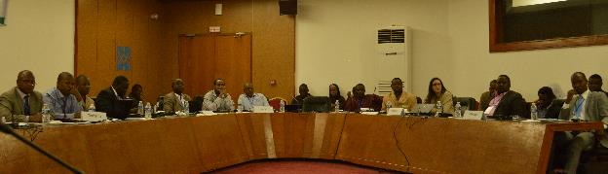**

**Theme B: Innovative Financing Measures for Resilience**

* [**UNCDF: Local adaptive living facility (LoCAL)**](https://undp.unteamworks.org/node/483060) **–** *Sophie De Coninck, UNCDF LoCAL Project Manager*

LoCAL provides a mechanism to channel adaptation finance to the local level, integrate climate change adaptation into local government planning and budgeting, raise awareness to increase response to climate change, and increase the longterm flow of adaptation funds at the local level. LoCAL operates through a process called Performance-Based Climate Resilience grant, which channels additional funding in order to cover costs associated with climate change adaptation interventions. Performance is evaluated in terms of the contribution of additional resources to the improvement of adaptation and resilience to climate change. The project is being implemented in Bhutan and Cambodia (phase II - learning), Bangladesh, Laos, Nepal, Benin and Mali (Phase I - testing), and under development in Mozambique, Niger, Ghana, and Solomon Islands.

#### Country experiences:

* [**Sudan: Revolving funds and micro-financing**](https://undp.unteamworks.org/node/483066) **–** *Adil Seedahmed, CCAF project manager, Sudan*

The local communities in Sudan, especially women, use small savings in the form of a revolving fund (Sandug) for social purposes. Through extension and awareness raising activities supported by the NAPA/CCAF project, these Sandugs extend adaptation measures to all the members of the targeted communities. In the state of Gedarif, for example, the revolving fund helped the women establish a small farm, build a Women Development Centre and acquire butane gas units. One ***challenge*** was the adoption of new adaptation technology, such as the use of butane gas as an alternative source for domestic energy. This was addressed by intensifying the sensitization and awareness raising activities.

* [**Cambodia: Water management committees**](https://undp.unteamworks.org/node/483067) **-** *Leang Seng, Department of Agriculture, Kratie Province Cambodia*

Cambodia faces the challenge of water shortage, including limited supply of water for irrigation, absence of complete regulation, and lack of financing at the community level to sustain the project’s activities. To address these challenges the NAPA project conducted a vulnerability reduction assessment to capture the perception of climate change and its impacts. It also organized farmers into water users groups and built the technical and managerial capacity of the targeted beneficiaries. Finally, it carried out demonstration activities in target villages to enable farmers to compare new technologies and practices. ***Some achievements*** in implementing this approach are that water is now available for domestic and production purposes, food security is increased, and new incomes steams are generated.

### 

### Theme C: Awareness raising and advocacy

#### Country experiences

* [**Niger: Integration of climate change into education curriculum**](https://undp.unteamworks.org/node/483324) **–** *Hassane Iro, Expert in curricula reform & innovations in Niger*

Under the NAPA/CCAF project, CNEDD worked with the Ministry of Education to integrate climate change into the education program. They elaborated didactic tools, trained inspectors, pedagogic counsellors and school directors in eight regions in Niger. An teaching guideline was developed to support teachers during their activities in the classroom. As a whole, 16 inspectors, 560 school directors, 202 supervisors and 151.200 students were trained.

* [**Haiti: Environnement Education center –**](https://undp.unteamworks.org/node/483059)*Dorine Jean-Paul, Project manager, UNDP Haiti*

The Environment Education Center in Haiti provides basic information on climate change and the different ecosystems for the South Department of the country, targeting students in the surrounding region. The Center works with the Ministry of Education to raise awareness about climate change, through education programmes and dissemination of literature. The Center is composed of three rooms, one each for ecosystems, biodiversity and climate change. In addition to the rooms, there is a possibility to observe the plant nurseries outside or to do a field trip to different areas of the island. To date, the Center has received approximately 1168 visitors, 60% representing students. The Center helps develop radio programmes about climate change and natural resource management, broadcasted on the community radios.

* [**Cabo Verde: Cabo Verde radio programme**](https://undp.unteamworks.org/node/483055) **-** *Domingos Lopes Dias Goncalves, MDR Cabo Verde*

The Cabo Verde radio programme is called “Climate change and food security for everyone”. The programme was launched in October, 2014 and is broadcast on Saturdays and replayed every Tuesday. The objective of the programme is to improve the resilience of vulnerable people of Santo Antao and Santiago Islands by raising awareness. The programme is produced under a partnership between Radio of Education and Technology (RTE) and the project. As of today, eleven programmes have been broadcast related to climate change impacts on agriculture, food security, and its relationship with gender. The programme demonstrates that climate change is real and needs to be factored into agriculture and water related activities through the dissemination of best practices. Challenges include the mobilization of experts to intervene in the programme and a limited reach of the programme to all parts of the country.

#### Key points from discussion:

It is easier to integrate innovative thematic issues into an education system which has unique curriculum for different states, as is the case in ***Niger***, as opposed to a country with a federal curriculum. In ***Niger***, the documents developed to raise awareness on climate change within the education community were translated into five local languages to reach out a larger audience

* In ***Cabo Verde***, RTE is owned by the Ministry of Education, and only broadcasts on Santiago Island. However, discussions are ongoing to have its programme replayed on other community radio stations.
* The entry points for the ***LoCAL*** ***project*** vary among countries. It can be the Ministry of Environment and climate change or the Ministry of Finance. Further, ***LoCAL*** uses the mechanism already in place to channel funds to local authorities.

**[Summary of report back on Planning and Financing](https://undp.unteamworks.org/node/483043)**

* ***Good examples Tools/methodologies for planning include:*** “Plan de co-gestion”from ***Haiti*** for sectoral planning; The ***Strategic Document for Poverty Alleviation*** for sectoral planning.Local development plan guideline in ***Niger*** for integrating climate change in local planning – incorporating development issues, such as gender links between climate change and equity; Districts socioeconomic development plan and municipality development plan in ***Cabo Verde*** which coordinates work at the local level.
* The ***challenges*** in implementing these tools are: political instability; absence of institutional coordination; utilization of expensive software and the lack capacity to use the tool or guideline.
* The ***factors of success*** include: the dynamism of implementers; operationalization of the institutional platform for coordination; the dissemination of information; synergies among actors; and capacity building of technicians to help districts in planning activities.
* ***Good examples of innovative financing approaches include:*** UNCDF ***LoCAL*** project. Micro-finance in ***Cabo Verde*** with financing and monitoring systems in place. The ***challenge*** is that financing mechanisms are usually limited to the duration of the project.
* ***Factors of Success*** include: changing the mindset of beneficiaries to help them play an active role; partnering with microfinance institutions. To ensure ***sustainability***, projects need to use existing government systems and structures, and good governance and financial contribution from beneficiaries. To ***scale up***, we need innovative approaches to be mainstreamed into national strategies, and there is a need to take into consideration knowledge management, disseminate best practices, and identify users and services providers within the current budget.
* 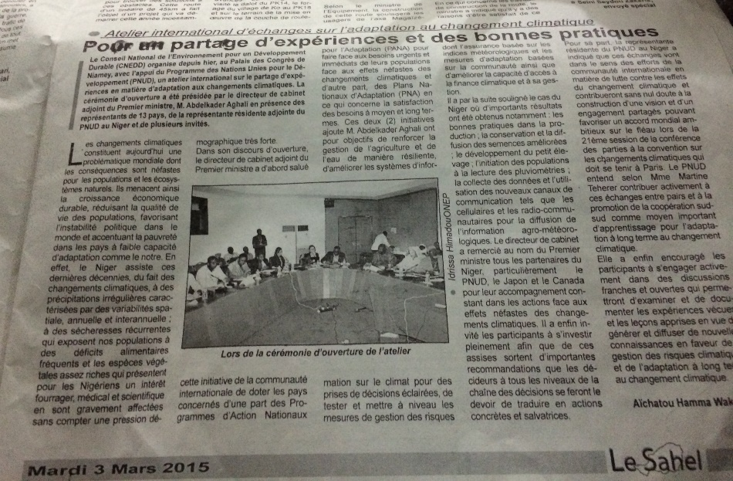

**Training: Communications and Social Media**

To help strengthen capacity of project teams to document and share the results emerging from their projects, a communications training was organized prior to the field trip, so that participants could apply the newly learned skills during the site visit.

[**Communications training and resources**](https://undp.unteamworks.org/node/483087) **–** Camille Maitre, Communication Specialist, UNDP

Blogs and social media are good tools to share knowledge, promote project activities, and show the human face of adaptation. Examples of social media were shared, e.g. twitter for micro-blogging, LinkedIn for professional network, Instagram for photo/video, YouTube for videos, Facebook for stories, photos and films building on a friend based network, and Google+ a social networking service. Blogging was also emphasized, to be used as a knowledge sharing tool and to showcase personal expertise. Simple guidelines were provided for developing blogs about the project (e.g. avoid jargon and acronyms, keep it short (300-400 words), choose catchy headline), and tips were shared as to how to take a good photo and video. This focused on what to capture in the image, how to use basic equipment (phone, simple camera), how to frame and light a given photo, the most effective duration for a video, and where to best capture photos and film. The presentation and more resources are available <https://undp.unteamworks.org/node/483087>.

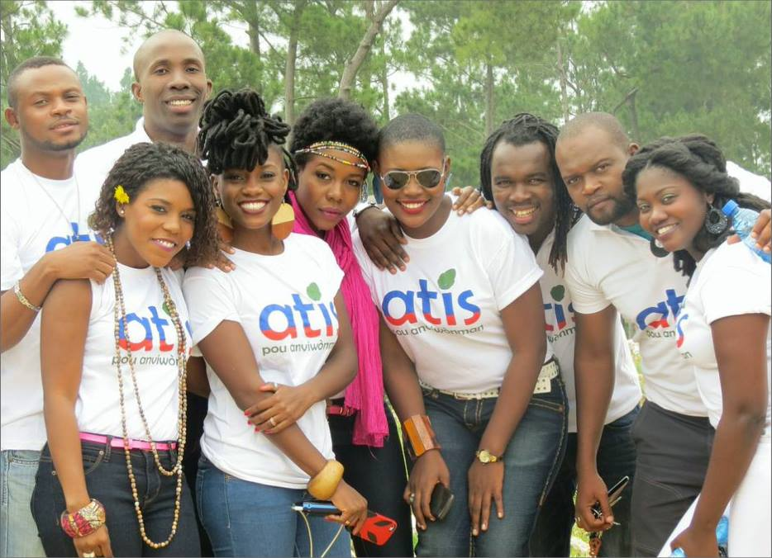

**Nou an danje: pour un changement de mentalité**  
En Haiti, 10 artistes se sont réunis pour sensibiliser la population sur les changements climatiques a travers une chanson titree #Nouandanje . Ces artistes sont maintenant des ambassadeurs des changements climatiques dans le pays.

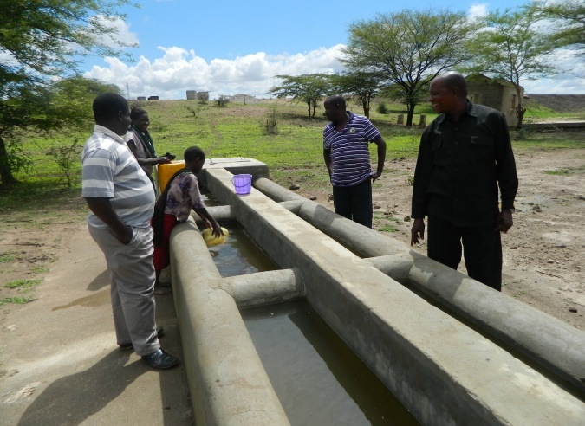

Through a UNDP supported Africa Adaptation Project, communities in Igunga, Tanzania now have reliable access to water through this water trough constructed to separate uses between livestock and household

**Day 3: Wednesday 4 March 2015**

**Field Trip**

A field trip was organized in three project sites around Niamey to demonstrate adaptation interventions under the CCAF project and provide participants an opportunity to interact with project beneficiaries.

#### Gardening site - Community of Gormi, Gaba Goura, Municipality of Niamey I

**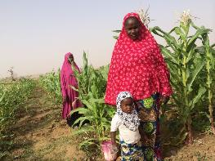**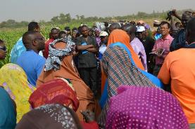The women’s group that manages this site is composed of 50 widows. The total area of the plot is 2 hectares leased for free by the landowner. They grow a variety of vegetables, including beans and tomatoes. Prior to CCAF project support, each member of the group worked individually on her own small plot. The production was very low, and they experienced a lot of damage from animals. With support from the CCAF project, they were brought together to farm in a large plot, which includes a fence around the site to protect it from animals. Today they are very happy and confident about future production. They are planning to extend their plot to about 10 hectares, and expand their activities to animal fattening, as their farm produces a lot of weeds to feed animals.

#### Gardening site - community group of Kondbiah, Municipality of Niamey I

This is one of the first women’s groups supported by the NAPA GEF-funded project, initiated 3 years ago. Prior to this project, the women were not involved in any gardening activities. With support from the project, they learned how to grow crops. Today they are totally independent and self-sufficient in terms of resources and management. They can contribute financially to household needs from selling their crops and receive more respect from their husband and family.

#### Soudour Village, Municipality of Niamey I

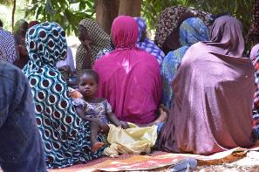This is a mix cooperative group (men and women) that worked with NAPA GEF-funded project for three years, and are now receiving support from the Government of Canada (under the CCAF project). The project provided support in training, agricultural inputs, improved seeds, fencing for gardening and dry season cropping. The village members can now read rain gauges and inform the farmers on how to better plan their crop seasons. Rain gauge observers have been provided with cell phones to inform the meteorological service about rainfall. In addition, the project provided each woman with sheep and training for fattening. After three months of fattening, some women sold their animal, bought another sheep and put a certain amount of money into the cooperative fund. With the money saved in this fund, they plan to embark on other income generating activities. The project also introduced climate-resilient seeds. The seeds used before the project took about 90 days to grow, which makes it difficult with the shorter seasons due to climate change. The improved seeds provided by the project have a cycle of 60 days, which allow the communities to grow and harvest the crop within the shorter season.

**Session 4: In Depth Examination of Innovative Approaches**

This session focused on specific innovative practices being implemented in different countries. Each presenter gave a detailed presentation about the practice, including why this was innovative, what types of challenges they faced, and how to replicate or scale up this practice in other contexts. The participants then had an opportunity to walk around the room for deeper, direct discussions with the presenters.

* [**Niger : Dissemination of drought resilient seed varieties**](https://undp.unteamworks.org/file/483090/download/526402)  **-** *Abdoulaye Issa, CNEDD Niger*

In Niger, climate change has impacted the frequency and intensity of rainfall, and the length of the season. As such, many existing seed varieties used in the past are no longer viable for sustained productivity. One objective of the NAPA/CCAF project was to test and disseminate drought resilient seed varieties, which are adapted to this new reality. This intervention was carried out in the most vulnerable communities of seven municipalities of Niger. The ***innovation*** is the research/development approach, engaging with both the Agriculture Research Institute, which provided the improved seeds, and the National Direction of Meteorological, which disseminated meteorological information to help farmers know when to plant the new seeds. The project tested eight drought resilient seed varieties which have proven to yield two to three times more than the traditional varieties. The improved seeds are resilient to climate change and crop pests, provide additional revenues to farmers, and ultimately will help strengthen food security in these areas. These seeds were welcomed and used by the population given the high productivity and rate of return associated with its utilization. The ***challenges*** are the high cost associated the production of improved seeds and the overall cost of the practice ($170) despite a high rate of return (21%).

* [**Haiti : Plan de ferme (Farm plan)**](https://undp.unteamworks.org/file/483586/download/526961) **-** *Borja Serrador Céspedes, Climate change Specialist, UNDP Haiti*

The Farm Plan approach is a participatory planning tool used to increase the productivity and profitability of farm activities during a defined period of time. Working directly with the farmers, individualized plans are developed to help strengthen food security and independence of the farmer through the sustainable and rational use of natural resources. The farm plan process consists of four stages: (1) collection of data on the family and the farm; (2) analysis of the information; (3) diagnosis of family needs, opportunities and potential; and (4) elaboration of the farm plan, based on a vision of where the family wants to be in five to ten years. The project has developed 1084 farm plans benefiting 1084 families (30% women). Agriculture and livestock production increased by 25% and forest cover by 20%. The main ***innovation*** is that the approach aims for independence using existing resources though technical and community support, as opposed to distribution of resources. The main ***challenge*** is behavioral change and the selection of beneficiaries. ***Sustainability*** is ensured by integrating farm plan processes into the agenda of the Ministry of Agriculture, and training extension workers who will support the process in the long term.

* [**Cambodia: Solar powered water pumps**](https://undp.unteamworks.org/node/485798) **–** *Dara Rat Moni Ung, Project Advisor Cambodia*

To initiate the introduction of solar-powered water pumps in Cambodia, first a Vulnerability Reduction Assessment was carried out to identify farmers’ needs. Roles and responsibilities of different stakeholders (project staff, local authorities and beneficiaries) were explained. The project also conducted a feasibility study assessing both the technical and environmental considerations. The project trained the beneficiaries in technical, managerial and financial aspects of revolving fund, and agricultural demonstration sites were established in the target villages, enabling farmers to compare new technologies and farmer practice. ***Achievements*** include: demonstration of water availability for domestic and production purpose; diversification to improve nutrition, food security and generate income; training and coaching the agents of the Ministry of Agriculture at the district level to provide extension services; change in the mindset from being beneficiaries to producers; increasing women’s access to water and extension services; and partnership with private sector, for example with regards to training on how to operate and maintain the solar devices. The main ***innovations*** are the integrated approach to agriculture and water management, the introduction of renewable energy, and the cross institutional coordination including the Ministries of Agriculture, Water Resources and Women Affairs. The ***factors of*** ***success*** are the use of decentralized and de-concentrated systems and structures and the linkages with government’s policies and strategies.

* **Niger: weather index insurance** – *Dieudonne Goudou, ACA Project Manager, CNEDD Niger*

Weather index insurance is a climate risk management tool being developed in Niger under the ACA project. The aim is to strengthen adaptation to climate change and alleviate poverty through the development of an index insurance scheme which targets smallholder farmers. Four thematic studies have been carried out during the preparatory phase, and the International Research Institute for Climate and Society (IRI) provided technical support for the implementation of this pilot project. Reliable climate change information and the engagement of the private sector have been identified as critical factors for the development of the index insurance scheme. An additional study is currently being carried out to determine how to successfully engage the private sector. Strategic actors and their respective roles have also been identified, which include the university; National Meteorological Service; Ministry of Agriculture; Ministry of Finance; private sector; association of farmers; and regional and local institutions. These actors were engaged in the selection of the priority areas for the implementation of the insurance, which include four villages in four municipalities of Niger. Their strategic actors were trained on the use of survey tools to get information about the population concerns as related to the insurance scheme. Right now IRI is developing the indices based on the data collected. Next, these indices will be validated, and the products developed. The project is starting with a non-commercial product. Then, the lessons learned will be shared with the strategic actors. The project will develop tools to monitor these products and later support the development of a commercial product and scale up.

# Day 4: Thursday 5 March 2015

**Session 5: Gender Sensitive Approaches**

**Country experiences**

* [**Sudan : Impact of climate change on women and children**](https://undp.unteamworks.org/file/485500/download/529043) **–** *Khalid Hashim, Project coordinator in Gedarif State, Sudan*

Women play a distinctive role in adaptation measures in the Canada-funded project in Sudan, including farming, creating nurseries and replanting activities. They have also benefited from and supported advancement in intensive awareness raising on the issues of climate change and adaptation approaches, as well as training on animal husbandry. In East Sudan there are significant gains from women participating in adaptation interventions. In addition, women organized themselves into revolving funds committees and started reducing debt on commercial bases.

* [**Cambodia : Gender and climate action plan**](https://undp.unteamworks.org/file/483585/download/526958) **–** *Ratha Chan, Ministry of Women’s Affairs Cambodia*

The NAPA/CCAF project in Cambodia supported the development of a Gender Strategy, training of project staff on gender mainstreaming, and incorporating gender indicators into the project monitoring framework. The key ***achievements*** include: gender and climate change mainstreamed in 16 municipality planning processes, as well as the Community Investment Plan and the Community Development Plan; increase in women’s access to agricultural extension services and water management; and increase in women’s livelihood and participation in decision-making processes. Some of the ***best practices*** include: Development of a monitoring and evaluation system addressing Gender responsive needs within the project cycle, including gender indicators in the project’s monitoring framework, from the beginning. The ***challenges*** include: Cross institutional coordination between three line departments (Agriculture, Water Resources and Women’s Affairs) and limited capacity and expertise on Gender and climate change issues among stakeholders at national and sub national levels.

#### Roundtable on implementing gender-sensitive approaches

During the round table, three questions were asked to participants in relation to their experience in addressing gender issues: *how does your project address gender-specific vulnerability and empowerment opportunities? What are the major challenges? What are the lessons learned?*

* It was first emphasized that if gender is not mainstreamed, interventions can only have a limited impact and not reach their full potential.
* In ***Niger***, Gender is a core component of the new policy ‘Nigerians Feed Nigerians,” and has also been a core focus of the NAPA project, where 80% of the beneficiaries are women and there is high participation of women in committee management. Challenges in Niger focus on illiteracy and lack of organization among women, as well as an incentive and motivation for women’s ownership over the project and its activities. This has been partially addressed through working directly with women’s collectives to educate and build capacity and increase income revenues of women through alternative income generating activities.
* Moving from policy to reality is an important challenge in ***Cambodia***. Currently the policy dictates that 40% of women are represented in all committees and organizations, but it has been a challenge to turn this into a reality.
* In **Cabo Verde**, rural women are often the most vulnerable, since they depend on rainfall for their livelihood and have issues accessing resources. The adaptation project has developed a strategy to mainstream Gender into its activities, and has shown significant achievements. However, the biggest challenges faced include the mentality of people in assessing and understanding gender in food security issues, as well as providing women with control over natural resources.
* Under the ACA project in ***Tanzania,*** the main intervention proposed in the Gender strategy is women’s empowerment for decision making given the persistent capacity gaps. Currently, there is 50% participation of women and 50% participation of men in village councils and other decision-making processes at the local level. Challenges which still persist include capacity, particularly around new technologies adopted (e.g. solar pumping systems), issues of climate change and gender incorporated into policies, and how to strengthen leadership when this keeps changes with new elections
* In ***Mozambique***, the project built on the national strategy for gender and climate change to address some of the challenges identified, including access to technology, natural resources and capacity building. However, these challenges still persists given that Mozambique is a patriarchal society, with limited participation of women in different situations. The government has been slow in mainstreaming gender into policy and planning. To address these challenges, it is important to discuss issues of gender and climate change with the local community, involving women to understand why it is important for them to participate in this process.
* The same cultural and social issues occur in ***Sudan,*** where cultural barriers and norms forbid participation of women in public affairs. Efforts under the project to include women in adaptation were slower in some regions compared to others, given these cultural challenges. However, with established trust within the community and leadership by other women in the project, this has changed slowly over time.
* In ***Benin***, there is strong political will to mainstream gender into national and subnational policies. For example, for more than ten years now, the government has put in place a micro-financing mechanism targeting women to increase their contribution to the household charges. The main challenge now is to address illiteracy among women.
* Similarly, in ***Morocco*** there is a policy requiring every project to incorporate gender considerations from the inception phase. An example is given by the solar panel project, which also aims to strengthen education access for girls. However, there is a difference in the perception of Gender among the development community, which makes it quite challenging to address Gender issues.
* With the introduction of a Gender Act, ***Malawi*** is well positioned at the policy level with the incorporation of gender in the NAP process as a cross-cutting issue. However, there are opportunities to go beyond “number of women engaged” as the sole indicator of success within this process. Questions arise with regards to at what stage do women participate? Who benefits at the end of the day? However, low self-esteem among women still hinders their contribution to development activities. This points to the need to integrate climate change into school curriculum and educate children at a young age about the importance of girls and women in climate change. At the local level, there is also a need to go beyond incorporation of gender simply as the number of women involved, and women need to drive the process with good ideas of their own, e.g. revolving funds.
* ***Burkina Faso*** experiences similar challenges, as a high level of illiteracy prevents women from contributing to decision making. Under the project, initiatives are identifying alternative activities which can focus on strengthening the capacity of women and contributing to medium/long term education.
* 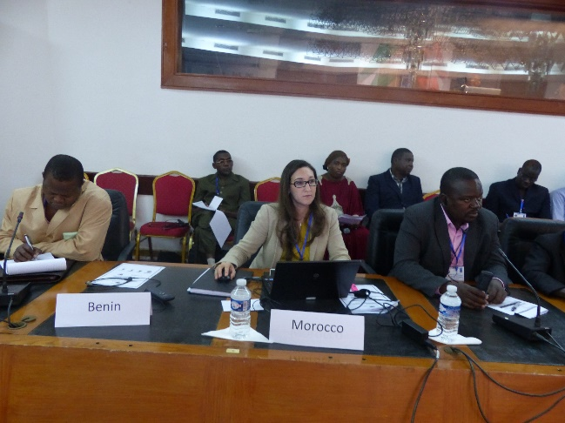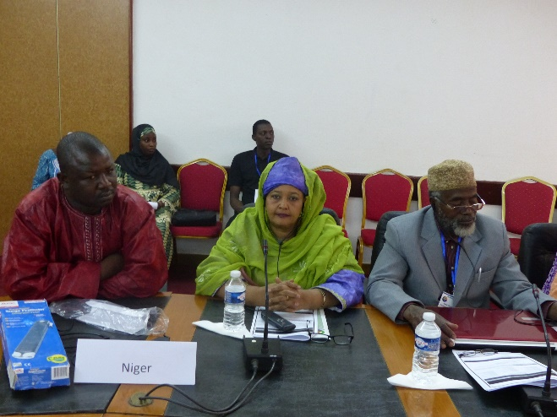In ***Haiti*** there is a lot of enthusiasm among women to participate in watershed management committees, and they have been increasingly involved in the committees established under the CCAF project. They have provided different perspectives on decision-making within the Committee – for example when selecting tree and seed varieties for planting, women chose fruit trees which can help address food security, while men chose trees which can produce cash crops for selling on the market. More than 30% of households leading the farm plans are women. The project carried out an analysis of differentiated needs between men and women and spends the same amount of money on men and women. The main challenge is that there is no previous experience to build on in the region, and there are still cultural and social challenges with mainstreaming gender at the local level. However, critical lessons have already been learned from the CCAF project, such as the different types of decisions women will make when included in decision-making processes (e.g. type of seeds), and that if involved in water management committee decision-making processes, women often show higher participation and commitment rates than men.

### Session 6: Scaling Up Innovation

This session discussed what is needed in order to scale up proven innovations in terms of financing, technologies and policy/planning.

#### How to establish partnerships with the private sector to scale up successful innovations such as weather index insurance and climate information products?

* In ***Burkina Faso***, the project established partnership with the private sector at an early stage of its implementation. Right now, the project is exploring a partnership agreement with *Allianz* and two other local banks, which committed to participate in climate insurance. A local level workshop will further engage micro-credit institutions. There is an ongoing feasibility study under the project looking at how climate insurance can be applied in the project area and later scaled up at the national level, which will consider the role of these banks and other private entities.
* The weather Index Insurance pilot supported by the ACA project in ***Niger*** also recognizes the importance of engaging the private sector for efficient approach. The initiative builds on the work of the Pilot Progamme for Climate Resilience (PPCR) project implemented by the World Bank, which concluded that the participation of the private sector in climate insurance was weak and needed to be reinforced. One objective of the ACA project is to address this gap. The project is still at the level of experimentation. A seminar was organized about sharing a vision on climate insurance, and involving banks, micro-finance institutions and insurance companies. A study was carried out to assess the capacity of financial institutions and how they can be involved in climate insurance. At the end of the experimentation phase, the results will be presented to the private sector. The next step will be to develop the commercial product and have it validated and regulated by the private sector. If the commercial product is tested positive, then it can be scaled up to other regions, building on ownership and lessons learned.
* In ***Cambodia***, the private sector was identified as a partner for solar-powered water pumps from the beginning, as part of developing partnership and cooperation. The private sector, especially bank institutions, believes that communities can be a profitable partner when well mobilized. The public and private sector partnership still remains weak and the project is now is engaged in incremental management. However, the importance of knowledge management to capture and share information being generated by the project is an important step in engaging the private sector.
* In **Benin**, the project contributes to the dissemination of climate information through SMS. Observer villagers send rainfall information to the meteorological center using cell phones provided by the project. The project partners with private mobile phone companies to reduce the SMS cost to less than a cent. The approached proved successful, given that the flooding in 2014 was not as damaging as the one in 2010. Further, a study was carried out about products and needs on climate information, which showed the need for increased engagement of the private sector. The results of this study are being capitalized to strengthen their contribution to climate change interventions.
* A similar approach was undertaken in ***Malawi***. Farmers were provided with cell phones by the project to receive weather information from the meteorological service. One challenge is that the information received at the district level is too general and sometimes not in real time. In addition there is a problem with the network which does not cover the whole district.
* In ***Mozambique***, the National Institute of Meteorology provides weather information through traditional channels, such as radio and TV. The National Institute of Meteorology first sends the information to the National Institute for Disaster Management, which then disseminates the information to the users. There is no partnership with the private sector at this point, as it is still in the pilot phase.
* In ***Morocco*** there is a strong data sharing partnership between the public and the private sector. This partnership seeks to share data related to weather and food production with farmers. The partnership involved the National Meteorological Service and a private company, which is developing a Smartphone application to facilitate access to weather information.
* In ***Haiti*** there is a platform established in the Southern region focusing on the utilization of GIS in environmental management and monitoring. The project is exploring how to scale up this platform at the national level, to support sensitization and watershed management in local communities.
* In ***Sudan****,* there is a lot of potential to engage the private sector in scaling up adaptation measures being introduced by the project. Banks have already offered their services to farmers for climate change adaptation, and the project has discussed with villagers their fears and barriers to engage with micro-finance from the banks. There is still some hesitation from communities, but the project is working with them to identify opportunities.

***How do we better incorporate project innovations into national and local policies, plans and budgets in order to scale up throughout the country and sustain them beyond the life of the project?***

* The process for developing national and sectoral adaption plans is ongoing in ***Tanzania***. A national roadmap is developed to guide the process at the national level. At the sectoral level, the Ministry of Agriculture developed a climate resilient action plan that includes the interventions to be implemented, such as capacity development, weather inforamtion sharing, and small-scale irrigation for rice and maize production. The Ministry of Water also developed a plan for water management in the context of climate change. There are also efforts to integrate adaptation into local level planning and budgeting, supported by district councils, and last year’s budget will be reviewed to see how the training actually led to integration of climate change. The challenge faced is that climate change is an emerging issue and most Ministries see it as an environment issue. Capacity building is underway to sensitize different stakeholders to climate change, and further engage ministries of Planning and Finance.
* ***Mozambique*** is also working to develop a national adaptation plan (NAP), building on other countries’ experiences, such as Burkina Faso. It aims to elaborate the Local Adaptation Plans currently being developed to link with NAPs to maximize the experience from the local level. However, challenges emerge with regards to prioritization of interventions and lack of data for informed decision making. There is also the aim to develop one local plan that incorporates all sectors related to sustainable development at the local level. There is limited institutional arrangements to support this, but the project is working to ensure plans are implemented through the environmental unit in the Prime Minister’s Office and other Ministries. Limited financial resources ia slo a challenge, so they are working to lik the state budget with partners support for adaptation activities. Synergies with other initiatives on poverty, is also one approach.
* ***Burkina Faso*** developed its national adaptation plan and now wants to develop the national investment plan. This could be used as an advocacy tool, including a roundtable with partners. NAPs will start implementation in 2016/2017pending necessary resources.
* ***Niger*** is still at the beginning of the process of developing planning and budgeting tools for the NAP. A training and evaluation on costs and benefits of adaptation was initiated by UNDP, focusing on the agricultural and forestry sector. In addition, the Third National Communication is being finalized, which assesses the evaluation of financial flows for water resources. At the regional level, evaluation of community based adaptation for water resources and agriculture will lead to prioritization of adaptation options in these two sectors. This is an important input into the planning process. The NAPA project has also worked to integrate adaptation into local development plans which is supported by an investment plan at the commune level. Currently 266 communes (more than one third, have taken into account climate change issues into planning document. Now the challenge is to support them to find resources to implement these issues.

### Session 8: Measuring Impact: Sharing experiences in monitoring the progress of climate adaptation and evaluating their development impacts

**Country experiences**

* [**Cambodia : Working with survey companies**](https://undp.unteamworks.org/node/485507) **-** *Dara Rat Moni Ung, Project Advisor Cambodia*

Confronted with the challenge of qualitative assessment of their project, Cambodia introduced a comprehensive impact assessment system while building the M&E capacity of the staff both at the local and sub national. The ***approach*** used was to design a comprehensive survey that would collect information from both communities who received the project interventions, and a “control group” of communities who did not receive the interventions. The project team worked with a consulting firm to develop the survey and train project staff. The ***challenges*** included collecting data, transferring knowledge and skills and limited internet coverage. Projects without an M&E system from the beginning carried out a qualitative assessment during implementation. The ***lesson learned*** is that the M&E system needs to be developed during the project design and the capacity of the local staff built in monitoring and evaluation.

* [**Malawi: National M&E Framework**](https://undp.unteamworks.org/file/485509/download/529053) **-** *Kumbukani Ng'ambi, Ministry of Economic Planning & Development*

Malawi’s Climate Change Investment Plan needs a systematic approach to track progress and enhance accountability of results, which led to the development of a Monitoring & Evaluation (M&E) framework. A literature review was done to understand the technicalities involved in the M&E development process. A write-up was thereafter developed to outline the rationale and operational modalities. The indicators have been prioritized considering the key components of the Investment Plan. The next steps include finalizing indicator prioritization, populating the matrix with baselines and targets, and conducting baseline surveys where there are data gaps. As a ***challenge***, climate change programming is a complex, dynamic process encompassing a wide variety of measures, processes and actions that cut across sectors and levels of intervention. This diversity needs to be reflected in any monitoring and evaluation framework. This challenge requires engagement, sensitization and data triangulation.

* [**Cabo Verde : Working with research institutions**](https://undp.unteamworks.org/node/485508)  **-** *Gilbert Buante Silva, Researcher, INIDA*

Cabo Verde is composed of ten islands with specific needs in terms of research outcomes. INIDA needs to develop technologies that can be used in all the ten islands. INIDA consists of three departments: environmental science, socioeconomic, and agriculture and livestock. The department of agriculture proposes technologies to rural farmers to promote agriculture development.

* [**Tracking Adaptation and measuring Development (TAMD)**](https://undp.unteamworks.org/node/483533) **-** Irene Karani, Consultant, International Institute for the Environment and Development (IIED)

TAMD was developed by IIED as a framework for evaluating adaptation and its impact on development. Adaptation and development were not separated in this case, because it is a ‘twin-track’ framework: track 1 (top down) measures the extent and quality of climate risk management processes and actions by government, and track 2 (bottom up) measures development and adaptation outcomes and impacts on the ground. In between the two tracks we have attribution and learning. TAMD has been applied in Kenya, Tanzania, Uganda, Mozambique, Ethiopia, Cambodia, Pakistan and Nepal – all countreis which expressed demand for this approach. The design of the M&E system ideally has to be done before the implementation of the project, but can also be done ex-post to measure outcomes and impacts. The TAMD system has six distinct steps, and guidance to support the process. The specific tools used by TAMD approach include: a score card – which is used for track 1 to measure progress, Theory of Change (ToCs) - used to map the sequence of a development/adaptation intervention from inputs to outcomes, while examining assumptions about how these changes might happen, and climate trends – which is overlaid on the other data to see how the results have been achieved in the context of climatic changes. More information and a series of guidance and policy documents can be found here: <http://www.iied.org/tracking-adaptation-measuring-development-tamd>.

**Key points from discussion:**

* The participation of all the stakeholders is essential for an M&E to operate smoothly. In ***Malawi***, there is guideline for engaging stakeholders in the M&E process
* It is important to have a harmonized M&E framework in all countries. The TAMD approach seems to provide a methodology for achieving that. The scorecard is used to help countries identify different indicators. However, how can the scorecard be used at the community or farmer level to also help link policy and project outcomes? IIED is currently engaged in doing a study on how local indicators respond to indicators at national level, since national level indicators are usually at a higher level such as poverty reduction
* Many projects are have specific sources of funds which require specific processes and link to corporate UNDP outcomes. There is a need not to overburden the M&E process, and ensure that this type of approach is integrated into the project development process from the start. The TAMD approach is meant to be a framework, whereby existing processes (e.g. logframes, indicators) can be integrated.

#### Hands-on working session: report back of country team on how to improve impact measurement plan

Following these discussions and the presentation of TAMD, country teams met together to apply the TAMD approach. Some countries used the scorecard to identify where the gaps and challenges were with regards to climate risk management processes. Others began the process of designing a Theory of Change for their project activities – linking them to development outcomes.

**Recap of the workshop and identification of way forward**

Each country team had a chance to reflect on what they learned throughout the workshop, and what they will take back with them and try to apply in their own country.  Each country highlighted at least one or two concrete items that they heard from other countries which they found relevant and applicable in their country. In most cases, these were all different – showing the vast array of relevant experiences and lessons learned shared throughout the week. These reflections have been captured by video, and will be shared with the participants.

In addition, the workshop organizers provided a list of follow up activities which will build on the discussions undertaken during the workshop. These include:

* Knowledge Products:
  + Presentations, photos, video interviews, discussions posted on Teamworks site
  + Case studies highlighting country-specific innovation (one per country)
  + Series of comparative analyses covering four issues:
    - Gender-sensitive approaches
    - Innovations on integrated water, energy and crop management – building on local knowledge and community ownership
    - Climate information services
    - Scaling up innovations through national and local planning and budgeting processes
  + Workshop video – disseminated through UNDP website and others
* Following up with countries to further explore TAMD and completing Theory of Change for the projects – to collect indicator information on development impact
* Continue knowledge exchange facilitated by UNDP (email listserve, facilitate exchange visits from national projects, newsletter, teamworks)
* Share outputs of exchange with global community at COP21
  + Possible side event led by Canada and project countries
  + Technical publications for dissemination
* Innovation Facility is available for countries in Africa, based on demand (more information here: [www.unteamworks.org/innovation](http://www.unteamworks.org/innovation))

M&E Impact Assessment – national training and regional ToT based on demand and support from projects

1. Th list of the participants is provided in Annex II [↑](#footnote-ref-1)