Medium-sized Project proposal
Request for GEF Funding
Agency’s Project ID: 3334
GEFSEC Project ID:
Country: Hungary
Project Title: Lake Balaton Integrated Vulnerability Assessment, early warning and adaptation strategies
GEF Agency: UNDP
Other Executing Agency(ies): LBDC
Duration: 30 months
GEF Focal Area: Adaptation to climate change
GEF Operational Program:
GEF Strategic Priority: Pilot Operational Approach to Adaptation (SPA)
Estimated Starting Date: April 2005
Implementing Agency Fee: $146,000

Financing Plan (US$)
GEF Project/Component
Project | 985,000
PDF A* | 0
Sub-Total GEF | 985,000

Co-financing**
GEF Agency | 0
Government | 3,000,000
Bilateral | 0
NGOs (in kind) | 40,000
Others | 50,000
Sub-Total Co-financing: | 3,090,000
Total Project Financing: | 4,075,000
Financing for Associated Activity If Any: 0
* Indicate approval date of PDFA
** Details provided in the Financing Section
Record of endorsement on behalf of the Government:
Mr. Tibor Farago, GEF Focal Point, Ministry of Environment and Water, Government of Hungary | Date: June 1, 2004

This proposal has been prepared in accordance with GEF policies and procedures and meets the standards of the GEF Project Review Criteria for a Medium-sized Project.
Frank Pinto  UNDP/GEF Executive Coordinator | Ms. Keti Chachibaia  Project Contact Person
Date: 6 April 2005 | Tel. and email: keti.chachibaia@undp.org  +421 2 59 337 422


GLOSSARY

BAU business-as-usual
BLRI Balaton Limnological Research Institute
CBD Convention on Biological Diversity
EW early warning
EWG Expert Working Group
EXA executing agency
GCM global climate model
GEF Global Environment Facility
HAS Hungarian Academy of Sciences
IA implementing agency
IEA integrated environmental assessment
IIASA International Institute for Applied Systems Analysis
IISD International Institute for Sustainable Development
ILEC International Lake Environment Committee
INRIC International Network of Resource Information Centres
JICA Japan International Cooperation Agency
K-B Kis Balaton (Balaton Minor)
LBA Lake Balaton Act
LBDC Lake Balaton Development Council
LBDCA Lake Balaton Development Coordination Agency
LBP Lake Balaton Project
LBRA Lake Balaton Resort Area
LS limnosystem
MARD Ministry of Agriculture and Rural Development
MC Monitoring Committee
ME&T Ministry of Economy and Transportation
ME&W Ministry of Environment and Water
NDP National Development Plan
NEA national executing agency
NIA national implementing agency
NMS National Meteorological Service
NPD National Project Director
PM Project Manager
PMB Project Management Board
PPP public-private partnership
SC Steering Committee
SD sustainable development
SDP Strategic Development Programme of LBRA
SLM sustainable land management
UNCCD United Nations Convention to Combat Desertification
UNDP United Nations Development Programme
UNEP United Nations Environment Programme
UNFCCC United Nations Framework Convention on Climate Change
WQ water quality
CONTENTS

GLOSSARY 1
A – Summary 5
B - Country ownership 7
B-1 Country Eligibility 7
B-2 Country Drivenness 7
C – Program and Policy Conformity 10
C-1 Program Designation and Conformity 10
C-2 Project Design 11
C-2.1 Institutional context 11
C-2.2 Description and Physical Features 11
C-2.3 Global Ecological and Biodiversity Significance 13
C-2.4 Socio-Economic Context 13
C-2.5 Water Management 14
C-2.6 Problem Statement 17
C-2.7 Baseline Scenario 19
C-2.8 Alternative Scenario 20
C-2.9 Project Purpose and Objectives 21
C-2.10 Scientific and Technical Background 21
C-2.11 Project Outcomes, Outputs and Activities 26
C-2.12 Logical Framework and Project Performance Indicators 29
C-2.13 Project Risks and Assumptions 37
C-2.14 Global Environmental Benefits 37
C-3 Project Sustainability 38
C-4 Replicability 38
C-5 Stakeholder Involvement 39
C-5.1 Stakeholder involvement in project development 39
C-5.2 Roles and responsibilities of relevant stakeholders in project implementation 40
C-5.3 Involvement of other stakeholder groups in the project implementation 42
C-6 Monitoring and Evaluation 43
C-6.1 Monitoring of project implementation 43
C-6.2 Monitoring and evaluation of project impacts 43
C-6.3 Monitoring of the allocation and use of the project budget 44
D – Financing 45
D-1 Financing Plan 45
D-2 Cost Effectiveness 50
D-3 Co-financing 50
E - Institutional Coordination and Support 51
E-1 Core Commitments and Linkages 51
E-2 Consultation, Coordination and Collaboration between and among Implementing Agencies, Executing Agencies, and the GEF Secretariat, if appropriate. 51
E-2.1 Distribution of roles and responsibilities among project agencies 52
E-2.2 Consultations and agreements 53
References 54
Response to Reviews 57
A - Convention Secretariat 57
B - Other IAs and relevant ExAs 57
ANNEX 1: Location and map of Lake Balaton region 58
ANNEX 2: List of Relevant Laws, Government and Regional Level Action Plans and Programmes 59
ANNEX 3: Chronological review of important events affecting Lake Balaton and its surroundings 63
ANNEX 4: SUMMARY REPORT OF THE WORKSHOP 66
ANNEX 5: LBCD DECISIONS RELATED TO THE PROJECT 68
ANNEX 6: Project endorsement by the Government of Hungary 71
ANNEX 7: Letter of commitment from LBDC and LBDCA 72
ANNEX 8: Letter of commitment from UNEP-DEWA/GRID-Geneva 73
ANNEX 9: Letter of commitment from IISD 74

A – Summary

Since 2002 the Lake Balaton Development Coordination Agency (LBDCA) has been working with domestic and international partner organizations to launch a forward looking initiative focused on sustainability problems in Hungary’s Lake Balaton region. The overall purpose of the project is to contribute to a better understanding of the Lake Balaton ecological and socio-economic system’s vulnerability and resilience arising from multiple forces of global and local change, including land use, demographic, economic and climate change and build capacity for more effective policy-making and adaptation measures in response.

Following many years of water quality problems, a negative water balance induced water shortage starting in 2000 and lasting for four years. This raised and continues to raise serious sustainability concerns in the Lake Balaton area, Hungary and the region. Due to these trends sensitivity of Lake Balaton to climate change and its impacts came to the fore both for policy and science. Because of Lake Balaton’s high profile and the relative immaturity of the vulnerability and adaptation policy agenda, there is a strategic opportunity to influence the way this agenda unfolds in Hungary and other countries of the region. Besides Balaton there are also many other shallow lakes and reservoirs of significant economic and ecological importance in Hungary and the region facing similar vulnerability and adaptation problems where lessons from this initiative can be applied.

Lake Balaton’s internationally unique vulnerability situation is the combined result mainly of its very shallow profile and the fact that through heavy reliance on tourism as a primary source of livelihoods, the socio-economic consequences of ecological deterioration can be severe and immediate. This is particularly the case as society hasn’t fully dealt with the legacy of transition from centrally planned to a market economy. If the frequency of years with negative water balance indeed increased in the future, as indicated by applicable climate change scenarios, Lake Balaton and the coupled socio-economic system is expected to emerge as a highly sensitive and internationally unique indicator of vulnerability to global change. On a more positive side, it could also serve as a high profile example of adaptation measures consistent with sustainable development. In recognition of this potential UNEP’s Division of Early Warning and Assessment confirmed its interest in designating through this project Lake Balaton as a pilot under its Early Warning Strategy.

The project is complementing ongoing policy initiatives and scientific research, and has a clear niche by focusing on better understanding the vulnerability of the Lake and its watershed from an integrated perspective. Climate change is seen as one of the emerging important determinants of vulnerability, but its impacts are considered in the broader context of sustainable development. The project aims to build on the results and significant tradition of scientific work in the Lake Balaton region, recently initiated research in Hungary focused on adaptation to climate change, as well as innovative approaches to integrated assessment of vulnerability to global change and the formulation of adaptive measures. The ultimate goal is to facilitate the development and implementation of effective adaptive strategies.

Methodologically the project will build on schools of thought and practice associated with vulnerability, adaptation and resilience, in the overall context of sustainable development. It draws on experience with the integrated environmental assessment (IEA) approach of UNEP’s Global Environment Outlook (GEO) and the theory and practice of integrated vulnerability assessment. Concerning its adaptation component it builds on UNDP’s and other organizations’ experience with the formulation of adaptive management strategies compatible with sustainable development, and participatory methods in identifying, modelling and analyzing policy and project options using, as appropriate, innovative financing mechanisms.

The project aims to engage stakeholders in:

- developing a lake- and watershed-specific information system designed to help identify, understand and track issues critical for vulnerability and sustainable development and interfacing with national SD information systems;
- identifying and analyzing adaptive strategies and policy initiatives;
- formulating and implementing pilot adaptation initiatives to capture global environmental benefits, and increase social and ecosystem resilience in response;
- synthesizing lessons learnt and sharing them with relevant local, national and international audiences by implementing the project’s influencing strategy; and
- short and long cycle project monitoring and evaluation.

National audiences will be involved in drawing lessons from adaptation mechanisms and pilot initiatives on the regional scale and considering their relevance for national sustainable development strategies and other policy measures.

Expected outcomes include improved understanding of critical emerging vulnerabilities as a combined effect of global and local forces of change, such as land use and climate change. Through its training component the project will lead to measurable improvements in vulnerability assessment and adaptation capacity, and on-the-ground results will be achieved through initiatives financed by a small grants program using innovative financing mechanisms, such as public-private partnerships. Longer-term impact will be ensured by integrating criteria related to adaptation to global change into the regular grant-making activities of the Lake Balaton Development Council. Due to Lake Balaton’s high profile and a focused engagement and influencing strategy, the project will significantly increase awareness of climate change impact, vulnerability and adaptation issues locally, nationally and internationally.

B - Country ownership

B-1 Country Eligibility

Ratification of applicable international conventions by Hungary:

United Nations Framework Convention on Climate Change (UNFCCC) ratification: February 24, 1994; (Act LXXXII/1995)

Ramsar Convention ratification: August 11, 1979

UN Convention on Biological Diversity (CBD) ratification: February 24, 1994; (Act LXXXI/1995)

UN Convention to Combat Desertification (UNCCD) ratification: July 13, 1999.

B-2 Country Drivenness

Hungary has submitted its third national communication to the UNFCCC in 2002 (Government of Hungary 2002). The report is the last one the country produced before accession to the European Union and provides an overview of both mitigation and adaptation measures and research programs. With regard to vulnerability the report highlights recurring drought as the most important area where research and adaptation measures are needed. Despite previous efforts, adaptation measures to drought are still often ineffective, improvised and reactive instead of anticipatory and proactive. The communication calls for more systematic and integrative approaches and identifies a number of ongoing research and assessment efforts that can serve as the basis for strengthening this area. Due to a continuing declining trend in precipitation, Hungary can be considered as a country affected by drought based on the terminology accepted by the United Nations Convention to Combat Desertification (UNCCD).

The condition of Lake Balaton, also known as the ‘Sea of Hungary’ is a high priority issue for Hungarians, the Government of Hungary and the millions of foreign tourists visiting its unique habitat, the shorelines and upland protected areas, every year (see map in Annex 1). The lake and its watershed are covered by several legal and programming documents at various levels of authority (Annex 2). In order to contribute to more effective adaptation, the project will facilitate the consideration of vulnerability in policy planning and the integration of applicable policy initiatives and programs on the local, regional and national level.

Importance of the Lake Balaton Resort Area (LBRA) is underlined by the fact that it is the only special recreational district identified in the Regional Development Act of 1996. Recognizing the importance and unique status of the lake Act CXII/2000 or the Lake Balaton Act (LBA) sets the legal background for sustainable structural planning and development in LBRA. LBA makes provisions for protecting forests and wildlife, natural ‘green’ areas and shorelines, landscape and cultural heritage, and regulates construction, plot-sizes, sewer development and connection. It defines 11 types of land-use zones, such as nature conservation, water quality (WQ) protection, land protection, manufacturing, and so on. It also sets specific rules for activities in each zone. LBA’s associated action plan contains twelve measures related to ecological and landscape rehabilitation, WQ management and erosion control, among others.

The Action Plan for the Protection of the Ecological Conditions and Improvement of Water Quality of Lake Balaton of 1996 and its 1999 modification were Government Resolutions with the following objectives: a) improvement of the ecological conditions of the lake and its watershed; b) conservation of indigenous species of flora and fauna; c) water quality and quantity protection through integrated watershed management; d) completion of Stage II of the Kis-Balaton (Balaton Minor) WQ protection area and implementation of other water quality control measures. Following recent actualizations of the Government Resolutions the action plan became the appendix part of Government Resolution No. 1033/2004.

A 1997 Ministry of Environment Ordinance set up the Lake Balaton Uplands National Park to ensure the conservation of the unique natural environment north of the lake and the Kis-Balaton reconstructed wetlands.

The Lake Balaton Development Coordination Agency (LBDCA), the operational arm of the multi-stakeholder Lake Balaton Development Council (LBDC) has a long-term conceptual development plan prepared for the 2002-12 period. The plan identifies five development priorities as follows:

- protection of environment and nature;
- infrastructure development;
- mobilization of economic resources;
- development of human resources; and
- strengthening the institutional framework and co-operation.

Implementation of the plan is facilitated by a grant facility operated by LBDCA. Funding for the grant facility is provided annually from the national budget based on a an agreement between LBDC and various Ministries of the Hungarian Government, including the Hungarian Territorial and Regional Development Office in the Prime Minister’s Office, Ministry of Environment and Water Management, Ministry of Economy and Transportation, etc. Priority funding areas are defined and agreed on an annual basis, based on the Regional Strategic Development Programme of LBR. LBDC sets the eligible activities and other criteria and after a due procedure of selection, makes the decisions to provide grants to proposed projects. The grant program is managed by LBDCA on behalf of the LBDC.

The long-term development plan was endorsed by a Government resolution in 2002 (Res. 2153/2002 (V.15.). Based on this plan, LBDCA prepared a complex Strategic Development Programme for LBRA in 2001 through extensive consultation with regional stakeholders. Elements of the program funded through a variety of international grants involved are shown in Table 1.

Currently several programme elements are or planned to be implemented related to the Lake Balaton Sustainable Development Programme (Table 1). Two of these, the EU-LIFE ‘Sustainable Tourism Development Project’ and the OECD study on ‘Place-Based Rural Development Strategies’ have been designed to deal with institutional, financial and partnership issues. The Place-Based Rural Development Strategies project in particular identifies, from an institutional perspective, the potential of institutional mechanisms such as public/private partnerships (PPPs) and ways they can contribute to sustainable regional development. In addition to LBDCA being directly involved in the SD programme implementation, there are other important partnerships of stakeholders who are involved both in the sustainable development programme and the present project. Some of the results and capacity from the SD programme will be transferable and applicable to the vulnerability and adaptation project.

Other ministry-sponsored programmes, such as the Lake Balaton Water Management Development Programme by the Ministry of Environment and Water, or the Tourism Development Programme of LBRA by the Ministry of Economy also indicate the distinguished status of Lake Balaton in national affairs.

Table 1: Summary description of the elements of the Lake Balaton Sustainable Development Programme.
Project Element Title / Focus | Primary Sponsors /  (Budget US$) | LBDC status | Time span
Climate Impacts on Lake Ecosystems (CLIME): Impacts of climate change on lake ecosystems | EU  (490.000) | End-user | 2003-2005
Sustainable Tourism Development: Decision-support mechanism for sustainable tourism development | EU LIFE  (1.840.000) | Co-sponsor,  end user | 2003-2006
Place-Based Rural Development Strategies: Strengthening institutional framework and capacity for regional development | OECD/ PMO  (120.000) | Co-sponsor,  end user | 2003-2004
Lake Balaton Water Quality Improvement: Feasibility for water quality improvement measures | JICA  (4.900.000) | End user | 1997-1999  2001-2003

The upcoming review of several regional and national policy initiatives and instruments will present a unique opportunity for mainstreaming project learnings related to vulnerability and adaptation. The Long Term Development Plan of Lake Balaton was prepared in 1999 and endorsed by Government Resolution No. 2153/2002. The update of the regional development plan will soon be initiated, as part of the review of the National Development Plan. Similarly, the implementation of the Spatial Development Plan of LBRA that was enacted by the Hungarian Parliament in 2000 (Act CXII/2000) will be evaluated, followed by the revision of the Act by the end of 2005. The implementation of the five-year Regional Strategic Development Program was started in 2002 and it will be revised in 2004/2005 in response to recent trends and emerging opportunities.

In cooperation with the central government, LBDCA is currently engaged in the preparation of the 2nd National Development Plan through which EU development funds will be allocated in Hungary for the Union’s 2007-2013 budgetary period. Due to its timing, opportunities for influencing the planning process by introducing vulnerability and adaptation related policy mechanisms and specific projects based will emerge. After completion of the present Regional Strategic Development Programme, a new regional programme will be prepared for the 2007-2013 period. LBDC is responsible for the preparation of the new programme document, while LBDCA will be carrying out the programming/planning work through a series of stakeholder consultations. Based on the principle of subsidiarity municipalities and sub-regions are preparing their relevant plans by taking national and regional programming documents into account.
Given LBDC’s key role in all of these policy mechanisms, there is a direct channel to bring project results to bear on the policymaking process.

Before joining the EU, Hungary was the beneficiary of three types of pre-accession programs: PHARE, ISPA and SAPARD. These programs provided EU development funds for candidate countries and were managed by the central government. In the Lake Balaton Region several PHARE projects were implemented, the largest being the PHARE TAS (Technical Assistance Service) – Balaton project in 1999-2000. This project resulted in a pilot state of the environment report and a draft action plan to tackle chronic environmental problems. The ISPA program supports infrastructure and environmental projects. In the Lake Balaton Region there are three on-going ISPA projects, focused on establishing integrated waste management systems. SAPARD programs were prepared for rural development of ‘micro-regions’ and are being implemented through the national government.

After joining the EU in 2004, Hungary started to implement the first National Development Plan (NDP), which provides a framework for the use of structural and cohesion funds. The NDP is not regional but sectoral in nature, consisting of 5 operative development programs, including: environmental and infrastructure, economic, agricultural and rural, human resources, and regional development operative programs.

As part of the NDP, under the Regional Operative Program (measure 3.1.3) LBDCA is one of the beneficiaries of a capacity building partnership training project which will be implemented through a 2.5 year period beginning in October, 2004. The results and lessons learned from this project will be very important in improving the cooperation between the partners involved in the implementation of the recommendations of the planned GEF project.

C – Program and Policy Conformity

C-1 Program Designation and Conformity

Although Lake Balaton is well researched and intensively managed, the current problems go well beyond the capacity of regional and national organizations to solve. GEF funds will complement and amplify the effect of locally available resources aimed at improving science, policy and practice in a way that is directly related to addressing problems of the lake. It would set a powerful precedent for integrating knowledge from the traditionally higher profile disciplines of ecology and engineering with knowledge from social and policy sciences. Experience with designing and implementing scientifically and technically sound and politically well-supported vulnerability and adaptation initiatives in Central-Eastern Europe is very limited. The region is still in interregnum as many external donors have withdrawn or are withdrawing before climate change adaptation funds come on line, and governments have not yet been able to step in and fill the gap. Because of Lake Balaton’s high profile there is a strategic opportunity to influence the way the vulnerability and adaptation policy agenda unfolds in Hungary and other countries of the region.

The project is directly relevant for the climate change adaptation priority area of the GEF and produce significant, internationally important benefits. This is partly due to the expected result that biodiversity of a Ramsar site would be protected through addressing some of the key underlying sustainability factors that threaten native species and their habitat. The project would not only uncover physical processes that contribute to increased vulnerability of species, such as land use change or eutrophication, but also make a link to underlying policies and possible policy options. Further indicating the international importance of the area, the Tapolca Basin in the north-western corner of the lake has applied to relevant authorities to become a World Heritage Site with volcanic cones and remnants of a vast wetland. Many regional and municipal organizations prepared strategies and action plans in the 1980s and 1990s, but implementation is lacking due to shortage of funds.

The project is fully in line with the Decision 1/CP.10, Buenos Aires “programme of work on adaptation and response measures”, section (b) on vulnerability and adaptation. It will particularly corresponds to the following: “(i)… adaptation projects identified in national communications and other relevant sources, including activities that strengthen adaptive capacity; (ii) Enhancing technical training for integrated climate change impact and vulnerability assessment; (iii) Building capacity, including institutional capacity, for preventive measures, planning, preparedness and management of disasters relating to climate change…”

Most importantly, the Balaton case provides a unique opportunity to practically apply and test Adaptation Policy Framework and design all components that need to come to play including, scoping exercise, assessment of current vulnerability and future climate risks, formulating the adaptation strategy and measures and implementation and monitoring. As noted and described in greater detail in the following sections the current policy, legislative, scientific research and financial systems of the region creates rather conducive environment for adaptation strategies and local responses to vulnerability. The project offers an apparent potential for applying and generating lessons and knowledge for the further replication and up-scaling of APF approaches both in the region and globally.

C-2 Project Design

This section provides an overview of social, economic, geographic, land use, water use and nature conservation context of the Lake Balaton catchment area. Lake Balaton research has a long tradition going back at least to the early 19th Century. This tradition is characterized by the dominance of natural science research and, apart from early ethnographic work and more recent sociological analyses carried out most prominently by the Sociological Research Group established by LBDCA in 2001, a relative paucity of social studies. Pioneering systems oriented research was initiated through the Laxenburg, Austria based International Institute for Applied Systems Analysis (IIASA) with emphasis on eutrophication in the late 1970s. This research laid the foundation for policy responses that contributed to water quality improvements by the end of the 1990s (e.g., Somlyódy 1995).

C-2.1 Institutional context

Lake Balaton proper is shared by three counties and its entire watershed by four, which are second level administrative units in Hungary. Regional resource allocation is complicated by the LBRA falling into three different Development Planning Regions, and the division of governance responsibilities currently shared by three Environment and Water Management Directorates, three Environmental Inspectorates, and three Water Inspectorates - whose areas of operation do not overlap with those of the counties or regions - and three Public Health Authorities. Following recent restructuring nature conservation in the LBRA became the sole responsibility of the Balaton Uplands National Park.

According to the Regional Development Act of Hungary, the geographic area of operation of LBDC is the LBRA. At present, LBDC is widely considered as the most effective and powerful decision making body based in the region.

C-2.2 Description and Physical Features

Located in the Transdanubian region of Western Hungary, the Lake Balaton catchment area, including the lake itself is 5775 km².

Lake Balaton is the largest lake in Central-Europe. With a surface area of 593 km², 78 km in length, 7.6 km width and an average depth of 3.2 m, it is one of the shallowest large lakes of the world.
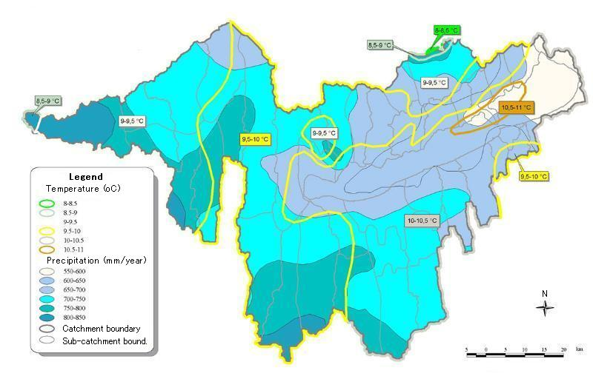
Figure 1: Meteorology of the catchment area (Kocsis L. et al, 2000).

Detailed meteorological data are available since 1921. Average temperature in the LB catchment is ca. 10 °C, the coldest month being January with -1 to -2 °C while the warmest is July with 20 to 21 °C. Average precipitation is 686 mm/year. A slight negative trend in precipitation is observable over the last 80 years. Intensity of precipitation is typically a few 10 mm/day, but several strong storm events occur in summer with intensities exceeding 10 mm/h. Most frequent wind directions are North and Northwest, with average hourly wind speeds between 1.8 (Keszthely) to 3.6 m/s (Siófok). Spatial distribution of meteorological data is shown in Figure 1.

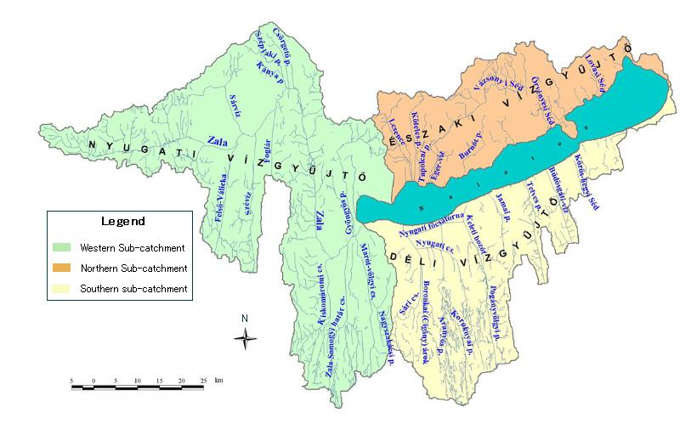
Figure 2. Water courses of the catchment area (Kocsis L. et al, 2000).

Of the 52 surface watercourses on the watershed 20 are monitored for water quality regularly. Average discharge of the Zala River, the largest surface watercourse is ca. 8 m³/s. Hydrology of the watershed is shown on Figure 2. Most of the tributaries of Lake Balaton are short, steep watercourses with intensive flash floods in case of storm events. During flash events the maximum discharges may reach as much as 100 times the average.

The average slope of cultivated land is 5.6 degrees, but 33% of it lies on slopes greater than 5 degrees where surface runoff may result in significant washout of nutrients and soil erosion.

C-2.3 Global Ecological and Biodiversity Significance
Lake Balaton, as the largest freshwater lake in Europe, is a critical site for migratory species. Ducks Anas platyrhynchos, A. clypeata, A. penelope, Aythya ferina, A. marila, A. fuligula, Bucephala clangula, Melanitta fusca and Mergellus albellus, geese Anser anser and A. fabalis, swan Cygnus olor, coot Fulica atra, and diver Gavia arctica, use the site as a staging area, and over 1% of the global Anser fabalis population can be found on the lake. Among endangered resident species, the black stork (Ciconia nigra) and black woodpecker (Dryocopus martius) are prominent. Some other ecologically important protected species include Egretta alba, protected since 1922, E. garzetta, Ardea purpurea, Ciconia nigra, and Grus grus. The lake itself contains about 2000 species of algae, 1200 species of invertebrates and 51 species of fish.
The flora and fauna of the surrounding landscape are particularly diverse due to the mild, Mediterranean-like climate. A large number of rare and protected plant species can be found in the area, including several rare, sub-mediterranean plant species, such as Sternbergia colchiciflora and Scilla autumnalis on grasslands surrounding the lake. The area is especially rich in insects: over 1,000 species have been identified. About 800 species of butterflies occur, some of them are extremely rare, such as the ruby tiger (Phragmatobia fuliginosa) and the red underwing (Spialia sertorius).
The Kis Balaton, as a huge wetland habitat is unique in the whole of Europe, which is why it has always been recorded by international nature conservation. In recognition of its importance for biodiversity, Lake Balaton has been designated a seasonal Ramsar site between October 1 and April 30 each year, while the adjoining Kis-Balaton, a reconstructed wetland and water pollution control structure in the westernmost end of the lake received year-round designation and protection (Ramsar Convention 2003a, Ramsar Convention 2003b).

The Uplands Balaton several basins, (Pecsely basin, Kali basin, Tapolca basin), representing unique ecosystems. According to the national red data book around 30 important plant species are currently or potentially endangered and fall under the protection and / or strict protection regimes (refer to Annex 2 for additional information).

C-2.4 Socio-Economic Context

The Lake Balaton Resort Area (LBRA) is an area of 3780 km² that lies almost entirely in the watershed of the Lake and has a permanent population of 250,000. Comprising 164 municipalities, its legal boundary is described in the Lake Balaton Act of 2000. In LBRA 49.1 % of the land is used for agriculture and 28.1% is forest. Arable land, vineyards and orchards take up some 80% of agricultural land.

Demographic trends in the LBRA are characterized by aging and outmigration of younger generations. Permanent population at present is 250,000. Concentrated in lakeside communities, summer season peak population in July and August may reach 800,000, exerting substantial stress on the environment and infrastructure. Permanent population during the last decade has been declining at an annual rate of -0.41 %. Migration balance is slightly positive, +0.17%/year in the same period, resulting in -0.24%/year net population decline. This means that the population will decrease by 11% by 2050, provided the present trends continue. Another worrisome aspect is that the majority of immigrants to the region are pensioners, contributing to an even older age structure than the nationwide average.

The economy of LBRA is driven predominantly by highly seasonal tourism. Seasonality also affects the construction industry and agriculture. Annual average unemployment is about 9%, reduced to around 5% in summer months. Actual off-season employment is lower than shown by unemployment data, since some of the employers retain staff at minimum wages. On the other hand, actual summer unemployment is lower than statistical figures because of non-registered employment. The relative weight of tourism, industry and agriculture in the economy of the region is about 12 : 4 : 1. According to official statistics tourism related income in the region is about US$1.5 billion/year, but the actual figure may be up to two to three times higher, since many of the tourism businesses are registered and pay taxes outside of the region in Budapest or other large cities, and because of unregistered private accommodations and employment (Lake Balaton Development Coordination Agency 2003).

C-2.5 Water Management

Lake Balaton has already been utilised in the era of the Roman Empire and referred to as Lacus Pelso in early scripts. During the middle ages its depth and size fluctuated, but average depth generally reached 10 m. About half of the catchment area is drained by the Zala River in the western part, its largest tributary carrying about half of the inflow.

The only natural outlet of the lake is through the Sió River in its south-eastern corner to the Danube. Early drainage works started in the 18th century and, since the construction of a weir on the canalized Sió River in 1863 the lake’s level has been regulated with increasing precision. Continued water level control and drainage projects conducted from 1863 to World War II resulted in substantial anticipated losses in lake volume, marshland area and wildlife habitat. After the war, the wetland area called Kis-Balaton at the westernmost end of the lake shrunk substantially. To prevent further losses of wildlife habitat, the entire area was placed under protection in 1951.

Lake Balaton now has a decades-long history of eutrophication. The first definite signs of eutrophication were observed in 1972, while in 1982 the first mass bloom of algae occurred, forcing the government into action. The measures taken included, among others, sewer development, sewage treatment plant effluent diversion to neighbouring watersheds, introduction of phosphorus removal at sewage treatment plants, and reconstruction of the Kis-Balaton (K-B) wetland as a water pollution control facility.

The K-B Water Pollution Control System was designed to consist of two artificial lakes, the 18 km² upper lake (Stage I), with mainly open water surface, and a 54 km² heavily vegetated lower lake (Stage II). Stage I started operating in 1985 and next year protection was extended to all 87 km² of the K-B area. A 14 km² section of K-B has been a Ramsar site in 1979 and the designation was extended to 147 km² in later years. Inundation of the northern 16 km² part of Stage II of K-B took place at the end of 1992.

The most severe algal bloom in the history of Lake Balaton occurred in 1994. Post-1994 water quality stabilized and somewhat, though probably not irreversibly, improved due to the temporary drastic reduction in fertilizer use after the collapse of state farms and agricultural cooperatives in the early 1990s. As of 2003 fertilizer use is still less than 20% of the amounts used in the early 1980s. However, fertilizer application is expected to rise, since soils have become increasingly nutrient depleted and the gradual introduction of EU farm subsidies will likely result in increased fertilizer use and a consequent rise in nutrient load on the lake.

Due to the combined effects of planned water quality protection measures, the unplanned drop in fertilizer use and favourable meteorological conditions, water quality was not as serious a concern over the last few years as before 1995. However, in the western half of the lake algae concentrations are still on the borderline of eutrophic/ hypertrophic, according to the OECD classification.

A new and potentially more damaging threat, decreasing water level started to emerge in 2000. The water budget became and remained negative through 2000, 2001, 2002 and 2003 resulting in, for the first time in recorded history, a zero-outflow situation for more than 4 years by now. The serially negative water balance may well be an early warning sign of climate change, manifested at the regional level. By late 2001 the situation was approaching crisis proportions and prompted the LBDC to call for proposals to explore possible long-term solutions to the water deficit. The alternatives discussed indicated the gravity of the situation and prompted the government commissioning studies to explore a wide range of engineering options such as diverting water from neighbouring watersheds. In the face of considerable uncertainties related to the expected trajectories and impacts of climate change and both ecological and socio-economic acceptability of such measures, the idea of an engineering solution was rejected in favour of a multi-pronged approach combining more conservative lake level management with measures aimed at reducing negative impacts (Vituki Rt. 2002; Somlyódy and Honti 2003). Due to an extremely wet spring, the water balance in 2004 is expected to be positive for the first time in four years but with negligible probability of outflow generation in 2004.

Since 1863, lake level has been regulated with increasing precision and, therefore, with decreasing fluctuation. The presently authorized range of regulation is between 70 cm minimum and 110 cm maximum measured at the Siófok gauge. During the last decade water use was near to the long-term average i.e., 31 lake mm, having little effect on the water balance of the lake.

Water use in the catchment area falls into four categories, including drinking water supply, industrial supply, irrigation, and fish ponds. Except the evaporated fraction (in the case of irrigation and fish ponds), most of the water returns to surface water bodies and eventually reaches the lake, or ends up increasing the ground water supply. The only exception is a fraction of effluents from sewage treatment plants diverted to neighbouring watersheds. This amounts to an insignificant 20-25 lake mm/year.

Artificially created water surfaces, such as the Kis Balaton reconstructed wetland in the westernmost end of the lake and fish ponds in the watershed result in increased evaporation and reduction of inflow to the lake. The total area of such surfaces is about 40 km² and the resulting excess evaporation is estimated to be 30-35 lake mm/year. The average annual precipitation in the watershed is 686 mm, somewhat higher than on the lake. The average runoff coefficient is quite low, 0.06 to 0.27, or 0.15 on average.

The water budget of Lake Balaton shows large year-to-year fluctuation, in accordance with large scale changes in meteorological conditions. In order to reduce the noise in data due to annual fluctuation, 3 year moving averages of specific water budget components were compared to average values (Table 2). In this way, years of maximum deficits and surpluses were determined. This calculation shows that most of the 3-year periods with the largest deficits fall into the last 20-year period and none of the largest surpluses do. This can be interpreted as a strong indication of multi-decadal scale changes in the water regime of Lake Balaton. The causes of this change are possibly both local (e.g., increased evaporation from constructed surface water bodies) and global (e.g., climate change and variability).

Table 2: Water balance elements of Lake Balaton (1921-2002 averages, minimum and maximum values, in lake mm*).
Balance term | Direct precipitation | Inflow | Evaporation | Direct use | Outflow
Average | 619 | 893 | 901 | 31 | 597
Minimum | 433 | 293 | 723 | 16 | 0
Maximum | 905 | 1974 | 1073 | 51 | 1971
* 1 lake mm corresponds to a water volume of 600,000 m³
# Source: CTD Water Management Authority, 2003

According to the National Meteorological Service (NMS) of Hungary, there has been demonstrable warming in Western Hungary over the last two decades, coupled with a pattern of below average annual precipitation (Figure 3). The situation appears to be particularly sensitive due to Lake Balaton’s extremely shallow profile. The frequency of atmospheric circulation patterns associated with low water levels in Lake Balaton, taking all elements of the water budget into account, are expected to increase in the future according to mainstream global climate models (GCMs) and scenarios (e.g., Weidinger, Matyasovszky and Bogárdi 1994; Bartholy, Matyasovszki and Bogárdi 1995; Watson et al. 2001).

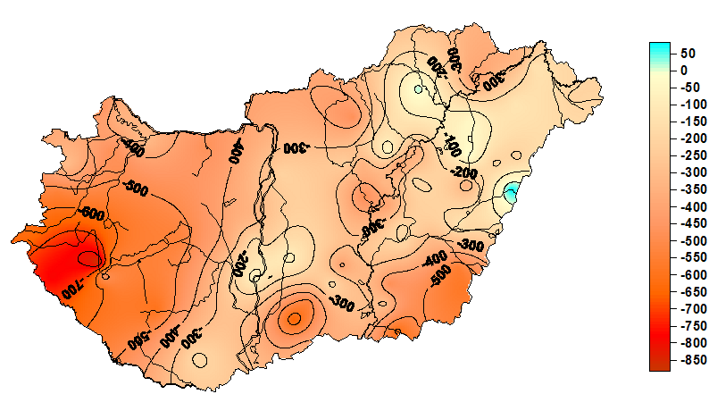

Figure 3: Deviation of the accumulated four years’ precipitation amount (2000-2004) from average totals in Hungary (ME&W, Varga, Gy., 2004).

All development arising from the project will be in accordance with the EU Water Framework Directive. According to the Water Framework Directive of the European Union, a River Basin Management Plan has to be produced for the catchment of Lake Balaton, the actual planning process starting probably in 2006. This project may utilize the Plan as an important entry point to provide a better insight into vulnerability aspects and integrate the measures for adaptation by offering additional policy options to be included into the Programme of Measures of the watershed.

A detailed chronology of water management in Lake Balaton from the middle of the 19th century to present is provided in Annex 3.

C-2.6 Problem Statement

There are early signs that Lake Balaton, a natural resource of exceptional ecological and socio-economic value to the international community and Hungary may be entering a new phase of its evolution. Due particularly to its shallow profile and precarious water quality and water balance situation Lake Balaton is uniquely sensitive to both natural and anthropogenic influences. Indeed, many ecological parameters of the Lake and its watershed have been in constant change during recorded history. However, current trends appear to indicate the beginnings of a new trajectory, characterized by global and local forces of accelerated change increasing the vulnerability of both ecological and socio-economic subsystems.

Adverse changes in environmental variables related to the hydrological system and terrestrial ecosystems in the watershed have already led to increased ecological and socio-economic costs. Most notable is the recent multi-year negative water balance that has brought renewed attention to the sensitivity of the lake. The exact causes are still being debated, but clearly, multiple forces of change are at play, some local, others possibly regional or global, including climate change.

Regional authorities and stakeholders are already alarmed and the public is increasingly concerned about short and potential long term economic, environmental and public health consequences. The impacts of these more recent phenomena are being combined with long-standing concerns about issues such as water quality or permanent alteration of the natural landscape through overbuilding. Between 2000 and 2004 by the peak tourist seasons of July and August, water deficit in the lake became an increasingly discussed concern in the local, national and by 2003 the international media. Should these trends persist or the frequency of water deficit situations increase, without appropriate adaptation measures both the socio-economic and ecological systems of the Lake will be stressed beyond their current adaptive capacity and resilience.

In light of the preliminary assessment of the situation concerning the ecological and socio-economic integrity of Lake Balaton and its watershed, long-standing and recently emerging issues can be identified as shown in Table 3. Note that while some long-standing issues, such as eutrophication have partially or temporarily been resolved, the risk that they re-emerge again may increase as a combined result of multiple stressors.

Table 3: Historic and emerging issues contributing to increased vulnerability
Category of issue | Historic | Newly emerging
Environmental | Vulnerable water quality (WQ), eutrophication  Landscape degradation  Overbuilding  Intensive use of agrochemicals | Negative water balance  Declining fish catch  Reed degradation  Appearance of invasive species  Aging vineyards
Socio-economic | Slow pace of WQ control measures  Sub-standard waste management  Conflicts of conservation vs. development  Aging and other demographic issues  Complex governance framework, weak policy coordination  Excessive reliance on tourism for livelihoods  Grey economy and tax evasion | Deficiencies in WQ monitoring system  Water conveyance conflicts  Declining number of tourists and tourism income  Fragmented land ownership

Although not widely studied and understood apart from water quality aspects, these problems and the lake’s sensitivity and exposure to stress are culminating in substantial increase in ecological and socio-economic vulnerability and loss of resilience. For example, low lake level can damage the ecological and socio-economic subsystems of the lake and its catchment in a multitude of ways: loss of wildlife habitat, loss of fish catch, increased benthic primary productivity, changing water chemistry, difficulty for commercial or recreational watercraft operation, aesthetic concerns, loss of tourism related income, and so on. As a consequence, the lake’s decreasing capacity to provide habitat for wildlife and environmental services to key sectors such as tourism or agriculture could induce societal vulnerability.

Hungary and the Lake Balaton region have a long tradition and a well established infrastructure for scientific research. However, research connecting global and local forces of change, such as climate change, started only recently (e.g., Ürge-Vorsatz 2002). Through LBDC and other partners Lake Balaton has been included in the international CLIME project that tries to understand the impact of climate change on the ecology of a number of lakes in Europe. Work on adaptation in Hungary has also just started through the VAHAVA project lead by the Hungarian Academy of Sciences (HAS) and the Ministry of Environment and Water that is looking at adaptation issues with primary emphasis on agriculture on the national level. Additional research related to adaptation is carried out in the context of drought mitigation and adaptation, as noted in the third communication of Hungary to the UNFCCC (Government of Hungary 2002). Specific key activities relevant for this project include research exploring the hydrological aspects of climate change, carried out at the Budapest Technical University and the Water Resources Research Institute (VITUKI Plc), meteorological observations and assessments by the National Meteorological Service and Eötvös Loránd University in Budapest, and research related to sustainable agriculture lead by the Szent István University in Gödöllő. The national communication also mentions efforts to establish a National Drought Commission.

To date no significant and systematic effort has been made to understand the incremental impact of climate change on baseline vulnerability on the regional level, to mobilize stakeholders and the wider public in mapping out the range of emerging vulnerabilities and adaptation options, and to bring the lessons to bear on regional and national sustainable development policy processes.
Thus there is a need not only for strengthening research on vulnerability and adaptation, but also for connecting its results to policymaking and the emerging social discourse on the condition and future direction of the lake systems. Forward looking integrated assessment, involving the participation of science and a wide range of stakeholders, is an essential next step in order to review existing knowledge in light of new concerns, assess policy implications and options, and to engage affected stakeholders in constructive dialogue about adaptation.

C-2.7 Baseline Scenario

The current baseline constitutes well capacitated regional governance system currently in place in the region of Lake Balaton. The Lake Balaton Development Coordination Agency (LBDCA), and its operational arm of the multi-stakeholder Lake Balaton Development Council (LBDC) has a long-term conceptual development plan prepared for the 2002-12 period. In addition, the LBDCA extends a grant facility for on-the-ground initiatives to address the issues of local development. As noted above the scientific and research community provides a substantive foundation for the vulnerability assessment and APF formulation. Therefore, appropriate legislative and policy framework, essential capacities in relation to the key elements of governance, including highly qualified technical resources and a regional funding facility provides considerably strong baseline for GEF’s support.

However, without the GEF support the current system will show continuous capacity deficiencies and leave the existing gaps in relation to adaptive management and systematic response to vulnerability. The key gaps and “Without GEF” scenario is outlined below.

Under the baseline scenario, management decisions in the Lake Balaton region continue to be fragmented and weakly coordinated, reacting to crises, rather than having an anticipatory element. While the terminology of sustainable development and conservation populate regional action plans, they are not internalized and integrated into planning and decision making carried out by organizations on various levels. Information related to sustainable development trends continues to be fragmented, often anecdotal. In the absence of a shared vision of where the region is and where it is going, policy development in jurisdictions around the lake is incoherent and often in conflict with goals and the policies of the next County or town.

Although the volume of scientific research focused on various aspects of the lake and its watershed is significant, results of this research are rarely applied to answer policy questions; typically research is not even designed to be relevant for policy. Socio-economic policy and the facts of spatial development policy on the ground continue to work against the needs of keystone species and the ecological integrity of the lake. As the temporary reduction in pressures on the environment due to technological measures and the economic collapse of the early 1990s are gradually neutralized by the effects of new growth, ecological problems that were thought resolved reappear.

Despite its economic importance of Lake Balaton, the tax base continues to be weak and the rate of reinvestment of funds generated in the region is low. Caught in the trap of competing spending needs related to halting environmental quality deterioration and the pressure for continuing development to attract tourists, local and regional governments find their budgets stretched and adaptation sporadic or beyond their capacity. Mechanisms for mobilizing the private sector in adaptation initiatives are ad-hoc and ineffective.

Municipal and regional action plans in the Lake Balaton region will continue to be revised and updated with poor or no consideration of vulnerability and need for actions to increase adaptive capacity in order to expand the coping range under the current and future impacts of climate change.

The majority of the science establishment continues to be highly sceptical of the notion of integrated analysis in general and emerging issues such as climate change in particular. Perspectives that constructively challenge the status quo appear only on the margin of science and policy discourse. In the absence of powerful and internationally credible local champions, the reality of unsustainable development, vulnerability and the need for adaptation to climate change reaches the various publics in fragmented and incoherent ways, depriving them of the opportunity to make informed judgment. Adaptation is ad hoc and mostly reactive, as various stakeholders labour out solutions in isolation.

C-2.8 Alternative Scenario

As a result of the project the principles of both environmentally and economically sustainable development are used to critically review trends and lessons and are integrated into regional regulatory and policy frameworks. Information on key regional trends, including vulnerability and impacts of climate change is readily available, through region-specific, but nationally connected indicators and their interpretation in forms that are understandable to decision-makers and the public. The broadly participatory APF process will generate and substantive lessons and knowledge for an up scaling and further replication in other countries of the region and beyond. The practical application of APF will largely contribute to the regional and international discussion on vulnerability assessment and meaningful response to change through adaptation policies and measures.

Growing awareness of past and current trends is accompanied by regionally coordinated but autonomously initiated and governed local scale processes to identify, initiate and monitor elements of practical visions for sustainable development. Many of the organizations that received co-funding from LBDC through the GEF project found ways of maintaining their initiatives. Due to a more enabling national policy environment and learning from the successes and challenges of pilot projects, many other organizations – local governments, NGOs and companies – decided to join in.

In addition to action focused on individual species or ecosystems, management is concerned with maintaining ecosystem integrity. Ecosystem – socio-economic system linkages and trade-offs are made explicit and their vulnerability consequences increasingly brought to bear on policy assessment and planning. Ecological problems do not disappear, but through adaptive ecosystem management big mistakes are avoided and environmental problems are dealt with more in an anticipatory rather than reactive way.

Although economics continues to be tight, local and regional authorities found creative ways to increase their tax base through the application of innovative charges and levies designed with sustainability and climate change adaptation in mind. The private sector is engaged in the adaptation discourse the results of which are factored in the design of PPPs and other cost-sharing arrangements where as a result of engagement on V&A alignment of public and private interests are better recognized. Through increased reinvestment at the local-scale, but regionally coordinated restoration of ecosystems and ecosystem services, municipalities strengthen the base for higher quality tourism and open the possibility for economic diversification.

Existing disconnect between the scientific research and policy decision making and planning will be overcome by integrating the measures to address vulnerability and adaptation through various strategic planning tools at regional and municipal levels.

While climate change continues to pose a threat and the uncertainties concerning its magnitude and impact are still significant, there is widespread awareness of the nature of the problem and the possibilities as well as constraints on mitigation and adaptation. Given the uncertainties, local and regional authorities are more open to an adaptive learning approach. Rather than simply waiting for crises, they identify and strengthen policies and associated time-bound targets that are necessary for more successful adaptation.

C-2.9 Project Purpose and Objectives

The overall development objective of the project is to build capacity and generate knowledge for increased understanding of the adaptability and vulnerability of human and natural systems on the example of the Lake Balaton and improve preparedness for climate change and enhance adaptive capacity elsewhere through lessons learned and dissemination. The project specific objective is to contribute to a better understanding of the Lake Balaton ecological and socio-economic system’s vulnerability and resilience arising from multiple forces of global and local change, including climate change, and build capacity for more effective policy-making and adaptation measures in response. In pursuit of the objective the project will deliver the following outcomes.

- strengthen ecological and socio-economic resilience by increased understanding of lake and watershed processes viewed through the lens of vulnerability and adaptation;

- strengthen capacity for formulating and implementing adaptive strategies compatible with sustainable development;

- strengthen the policy framework conducive to adaptive management with particular interest to institutional mechanisms and economic incentives and disincentives;

- facilitate adaptation to the impacts of climate change through direct action in the form of pilot initiatives funded through LBDC’s existing small grants facility and innovative financing mechanisms; and

- enhance public and policymaker awareness of integrated vulnerability and adaptation approaches locally, nationally and internationally, including contribution to the GEF’s project on the Adaptation Learning Mechanisms.

C-2.10 Scientific and Technical Background

As demonstrated by the emphasis on Integrated Water Resources Management (IWRM) and adaptation strategies at the 3rd World Water Forum held in Japan in March 2003, an integrated approach will be essential for meeting water related and other Millennium Development Goals. IWRM requires attention to three objectives, water use efficiency, equity in water allocation and ensuring ecological sustainability. The approach is characterized by a bottom-up participatory approach and capacity building, cross-sectoral and interdisciplinary water resource management, and coordination with related sectors affecting water.

Vulnerability and adaptation are fields with a rich history of theoretical and applied work (Roy 2003) and events that showcase an impressive body of innovative research. While the risks associated with climate change provided new impetus to vulnerability research, it also strengthened calls for a vulnerability concept that integrates multiple types of stressors interacting with the landscape on multiple spatial and temporal scales and harmonizes with policy measures designed in the context of sustainable development strategies (Steffen et al. 2004).

In many ways, developing and implementing adaptation measures is an exercise in understanding and learning to live with complexity, uncertainty and change. Due to complexity and uncertainty of how regional futures will unfold in the face of global, including climate change, no adaptation measure can come without some risk of mal-adaptation and failure. In order to minimize this risk designing adaptive measures must be based on the ex ante integrated assessment of the proposed measures, and also the ex post monitoring and evaluation of the system and the changes attributable to adaptation. While ex ante assessment feeds into the adaptation design process in an early phase, in order to be effective ex post monitoring and evaluation must be part of a learning cycle where adaptive measures can be flexibly adjusted depending on the observed changes in applicable performance indicators.

The project therefore will closely follow the guiding principles outlined in the recent UNDP/GEF guidebook “Adaptation Policy Frameworks for Climate Change: developing strategies, policies and measures”. It will also align with the key five phase components of Scoping to ensure that APF is well grounded into the country wide policy planning and development process; Assessment of current variability ensuring that APF builds on available data, scientific research and technical knowledge; Assessment of future climate risks focusing on multiple variables of climatic, environmental and socio-economic factors; Policy Formulation through multi-stakeholder participation employing integrated approach; Application through systematic monitoring and evaluation process.

The vulnerability assessment component of the project methodology follows the IEA methodology underlying the Global Environment Outlook that is focused on the environment, but must also draw on social and economic driving forces and pressures (UNEP 2002). It also builds on the rich body of literature on vulnerability assessment, adaptation and resilience (e.g., Roy, 2003; Polsky et al. 2003; Bohle, 2003). Assessing the vulnerability of Lake Balaton LS will require a thorough understanding of the components’ structure, expressed by some key descriptors (water quantity, land cover, etc), as well as of the causal links between these (climate forcing, stress, etc). The identification and prioritization of these causal linkages could be done using the approach of causal chain analysis.

A conceptual model of the Lake Balaton system was developed at the start-up phase of the project, depicting cause-effect interactions among elements of the limnosystem, the socio-economic system and the political system under the influence of global and other forcings (Figure 4.).

Human activities in the watershed are influenced by the body of land and water management practices, themselves steered by the Hungarian legal framework. This political system (governance) compartment also includes the effects of public opinion and pressure (via local democracy and NGOs), and may be somewhat under the influence of diffuse threats, such as climate change.

The Lake Balaton limnosystem (LS = the lake and its watershed) can be considered as a natural resource providing, in its present state, the local community and visitors from all over Europe with the following environmental services and sources of materials, space and information: drinking water, biomass (fish, reed, agricultural products), habitat for humans and wildlife, recreational space, transportation space and inspiration (scenic beauty and culture).

Vulnerability of a natural or human system to natural or anthropogenic stresses is the degree to which it is susceptible to, or unable to cope with their adverse effects. In general terms, vulnerability (V) can be expressed as follows:

V = Function {type of stress, system’s sensitivity, system’s adaptive capacity}

The adverse effects induce changes in the LS’s integrity and ’metabolism’ resulting in fluctuations or changes in water quantity, water quality and biological diversity beyond acceptable thresholds. As a consequence, environmental services and benefits may radically change or disappear.

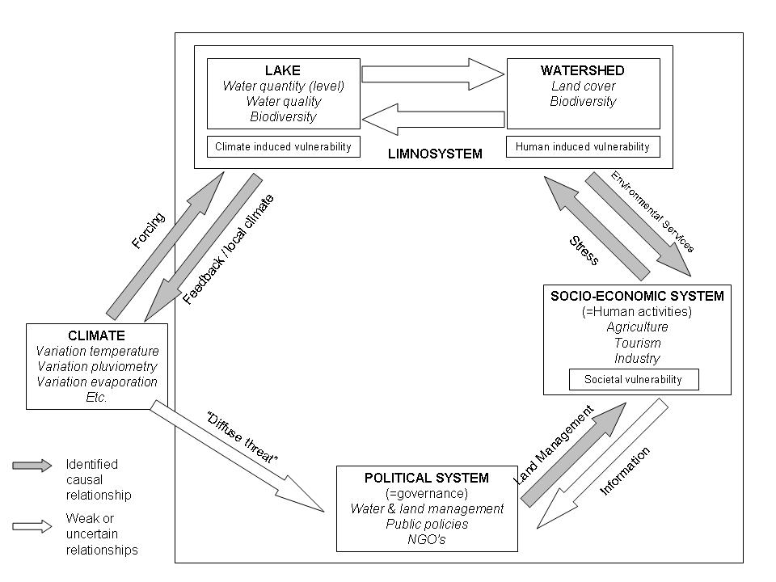
Figure 4: Conceptual model of the Lake Balaton system and causal relationships.

The analysis will take into consideration of processes on multiple spatial scales: Lake Balaton and its riparian zone, the watershed, Hungary, and the global scale in terms of climate change. At the same time, there are multiple temporal scales to be taken into account. Drawing on the results of ongoing projects such as CLIME, the work of partner organizations in Hungary and elsewhere and the published literature, the retrospective part will present a picture of trends and interactions serving as a baseline to understand the historic, including the policy context of vulnerability. This will include the description and analysis adaptation measures to past climatic events as this may both help identify region-specific sensitivities and critical thresholds, and inform subsequent efforts to explore possibilities for adaptation in the future.

Forward looking analysis will focus on a medium and long-term projection with times horizons in the 15-20 and 40 to 50 year range. Using a dual time scale will involve working with different levels of global change risk, and also different assumptions about adaptation requirements. It is expected that making long-term risk and adaptation needs more explicit will help the formulation of shorter-term policy and project more robust and effective. They may also lay the foundations for subsequent adaptation measures, both by reducing future risk of crossing critical impact thresholds, and by reinforcing or establishing patterns of social learning and adaptation that are necessary for successful adaptation in the future (Jones et al. 2004, Jones et al. 2004a).

The purpose of the ex ante analysis is to (a) determine the range of fluctuations in key sustainability indicators as a result of interacting global and local forces, particularly climate change; (b) explore through a process of stakeholder dialogue the possible vulnerability implications of the changes on the local ecosystem and population, including livelihood systems and economics; this will include the establishment of critical thresholds, where feasible, beyond which the existing coping capacity of human and ecosystems would be inadequate to deal with risk without adaptive measures; (c) work with stakeholders to identify and describe short and long-term adaptive policy options in response to emerging vulnerability; (d) identify and facilitate the introduction of policy measures that enable effective adaptation on the local and regional scale; and (e) identify monitoring and evaluation criteria that will be used in tracking the impact of implemented adaptation measures (direct actions and policies).

In order to assist the analysis and exploration of inter-linkages and adaptive policy options, the conceptual model will be translated into a quantitative integrated assessment model through a process that combines expert knowledge with stakeholder input. The model would help analyze dynamic environment-society interactions in retrospect and it would help map vulnerability spots, both in the spatial and conceptual sense. Building on the understanding of historic trends and interactions, the modelling process would then provide the foundations for participatory policy exercises to explore the implications of policy measures designed to tackle emerging vulnerability and increase adaptive capacity.

The base model would have a GIS component to enable vulnerability mapping and engagement with stakeholders on issues that are tied to a particular place or community. In forward looking analysis its climate sub-model would build on the results of the global IPCC Special Report on Emissions Scenarios (SRES), as suggested by leading impact studies (e.g. Parry 2004), and the analysis of the range of potential impacts in the Lake Balaton region produced by global climate model (GCM) downscaling exercises.

In addition to the more detailed quantitative base model an interface would be developed to communicate key interactions and results with non-expert audiences, including decision-makers, using projections of key indicators and qualitative scenario narratives. Community and sub-watershed scale policy exercises will be held to identify the types of adaptive measures and build them as criteria into a subset of LBDC’s grant program designated to specifically focus on adaptation to emerging vulnerability associated with global change.

Adaptation can occur on short and long time scales and can involve a range of mechanisms and participants. As most adaptive measures would have to be taken beyond the lifespan of the project, there is a need for a dynamic macro-policy environment that is both sensitive to and supportive of adaptation measures. Sensitivity will require that policymakers on the national level are able to recognize emerging adaptation needs and opportunities that are currently unknown due to the inherent uncertainty associated with climate and global change risk. Support will be needed in priority areas where climate risk is pushing adaptive capacity beyond critical thresholds with the potential to cause long term and irreversible damage, or where crossing a critical threshold would initiate a cascading effect in a major socio-economic or environmental compartment.

The choice of the actual policy measure within an adaptive policy framework will vary according to the nature of the particular vulnerability risk and may involve a range of regulatory measures, economic instruments or other mechanisms. What is important and what will guide the engagement with national scale policymakers is the need that they recognize their role in facilitating sub-national level adaptation, that they are able to allocate scarce resources according to priority needs, and that they are open to experimentation and the application of innovative policy measures, fiscal, regulatory or other, according to the nature of the vulnerability threat and the potential for damage.

In order to maximize the impacts of the project, an engagement and influencing strategy will be developed in an early phase and implemented throughout the project. The influencing strategy specific to the Balaton project will be developed on the basis of a strategy template developed by IISD and having the following main components:
(1). Decision or change we wish to influence: Identification of decision(s) to be influenced through the project;
(2) Relationship management: Identification of people in position to effect the changes / decisions we seek;
(3) Knowledge management: What do the people we need to influence need to know? What knowledge do we need to have / develop in order to influence them?
(4) Opportunity management: What are our tactics to move our knowledge into the hands of those we are trying to influence?
(5) Monitoring: Monitoring the effects of our work towards the decisions or changes we seek; and
(6) Learning: Reflections and internal learning on the design and implementation of vulnerability and adaptation projects.

C-2.11 Project Outcomes, Outputs and Activities

Outcome 1: Improved understanding of integrated vulnerability and adaptation options in the context of sustainable development in the Lake Balaton watershed

Output 1.1: Description and analysis of baseline ecosystem and social system conditions and dynamics

Activities:
- Agree on analytic framework suitable for the integrated assessment of vulnerability and adaptation to global change;
- Initiate and manage participatory process to identify a core set of sustainability indicators, associated targets and critical thresholds when possible, building on earlier work in the region and internationally;
- Construct database and compile relevant spatial and non-spatial baseline data, building to the extent possible on the database available to LBDCA;
- Drawing on experience from UNEP’s GEO and other applicable assessment systems, carry out integrated assessment of ecological and socio-economic trends and dynamics to identify existing and emerging vulnerability and its root causes;
- Formulate concept for integrated monitoring system compatible with vulnerability and adaptation indicators and building on existing monitoring capacity.

Output 1.2: Description and analysis of vulnerability under alternative adaptation scenarios

Activities:
- Using participatory modelling methods construct an integrated watershed management support model;
- Using quantitative indicators and model results as well as qualitative storylines, develop business as usual (BAU) scenario and provide early warning of anticipated changes on two, a medium and long-term time horizon;
- Identify policy and technological innovation options to reduce vulnerability in the context of alternative scenario(s) on the two time horizons.

Outcome 2: Strengthened organizational and individual capacity for interpreting emerging vulnerabilities, and increasing resilience by implementing adaptive measures in response

Output 2.1: Capacity development strategy for adaptation

Activities:
- Identify relevant audiences and types of capacities for adaptation (such as human resources development, organizational strengthening, or institutional reform);
- In collaboration with relevant stakeholders develop an indicator system for assessing and tracking the status of adaptive capacity;
- In consultation with local, regional and national partners formulate capacity development strategy identifying capacity development activities needed.

Output 2.2: Training program to implement adaptation

Activities:
- Identify key audiences (such as opinion leaders in sectoral umbrella groups, staff members of research organizations providing extension-like services, staff members of relevant local government agencies, etc.), knowledge gaps and relevant needs;
- In cooperation with local partners develop, test and finalize training modules;
- Help incorporate adaptation training modules into the existing capacity building program(s) of relevant regional organizations.

Outcome 3: Policy framework conducive to adaptive management strengthened

Output 3.1: Policy mechanisms analyzed and developed to achieve better alignment between national policies and local adaptation needs

Activities:
- Identify policy barriers, including macro and micro-scale economic barriers constraining the introduction of adaptation measures and policy options to overcome them;
- Organize national, regional and community level forums to conduct policy dialogue on vulnerability and adaptation;
- Facilitate a dialogue between regional stakeholders, regional and national authorities to overcome differences and introduce or modify policy mechanisms, including changes in economic dis/incentives to help adaptation.
- Identify key policy and planning tools to adequately integrate adaptation measures and opportunities for their testing and wider introduction.

Outcome 4: Pilot initiatives to facilitate adaptation to the impacts of climate change through direct action implemented

Output 4.1: Guidelines for adaptation pilot projects

Activities:
- Identify priority adaptation areas that would be targeted through pilot projects;
- Identify opportunities for implementing adaptation projects using innovative financing mechanisms, such as cost sharing through public-private partnerships (PPPs);
- Develop specific guidelines for grant applications and build them into calls for proposals issued by LBDC and/or by the ME&W and MARD.

Output 4.2: Adaptation pilot projects implemented

Activities:

- Issue call for proposals and select pilot projects
- Grantees selected for pilot project funding to implement projects and project partners to monitor implementation;
- Evaluate pilots, draw and communicate lessons and consider modifying LBDC’s policy for small grants in the future.

Outcome 5: Knowledge generated and awareness raised of integrated vulnerability and adaptation approaches locally, nationally and internationally enhanced through knowledge management, dissemination and replication strategy;

Output 5.1: Engagement and influencing strategy

Activities:
- Identify audiences, key decisions to be influenced, and channels for communicating project related information and engagement;
- Develop influencing and engagement strategy;
- Systematically implement strategy throughout the project.

Output 5.2: Synthesis report and other lessons learned and knowledge products prepared and communicated

Activities:
- Prepare, organize peer review of and finalize synthesis report and other knowledge products, including lessons learned notes and how to guide synthesising all lessons of APF process, including pilot(s);
- Communicate and disseminate products with clear replication strategy.

Output 5.3: Synthesis and communication of lessons learnt for regional and global audiences

Activities:
- Prepare synthesis report to be communicated to regional and global audiences through channels such as UNEP’s Early Warning program, UNDP’s knowledge management system, IISD’s network and other;
- Contribute to GEF’s project on the Adaptation Learning Mechanism currently under preparation by UNDP;
- Organize workshop to discuss experience with vulnerability and adaptation projects and policy initiatives in the Central and Eastern European region;
- Present results at other relevant international science/policy forums, including contributing to LEAD International’s 2005 annual training event for global LEAD Fellows to be held at and focused, among others, on vulnerability and adaptation issues related to Lake Balaton.

C-2.12 Logical Framework and Project Performance Indicators
Project Strategy | Objectively verifiable indicators |  |  | Sources of verification | Assumptions
 | Indicator | Baseline value | Target value and date
Long-term goal of the project is to build capacity and generate knowledge for increased understanding of the adaptability and vulnerability of human and natural systems on the example of the Lake Balaton and improve preparedness for climate change and enhance adaptive capacity elsewhere through lessons learned and dissemination.

Project objective is to contribute to a better understanding of the Lake Balaton ecological and socio-economic system’s vulnerability and resilience arising from multiple forces of global and local change, including climate change, and build capacity for more effective policy-making and adaptation measures
Outcome 1: Improved understanding of integrated vulnerability and adaptation options in the context of sustainable development in the Lake Balaton watershed | Regional, national and sectoral development frameworks integrate adaptation approach | Even though necessity of adaptation measures is well recognized and extensive research conducted there has not been any concerted effort placed for vulnerability assessment and adaptation strategy formulation. | At least five frameworks integrate adaptation by he end of the project  APF has been formulated for the Lake Balaton Watershed (timeline of impact 6-30+ months) | Reports; policy documents; records of amendments.
Output 1.1: Description and analysis of baseline ecosystem and social system conditions and dynamics | Comprehensive baseline report prepared integrating all available results of previous research and assessment |  | Participatory scoping exercise launched and completed by end of first year of the project.  Indicator system formulated and agreed (time line of impact 3-12 months)
Output 1.2: Description and analysis of vulnerability under alternative adaptation scenarios | Current vulnerability assessment report formulated; alternative scenario with a mid term view outlined |  | BAU and Alternative models developed through participatory process by end of first year of the project (timeline of impact 6-12 months) | Assessment reports, records of meetings and workshops;
Outcome 2: Strengthened organizational and individual capacity for interpreting emerging vulnerabilities, and increasing resilience by implementing adaptive measures | Regional Development Council and other relevant institutions adopt and employ adaptation and vulnerability indicator framework for socio-economic development planning | The Lake Balaton Development Coordination Agency provides a strong governing body for regional policy formulation, stakeholder coordination and fund allocation to the communities, but have very limited capacity to understand and formulate adaptation policy framework | Vulnerability indicator system adopted and applied by the end of the second year of the project (impact timeline 6-18+months)
Output 2.1: Capacity development strategy for adaptation | Capacity development strategy developed |  | Capacity development strategy and action plan formulated through participatory process by the end of the first year of the project (timeline of impact 10-12 months) | Reports, CD document, records of consultation meetings.
Output 2.2: Training program to implement adaptation | Training tool-kit formulated and the programme launched |  | Targeted training programme launched and implemented by the end of the second year of the project (timeline of impact 10-18 months) | Training session reports, attendance sheets
Outcome 3: Policy framework conducive to adaptive management strengthened | APF developed | There is some research targeted to the problems of the Lake Balaton but no existing policy framework to respond to vulnerability. | At least five policy framework and legislative documents have adaptation measures mainstreamed by the end of the project (impact timeline 18-30 moths) | Reports, policy analysis report
Output3.1:Policy mechanisms analyzed and developed to achieve better alignment between national policies and local adaptation needs | Policy analysis report with detailed set of recommendations for amendments formulated |  | Relevant policy and legislative modifications made by the end of the project (impact timeline 18-30) | Reports, official records for amendments.
Outcome 4: Pilot initiatives to facilitate adaptation to the impacts of climate change through direct action implemented | Observable trends of improved adaptive management and risk reduction against vulnerability indicator framework  LBDCA grant facility integrates adaptation into the funding eligibility criteria | LBDCA has installed a grant facility to local municipalities and communities to support local development in the region of Balaton but there is no criteria or incentives to promote local actions to address the impacts of climate change through local adaptive capacity building | The response system to vulnerability at local levels shows improvements against vulnerability indicator system (by the end of the project)  At least two adaptation pilot projects implemented by the end of the project; | Pilot project evaluation reports.
Output 4.1:Guidelines for adaptation pilot projects | How to guide produced base on lessons learned from the pilot activities |  | The guide available by the end of the project (impact timeline 18-30 months)
Output 4.2: Adaptation pilot projects implemented | At least $700,000 disbursed for implementation of the pilot projects | There are no targeted or systematic activities implemented to enhance adaptation at the local level with active participation of communities, local municipalities and NGOs. | At least two adaptation pilot projects implemented by the end of the project; | Pilot project evaluation reports.
Outcome 5: Knowledge generated and awareness raised of integrated vulnerability and adaptation approaches locally, nationally and internationally enhanced | “Influencing strategy” and knowledge products developed and employed according to the replication plan | There is very poor knowledge and understanding of local communities and policy makers of integrated vulnerability and adaptation approaches. | “Influencing strategy” and knowledge products developed and employed for up scaling and replication by the end of the project (impact timeline 6-30+months) | Strategy; replication plan; knowledge products.
Output 5.1: Stakeholder engagement and influencing strategy | All sectorial ministries, regional governance bodies (LBDCA), local municipalities, communities, research and academia institutes and NGOs participated in the project. | Limited and sporadic stakeholder consultations around the adaptation issues. | Strategy developed in accordance with IISD guidelines developed by the fourth month of the project | Strategy; reports, workshop minutes, list of participants.
Output 5.2: Synthesis report and associated products prepared and communicated | Synthesis report and the knowledge products developed and disseminated through knowledge and education networks. | There is not synthesized knowledge derived from practical implementation of APF process or on-the-ground piloting of adaptation measures | Synthesis report and the knowledge products developed and disseminated through UNDP knowledge management system by the end of the project | On-line access to knowledge products; dissemination spread by publication. Number of responses from organizations, countries etc.
Output 5.3:Synthesis and communication of lessons learnt for regional and global audiences | Results and lessons disseminated through international events, UNDP, UNEP, IISD networks; internal country networks | There is not synthesized knowledge derived from practical implementation of APF process or on-the-ground piloting of adaptation measures | Regional workshop for lessons learned and dissemination orgnised by the end of the project | Presentation of results to international fora  References to project results in international initiatives

C-2.13 Project Risks and Assumptions

The main risks associated with the project are arising due to political, financial and scientific uncertainties. Some of the risks are arising from inherent uncertainties associated with the complexity of the issues dealt with. While many risks can be reduced most cannot be eliminated only reduced and managed. Early recognition and flexibility in project design to allow adaptation to changing circumstances are the keys to success.

The main types of risks, including the rating of the degree of risk are as follows. The table also includes elements of the project strategy designed to counter the risk identified.

Table 4: Risk factors and countermeasures
Type of risk | Risk | Degree | Risk management
Political | Changing government priorities or approach to the Lake Balaton region | Low | Government representative(s) on steering committee, regular updates for key Ministries
Political | Changing legislative framework due to EU accession | Medium | Integration of EU Water Directive, monitoring of policy changes
Political | Weak stakeholder interest in participation | Low | Early establishment of stakeholder group, engagement strategy
Financial | Uncertainty related to funding commitments | Low | Securing early and formal commitment, close cooperation with key donors, diversify funding sources
Scientific | Unavailability of high quality data | Medium | Multiple data sources, gap filling, extrapolation from existing data sets, use of relevant proxy measures
Scientific | Inaccuracy or inconsistency of models and scenarios | Medium | Peer review, verification of results across a range of projections, stakeholder involvement in consistency analysis

In order to keep the risks manageable the project will need a short-cycle internal project progress monitoring and adaptation mechanism (included in C-3).

C-2.14 Global Environmental Benefits

Global environmental benefits of the project arise from a number of factors.

First, as described earlier Lake Balaton’s global biodiversity significance has been recognized through its designation as a Ramsar site. As described above, the last century has seen various threats to the globally significant biodiversity of the Lake Balaton region, including pollution and eutrophication, and the impacts of tourism. However, partly due to the reduction in fertilizer use following the political changes of the 1990’s, and partly due to the introduction of strict regulations, supported by a strong programme of scientific research, such threats are largely under control. However, the potential impacts of climate change on water levels of the lake would be catastrophic. The bird and insect fauna are dependent both on the lake surface itself, and particularly on the surrounding vegetation. Climate-related changes in hydrology will have a major impact on vegetation and a consequent catastrophic impact on the biodiversity of the region. The accelerated change is increasing the vulnerability of both ecological and socio-economic subsystems. As described above the impacts are becoming increasingly tangible, mobilizing the great attention of scientific community both in Hungary and internationally. Better understanding of the dynamics of change has been recognized necessary. Consequently, measures to promote adaptation to climate change can result in substantial benefits at national and global levels.

The project would also play, as explained in Section C-1 earlier a catalytic role in the Central and Eastern European region where vulnerability and adaptation initiatives with a sustainability and climate change focus have not generally started. The project will generate the extensive knowledge on APF process and widely disseminate lessons through various knowledge and cooperation networks. The APF process through multi-stakeholder dialogue, targeted training and on-the-ground pilot activities will build the national and local capacities and improve understanding of the new trajectories of change and their impact on socio-economic and ecological sub-systems of the Balaton Lake region. Some of the innovative approaches tested during the APF process and local demonstration actions will be distilled through the How to guide and other knowledge products for an uptake and further replication at least in the region and may be globally.

C-3 Project Sustainability

On the level of words and, to a limited extent policies environmentally sustainable development has been identified as long-term goal for LB and LBRA. Building to the extent possible on the existing, but inadequately implemented policy framework and local capacity the project will seek to both reinforce positive trends and introduce new ideas. Keeping in mind the complexity of technical, institutional and political challenges associated with adopting new practices and policy, the project will provide advice not only on better practices, but also on transition strategies.

The policy options developed in response to the increased risk of vulnerability will include the central goal of strengthened local and regional institutional capacity. On the human resources level this will be achieved through increased local expertise in carrying out forward looking, place-based or sectoral analysis and policy work integrating adaptation measures into the local development planning. On the resources side it will involve the identification of specific policy measures that can help revenue stay in the region and being spent in ways more compatible with successful adaptation to existing or emergent vulnerability.

C-4 Replicability

Knowledge transfer is a crucial aspect of the project, both because vulnerability and adaptation in the sustainability and climate change context are new concepts in the region, and because successful adaptation requires coordinated action by many stakeholders and on many scales. In order to improve replicability of the integrated vulnerability and adaptation approach piloted the project involves the following activities. Note that all activities are included in the budget and work plan.

Engagement and influencing strategy – Strategy to define overall approach to reaching key stakeholders and audiences. The strategy will build on the general influencing strategy template developed by IISD (IISD 2004). This will include a scoping of key audiences, mapping of information needs and the way they can be met, designing and delivering a range of information products (reports, websites, events etc.) according to needs identified.

Stakeholder forums – Stakeholder and public participation is integrated into all project phases to increase buy-in and increase effective knowledge transfer. The role of these forums will vary from involving local stakeholders to high level policymakers. Stakeholder for a will play a role e.g., in indicator selection and design, the identification of sector- or place-specific vulnerabilities to the development of scenario storylines and local level options for policy, technology or other adaptation options. Forums involving national level policymakers will facilitate dialogue with local actors across sectors and scale and focus on identifying and exploring national level policy alternatives synergistic with local adaptation needs.

Training – The project will involve capacity building for vulnerability analysis and adaptation by stakeholders by developing and delivering training modules. The training modules and sessions will be based on highly interactive, hands-on training methods and involve local staff who will be able to serve as resource people for training in academic or non-academic settings beyond the project. Consideration will be given to integrating V&A modules into existing training programs of organizations in the region (e.g., at universities, organizations involved in outreach activities in the agriculture sector etc.).

Innovative financing mechanisms – Replicability of adaptation measures beyond the lifespan of the project will require capacity that includes not only know-how and a supportive policy environment, but also innovative financing mechanisms. Through exploring and piloting the use of PPPs for adaptation the project will set precedents for mobilizing a broader set of financing options and establish patterns of engagement with the private sector who may then be more likely to engage in adaptation work in the future.

Knowledge transfer through conference organization and presentations – Project results and final reports will be presented in the form of conference papers. In its final phase the project will also involve organizing a conference on the integrated V&A approach in its final phase for a regional audience. Beyond the region knowledge transfer will be facilitated through UNDP, UNEP and IISD, and through the involvement of LBDCA in international networks such as LakeNet and the Living Lakes Network.

C-5 Stakeholder Involvement

C-5.1 Stakeholder involvement in project development

The project concept is that result of now multi-year cooperation between LBDCA, UNEP and IISD. Phase 1 of the project started in the spring of 2002 with laying down the fundamental concepts and approach during personal meetings and other means of communication, culminating in a two-day international workshop during the 2002 Annual Meeting of the Balaton Group (Pintér 2002). Supported by grants from UNEP and LBDC as well as in-kind contribution by IISD, the project Steering Committee was established in Siófok, Hungary in April 2003. A workshop and consultation involving local and international experts, including a representative of the Living Lakes network of which Lake Balaton became a candidate in 2003 was convened by LBDCA in July 2003. Steering committee members visited several potential partner organizations and met with government officials and the Chairman of LBDC.

Parallel to the involvement of local experts and organizations, including NGOs and their networks through consultations and workshops, local and national government was officially briefed through LBDC, a political entity with supervisory duties for LBDCA. Given LBDC’s broad responsibility for regional development, LBDC members include representatives of several ministries, regional and county councils, local governments and chambers of commerce and industry as well as agriculture. Representatives of several local organizations including NGOs and the Lake Balaton Alliance, an association of the local governments in Lake Balaton region, are permanent invitees to LBDC regular sessions with consultative rights. LBDC gave approval of LBDCA funding to Phase 1 of the project and made several resolutions supportive of its goals.

C-5.2 Roles and responsibilities of relevant stakeholders in project implementation

The project’s main organizational units and their relationships are show on Figure 5 and their nature, roles and responsibilities are described below.

Selected as the National Executive Agency, LBDC will provide high level stakeholder involvement and coordination throughout the implementation of the project. LBDC will also delegate members to the Steering Committee and to the Project Board.

Implementing Agency (IA): United Nations Development Program (UNDP)
UNDP RBEC Regional Support Centre, Bratislava, Slovakia

The UNDP RBEC Regional Support Centre Bratislava will provide support to the national executing and implementing agency as needed during the project implementation. Specifically, support will be provided in the following areas: assistance in the project launching, potential participation in the Steering Committee meetings, monitoring the implementation of the work plan and timetable, field visits and preparing and circulating reports after the visit, project documentation revision, reviewing, editing and responding to the project reports, technical backstopping, support to the policy negotiations, financial management and accountability, advising and consulting during the audit process, preparation of budget revisions, financial completion activities, direct payments, advance payments, other support services as networking and exchange of best practices, preparation of the APRs, TPRs, PIR, and arranging the independent evaluations.

National Executing Agency (NEA): Lake Balaton Development Council (LBDC)

The Lake Balaton Development Council (LBDC) is a territorial development council created by national law in 1996, to tackle problems specific to the Lake Balaton Region. LBCD harmonizes and coordinates regional development put forward by 164 municipalities, the three counties, and the three regional development councils in the area. LBDC’s tasks can be summarized as follows:

- Passing of resolutions related to the appropriation of development funds available to the council;
- Defining the general direction of development of the Lake Balaton Region, overseeing the elaboration and implementation of development programmes and projects according to national and regional program priorities; and
- Decisions related to the functioning of the Council.

National Executing Agency (LBDC)
Implementing Agency
(UNDP)
Other Stakeholders
National Implementing Agency (LBDCA)

Expert Working Group
Auditing
Project Secretariat
Steering Committee
Project Management Board
AUDIENCES
(National Government, United Nations, Regional Organizations)
5. Figure: Project organization units

Presently, LBDC has 15 regular members (with voting rights), representing a wide range of key stakeholders from the region. The Government is represented through the Chairman of LBDC and through 4 delegates of different Ministries. Other sectors represented include local governments (3 delegates), development councils of the 3 counties (3) and three NUTS-2 level regions of territorial relevance (3), and the Lake Balaton Regional Tourism Board (1). Permanent invited members (no voting rights) are the representatives of the county level Chambers of Commerce and Industry (3) as well as those of the Chambers of Agriculture (3), The Lake Balaton Chief Architect Office(1), the representative of the Public Administration Office of Somogy County (1) and the representatives of regional NGOs (2).

The Lake Balaton Development Coordination Agency (LBDCA) was established by LBDC as its executive arm on January 1, 2000. Through establishing LBDCA, the Council’s goal was to make the Lake Balaton Region one of the most attractive and successful both in Hungary and Europe for the local population, tourists and visitors as well as investors. One of the most important tasks of LBDCA is the co-ordination of regional development activities and projects based. It also has a decision support function to LBDC.

LBDCA’s commitment to ecological, social and economic sustainability is expressed in the Lake Balaton Sustainable Development Programme. The Agency is interested in development projects focused on environmental protection, infrastructure development (transportation and information networks), and the development of human resources, all with equal importance. LBDCA works towards these goals through a grant program to regional actors. Most grants awarded by LBDCA require a significant co-financing component.

Established a public interest, not-for-profit organization, the Agency has about 25 employees organized into three divisions, including: program management, environmental planning, and socio-economic research. The territory of activities of LBDCA is focused on the Lake Balaton Region, however, when catchment scale developments are considered, the activities of LBDCA expand accordingly.

LBDCA has established and maintains partnership with organisations active in the region, such as county, regional (EU NUTS-2 and lower level) and government offices, municipalities, NGOs, and businesses.

As executing agency, LBDC will be responsible for the planning and overall management of the project, reporting, accounting, monitoring and evaluation, liaising with the implementing agency and management and audit of project resources. The executing agency is accountable to UNDP for the production of outputs, for the achievement of project objectives and for the use of UNDP resources.

National Implementing Agency (NIA): Lake Balaton Development Co-ordination Agency

The LBDCA as the implementing agency will provide services and carries out activities such as the procurement and delivery of project inputs and their conversion into project outputs. The implementing agency is accountable to the executing agency for the quality, timeliness and effectiveness of the services it provides and the activities it carries out, as well as for the use of funds provided to it.
The LBDCA will maintain separate accounts, including a separate bank account, for UNDP/GEF resources, to be denominated in US dollars. It will use the funds provided to it only for inputs financed by UNDP/GEF, in accordance with the project budget, covering UNDP/GEF’s contribution.
The LBDCA has already a well demonstrated capability to develop and manage complex domestic and international co-operation programs with 4 years of experience in this field. It has ample experience in the operation of full grant-aid schemes from calls for proposal to ex-post project monitoring. It has experience in project initiation and cooperation with central government agencies, local governments, and other local and regional players.

C-5.3 Involvement of other stakeholder groups in the project implementation

Other stakeholders will include a currently unspecified, but manageable number of members, including relevant NGO, local government, academic, business and other groups and opinion leader citizens from the region. Their main task will be to help identify key issues, play a role in participatory modelling, review and comment on preliminary results, help communicate and interpret findings to other local, regional and national audiences, and taking part in participatory monitoring and evaluation with a feedback to policy adaptation as needed.

Although some key stakeholders are already represented through LBDC itself, participation in the project will be significantly extended by creating fora for formal public consultation(s), informal bilateral discussions and seeking feedback on the interpretation of key findings through the local media and other channels.

Some of the other stakeholders whose participation will be strengthened through the project include the following:

- Educational and research institutions (high schools, universities, research institutes based in the region);
- NGOs (there are ca. 1200 registered NGOs in the region, with an umbrella organization founded in 2001)
- Business community (tourism, fishing, transportation, industry, consulting, agriculture, media)
- Individuals (emphasis on high profile opinion leaders in local communities, such as professionals, artists, etc.)

As another indication of the internationally unique set of problems facing the Lake Balaton region, LEAD International is organizing its annual training event in 2005 for LEAD Fellows at Lake Balaton. Collaboration with LEAD, expressed by their letter of support (Annex 10), will help both to further expose initial results of the project and also bring relevant lessons from other parts of the world to bear on the way work on the project is going to unfold.

C-6 Monitoring and Evaluation

Monitoring and evaluation functions in the project can be divided into three categories:

- Monitoring of project implementation
- Monitoring and evaluation of project impacts
- Monitoring of the allocation and use of the project budget

While monitoring project allocation and the use of project resources is part of standard management practice, monitoring and evaluation of project impacts plays a special role in adaptation.

C-6.1 Monitoring of project implementation

Project progress will be monitored using annual reviews against a set of implementation milestones. Monitoring will be ongoing, involving data collection and assessment of the project’s implementation on the field and involve key project staff meeting periodically to review operations and implementation and assess whether new priorities require a shift in the project’s implementation. Short cycle adjustments in project implementation in light of interim evaluations represent opportunities for learning and adaptation that is internal to the project.

Primary monitoring functions will be provided by the Steering Committee (SC). The SC will meet at least twice a year to assess the project’s progress against planned outputs and to provide strategic directions to further implementation and adjustment, if necessary. Quarterly Progress Reports reflecting all aspects of project implementation will be prepared by the NIA and submitted to the SC members for review.
Annual Progress Reports (APR) will be prepared by the NIA and submitted to the SC for approval. The APRs, prepared in a format required by UNDP-GEF, shall assess the performance of the project and the status of achievement of project outputs and their contribution to the relevant UNDP Strategic Results Framework Outcomes.

C-6.2 Monitoring and evaluation of project impacts

Evaluation of the impacts of the project will be both ongoing and ex-post, that is beyond the project time line. During the implementation of the project (ca. 30 months) the SC will periodically evaluate the impact of implemented project elements. Independent third party monitoring will be carried out by the Monitoring Committee (MC) of the LBDC, an already existing permanent entity set-up for general third party LBDC project monitoring. The MC will prepare an Evaluation Document annually and at the end of the project and submit it to LBDC and the SC. Results of these evaluations will be fed back to project implementation through the SC and used in reviewing and if necessary adjusting project implementation strategies.

Since many project impacts will be measurable only on time horizons longer than three years, capacity to conduct ex-post evaluation will be essential for successful adaptation in the future. Ex-post evaluation will be performed annually by LBDC’s MC, utilizing, to the extent possible the vulnerability and adaptation performance indicators developed through the project.

As local scale monitoring, evaluation and learning is also a precondition for successful local scale adaptation beyond three years, monitoring and evaluation as part of the learning and adaptation cycle will be integrated into the capacity building and training program delivered to local stakeholders.

C-6.3 Monitoring of the allocation and use of the project budget

The IA and the project manager will prepare quarterly and annual financial reports. The financial reports will be reviewed by the official auditor of the IA. The project will be subject to annual external financial audit in accordance with established UNDP regulations.

D – Financing

D-1 Financing Plan

Financing for the project will come from national and international sources and reflects the project’s integration into government and partner agency work programs. The distribution of funds across activities reflects the interests of particular contributors in different activities and outputs associated with the project.

Funding requirements have been discussed with key stakeholder organizations and project partners during bilateral consultations and workshops. Further details broken down according to project partner and sub-activity level will be finalized once funding from the GEF has been approved. Arrangements for signing Memoranda of Understanding with project partners will be made following Implementing Agency guidelines.

Table 5: Budget summary

Outcomes | Outputs | Co-financing details |  |  |  | Co-financing total | GEF financing | Subtotals
Outcomes | Outputs | LBDC(A) | UNEP |  | IISD | Co-financing total | GEF financing | Subtotals
Project development, management and monitoring | Project development | 4,000 | 25,000 |  | 20,000 | 49,000 | 0 | 54,000.00
Project development, management and monitoring | Project Secretariat, Steering Committee | 0.00 | 0.00 |  | 0.00 | 0.00 | 150,000.00 | 150,000.00
Project development, management and monitoring | Implementing agency costs (UNDP) | 0.00 | 0.00 |  | 0.00 | 0.00 | 80,000.00 | 80,000.00
1. Improved understanding of integrated vulnerability and adaptation options in the context of sustainable development in the Lake Balaton watershed | 1.1 Description and analysis of baseline ecosystem and social system conditions and dynamics | 0.00 | 0.00 |  | 0.00 | 0.00 | 220,000.00 | 220,000.00
 | 1.2 Description and analysis of vulnerability under alternative adaptation scenarios | 20,000.00 | 10,000.00 |  | 10,000.00 | 40,000.00 | 135,000.00 | 175,000.00
2. Strengthened organizational and individual capacity for interpreting emerging vulnerabilities, and increasing resilience by implementing adaptive measures in response | 2.1 Capacity development strategy for adaptation | 0.00 | 0.00 |  | 0.00 | 0.00 | 20,000.00 | 20,000.00
 | 2.2 Training program to implement adaptation | 0.00 | 0.00 |  | 0.00 | 0.00 | 110,000.00 | 110,000.00
Outcome 3: Policy framework conducive to adaptive management strengthened | 3.1 Policy mechanisms analyzed and developed to achieve better alignment between national policies and local adaptation needs | 0.00 | 0.00 |  | 0.00 | 0.00 | 80,000.00 | 80,000.00
Outcome 4: Pilot initiatives to facilitate adaptation to the impacts of climate change through direct action implemented | 4.1 Guidelines for adaptation pilot projects | 0.00 | 0.00 |  | 0.00 | 0.00 | 25,000.00 | 25,000.00
 | 4.2 Adaptation pilot projects implemented | 2,970,000.00 | 0.00 |  | 0.00 | 2,970,000.00 | 0.00 | 2,970,000.00
Outcome 5: Public and policymaker awareness of integrated vulnerability and adaptation approaches locally, nationally and internationally enhanced | 5.1 Engagement and influencing strategy | 0.00 | 0.00 |  | 0.00 | 0.00 | 60,000.00 | 60,000.00
 | 5.2 Synthesis report and associated products prepared and communicated | 0.00 | 0.00 |  | 5,000.00 | 5,000.00 | 35,000.00 | 40,000.00
 | 5.3 Synthesis and communication of lessons learnt for regional and global audiences | 6,000.00 | 15,000.00 |  | 5,000.00 | 26,000.00 | 70,000.00 | 96,000.00
SUBTOTALS |  | 3,000,000.00 | 50,000.00 |  | 40,000.00 | 3,120,000.00 | 985,000.00 | 4,075,000.00
The project is divided into six phases as shown in Table 5 and explained below.

Table 5: Project phases and approximate time line

Project phases | Project months
Project phases | 1 | 2 | 3 | 4 | 5 | 6 | 7 | 8 | 9 | 10 | 11 | 12 | 13 | 14 | 15 | 16 | 17 | 18 | 19 | 20 | 21 | 22 | 23 | 24 | 25 | 26 | 27 | 28 | 29 | 30
(Phase 1) | In progress
Initial conceptualization, project development and fundraising | Initial conceptualization, fundraising, establishment of steering committee, workshops, political engagement, preparation of concept paper
Phase 2*
Project initiation | Preparation of final project document, signing funding agreements, setting up project management system & secretariat
Phase 3
Integrated vulnerability assessment | Data collection and analysis, setting up participatory process, socio-economic analysis, assessment of vulnerability
Phase 4
Adaptation planning | Identification of adaptation mechanisms, evaluation of uncertainties, institutional and technical measures, policy integration
Phase 5
Capacity building and pilot projects | Call for and selection of pilot projects, capacity building and training, implementation of PPs
Phase 6
Synthesis | Evaluation of pilot projects, identification of policy implications, drawing and communication lessons at the local, national and international level
* Start of Phase two is subject to donor approval and date of the signing of funding documents
Phase 1: Initial conceptualization and fundraising
Phase 1 started in the spring of 2002 with laying down fundamental concepts and approach during personal meetings and other means of communication, culminating in a two-day international workshop during the 2002 Annual Meeting of the Balaton Group (Pintér, 2002). Supported by grants from UNEP and LBDC as well as in-kind contribution by IISD, the project Steering Committee, lead by LBDCA was established in Siófok, Hungary in April 2003. A workshop and consultation involving local and international experts, including a representative of the Living Lakes network of which Lake Balaton became a candidate in 2003 was convened by LBDCA in July 2003. Steering committee members visited potential partner organizations and met with government officials and the Chairman of LBDC. In 2003 IISD carried out a literature survey related to vulnerability and adaptation and starting September 2003 an IISD-sponsored intern spent six months at LBDCA to establish a GIS database and prepare imagery for subsequent analysis of vulnerability with help from UNEP/GRID-Geneva.

Phase 2: Project initiation (ca. 2 months)
Phase 2 starts when funding agreements have been finalized and signed. It involves establishing the project management system, including a small secretariat at LBDCA in Siófok to support the work of the Steering Committee, coordinate the work and maintain contacts with partners and stakeholders, continuously monitor project results and report to donors.

Phase 3: Integrated vulnerability assessment (ca. 10 months)
Phase 3 involves carrying out an integrated vulnerability assessment using existing historic data. The assessment involves a participatory process to identify key sustainability issues in the ecological and socio-economic domain, developing indicators, collecting the required data, carrying out a retrospective SoE analysis focused on the interpretation of trends, inter-linkages and policy drivers of change.

The assessment will also serve as a preliminary scan to identify areas of potential vulnerability based on historic sensitivity and adaptive capacity gaps. Reflecting the understanding that vulnerability is typically an aggregate outcome of the interplay of climate change and other key factors of sustainable development, vulnerability dynamics will be conceptually mapped through participatory integrated modelling. Phase 3 will be concluded with the construction of a business-as-usual scenario based on mid-range climate change projections and minimum two additional scenarios representing the least and most favourable feasible trajectories.

Phase 4: Adaptation planning (ca. 6 months)
Adaptation planning is focused on identifying adaptation mechanisms to increase socio-economic and ecological resilience in the face of emerging uncertainties, and to help ensure adaptation is integrated into national sustainable development strategies.

With regard to adaptation mechanisms emphasis will be on identifying institutional and technical measures targeting key vulnerabilities that can be implemented on the regional and local level. This will lead to identifying adaptation project criteria that will be built into a call for proposals for pilot projects.

Concerning the work on policy integration the emphasis will be on identifying national policy mechanisms that enable rather than constrain adaptive behaviour on the regional and local level, and engaging national government and other relevant bodies to explore options for initiating the required change.

Phase 5: Capacity building and pilot projects (ca. 10 months)
Phase 5 includes the competitive selection of pilot projects, capacity building to assist in pilot project implementation, and actual implementation of pilot initiatives.

Grants for a small set of pilot projects will be awarded by LBDCA based on the established criteria and building on the existing grant-making rules of the organization. In order to increase grantee buy-in and increase pilot project scope and impact, demonstration of a required level of co-financing will be among the conditions for application. At the same time, grantees would be able to access a portion of the pilot adaptation grant up front as this would ease the financing burden and increase the number of applications. Specific rates are to be determined following the consultation process.

The pilots will need to address key emerging vulnerability issues and lead to demonstrable adaptive capacity. Grantees will be assisted in their work through a training program focused on strategic perspectives and practical cases related to adaptation. The program and action-learning oriented training modules will be designed and delivered by local universities, assisted by international project partners as needed. The pilots will be carried out in the Lake Balaton region.

Phase 6: Synthesis (ca. 5 months)
Final results, including the short-term lessons learnt from pilot projects will be synthesized in collaboration with pilot project implementing organizations, stakeholders and experts, and published in final reports for regional, national and international audiences. General lessons with regard to early warning will be synthesized and communicated internationally through UNEP’s Early Warning program. Results will be translated into recommendations for concrete policy options for various time scales.

D-2 Cost Effectiveness

Although detailed quantitative projection of cost effectiveness at the proposal stage is not feasible, a number of measures can be listed designed to increase the effective use of resources.

- Synergies of project goals and national priorities
The project is designed to support long term strategic priorities of the Government, as well as regional and local governments. As a result, project results will stand to influence policy designs and resource allocations of mainstream institutions, causing a multiplication of effects.

- Pilot project cost effectiveness
Cost effectiveness is already one of the key criteria built in the grant program of LBDC. Successful applications are normally required to demonstrate the availability of secure co-financing. The same criteria will be applied to the adaptation pilot projects financed by LBDC under this initiative.

Pilot project activities can continue and be mainstreamed into LBDC’s grant making program beyond the project’s lifespan, thus further increasing the impact per unit of investment ratio.

- Cost effectiveness monitoring
Effectiveness of use of resources and other in-kind contributions will be among the monitoring and evaluation criteria associated with the project.

D-3 Co-financing

Table 7: Summary of sources of co-financing

Co-financing Sources
Name of Co-financier (source) | Classification  (type of co-financier) | Type | Amount (US$) | Status*
LBDC | Government | cash | 3,000,000.00 | committed
UNEP | Multilateral | cash | 50,000.00 | committed
IISD | NGO | in-kind (interns) | 40,000.00 | committed
Sub-Total Co-financing |  |  | 3,090,000.00

E - Institutional Coordination and Support

E-1 Core Commitments and Linkages

Capacity Development and Adaptation Cluster (CDAC) of UNDP was established in response to the new opportunities and challenges represented by GEF3 in relation to cross-cutting areas of Adaptation and Capacity Building. UNDP has developed the strategy for supporting national adaptation to climate change. UNDP’s strategy places national policy at the centre piece of adaptation by matching global and national agendas and benefits.
The project is designed according to the strategy that is to work from ..”current climate variability and extremes as the starting point for assessing national needs for coping with future climate. In other words, the strategy will strengthen adaptive capacity to deal with current climate variability as a first step towards developing national response measures for future climate change”.

The project is also placed within the context of MDGs that is the main platform for UNDP’s work, including in the sub-region of Central and Eastern Europe. The main areas of support in Hungary are: Socio-economic development, development cooperation and environmental sustainability. The project will contribute to all these areas.

Country Cooperation Framework commits UNDP to continue to strengthen country’s capacity to comply with global environmental objectives.

UNDP is already supports implementation of number of projects contributing to global environmental management:

“Conservation and Restoration of the Globally Significant Biodiversity of the Tisza River Floodplain Through Integrated Floodplain Management” and “Public Sector Energy efficiency Programme”

The project will also capitalize on UNDP’s knowledge management system for documenting and disseminating the key lessons generated and good practices established by the project. The project will also utilize Capacity development Indicator Framework of UNDP in order to tailor capacity indicators to serve the objectives of the project.

E-2 Consultation, Coordination and Collaboration between and among Implementing Agencies, Executing Agencies, and the GEF Secretariat, if appropriate.

UNDP closely cooperates with UNEP in support of National Capacity Self-Assessment Projects both globally and in the region. UNEP supports NCSA implementation in Hungary. The project will closely coordinate with NCSA to build on the key findings of the assessment as it relates to adaptive capacities. It will also draw on key lessons regarding the methodologies of capacity needs assessment.

E-2.1 Distribution of roles and responsibilities among project agencies

Coordination and collaboration among the Implementing Agencies, the National Executive Agency and key participating organizations will take place on different levels. The project organization chart (Fig. 5) shows the key actors and their connections.

The Steering Committee (SC, 5 members) will be the main coordinating body throughout the implementation of the project. A temporary SC has been established with 4 members (including one member each from UNEP, IISD, and 2 members representing LBDCA) at the inaugural SC meeting of Phase 1 of the project, at the headquarters of LBDCA, Hungary, on April 6, 2003.

The SC of the project will be re-established with members as follows: (1) the Chairman of LBDC (Chairman of SC); (2) representative of the Ministry of Environment & Water in LBDC; (3) representative of the local municipalities in LBDC; (4) representative of the chambers of commerce and industry in LBDC; and (5) representative of UNDP. The Chairman of LBDC represents the Government of Hungary in the organization.

The 5 member SC will be responsible for high-level oversight of project strategy implementation, coordination of monitoring and evaluation, and overall strategy for managing government and media relations.

Project Management Board (PMB, 4 members): A Project Management Board will be set up to exercise operative control over the project strategy. The PMB will be composed of a Project Director (PD), a Project Manager (PM), and two international members, one representing UNEP and one IISD. The PMB will report to the SC and assist the work of the Project Manager and the Project Director. Also, the PMB will provide professional supervision over the activities of the NIA and the Expert Working Group.

The Expert Working Group (EWG 10-15 members): The EWG will serve as an advisory group and will serve to provide scientific and technical advice to the project. The EWG will have a key role in quality assurance throughout the project implementation by assisting with access to data, review of specific methodologies, and peer reviewing findings. EWG members will include representatives of key Ministries of the Government of Hungary, internationally renowned experts from the Balaton Group, and distinguished members of scientific research and educational organizations (e.g., Lake Balaton Limnological Research Institute of the HAS, Eötvös Loránd University of Sciences and Arts, Research Institute of Soil Science and Agro-chemistry of HAS, Budapest Technical University, Water Resources Research Institute (VITUKI Plc), University of Veszprém, Research Institute of Viticulture and Aenology in Badacsony, etc.)

Operative, day-to-day coordination and collaboration between the Implementing Agency (UNDP) and the National Executing Agency (LBDC) will be provided through the PMB and the Project Secretariat to be formed inside the National Implementing Agency (LBDCA).

Project Secretariat (PS, 3 persons): In order to assist the operation of the SC and to provide day-to-day administrative support to the PMB a Project Secretariat will be established at the headquarters of NIA in Siófok, Hungary. Operating under the daily supervision of the PD, the task of the project secretariat will be to ensure smooth and fast communication between the various project organizations, actual preparation of various project documents, archiving of communication and data, organization of meetings and consultations, and organizing public relation activity.

E-2.2 Consultations and agreements

As explained earlier, the project is a result of a multi-year, multi-institutional conceptualization and coordination effort. Besides the current proposal, these efforts also resulted in funding commitments and resolutions expressing support for the initiative.

At the phase of project inception, a 2-day workshop on vulnerability and adaptation was held as part of the annual meeting of the International Network of Resource Information Centers (INRIC; better known as the Balaton Group) in Csopak, Hungary in September, 2002. A narrative summary report of the workshop is attached in Annex 4.

During the project development phase the temporary SC held two meetings at the LBDC headquarters in Siófok. Two additional workshops were held in April, 2003 in Budapest and July, 2003 in Siófok.

LBDC, LBDCA, UNEP and IISD concluded agreements in 2002 as well as in 2003 on cooperation and the financing of Phase 1 of the project. On December 5, 2002 LBDC passed Resolution Nr. 49/2002 (XII.05.) concerning the allocation of HUF1 million (ca. USD50,000.00) towards LBDC involvement in the preparatory phase of the project and the contribution of 10 million Ft. towards later implementation.

Progress reports concerning the project were formally presented to LBDC sessions several times. On 1 April 2004 at the meeting of the LBDC budgetary support was again confirmed from the council. Resolution Nr. 18/2004 (IV.01.) stated the allocation HUF10 million towards the realisation of the UNEP project. On 13 May 2004 LBDCA accepted the report prepared by the LBDC specifying the council’s involvement in the vulnerability and adaptation initiative. Excerpts of LBDC decisions related to the project are shown in Annex 5.

References

Banczerowski, J., ed. (1999) Results of Lake Balaton Research. Budapest: Prime Ministers Office-HAS.

Banczerowski, J., ed. (2000) Results of Lake Balaton Research. Budapest: Prime Ministers Office-HAS.

Banczerowski, J., ed. (2001) Results of Lake Balaton Research. Budapest: Prime Ministers Office-HAS.

Bartholy, J., Matyasovszky, I., and I. Bogárdi. (1995) Effect of climate change on regional precipitation in Lake Balaton watershed, Theor. Appl. Climatol. (51): 237-250.

Bohle, H-G. (2003) “What do “We” Mean by Vulnerability?” SAVI Workshop, Maputo, June 19-21, 2003.

Convention on Biological Diversity. (2003) Parties to the Convention on Biological Diversity. Montreal: Convention on Biological Diversity.
< http://www.biodiv.org/world/parties.asp>

Government of Hungary. (2002) Third National Communication to the UNFCCC. Budapest: Government of Hungary. <http://unfccc.int/resource/docs/natc/hunnc3.pdf>

Herodek, S. et al. (1988) Research and Management of Lake Balaton. Kusatsu (Shiga prefecture), Japan: International Lake Environment Committee.

IISD. (2004) Influencing Strategy. Winnipeg: International Institute for Sustainable Development.

Lake Balaton Development Coordination Agency. (2003) An Unconventional Region.Brief Report about the Structural Problems of the Lake Balaton Special Recreational Area as a Special Region for Tourism in Light of the Most Recent Research. Balatonfüred: Sociological Research Group, LBDCA.

Lake Balaton Development Coordination Agency; K. Kutics et al. (2001) Strategic Development Programme for the Lake Balaton Region. Siófok: LBDCA.

Jones, R. et al. (2004) Assessing Future Climate Risks. The Adaptation Policy Framework. Technical Paper 5. New York: UNDP. <http://www.undp.org/cc/pdf/APF/TP%20final/Tech.Paper_5.qxp_01Sept04.pdf>

Jones, R. et al. (2004a) Assessing Current Climate Risk. The Adaptation Policy Framework. Technical Paper 4. New York: UNDP. <http://www.undp.org/cc/pdf/APF/TP%20final/Tech.Paper_4.qxp_30Aug04.pdf>

Kocsis, L. et al.: A Balaton vízgyűjtő területén végzett vízgazdálkodási és intenzív mezőgazdasági tevékenység összehangolt fejlesztése (A Balaton Fejlesztési Tanács Operatív Programtanulmánya), Veszprémi Egyetem, Georgikon Kar, 2000.

Ministry of Transportation, Telecommunications and Water Management; S. Kisgyörgy et al. (2000) Lake Balaton Water Management Development Programme. Revised edition. Budapest: Ministry of Transportation, Telecommunications and Water Management.

Parry, M. (2004) “Global impacts of climate change under the SRES scenarios” Global Environmental Change 14(1): 1.

Pintér, L. (2002) Lake Balaton’s Past, Present and Future: Dialogue on Vulnerability and Adaptation. Workshop Report. Balaton Bulletin, Fall 2002 issue.

Polsky, C. et al. (2003) “Assessing vulnerabilities to the effects of global change: An eight-step approach.” Research and Assessment Systems for Sustainability Program Discussion Paper 2003-05. Cambridge, MA: Environment and Natural Resources Program, Belfer Center for Science and International Affairs, Kennedy School of Government, Harvard University.

Ramsar Convention. (2003) Contracting Parties to the Ramsar Convention on Wetlands. Gland, Switzerland: Ramsar Convention. < http://www.ramsar.org/key_cp_e.htm>.

Ramsar Convention. (2003a) A Directory of Wetlands of International Importance. Hungary 3HU012. Lake Balaton. Gland, Switzerland: Ramsar Convention.
< http://www.wetlands.org/RDB/Ramsar_Dir/Hungary/HU012D02.htm>

Ramsar Convention. (2003b) A Directory of Wetlands of International Importance. Hungary 3HU004. Kis-Balaton. Gland, Switzerland: Ramsar Convention.
< http://www.wetlands.org/RDB/Ramsar_Dir/Hungary/HU004D02.htm>.

Roy. M. (2003) Adaptation and Vulnerability. Annotated review of the literature. Winnipeg: International Institute for Sustainable Development. Draft report.

Somlyódy, L. (1995): Eutrophication Management of Lake Balaton: a Systems Analytical Application. In: Miser, H. (ed.) Handbook of Systems Analysis, Wiley, pp. 65-107

Somlyódy, L. and M. Honti. (2003) “The case of Lake Balaton: How can we exercise precaution?” Presented at Uncertainty and Precaution in Environmental Management, Copenhagen, June 7-9, 2003.
< http://upem.er.dtu.dk/files/06%20Somlyody.pdf>
Steffen, W. et al. (2004) Global Change and the Earth System: A Planet under Pressure. Berlin: Springer Verlag.

UNEP. (2002) Global Environment Outlook-3. London: Earthscan Publications. <http://www.unep.org/geo/geo3/>

UNDP/GEF (2005) Adaptation Policy Framework for Climate Change: developing strategies, policies and measures. Cambridge University Press. http://www.undp.org/cc/whatsnew.htm

Ürge-Vorsatz, D. (2002) Third National Comunication to the UNFCCC. Hungary. Chapters on Research, Systematic Observations and Education. Budapest: Central European University.

Varga, Gy. and J. P. Urbán (2002) Overview of Lake Balaton Hydrological Trends. Budapest: Water Resources Research Centre Plc. and VITUKI Plc. Presented at the Lake Balaton’s Past, Present and Future: Dialogue on Vulnerability and Adaptation Workshop, September 9-10, 2002, Csopak, Hungary.

Watson, R.T. et al. (2001) Climate Change 2001 – Third Assessment. Synthesis Report. IPCC.

Weidinger, T., Matyasovszky, I., and I. Bogárdi. (1994) The influence of atmospheric circulation on the water budget of Lake Balaton, Meteorologische Zeitschrift, NF3, 5, 288-296.

Response to Reviews

A - Convention Secretariat

B - Other IAs and relevant ExAs

ANNEX 1: Location and map of Lake Balaton region

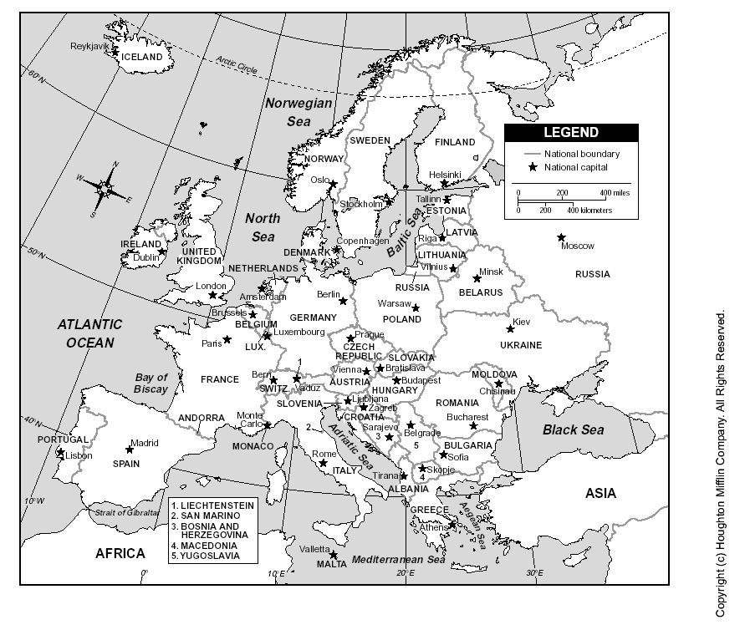
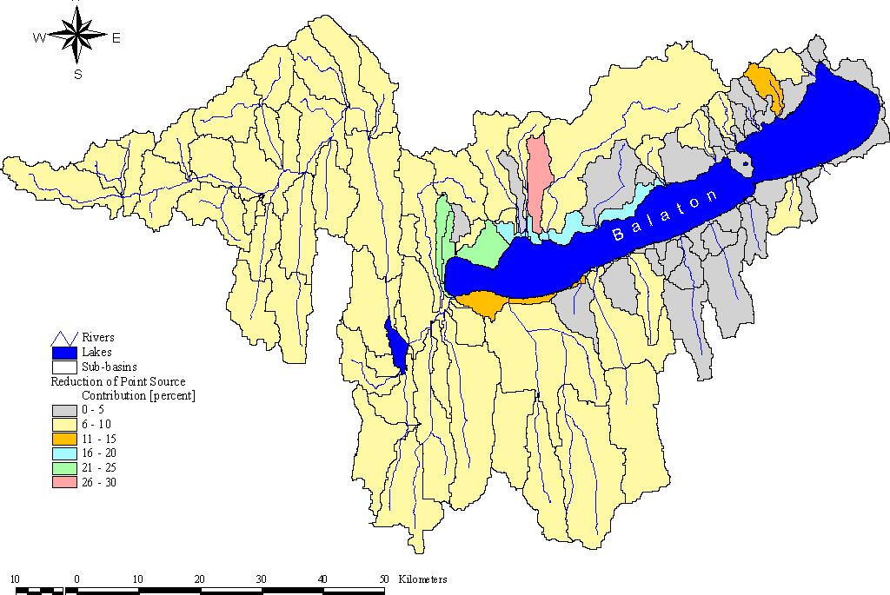
EUROPE
Budapest
Hungary
Lake
Balaton
Watershed
Zala River
Zala River
Sio Canal

Kis-Balaton Stage I (Inundated in 1985)

Kis－Balaton Stage II ( Inundated in 1992)

Planned inundation of Stage II

Lake Balaton Uplands National Park Area

Legal Border of Lake Balaton Resort Area

ANNEX 2: Globally Significant Biodiversity of Basins and Regions of Balaton-Uplands National Park

1. KIS-BALATON
The Kis Balaton, as a huge wetland habitat is unique in the whole of Europe, which is why it has always been recorded by international nature conservation. Its wonderful world of birds was already famous in the last century; and has survived despite the draining of the marsh started in 1922. It is therefore not surprising that when Hungary joined the Ramsar Convention in 1979, the Kis Balaton was included in the list of "Wetlands of International Importance as Waterfowl Habitat".
As a result of the reconstruction of the wetlands in the mid 1980s, waterfowl were able to return to formerly deserted habitats. In addition to 250 species of birds identified so far, several other rare animals and plants are found here. It is worth to mention the Northern vole, dogfish, pond loach and some rare species of dragonflies among them.
2. PÉCSELY BASIN
The gently sloping hillsides, wide mountaintops and basins, flat highlands with spotted karstic elements (e.g. karren fields) characterize the area. A relict of the basalt volcanic activities in the Quaternary is the Halom Hill at Mencshely.
The dry oak forests and the scrub forests rich in Balkan submediterranean species have significant influence on the flora. Typical elements are the rock grasses (closed dolomite rock grass, grassy stepp and rock grass slope steppes) and rock shrub. Amongst the botanical values it is worth to mention the significant population of Dictamnus albus, Adonis vernalis, Anacamptis pyramidalis and the Sternbergia colchiciflora, Epipactis palustris, Orchis laxiflora with their spotted appearance.
From zoological aspect the area is less examined, mainly its bird fauna is known, but at certain parts researches into the insect fauna where also carried out which revealed a rich capricorn beetle and ground beetle stand. Among the bird fauna some of the actually endangered species are of high importance, such as the white stork, the bee-eater and the middle spotted woodpecker.
3. KÁLI BASIN
Geological features of the area contribute to its outstanding natural values. Its geological structure is extraordinarily varied: Permian red sandstone mountains in the south, huge basalt mountains in the north, sandstone conglomerates in the west, limestone and dolomite in the east and in the middle of the basin. The basalt mountains stretch to the northern edge of the area in a broad plateau, to the valley of the Eger Creek.
The bogs of the area are of outstanding botanical value. In the Sásd meadows west of Köveskál, we find the largest population of a rare subalpine primrose; this plant can only survive in cool and humid places. Since 1983 the directorate preserves the rich flora of the wetland of Tódi-kút in Kővágóörs by a water supply system operated by a wind mill. There are several protected orchids, gentian and iris in the bog meadows of the mountain.
The forests on the mountain tops also show a great variety of plants. Diverse forests are found in the area: from acidophilic oak-forests (e.g. at Küszöborra) and villous oaks mixed with sumac (Köves Hill) to the linden groves on basalt talus slopes (Balatonhenye Madár Forest), the forests of Turkey oaks which are extremely rich in plant life (Sátorma Hill), and beech forests mixed with bornbeam in the northern slopes (e.g. the valley of the Eger Creek).
4. TAPOLCA BASIN
The basalt mountains of the area are not only unique geological relics, they are also the habitat of many rare plants and animals. Several botanical rarities live in the extreme climatic and geological conditions of the basalt mountains. A unique acidophilic ash-beech forest occurs on the rocky escarpments of the Badacsony; in its beech forests cyclamen can be found, while in the hornbeam-oak groves hepatica, black bryony, broomrape grow. On the rocks of the Szentgyörgy Hill there is a small population of Cheilanthes marantae (unique in Hungary), with caterack and Lumnitzer carnation. Several local subspecies of sorbtrees find habitat in the rock cracks. The flower stock of Csobánc is enriched by Pulsatilla grandis, Saxifragas and lilac.
On the rocks and in the forests of the basalt hills several rare birds nest: raven, red footed falcon, rock bird etc. In the reeds below the Szigliget Hill the protected greylag goose breeds.
5. KESZTHELY MOUNTAINS
The characteristic bedrock of the forested, area is dolomite. On this bedrock typical for the Transdanubian Mountains, the flora and fauna are determined by the special ecological conditions.
One the thin soil of the steep dolomite ridges and slopes are characterised by steppe-like vegetation. Scrub forests of tomentose oak and sumac cover large areas in the mountains, especially on the southern slopes and ridges. In these forests there are many orchids, Seseli leucospermum. The most precious botanical rarity of this hill is the Doronicum orientale living in the beech groves of Sipos-torok. This is the northern border of the habitat of this composite flower. In other places it can only be found in the Mecsek and the Tolna Hills in Hungary.

Proposed SPA Sites

Site | Total area  (ha) | Protected  (ha) | Protection level  (%) | Species of global conservation concern | Concentration of BD Annex I species | Congregations of migrating species, not listed on BD Annex I | Large congregations 20 000 waterbirds | ’Top 5 ’sites of Hungary
Balaton | 60000 | - | 0 |  |  | 7 | *
Kis-Balaton | 14800 | 14734 | 90 | 2 | 4 | 5 | * | 11
Nagy-Berek | 9300 | 1744 | 19 | 2 |  | 2
For criteria HU4 ’*’ indicates that the site fulfils the population threshold set.

Important concentrations of Ferruginous Duck (Aythya nyroca) at a global level

Site | Population (pairs)
Kis-Balaton | > 40
Nagy-Berek | 28-30

Concentrations of species endangered at Community level

Species | Population threshold (pairs) | Site
Ardeola ralloides | 15 | Kis-Balaton
Egretta alba | 20 | Kis-Balaton
Chlidonias niger | 40 | Kis-Balaton

Congregations of migratory waterfowl

Species | Population threshold (pairs) | Site
Anser anser | 200 | Balaton  Kis-Balaton
Anser albifrons | 1000 | Balaton  Kis-Balaton
Anser fabalis | 3000 | Balaton  Kis-Balaton
Anas strepera | 1000 | Kis-Balaton
Anas platyrhynchos | 22500 | Balaton
Aythya ferina | 10000 | Balaton
Aythya fuligula | 6000 | Balaton
Bucephala clangula | 700 | Balaton  Kis-Balaton

ANNEX 3: List of Relevant Laws, Government and Regional Level Action Plans and Programmes

No./year | Category | Title | Purpose/Contents
1033/2004 | Government Resolution | Balaton related tasks | Action Plan of short and mid-term activities related to current Balaton issues
2153/2002 | Government Resolution | Endorsement of the Long-term Regional Dev. Concept of LBRA | Approves and endorses the five priorities of the Long-term Plan (cf. below)
1/2002 | Ministry of Environment Ordinance | Enlargement of the Lake Balaton Uplands National Park | Protecting additional 22 ha area of unique natural value.
2001 | Programme (LBDC  Resolution) | Approval of Strategic Development Prog. for 2002-2006 | To implement the Long-term Regional Development Concept
1097/2001 | Government Resolution | Action Plan for the Implementation of CXII/2000 | Defines 12 actions, time frames and responsible ministries.
CXII/2000 | Law | Spatial Development Plan of LBRA | Defines the area of LBRA. Sets basic tasks and rules of spatial planning and development.
2000 | Programme (ME&W) | Lake Balaton Water Management Development Programme (Update) | Outlines water management tasks with deadlines and responsibilities for the 2001-2010 period.
2000 | Programme (MEC) | Tourism Development Programme of LBRA | To revitalize tourism through quality improvement and season extension
2000 | Plan (LBDC  Resolution) | Approval of Long-term Regional Development Concept of LBRA | 5 priorities including Environmental protection, infra-structure, economy, human res. & institutional dev.
2371/1999 | Government Resolution | Review and Modification of Plans for the Construction of Stage II of Kis-Balaton WCCS | Modification of the plan to ensure harmonization of water quality goals and ecological aspects
31/1997 | Ministry of Environment Ordinance | Creation of the Lake Balaton Uplands National Park | Nature protection on 570 km² area.
1068/1996  incorp. to 1033/2004as annex | Government Resolution | Action Plan for the Protection of the Ecological Conditions and Improvement of WQ of Lake Balaton | To reduce pollutant load, internal load, prepare new regional development plan, research plan, information of public
XXI/1996 | Law | Regional Development and Planning Act | Creation of 7 Regional Development Councils and LBDC

ANNEX 4: Chronological review of important events affecting Lake Balaton and its surroundings

Lines in the tables are categorized on the basis of the “Action or event” column’s primary relevance to the following dimensions:

Hydrology, water budget or water management
Ecology, wildlife, eutrophication, WQ issues
Tourism and economic issues
Political, institutional and other issues
Time | Action or event | Consequences | Policy or technical measures and responses
1863 | Level control/drop | 50 % loss of lake volume, separation and dry-up of vast wetlands | None
1890s | Start of use as resort area | Shore regulation, construction of “bathing houses”, hotels, etc. | Formation of bathing associations
1900s | Uncoordinated development | Conflicts, economic stress | 1904: Foundation of Lake Balaton Alliance (Association of Local Governments)
1920s | Drainage projects on the rest of wetlands, river embankment | Increased siltation, pollution, habitat loss | Putting egrets under protection
1920s | Still too much level fluctuation, ice damage, flooding | Ice and flood damage, economic losses | 1921:Reconstruction of Sio weir  Establishing of hydrological monitoring system
1890-1920s | Growing importance of the science of limnology | Demand for more understanding, biological data, etc. | 1927: Establishing the Biological Research Institute (Forerunner of LBLRI) in Tihany
1930s | Tourism gets going (more than 1 million guest nights) | Need for coordinated infrastructure, etc. development | Establishing the Lake Balaton Management Committee (“BIB”)
1950s | Formation of large, collective agricultural farms, increasing use of fertilisers and agrochemicals | Increasing pollution from agriculture and livestock breeding | None
1960s | Start of the development of mass tourism facilities | Loss of vineyards, landscape degradation, pollution | Start of sewage treatment  Shore line control (concrete structures)
1963 | More construction, growth of land prices, pollution | Recognition of the need of regional development | First regional development plan
1965 | Unidentified cause (pollution event?) | Massive fish kill occurs | No publicity
1969 | Definite signs of eutrophication | Scientific community gets concerned | More systematic research on algae

1960s –1970s | Mass tourism, increased use of fertilizers | Pollution increase further Changes in phyto-plankton structure, disappearance of species | More sewer development

1972 | First mass bloom of algae | Concern of experts | More research
1970s | Mass tourism intensifies  (more hotels, camp sites) | More signs of water quality deterioration | Intensified research activities, 1979: second regional development plan

Time | Action or event | Consequences | Policy or technical measures and responses
1978-82 | First large scale research project (IIASA involvement)) | Increased understanding of the lake and its watershed
1982 | Massive bloom of blue-green algae | Highest Chl-a concentration to date | 1983: Planning of eutrophication control measures, regulation of housing construction
1980s | Stopping water pumping from bauxite mines into Lake Balaton tributaries | Mid-term negative effect on water budget
1985 | Commencement of Kis-Balaton I reservoir (wetland reconstruction) | Reduced siltation and TP load, increased evaporation | 1985: Third regional development plan
1987 | Massive bloom of blue-green algae | Voices of discontent
1989 | Collapse of Communist System | Drastic reduction of the use of fertilizers
1991 | Massive fish kill (eel) | Impact on tourism  Losses of fishing industry | Eel elimination measures start; Cause of kills remained unclear
1992 | Fish kill (eel) | Losses of fishing industry | Eel elimination continues
1992 | Introduction of P removal at Zalaegerszeg STP | Drastic reduction of P load to Stage I of Kis-Balaton I.
1992-3 | Inundation of part of Stage II of Kis-Balaton reconstructed wetland | Humic load to Lake Balaton drastically increases | Revisions of Kis-Balaton plans start
1993 | Privatization of land, collapse of large-scale farming | Further reduction of fertilizer use, fragmentation of land ownership
1993 | Extremely dry year | Outflow at minimum  No boating on Sió Canal | Sió weir closed all year round
1994 | Record braking algal bloom, the whole lake is hypertrophic | Allergic reactions on bathing humans recorded | Emergency action plan: Intensification of sewer development, Dredging, Kis-Balaton II construction
1995 | Establishing Lake Balaton Office in the PMO | Power struggle with Ministries, difficulties in coordination
1996 | Massive algal bloom in Kis-Balaton | Fish kill, bird kill | Bird rescue operations
1996 | Deteriorating financial conditions | Implementation of 1994 Action Plan lags | Modification of the Action Plan

Time | Action or event | Consequences | Policy and technical measures and responses
1996 | Establishing Lake Balaton Development Council | Formal role, no funds in discretion
1997-99 | Second International Project,  JICA: Improvement of Lake Balaton Environment | Monitoring stations, database, simulation model development | Formation of steering committee, cooperation
1997 | Lake Balaton Highland National Park Commenced | Nature conservation improved
1999 | Termination of the operation of Lake Balaton Office in the PMO | Reinforcement of Lake Balaton Development Council | Increase in funds
2000 | Establishing LBDCA | Increased funds, regional development materialize, improved coordination | Sewer development, dredging, support of tourism SMEs
2000 | “Lake Balaton Law” enacted | Legislative control of development | Action plan
2000 | Negative annual water budget for the firs time on record | Low water level, losses of fishing industry | Outflow stopped
2001 | Negative annual water budget for the second year in row | Low water level, formation of sand islands, losses of fishing industry | No outflow,  Study on possible water conveyance ordered by LBDC
2001 | Strategic Development Plan | Planned development for 5 years
2002 | Negative annual water budget for the third year in row | Low water level, losses of fishing industry, tourism, shipping, etc. | No outflow, Water conveyance intensively discussed
2003 | No sign of the alleviation of water shortage | Losses of fishing industry, tourism, shipping, etc. Growing concern among stakeholders | Government commissioner is appointed

ANNEX 5: SUMMARY REPORT OF THE WORKSHOP

Lake Balaton’s Past, Present and Future: Dialogue on Vulnerability and Adaptation

Workshop Report

László Pintér

As for background, the idea of this workshop grew out of our discussions that took place at the 2001 Balaton Group meeting and that was reported in the fall 2001 Bulletin. Following those discussions, I took the idea of an integrated vulnerability assessment to a number of organizations. Colleagues at UNEP/GRID-Geneva found it very interesting in the context of UNEP’s new early warning strategy, and over the winter and spring months we worked on a concept paper to scope out some of the key issues and a possible approach.

The project day at this year’s meeting provided an excellent opportunity to bring together key people from Hungarian institutions concerned with the lake and a number of international experts, including of course several Balaton Group members. Our workshop went beyond the limits, so to speak, because rather than one, it needed two days, and it involved a fair number of external participants.

I should mention that we held our meeting to the backdrop of dramatically increased concern about the condition of the lake, particularly because water levels not only stayed at well below normal levels that we saw in 2001, but dropped even further. Due to a variety of reasons, possibly including the directly visible water deficit, tourism revenues for 2002 for the region were at least 20-30% lower than a year ago. Although not entirely unexpected, we were dealing with an issue that was getting much attention by the media, politicians and people in Hungary in general. It was also quite clear that the understanding of these changes was less than perfect, particularly with regard to its underlying causes - such as climate change - future dynamics, and possible impacts.

In the first part of the workshop we heard presentations from representatives of key Hungarian institutions concerned with the hydrological, ecological, meteorological and socio-economic aspects of the lake and region, followed by presentations of international participants about assessment strategies used in similar cases elsewhere. In the last presentation Hassan Partow from UNEP and I introduced the idea of a project based on the draft concept paper.

We received a number of comments, but found that in general participants supported the idea and all of the Hungarian organizations present expressed interest to be involved. We reached agreement that IISD, UNEP and the Lake Balaton Development Coordinating Agency (LBDCA) would be in charge of immediate follow-up, including setting up a project steering committee, communicating results of the workshop, revising the concept paper to make it a real proposal, raising the necessary funds and political support, and engaging project partners.

As it stands now, the project is envisioned as a three-year, highly participatory, phased undertaking: phase one is ongoing and includes conceptualization and getting the project under way; phase two, integrated assessment stage, including scoping out possible future regional trajectories taking climate change scenarios and their environmental and socio-economic impacts into account; and phase three, the elaboration of regional adaptation strategies, policy recommendations and possibly action plans.

As of mid-November, it is virtually certain seed money for establishing a lean project planning structure, including the steering committee, an advisory group, and a small secretariat based at LBDC will be available through UNEP and LBDC by the end of the year. We are planning a series of meetings for early 2003 with local and international project partners, most of them participants at the Csopak workshop, to further discuss their roles in specific terms, needed to finalize a full proposal. We will be taking the proposal to a series of funders and also planning to present it at the 3rd World Water Forum in Japan in March next 2003 where we also want to hold bilateral meetings with possible donors. Assuming successful fundraising, the project would be launched around September.

If anyone is interested, please email me and I will be glad to send further details, including electronic copies of presentations made at the workshop.

ANNEX 6: LBCD DECISIONS RELATED TO THE PROJECT

1. Meeting of the Managing Board of the Lake Balaton Development Council (LBDC)

Place: Siófok
Date: 05.12.2002

Present:
11 of 13 members

Topic: 7th on the Agenda:
- The purpose was to discuss the proposal regarding the participation of the LBDC in the joint UNEP, IISD, LBDCA initiative aiming to complete a complex survey of the Lake Balaton Region.

Nr. 74/2002 (XII.05.) LBDC Managing Board Resolution:
“The Managing Board of the LBDC has discussed the proposal ‘The participation of the LBDC in the UNEP programme aiming to complete a complex survey of the Lake Balaton”, and will propose the following to the LBDC for adoption:
- The Managing Board of the LBDC states that through the allocation of 1 million Ft the Council shall be involved in the preparatory phase of the project proposal preparation aiming to complete a complex survey of the Lake Balaton Region. This sum shall be covered from the residual of the 2002 LBDC development fund and will be subsidized by the UNEP.
- The Managing Board of the LBDC states that the LBDC shall also be involved in the executing phase of the project, contributing 10 million Ft. to the work.”

2. Meeting of the Lake Balaton Development Council (LBDC)

Place: Siófok,
Date: 05.12.2002

Present:
24 of the 30 members with voting powers
17 members with deliberative powers
2 invited members

Topic: 8th on the Agenda
-An executive report was presented detailing the LBDC’s participation in the joint UNEP, IISD, LBDCA project proposal aiming to complete a complex survey of the Lake Balaton Region.

Nr. 49/2002. (XII.05.) LBDC Resolution:
-The Managing Board of the LBDC has discussed the proposal ‘The participation of the LBDC in the UNEP programme aiming to complete a complex survey of the Lake Balaton’, and made the following resolution:
1. Through the allocation of 1 million Ft the LBDC wishes to be involved in the preparatory phase of the programme aiming to complete a complex survey of the Lake Balaton Region. This sum shall be covered by the residuals of the 2002 LBDC development fund and through subsidisation by the UNEP.
2. The LBDC wishes to be involved in the executing phase of the program, contributing to the work with 10 million Ft.”

3. Meeting of the Lake Balaton Development Council (LBDC)

Place: Siófok,
Date: 01.04.2004

Present:
23 of 30 members with voting powers
13 members with deliberative powers

Topic: included in the 2nd on the Agenda

Nr. 18/2004(IV.01.) LBDC Resolution:
- “2.5 The Council wishes to utilise the funds allocated for the acquisition of domestic and international resources as following:
- 10 million Ft towards the realisation of the joint project (worked out by the LBDC, IISD and the UNEP), which aims to complete a complex survey of the Balaton Region with an emphasis on determining the vulnerability of Lake Balaton and the development of appropriate adaptation strategies.”

4. Meeting of the Managing Board of the Lake Balaton Development Council (LBDC)

Place: Siófok
Date: 12.04.2004

Present:
8 of the 12 members

Topic: 2nd on the Agenda of reporting
- A summary regarding the status of the project was distributed, and an executive report was presented by the Lake Balaton Development Coordination Agency (LBDCA).

- Nr. 19/2004.(V.12.) LBDC Presidential Resolution:
“The Managing Board of the LBDC adopts the Lake Balaton Development Coordination Agency’s report about the Council’s involvement in the UNEP programme, and submits to the LBDC for adoption.”

5. Meeting of the Lake Balaton Development Council (LBDC)

Place: Siófok,
Date: 13.05.2004

Present:
18 of the 30 members with voting powers
15 members with deliberative powers

Topic: 2nd on the Agenda of reporting
- The report of the Lake Balaton Development Coordination Agency was adopted

Members with voting powers

- Governmental representatives (12):
- Prime Minister’s Office
- Hungarian Ministry of the Interior
- Ministry of Health, Social and Family Affairs
- Ministry of Agriculture
- Ministry of Economy and Transport
- Ministry of Water Resources and Environmental Affairs
- Ministry of Education
- Ministry of Informatics and Communications
- Ministry of Employment and Labour
- Ministry of Finance
- Ministry of Cultural Heritage

- Representatives of 3 Regional Development Councils (3)
- South-Transdanubia
- Central-Transdanubia
- West-Transdanubia

- The Presidents of the 3 County Development Council (3)
- Somogy County
- Veszprém County
- Zala County

- The representatives of 6 Self-Governmental (micro-regional) Development Associations (6)

- The representatives of the 3 Chambers of Commerce and Industry (3)
- Somogy County
- Veszprém County
- Zala County

- The representatives of the 3 Chambers of Agriculture (3)
- Somogy County
- Veszprém County
- Zala County

ANNEX 7: Project endorsement by the Government of Hungary

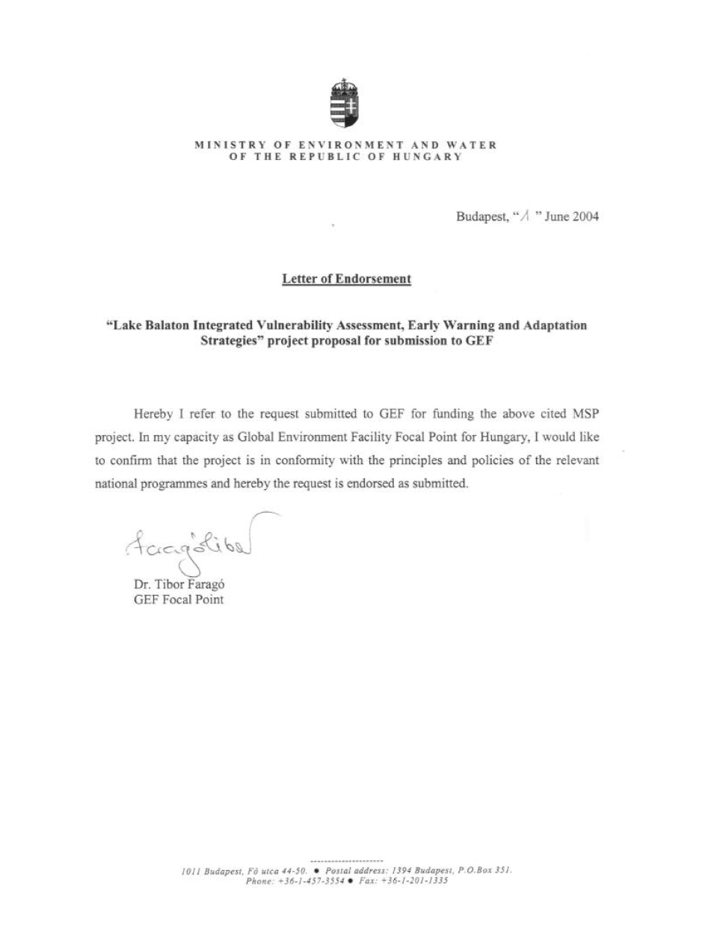
ANNEX 8: Letter of commitment from LBDC

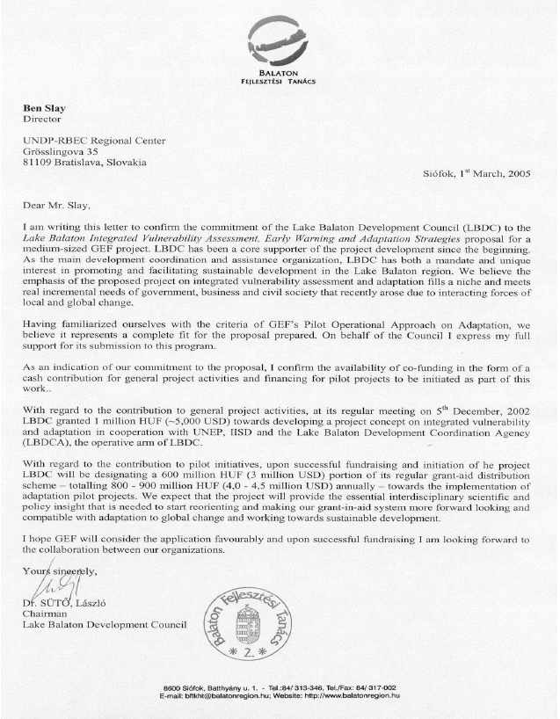
ANNEX 9: Letter of commitment from UNEP-DEWA/GRID-Geneva

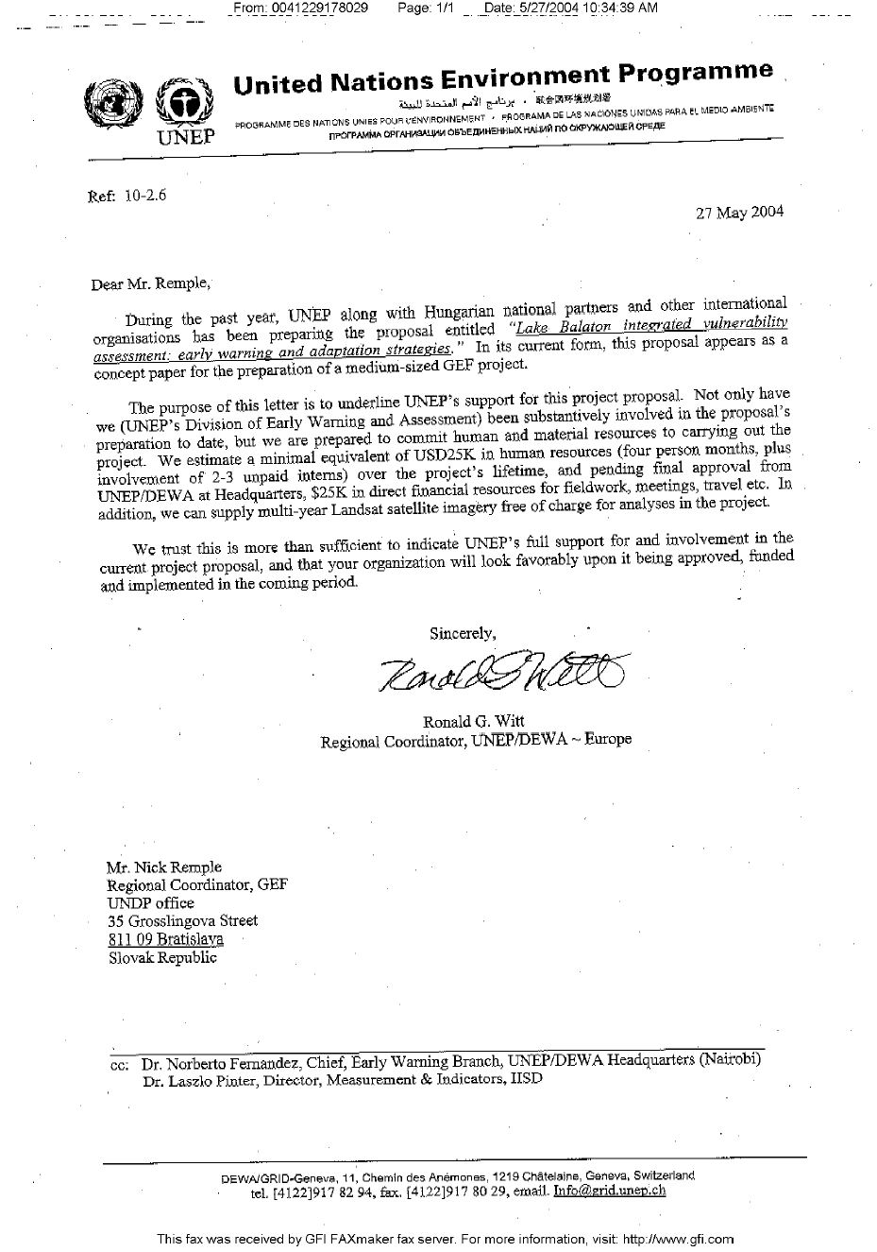
ANNEX 10: Letter of commitment from IISD

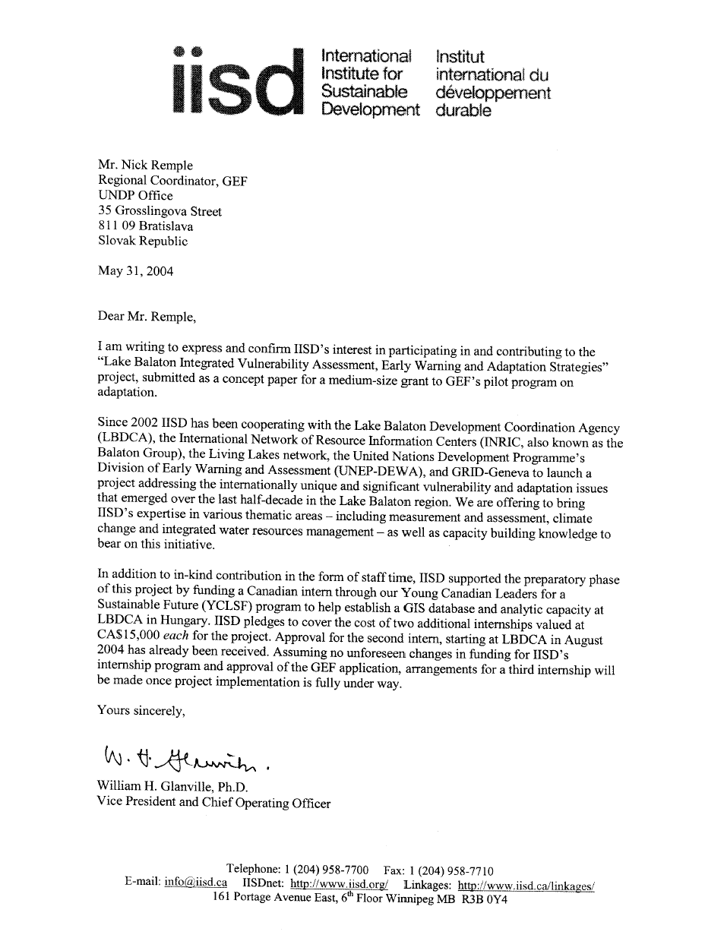
ANNEX 11: Letter of commitment from LEAD INTERNATIONAL

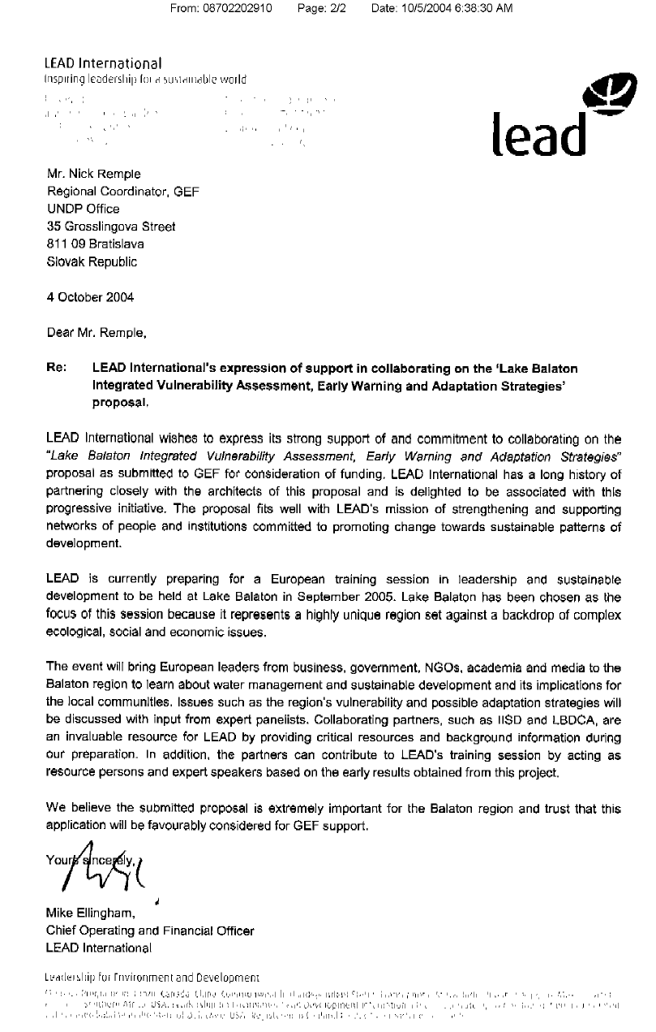

http://www.balatonregion.hu
Geoghegan, I. “Hungary’s Shrinking Balaton Fuels Climate Change Fears.” September 3, 2003 < http://www.enn.com/news/2003-09-03/s_7986.asp>
< http://www.vahava.hu/index.php?userid=&lang=en>
3rd World Water Forum Ministerial Declaration – Message from the Lake Biwa and Yodo River Basin. March 23, 2003 < http://www.world.water-forum3.com/jp/mc/md_final.pdf>
ToolBox on Integrated Water Resources Management < http://www.gwpforum.org/servlet/PSP?chStartupName=_water>
2003 Open Meeting of the Human Dimensions of Global Environmental Change Research Community <http://sedac.ciesin.columbia.edu/openmeeting/OM_Program_29sep03.pdf>
APF is available on-line at http://www.undp.org/cc/whatsnew.htm
IISD. (2004) IISD’s Influencing Strategy. Draft. Winnipeg, MB: International Institute for Sustainable Develoment.
UNDP/GEF (2005) “Adaptation Policy Framework for Climate Change: developing strategies, policies and measures” will be used as a primary reference for the necessary guidance in assessment.
Grindle, M.S. ed. (1997) Getting Good Government: Capacity Building in the Public Sectors of Developing Countries. Harvard Studies in International Development. Cambridge, MA: Harvard University Press.
<http://www.lead.org>
Table 5 above provides additional details of project funding (co-funding) per outcome
Reference as follows: Pintér, L. (2002) “Lake Balaton’s past, present and future: Dialogue on vulnerability and adaptation.” Balaton Bulletin, Fall.

