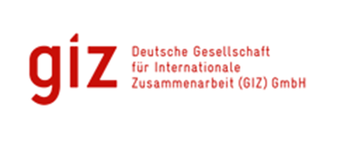
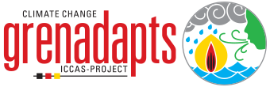
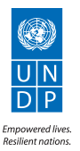

THEMATIC REPORT: ICCAS PROJECT

Water Resources Management

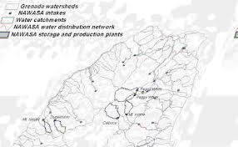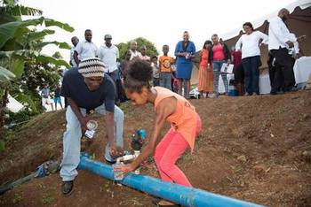

Submitted
By
David A. Simmons
92A Benjamin St., Diego Martin
Trinidad and Tobago
Email: davidAsimmons@outlook.com
Integrated Climate Change Adaptation Strategies (ICCAS): Thematic Report
Thematic Area: Water Resources Management |  | Period: January 2016 – August 2017
IMPLEMENTING AGENCIES
United National Development Programme (UNDP) | Ministry of Education Human Resources Development & Environment, NAWASA |  | German Development Cooperation (GIZ), BMUB
ICCAS Context | The Integrated Climate Change Adaptation Strategies (ICCAS) project was designed to provide a holistic approach to climate change adaptation and mainstreaming in Grenada. The overall aim of the ICCAS project was to increase resilience of vulnerable communities and ecosystems to climate change risks on the three islands: Grenada, Carriacou and Petite Martinique. The project, which has four Components, uses a comprehensive, integrated approach for analysing and implementing adaptation strategies. It also used a unique approach of establishing the institutional and operational framework for building adaptation and resiliency with direct support for the implementation of small-scale adaptation initiatives through a community based climate change adaptation fund which contributed immensely in informing ordinary citizens about the impacts of climate change and demonstrating through actual interventions, how they can initiate various activities, in their homes, schools and communities to build resiliency.  One of the specific goals/outputs expected in this programme was in the Water and Coastal Zone Resources Management (CZM), more particularly “planning, management and efficient use of the water and coastal zone resources is improved, through the establishment of integrated water resource management approaches and the formulation of CZM policies and management plans.” This thematic report presents projects and programs designed to address the issue of drought caused by climate change through water management mainly using large storage systems.
Background on Projects | Climate change poses a severe threat to Grenada’s water supply because the small island developing state (SIDS) relies on surface water sources and rainwater catchment. Water is a scarce resource in Grenada and climate change has already begun to aggravate the problem with an increasing average temperature and more erratic rainfall. More frequent heavy rainfall events make water supply outages more common due to high turbidity in the raw water supply. Saltwater intrusion in coastal groundwater aquifers due to sea level rise will further reduce the availability of freshwater in the future.  At the national level the focus was on the adaptation and resilience of the water sector and involved the implementation of the Blaize Rainwater Harvesting System pilot project while at the local level, the project partners supported specific adaptation measures that increase the resilience of local communities, while at the same time improving their living conditions. These formed part of the group of 27 small community projects funded under a climate change and adaptation strategies programme whose overarching goal is to help Grenada increase its resilience to climate change risk through integrated climate adaptation strategies.  Blaize Rainwater Harvesting System:  This pilot project was designed with a rainwater catchment area of 15,000 sq ft and a cistern with a 50,000-gallon capacity (that is a month’s worth of capacity at the total daily consumption figure of 2400 gallons for a population of 120 persons). A distribution network from the tank servicing the entire village was also part of the project.  Harvey Vale Government School Water Cistern:  This project addresses the decade-long water problems faced by the Harvey Vale Government School and villages of Belmont, Bellevue South and Harvey Vale area through the rehabilitation of an existing water cistern which upon rehabilitation should provide storage for 76,000 gallons of water. (approximately 1000 persons in surrounding communities affected).  Top Hill Water Cistern Rehabilitation  This project rehabilitated the Top Hill public water cistern to increase water storage and ensure availability of water year-round. The project aims to provide water to the most vulnerable families/groups; particularly during the dry seasons and periods of drought. It is anticipated that rainwater will be captured stored in the cistern during the rainy season, making it available for use when the dry season comes around. 45000 gallons of rainwater will be stored to ensure crop and livestock survival during the dry-seasons. This project was organized and managed by women’s group.  Rainwater Harvesting in Luthbur, St. Andrew’s  This project addressed the water shortages faced by an estimated 50 farmers farming within the Luthbur area in drought periods. The water is harvested from 4900ft² of roof on the Mirabeau Pentecostal Church, where guttering was installed and channelled through pipes to the newly constructed 20,000-gallon water storage tank through which farmers can tap into as water source for irrigation of their crops. In the past water falling from this sizable church roof has been resulting in considerable runoff, causing erosion and some local flooding, which is now being reduced given the capture of the rainwater water in the storage tank. This enhanced water storage capacity also helps reducing the increasing demand on an existing smaller water storage dam and complements the use of that source.  Rainwater harvesting at The Grenada School for Special Education -Grand Anse  The project has resulted increased water storage capacity through the construction of a 20,000-gallon water tank. This provision under the CCCAF has enabled the school to enhance water supply in dry periods and to revitalize its on-site vegetable gardening programme and make provision for a reliable source of various food crops to feed the children who attend the school (76 students). The results of this ICCAS intervention has also allowed the school for some sales of the produce to private organizations, generating some additional resources and to contribute toward the sustainability of the project.

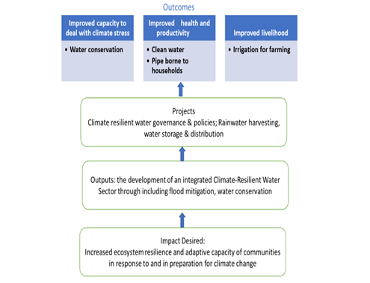
Overall Success

The projects identified in this report were all successful in achieving the outcomes desired as shown in the figure above. The projects all achieved goals of increased water storage using rainwater harvesting to store water during the wet season thereby reducing dependence on truck borne water and improving water availability during the dry season.

The notable findings are that there are enhanced capacities across communities to store up to 216,789 gallons of water due to the support of the CCCAF. There is also a high level of success reported in reducing the incidence of flooding through infrastructures installed.

In total, these projects installed cisterns with varying storage capacities. The overall in water installed capacity rose to 211,000 gallons of water.

Additionally, the provision of stored water in the dry season improved the lives of an aggregate total of approximately 1500 persons, in the project
communities in the following ways –
- Improved quality of home lives through clean water being made available during the dry season

- Higher attendance at school and work (anecdotal evidence)
- Higher food production due to irrigation networks to existing farms that formed part of the one of the projects
- New agricultural production and sales in the project where the establishment of a market garden formed part of the project.

Acknowledging the need for sustainable water resources the ICCAS project, with support from GIZ prepared, submitted and successfully obtained support from GCF to support the development of an integrated Climate-Resilient Water Sector (G-CREWS) project which would address not just the threats from climate change, but ensure that Grenadians would make some life-style behavioural changes triggered through appropriate governance, regulation, economic incentives and raising awareness in how they conserve and use their water resources.

Lessons Learnt
The mainstreaming of water resource management into the relevant development sectors together with the implementation of a number of community-based rainwater harvesting systems has been a tremendous success both at the local (community) and national levels. These successes have provided lessons which can be of tremendous benefits to other communities in Grenada and neighbouring islands encountering similar climatic impacts on their water resource sector. More importantly, within the country itself there are opportunities to scale up and, with the use of appropriate technologies, to contribute to enhancing the livelihoods of persons in these small communities.

- Project scoping and technology used
When developing the projects, the size of tanks, rainwater catchment area etc were all evaluated by those with expert knowledge and the projects were scoped appropriately given the budgets available.

- Project Concepts meeting community needs
Because all the projects were conceptualized based on very clearly observed community needs and by opportunities identified by those in the community (e.g. the quantum of water coming off the church roof in one of the projects sparked the idea to use that roof for rainwater catchment), the projects results were very positively viewed by the communities in question and are models for further projects built on the foundation provided by these.

- Community empowerment (Community, NGOs Other Cooperative entities) and Capacity building
- All the projects used community groups as the implementing agencies. There was a heavy involvement of Women’s Groups in several projects. Additionally, one of the projects was undertaken by a school for special needs children which consequently were introduced to drip irrigation and farming techniques.
- The use of community groups and NGO’s that are community-based helps to ensure community buy in and sustainability.
- Construction work was done using community members in the main.
- The grant funds obtained mainly went into the projects since overheads were minimal.
- Community members made in kind contributions to the construction activity on weekends which further acted to enhance their commitment to the project.
- The community members in some cases were trained in maintaining water quality providing a skill that will contribute to project sustainability
- There were issues with short term payments due to the disbursement procedures and that created resentment, delays and some community resistance on occasion. Flexibility in terms of procedures should be built into future projects, recognizing the limitations that exist in small communities with regard to things like chequing accounts and sophisticated accounting procedures.
- No technical training was done however in maintaining of the actual tanks and pipeline networks and given the remoteness of some of the projects this should be considered in developing future projects using this model.

- Anecdotal evidence and reporting of individuals in the community suggest that the projects have had a very positive effect on quality of life (for example higher school and work attendance) and on livelihood generation. However, no systematic collection of baseline data was done at the beginning of the projects on these key indicators, so it is difficult to ascertain the extent of the impact and improvement. An important takeaway therefore is the importance of collecting and establishing baseline indicators which can be compared to end of project indicators and give a more precise measurement of the project’s impact.

Best Practice(s) Identified
The use of rainwater harvesting in these pilots has provided a roadmap for sustainable provision of water to the larger Grenadian community and to other SIDs in the Caribbean in several ways:
- Use of existing facilities to provide a basic need within the community (rehabilitation of already built structures)
- Use of appropriate technology – easily maintained and highly replicable, and sustainable by stakeholders both within the community and within the governing agencies
- Integration of other climate resilience related activities - as in the case of the Top Hill agricultural irrigation linkage and the Grenada Special Education School which used solar panels to generate energy and combined with the rainwater harvesting activity produced crops to be sold.
- Generation of income from the project to enhance livelihood of persons in the community and simultaneously provide the potential for greater investment in the production and sale of agricultural produce in the case of the Special Education School

Recommendations based on the Lessons Learnt and Best Practices Analysis:
- Include collection of baseline indicators as part of the project.
- Allow for the setup of a small fund that could be disbursed by the project manager and accounted for after the fact to permit works to proceed more quickly
- Formally establish mechanisms for stakeholder engagement. Future projects following this model should be set up with a formal and periodic stakeholder involvement process to ensure ongoing stakeholder engagement.
- Training of some community members in maintenance of the system would assist in long term sustainability of the systems especially in remote areas

Author: David Simmons & Christina Barradas-Brewster/ Consultants/Caribbean
Contact: davidasimmons@outlook.com
Location of Project: Caribbean/OU/Grenada/St Andrew
MHT: What is the Major Habitat Type for this partnership? Rural, Farming, school
Types of Partners: Government, Place-based NGO, International NGO, Community Based Organization.
Priority: Freshwater
Date: June 2018
Links: https://www.eldis.org/document/A74069
http://www.iccas.gd/?q=community-projects
https://www.greenclimate.fund/-/climate-resilient-water-sector-in-grenada-g-crews-

