Summary of visiting GCF sites in Yom-Nan water management project located in Phitsanulok province on 30 November 2017

I. Introduction

This document presents an account of the field missions associated with the “UNDP-GIZ workshop on applying Cost-Benefit Anaysis and Ecosystem-based Adaptation methods to MOAC Agricultural Programmes” conducted on 27, 28 and 30 November, 2017.

The purpose of the field mission was to accompany delegates to GCF sites of the Yom-Nan project located in Phitsanulok province. The outcome of the visits was that delegates gained a better understanding on integrated water management.

II. Background - project overview

“Community management of water resources (Bang Ra Gum model 60)”

Every year farmers face floods during the period from August to October. The upstream areas of Yum river basin are very steep, started from from Prae province to Sukhothai province, and the midstream areas are floodplain and pond, located in Amphoe Krong Krailad, in Sukhothai province, Amphoe Prom Pi Ram, Amphoe Bang Ra Gum in Phitsanulok province (figure 1)

Farmers in irrigation areas need to cultivate crops before flooding occurs. The farmers need Royal Irrigation Department (RID) to allocate water in irrigation area before crop calendar, by changing flow irrigation

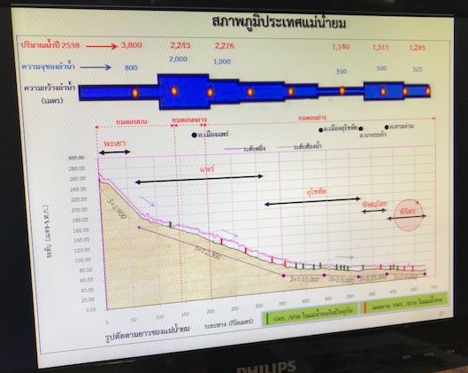
Figure 1: Cross-section of Yum Nan river topography
Bang Ra Gum model 60

Described changing the crop calendar (Bang Ra Gum model 60) (figure 2), the demanding farmers in Yum river basin need that the RID changing of water allocation in the irrigation areas before dry season.

Start flowing water allocation in the irrigation areas from December to March (second-season rice) and also flow the water in rainy reason (in-season rice) since April to July that can help the farmers to grow rice for 2 times per year. Thus from August to November the famers will be able to do the supplementary occupations such as fishing, making fish sauce, fish fermentation and labor.

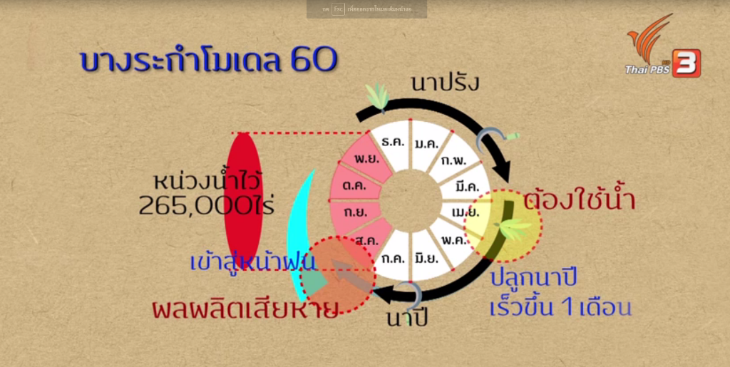
In-season rice=นาปี
second-season rice= นาปรัง
Start growing early of season rice in 1 Month
Farmers need water
Damaged production
Start of rainy reason
Retention area of 265,000 Rai
Figure 2: Bang Ra Gum model 60 from the Thai PBS

III. Field trip
After an introduction to the project at the RID Irrigation Office 3, delegates visited Bang Ra Gam and Klong Ta Khe water gates.

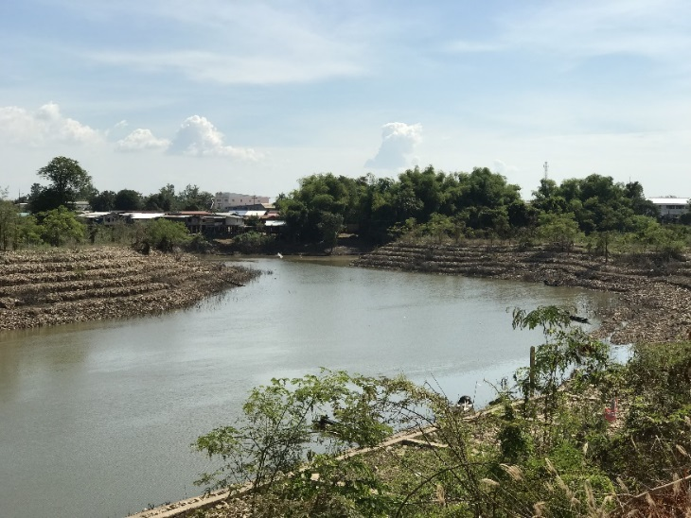
Figure 3: At Bang Ra Gam water gate, the gabion wall is constructed from large rocks that can reduce the velocity of water flow.

Bang Ra Gum water gate at Tambon Bang Ra Gum

The water distribution planningin Yum river basin was initiated with the relevant agencies such as Amay 3, Ministry of Interior, Ministry of Agriculture and Cooperatives, and the farmer groups in Bang Ra Gum areas, the planning is aim to define working frameworks, time duration, which could be assigned to the relevant agencies to proceed.

The drainage plan in retention areas was set up after discussions between the Bang Ra Kam working group, water user groups, and farmer’s representatives who defined the goal retention water level at 41 m (M.S.L.); this level does not affect community roads and areas. By storing the water level in the reservoir of 400 million cubic meters as a result to promoting fishery and water for the supply of second rice paddy field.

Water gate at Klong Ta Khe at Tambon Bang Ra Gum and discussion with water user groups

The chief administrator of the Sub district Administrative Organization (SAO), who is the head of water group, set up a water group of volunteers which manages the water resources in 12 villages. The water groups will be established, which are responsible for planning of water distribution with the RID, and for managing the allocation of water between farmers.

A pilot area for the retention reservoir

The next visiting of the delegations was, a retention reservoir will be constructed to storage the water. The benefits of building the reservoir include the following (Figure 4):

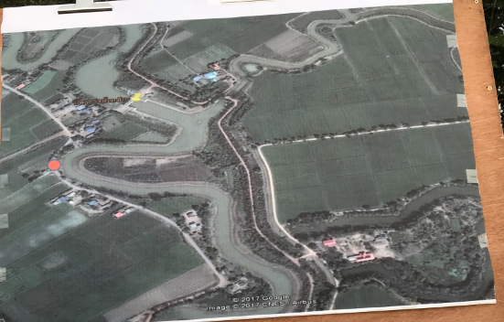
Figure 4: Pilot area for the retention reservoir at the GCF site (the blue line is the boundary for creating the retention area).

- fishing areas for the community
- storage of 400 million m³ water from August to November
- impedes negative effects of successional flooding, and can further be used to recharge groundwater

IV. Notes

Key issues include the following.

- Problems in the Yum Nan river basin include water scarcity and potential community conflict. Climate change phenomena include changes in precipitation patterns which may lead to more flooding in the rainy season.

- The negative effect of climate change to the community. The climate change problems cannot resolve by only. Themselves. The people and the government need to work together.

- For the suitable own crop need to be sought out knowledge to the people such as knowing how to grow, knowing how to modify, building a product and also creating a brand to their community.
V. References

Video programme was broadcast on ThaiPBS on 12 November 2017 http://program.thaipbs.or.th/thenorth/episodes/49088

Document from RID of the field trip “โครงการบริหารจัดการน้ำแบบชุมชนมีส่วนร่วมพื้นที่ทุ่งหน่วงน้ำบางระกำ (Bang Ra Gam model 60)” in Thai

